**“Online Pharmacy an E-Commerce”**

Submitted by

**Pronob Kumar Paul**

**ID: 1834902138**

**&**

**Md. Chan Miah**

**ID: 1834902058**

A project report submitted in partial fulfillment of the requirements for the Degree of Bachelor of Science in Computer and Engineering

Supervised By

**Tanzina Ferdous**

Lecturer

Department of Computer Science & Engineering

City University, Bangladesh.



**CITY UNIVERSITY**

**DHAKA, BANGLADESH**

**December 2021**

**ACKNOWLEDGEMENT:**

We would like to express our deepest appreciation to our honorable supervisor **Tanzina** **Ferdous**, Lecturer, Department of Computer Science and Engineering, City University for his continuous guidance, encouragement, patience and giving us to do this work. His guidance and gestures made “Online Pharmacy an E-Commerce” project possible with a well-organized report. We are especially indebted to Md. Safaet Hossain, Assistant professor and Head, Department of Computer Science and Engineering, City University for his valuable advice.

**ABSTRACT:**

The purpose of the project entitled as “Online Pharmacy an E-Commerce” is to computerize the Front Office Management of online store to develop software which is user friendly simple, fast and cost – effective, for personal use and makes the data processing very fast. Shopping Cart System is the Simple shopping Solution. It’s a full featured website and shopping cart system that bends over backwards to give us the flexibility we need to run our online store. The basic concept of the application is to allow the customer to shop virtually using the Internet and allow customers to buy the items and articles of their desire from the store. The information pertaining to the products are stores on an RDBMS at the server side (store). The Server processes the customers and the items are shipped to the address submitted by them. The details of the items are brought forward from the database for the customer view based on the selection through the menu and the database of all the products are updated at the end of each transaction.

**INTRODUCTION:**

In today's world, information technology has made great strides. Medical technology is one of them. Although Medical technology has improved but there are very few arrangements for delivering medicine home. Therefore, our main goal is to deliver the necessary medicine to the people. People can get the medicine they need by showing the prescription through the Online Pharmacy website. Online Pharmacy primarily serves as an online medicine delivery medium. When patients come to the doctor for treatment, the doctors prescribe the medicine to the patients. By showing that prescription, customers can easily purchase the medicine online and get the benefit of fast delivery.

**OBJECTIVES:**

The project objectives are:

* To make the shopping easier and comfortable.
* To serve the customers without wasting their precious time.
* To reach the products to the customer’s address with great care.
* To represent as compete in the e-commerce of Bangladesh.

**TECHNOLOGY:**

**Front End:** CMS **(**HTML, CSS, Java Script)

* **HTML:** HTML used to create and save web document. E.g. Notepad/Notepad++.
* **CSS:** (Cascading Style Sheets) Create attractive Layout.
* **Java Script:** It is a programming language, commonly use with web browsers.

**Back End: CMS** (PHP Framework LARAVEL 8.x, MySQL).

* **PHP:** Hypertext Pres-processor (PHP) is a technology that allows software developers to create dynamically generated web pages, in HTML, XML, or other document types, as per client request. PHP is open source software.
* **MySQL Server:** MySQL developed, distributed and supported by Oracle Corporation. MySQL is a database system used on the web it runs on a server. MySQL is ideal for both small and large applications. It is very fast, reliable, and easy to use. It supports standard SQL. MySQL can compiled on a number of platforms. The data in MySQL is stored in tables. A table is a collection of related data, and consists of columns and rows. Databases are useful when storing information categorically. My SQL is a database, widely used for accessing querying, updating, and managing data in databases.

**FEATURES:**

* Secure registration and profile management facilities for Customers.
* Browsing through the e-Mall to see the items that are there in each category of products like Medicine.
* Creating a Shopping cart so that customer can Shop N number of items and checkout finally with the entire shopping cart
* Customers should be able to mail the Pharmacy about the items they would like to see in the Pharmacy.

**Methodology:**

**System Model:**

The system model helps the analyst to understand functionality of the system and model are uses to communicate of users.

Types of Online Pharmacy Users:

There are mainly three users in this system. These are:

* Admin
* Salesman
* Customer

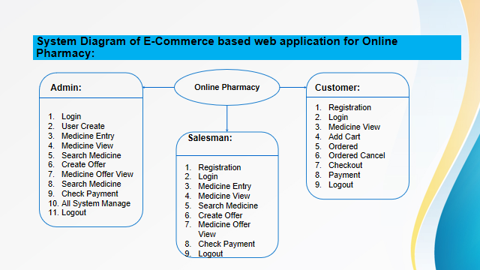

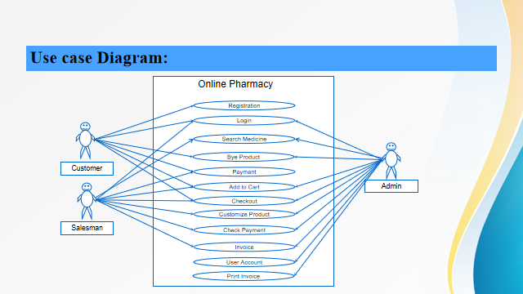

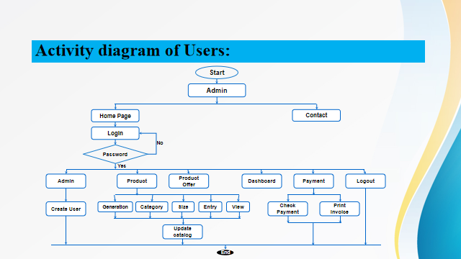

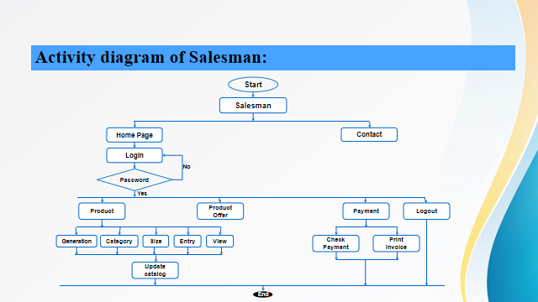

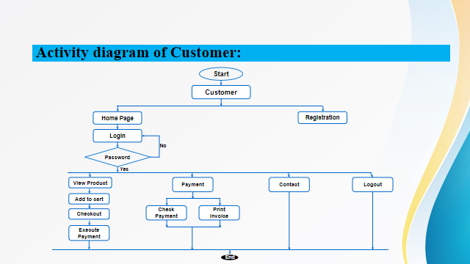

Software Development Life Cycle:

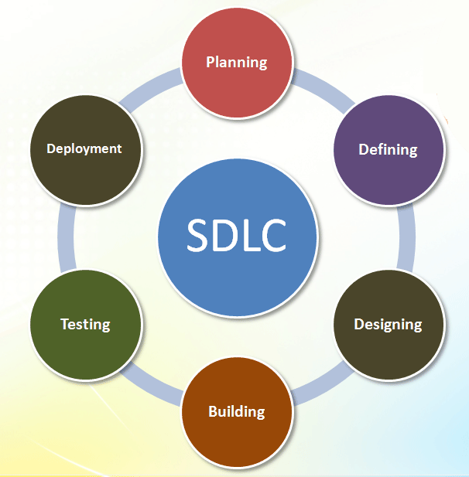

Figure: Software Development Life Cycle

**CONCLUSTION:**

In the study we try, our best to minimize problem of existing system, which we are facing in manual based system this application is, will be very essential for an online business for maintaining the regular activity this web application will allow to store huge amount of data for a long time without any damage.

Proposed system of our apps:

* Easy to handle and feasible.
* Fast and Convenient.
* Cost Reduction

**Reference:**

[1] Hokkanen, H. T. M. L., and David Pimentel. "New approach for selecting biological control agents." Canadian Entomologist 116, no. 8 (1984): 1109-1121.

[2] Peirce, C.S.S., 1906. Prolegomena to an apology for pragmaticism. The Monist, pp.492-546.

[3] Guha, Arjun, Claudiu Saftoiu, and Shriram Krishnamurthi. "The essence of JavaScript." In European conference on Object-oriented programming, pp. 126-150. Springer, Berlin, Heidelberg, 2010.

[4] Chaffer, J. and Swedberg, K., 2011. Learning jQuery. Packt Publishing Ltd.

[5] Davids, P.H.P, Groen, A.K., Rauws, E.A.J., Tytgat, G.N. and Huibregtse, K., 1992. Randomised trial of self-expanding metal stents versus polyethylene stents for distal malignant biliary obstruction. The Lancet, 340(8834-8835), pp.1488-1492.

[6] Yarger, Randy Jay, George Reese, Tim King, and Andy Oram. MySQL and mSQL. O'Reilly & Associates, Inc., 1999.

[7] DuBois, Paul. MySQL. Addison-Wesley Professional, 2013.

[8] He, Ren Yu. "Design and implementation of web based on Laravel framework." In 2014 International Conference on Computer Science and Electronic Technology (ICCSET 2014). Atlantis Press, 2015.

[9] Dvorski, Dalibor D. "Installing, configuring, and developing with Xampp." Skills Canada (2007).

[10] Balaji, S. and Murugaiyan, M.S., 2012. Waterfall vs. V-Model vs. Agile: A comparative study on SDLC. International Journal of Information Technology and Business Management, 2(1), pp.26-30.

[11] Lucassen, John M., and Stephane H. Maes. "MVC (model-view-controller) based multi-modal authoring tool and development environment." U.S. Patent 6,996,800, issued February 7, 2006.