## 一、Mysql

非root用户安装

假如用户为ba0986

创建文件夹 /usr/local/pgmangementmysql/mysql/

创建文件 my.cnf

[client]   
port=13306  
socket=/usr/local/pgmangementmysql/mysql/mysql.sock    
lc-messages-dir=/usr/local/pgmangementmysql/mysql/share/errmsg.sys  
tmpdir=/usr/local/pgmangementmysql/mysql/tmp  
[mysqld]   
port=13306   
basedir=/usr/local/pgmangementmysql/mysql  
datadir=/usr/local/pgmangementmysql/mysql/data   
pid-file=/usr/local/pgmangementmysql/mysql/mysql.pid   
socket=/usr/local/pgmangementmysql/mysql/mysql.sock   
log_error=/usr/local/pgmangementmysql/mysql/error.log   
server-id=100  
  
character_set_server = utf8  
init_connect = ‘SET NAMES utf8’  
query_cache_size=256M  
max_connections=1000  
wait_timeout=1814400   
interactive_timeout=1814400  
symbolic-links=0  
lc-messages-dir=/usr/local/pgmangementmysql/mysql/share/errmsg.sys  
tmpdir=/usr/local/pgmangementmysql/mysql/tmp

保存后执行

bin/mysqld --defaults-file=/usr/local/pgmangementmysql/mysql/my.cnf --initialize --user=ba0899 --basedir=/usr/local/pgmangementmysql/mysql --datadir=/usr/local/pgmangementmysql/mysql/data

再次执行，不加—initialize

Ps –ef|grep mysql查看是否启动

然后 执行 bin/mysql –u root –p

SET PASSWORD FOR 'root'@'localhost' = PASSWORD('123456');#修改密码

GRANT ALL ON *.* TO 'root'@'%' IDENTIFIED BY 'root';  
FLUSH PRIVILEGES;  
  
  
CREATE DATABASE IF NOT EXISTS portal default charset utf8;

如果产生错误 [Can't connect to local MySQL server through socket '/tmp/mysql.sock](https://www.cnblogs.com/wzbz/p/6686179.html)

Ln –s /usr/local/pgmangementmysql/mysql/mysql.sock /tmp/mysql.sock

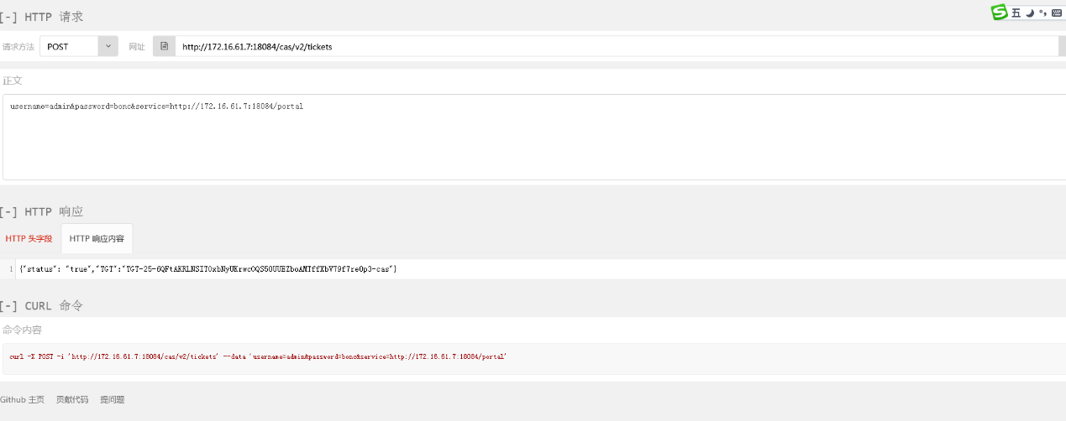

## 二、nginx

安装编译工具及库文件：

yum -y install make zlib zlib-devel gcc-c++ libtool  openssl openssl-devel

mkdir –p /home/ba0899/application

mkdir –p /home/ba0899/nginx

cd /home/ba0899/application

wget <http://nginx.org/download/nginx-1.10.3.tar.gz>

tar zxvf nginx-1.10.3.tar.gz

cd nginx-1.10.3

./configure --prefix=/home/ba0899/nginx

make && make install

如果出现./configure: error: C compiler cc is not found

需要安装gcc-c++包

yum -y install gcc-c++

继续 ./config

如果出现./configure: error: the HTTP rewrite module requires the PCRE library.

安装yum -y install zlib zlib-devel openssl openssl--devel pcre pcre-devel

yum -y install openssl openssl-devel

1.//打开防火墙文件

sudo vim /etc/sysconfig/iptables

//新增行 开放10000端口

-A INPUT -p tcp -m state --state NEW -m tcp --dport 10000 -j ACCEPT

保存退出

sudo service iptables restart//重启防火墙

2.开启 web 端口

firewall-cmd --permanent --add-port=10000/tcp

重启 firewall

firewall-cmd –reload

nginx需要在编译的时候加入  --with-http_ssl_module 支持

   ./configure --prefix=${dir}/nginx --with-http_ssl_module

3.或者关闭防火墙systemctl stop firewalld

sudo systemctl stop firewalld.service && sudo systemctl disable firewalld.service

http-https

1首先备份原来nginx目录

2.进入/opt/nginx/application/nginx-1.10.3

执行./configure --prefix=/opt/nginx --with-http_ssl_module

3.执行make

4,将/opt/nginx/application/nginx-1.10.3/objs/nginx 复制到原nginx/sbin下面

需要关掉再启动nginx

导入证书

1首先，nginx在编译安装时得安装ssl模块  
上传ssl证书到服务器/usr/local/nginx/ssl/xxx.pfx

生成证书crt可key

openssl pkcs12 -in /usr/local/nginx/ssl/xxx.pfx -clcerts -nokeys -out /usr/local/nginx/ssl/xxx.crt

openssl pkcs12 -in /usr/local/nginx/ssl/xxx.pfx -nocerts -nodes -out /usr/local/nginx/ssl/xxx.rsa

验证证书正确性

openssl s_server -www -accept 443 -cert /usr/local/nginx/ssl/xxx.crt -key /usr/local/nginx/ssl/xxx.rsa

server {

listen 443;

server_name localhost;

ssl on;

ssl_certificate /usr/local/nginx/ssl/xxx.crt;

ssl_certificate_key /usr/local/nginx/ssl/xxx.rsa;

ssl_session_timeout 5m;

ssl_protocols SSLv2 SSLv3 TLSv1;

ssl_ciphers ALL:!ADH:!EXPORT56:RC4+RSA:+HIGH:+MEDIUM:+LOW:+SSLv2:+EXP;

ssl_prefer_server_ciphers on;

location ~ /api/(.*) {

proxy_redirect off;

proxy_set_header Host $host;

proxy_set_header X-Ssl on;

proxy_set_header X-Real-IP $remote_addr;

proxy_set_header X-Forwarded-For $proxy_add_x_forwarded_for;

proxy_pass http://serverAPI;

}

}