Open Stack

Version 1.0 le 10 oct. 2019

1. What’s OpenStack?
As a part of Infrastructure as a service Cloud, OpenStack is a Cloud operating system which controls large pools of compute, networking and storage resources throughout a datacenter.

OpenStack project is an open-source cloud-computing platform for private, public and hybrid clouds.

OpenStack provides IaaS solution through a set of services.

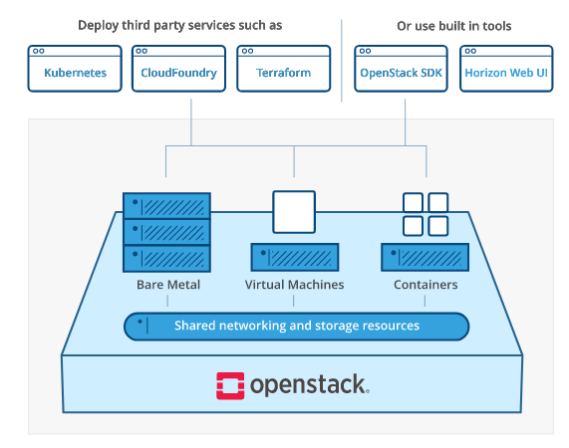
2. What’s OpenStack core functionality?
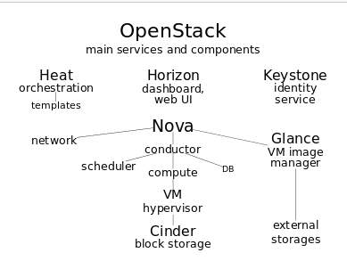
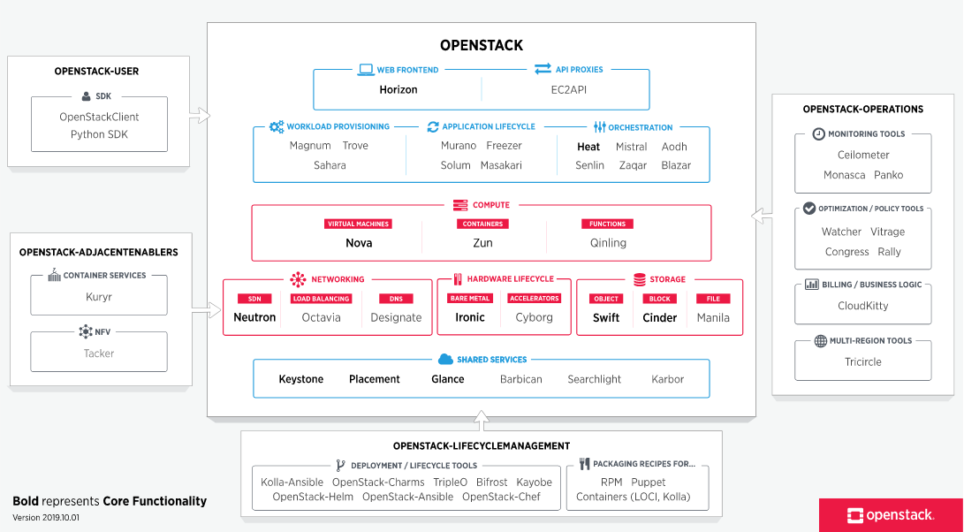

3. What’s the NFV (Network Function Virtualisation)?

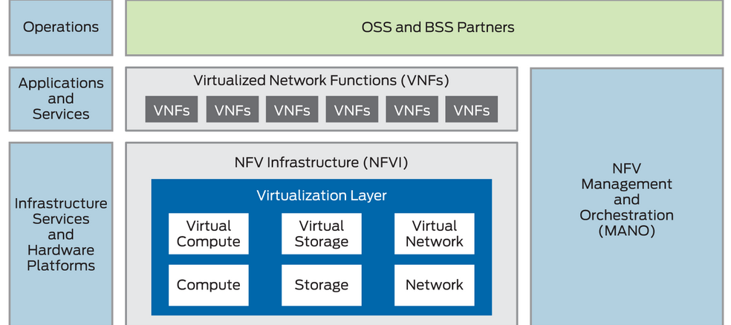
As a network architecture concept, NFV uses technologies of IT virtualisation to virtualize entire classes of network node into building blocks.

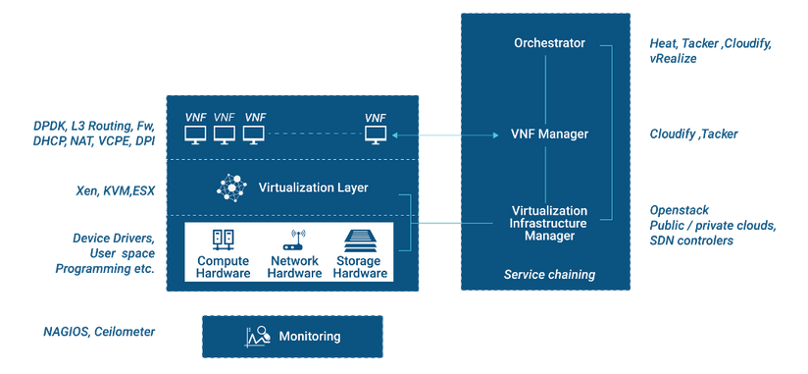
4. Compare OpenStack and AWS

