Rapport du HTTP/HTTPS

HTTP/HTTPS

Version 1 le 31/07/2019

1.URL
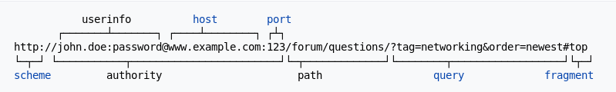
2. HTTP version
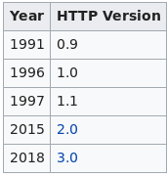

Terms:
HTTP: Hypertext Transfer Protocol, 80, 8008, 8080
HTTPS: Hypertext Transfer Protocol over TLS/SSL, 8080

