Rapport du Cloud

Cloud

Version 1 le 08/07/2019

I. Cloud Computing

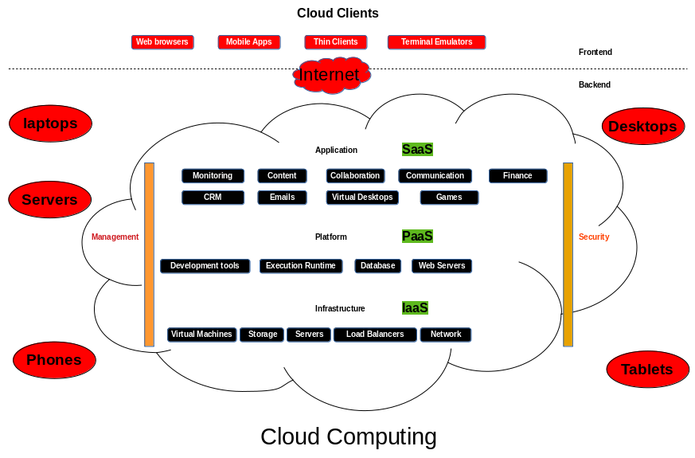

II. Cloud Computing Security
Cloud Computing Security or, simply, cloud security refers to a broad set of policies, technologies, applications and controls utilized to protect virtualized IP, data, applications, services and the associated infrastructure of Cloud Computing.

III.Cloud Computing Vulnerabilites

IV.Cloud Computing Platforms
Alpha7: Cloud firm in Singapore
AWS : (Amazon Web Services)
AppScale: AppScale Systems firm
Azure : Microsoft
Box : Box Inc.
Bluemix: IBM
CloudBolt: CloudBolt Software
CloudFoundry : Cloud Foundry Foundation
Cocaine:
Engine Yard :
Helion: HP (Hewlett Packard)
Predix : GE (General Electric’s)
Google App Engine : Google
GreenQloud :
Heroku :
InkTank :
Jelastic :
Mendix :
MindSphere: Siemens
Netlify :
Oracle Cloud :
OutSystems :
openQRM :
openShift : RedHat
PythonAnyWhere :
RightScale :
Scalr :
Force.com / Salesforce.com
SAP Cloud Platform :
vCloud Air : VMware
WaveMaker:

X. Annexes
PaaS : Platform as a Service
SaaS : Service as a Service
IaaS : Infrastructure as a Service
KVM : Kernel-based Virtual Machine
CSRO: Compliance and Security Risk Officer
SG: Société Générale
CWPP: Cloud Workload Platform Protection
CSPM: Cloud Security Posture Management.
CASB: Cloud Access Security Brokers

