**FORMS ON EMPLOYEE EDUCATIONAL INFORMATION**

**Qualification Setup**

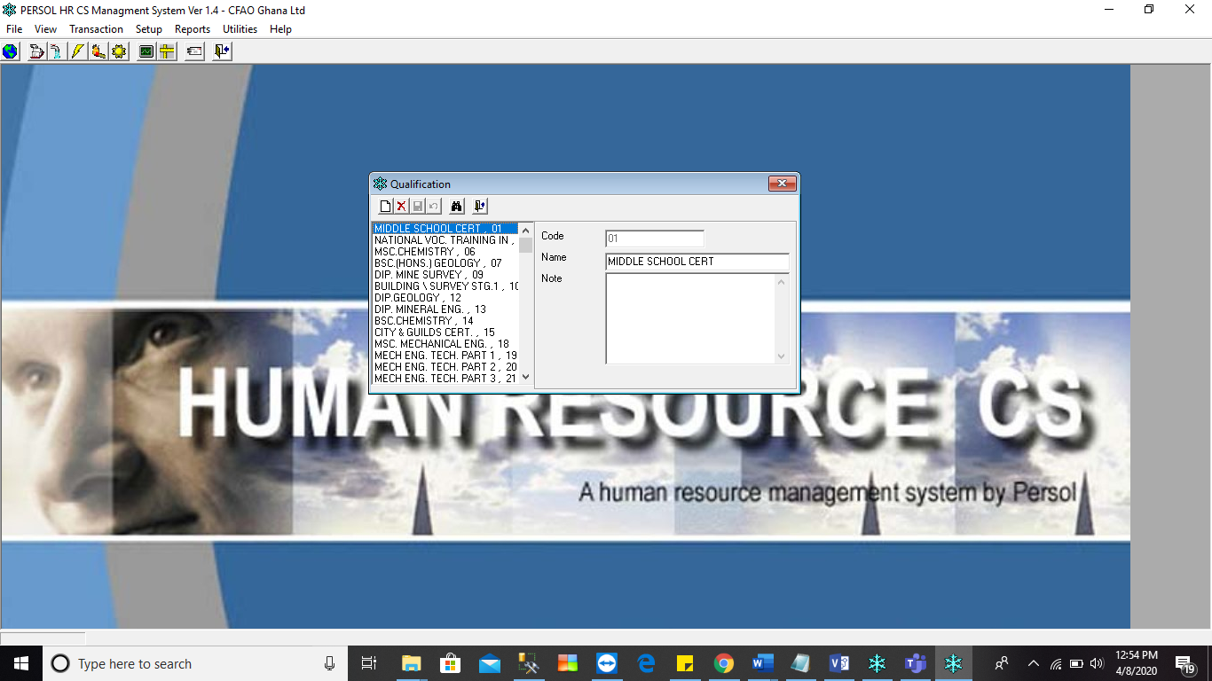

**Core area setup**

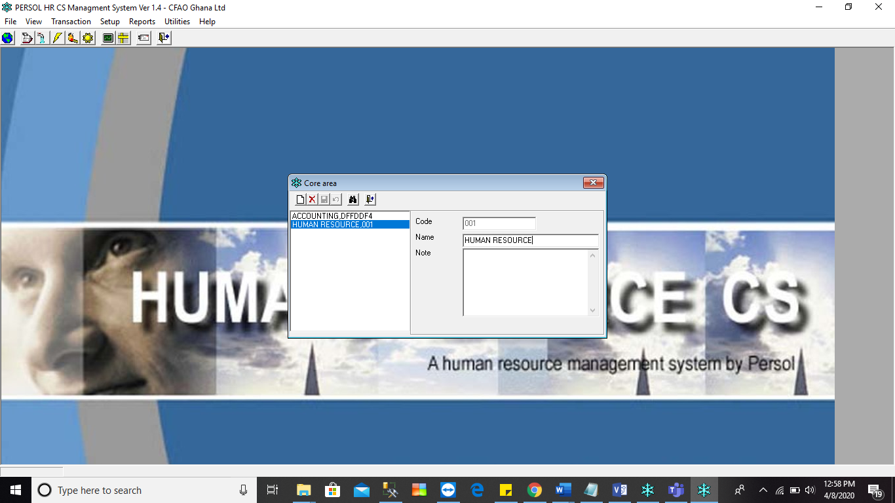

**Transaction**

**Step 1**

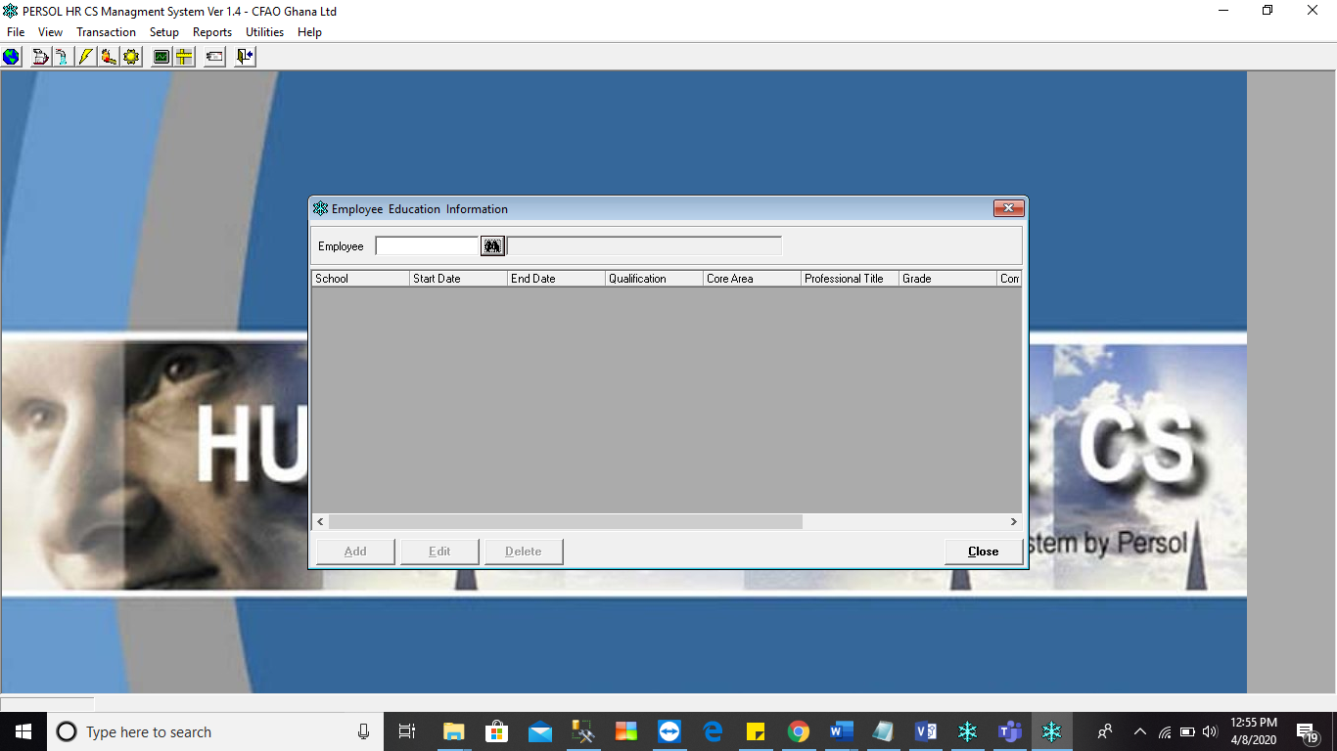

Step 2

