Programming exercise

DeepQ AI agent for the pong game
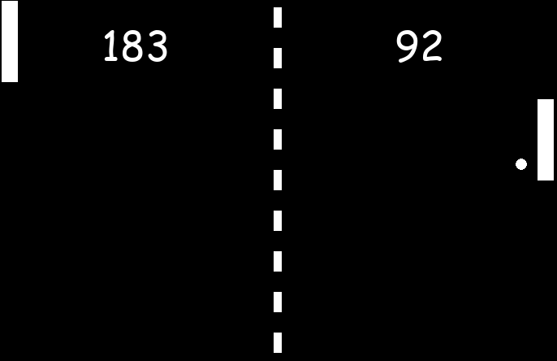
- Play the original pong game „pong_human_original.py“ to get a feeling for the game

- In the file pong_rl_environment.py, you will find a complete machine learning environment for the pong game. The ML environment already takes care of calculating rewards and returning the state of the game.

How are the rewards given? Explain!
+0.2 wenn paddle hittet, +1 wenn er scored
-1 wenn punkt gegen ihn

How is the state given? Explain!
Vektor aus 8 Werten mit Position, Geschwindigkeit, Position der paddles

You can generate a new game by calling the constructor of the pong_environment:

env=pong_environment(render=True)
a single step forward is then done by
positiondata, reward, rewardleft, done=env.one_step(actionrightpaddle)
#action=0 paddle moves up
#action=1 paddle moves down
#action=2 do nothing
Generate a Game and make a Screenshot of the working game using the pong_environment:

[Screenshot]
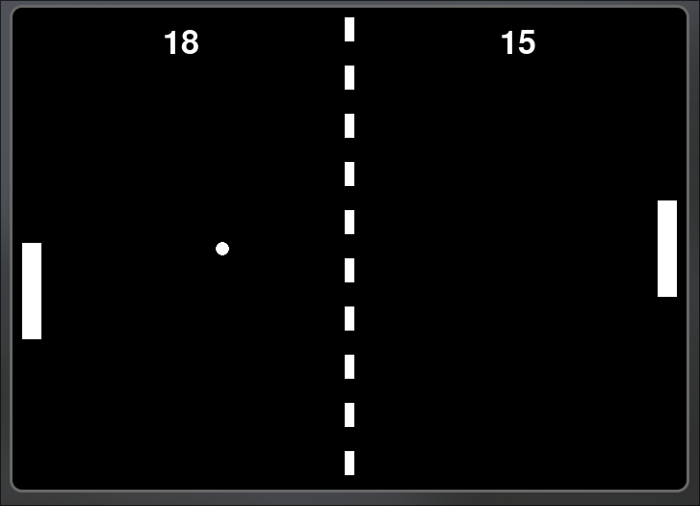

- A complete and very general deep-Q AI agent class is given in the file deepQ_agent.py.Try to understand the code and its parameters!
An agent can be created by
agent=my_agent(input_neurons,output_neurons,loadmodel,trainme)

loadmodel = True #existing model is loaded
trainme = False #no training, just play

Explain how the Neural Network is used to predict the next action.
State als Input
fully connected (Dense) Neural Network mit 3 Hidden Layers, mit 128 Neuronen und ReLU-Aktivierung, und einer linearen Output-Schicht, die für jede Aktion einen Q-Wert liefert.

- Write a new code, where you import the environment and the agent. Generate an environment and an agent object and initialize the system.

Level 1: Write a code that trains an AI agent for playing the pong game human vs. AI
Level 2: Write a code that trains two AIs that are playing against each other.

Hints:
The get_action function predicts the next action and already implements the epsilon greedy strategy:

newaction =agent.get_action(states)

The agent is trained on a batch that is randomly chosen from ist memory. Add items to the agents memory by:

agent.memory.append((state,action,reward,nextstate,done))

Train the agent with the function:

agent.train()

Futher general notes:
- In a game with moving objects, the AI needs to know the velocity of the objects. It is likely not good enough to store only a single time-step in state and nextstate.
- The training needs quite a lot of time!

