

eProject Report

On

E-Vaccination System

Submitted By:
Mr. ABDUL SATTAR (Student1619071)
Mr. MUHAMMAD ANUS (Student1598956)
Mr. MUHAMMAD AHMED (Student1604808)
Mr. MUHAMMAD ABBAS ZAIDI (Student1604806)
Mr. SARANG LATEEF (Student1598519)


Aptech Gulshan-e-Hadeed Center
Semester 2
June 2025

Certificate of Completion

Certificate of Completion
This is to certify that
Mr. ABDUL SATTAR (Student1619071)
Mr. MUHAMMAD ANUS (Student1598956)
Mr. MUHAMMAD AHMED (Student1604808)
Mr. MUHAMMAD ABBAS ZAIDI (Student1604806)
Mr. SARANG LATEEF (Student1598519)
have successfully completed the eProject titled
"E-Vaccination System"
as a partial fulfillment of the requirements for Semester 2.

Completed Completed
Head of Department Project Guide

Acknowledgements
We would like to express our deepest gratitude to our project guide and the entire faculty of Aptech Learning for their invaluable guidance, constant supervision, and for providing necessary information regarding the project. Their support was instrumental in the successful completion of this eProject.
We are also thankful to the eProjects team for providing us with this opportunity to work on a real-world application, which has greatly enhanced our practical skills and understanding of the software development lifecycle.
Finally, we would like to thank our parents and friends for their encouragement and support throughout this project.

Thank you,
The Project Team

Table of Contents
- Introduction
- Objectives
- Problem Statement
- Hardware/Software Requirements
- Project Analysis
  - eProject Synopsis
  - Customer Requirement Specification
- Project Design
  - Data Flow Diagrams (DFDs)
  - Flowcharts
  - Database Design / Structure
- Screen Shots
- Source Code with Comments
- User Guide
- Developer's Guide
  - Module Descriptions

1. Introduction
The thirst for learning, upgrading technical skills and applying the concepts in real life environment at a fast pace is what the industry demands from IT professionals today. However busy work schedules, far-flung locations, unavailability of convenient time-slots pose as major barriers when it comes to applying the concepts into realism. And hence the need to look out for alternative means of implementation in the form of laddered approach.

So what is this eProject?
eProject is a step by step learning environment that closely simulates the classroom and Lab based learning environment into actual implementation. It is a project implementation at your fingertips!! An electronic, live juncture on the machine that allows you to:
- Practice step by step i.e. laddered approach.
- Build a larger more robust application.
- Learn implementation of concepts in a phased manner.
- Enhance skills and add value.
- Work on real life projects.

2. Objectives of the project
The Objective of this program is to give a sample project to work on real life projects. These applications help you build a larger more robust application. The objective is not to teach you concepts but to provide you with a real life scenario and help you create applications using the tools.

3. Problem Statement
The problem is to digitize the manual vaccination tracking system to prevent children from missing critical immunizations. The E-Vaccination System will provide a centralized platform for parents, hospitals, and administrators to manage vaccination schedules, appointments, and records efficiently.

4. Hardware/Software Requirements

Hardware
- Pentium 166 or better
- 128 MB RAM or better

Software
- Operating System: Windows 2000/Linux or higher
- Web Server: Apache
- Server-side Scripting: PHP
- Database: MySQL
- Scripting: PERL (Optional)

5. Project Analysis

eProject Synopsis
The E-Vaccination System is a web application designed to streamline the process of childhood immunizations. It replaces inefficient manual methods with a robust digital platform, connecting parents, hospitals, and administrators. The core of the system is a centralized database that maintains accurate records of children, their vaccination schedules, and appointment histories. This ensures data integrity and easy access to information, helping to prevent missed vaccinations and improve public health tracking.

Customer Requirement Specification
Admin:
- Manage hospitals (add, update, delete).
- Manage vaccines (add, update, delete, set availability).
- View all registered children and their parents.
- Approve or reject appointment requests from parents.
- View all booking details and generate vaccination reports.
Parent:
- Register, login, and manage their profile.
- Manage their children's details (add, update, delete).
- View upcoming vaccination dates and schedules.
- Book appointments at available hospitals.
- View a complete vaccination history for each child.
Hospital:
- Register and log in to the system.
- View a list of approved appointments for their facility.
- Update the status of an appointment to "Completed" after administering a vaccine.

6. Project Design

Data Flow Diagrams (DFDs)

Context Level DFD (DFD 0)
This diagram illustrates the overall system at a high level, showing the interaction between the system and external entities such as:
- Admin
- Parent
- Hospital
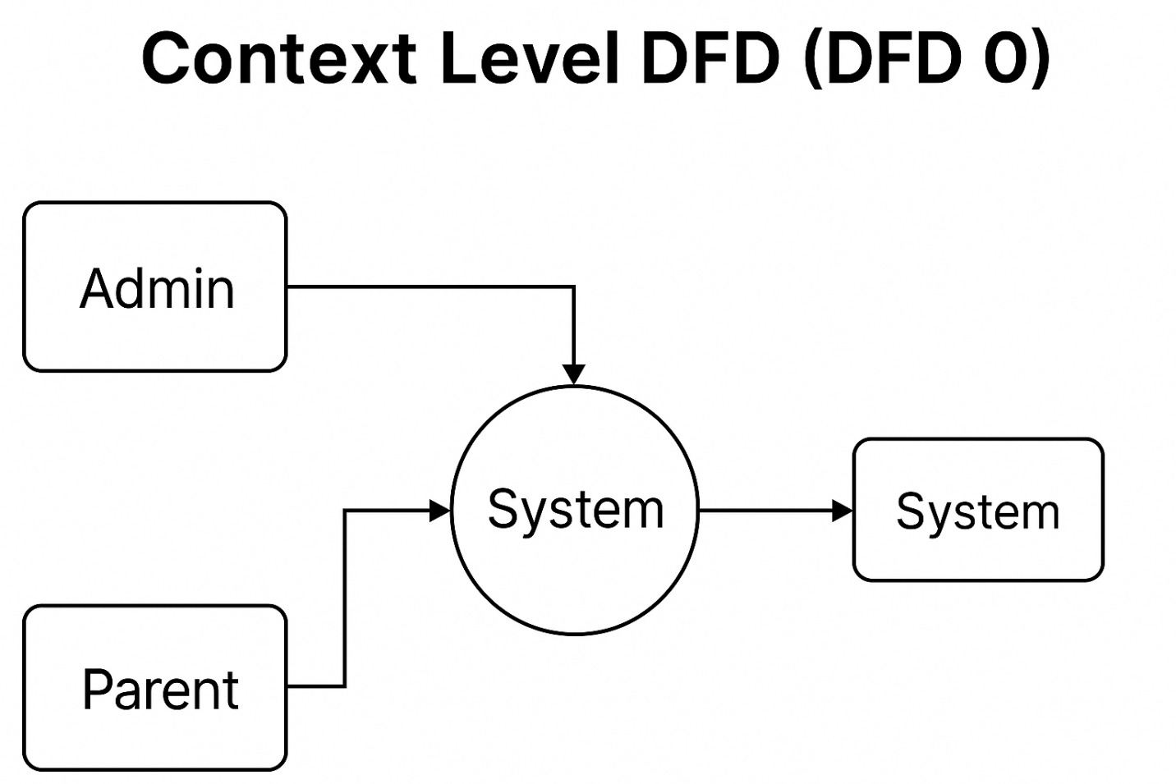

Level 1 DFD
This decomposes the main system process into the following sub-processes:
- User Management
- Appointment Management
- Reporting & Notifications
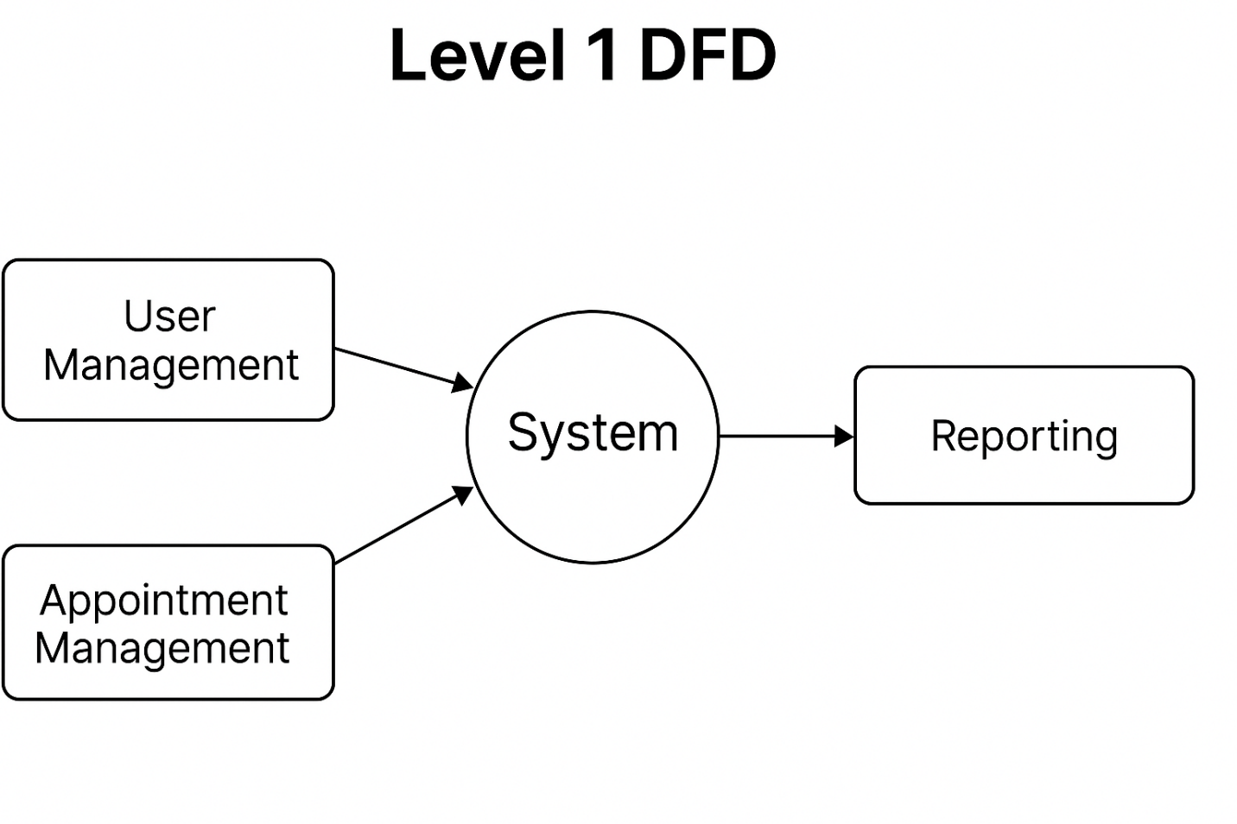

Flowcharts

User Login Flowchart
This flowchart describes the steps involved in the login process for all users (admin, parents, hospitals).
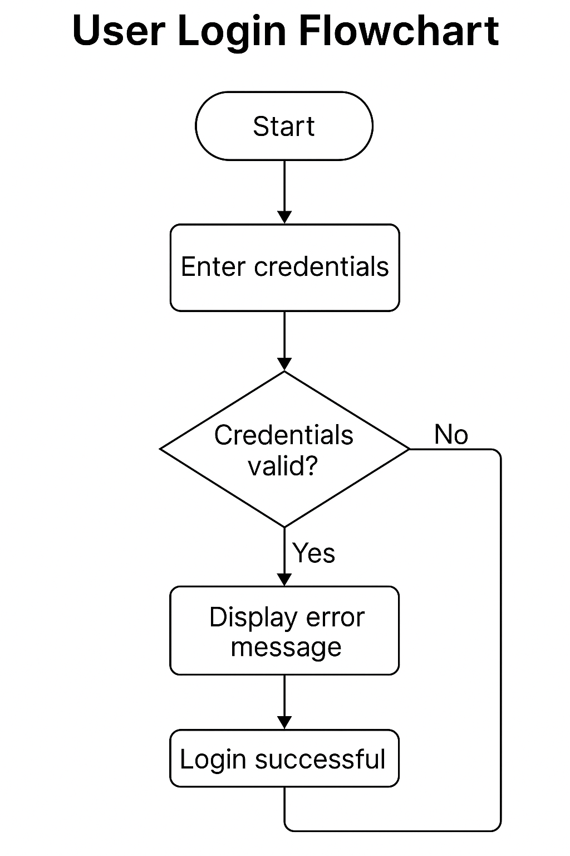

Appointment Booking Flowchart
This flowchart describes the process a parent follows to book a vaccination appointment for their child.
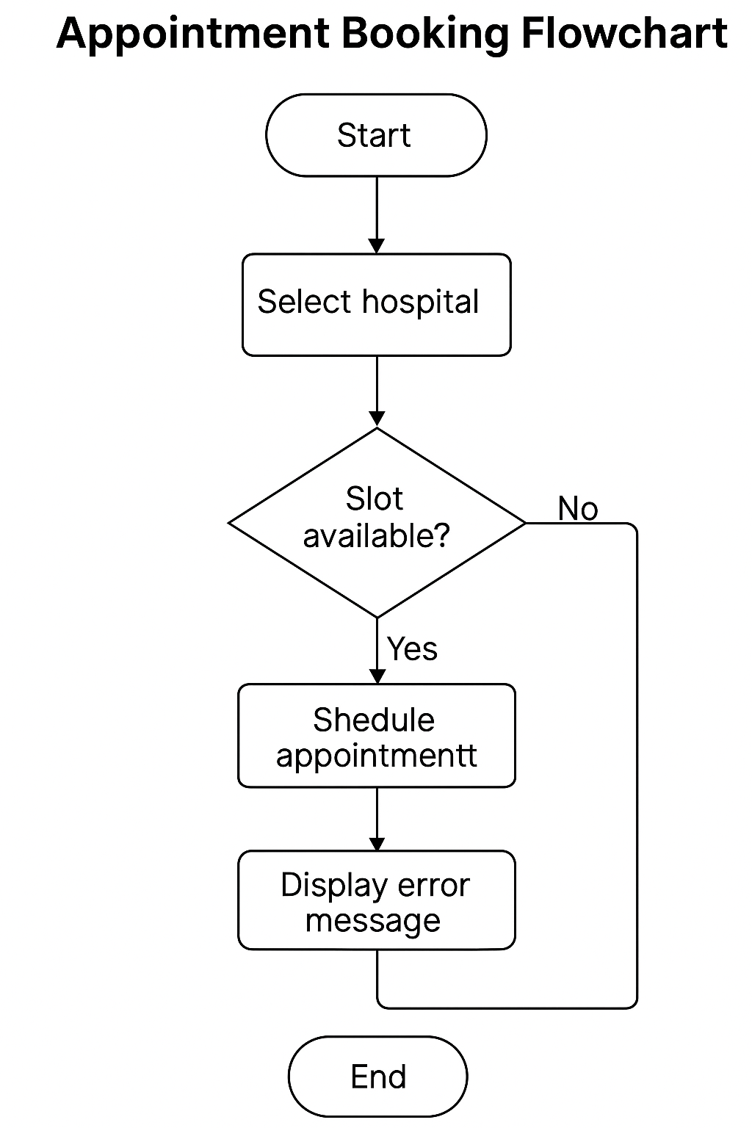

Database Design / Structure

E-R Diagram (Entity Relationship Diagram)
The ER Diagram shows the structure of the database, including relationships among the following entities:
- Users (Admin, Parent, Hospital)
- Hospitals
- Children
- Vaccines
- Appointments
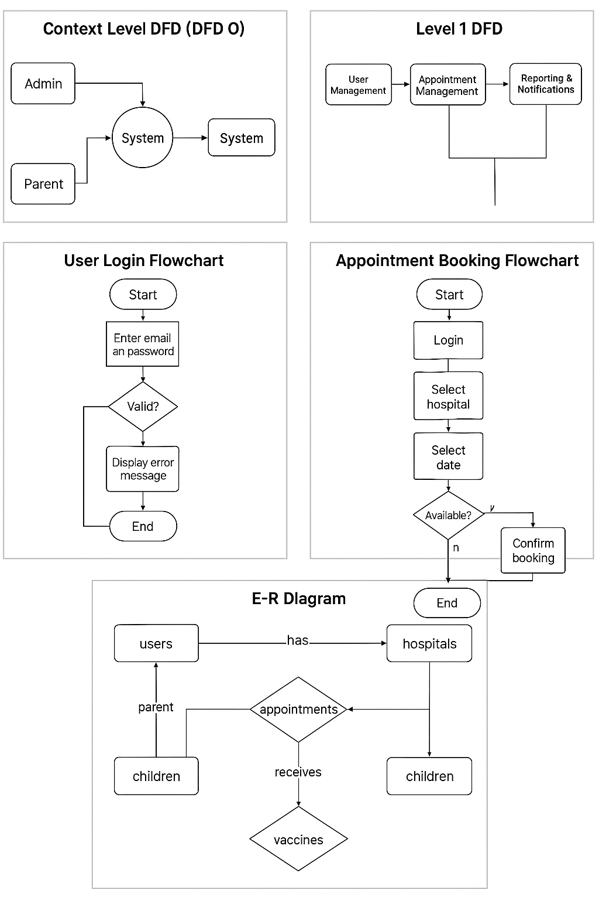

7. Screen Shots
Home:
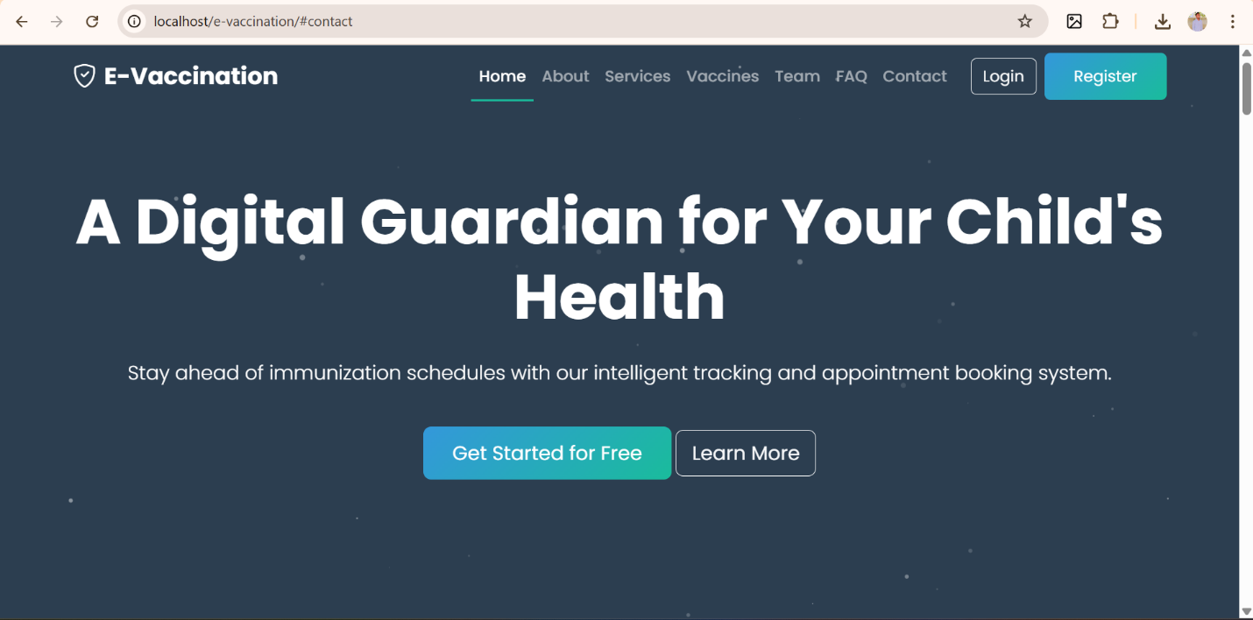

About:
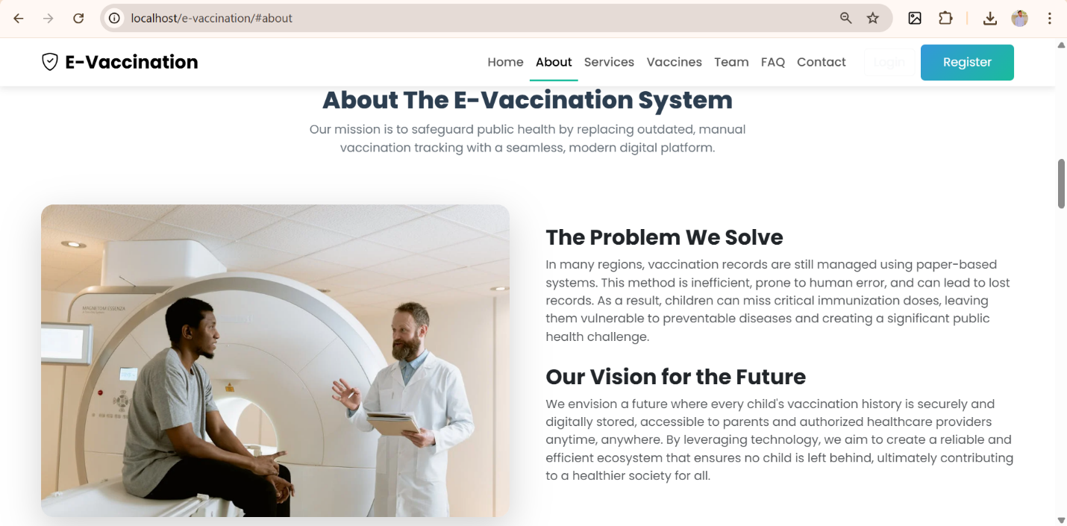
Services:
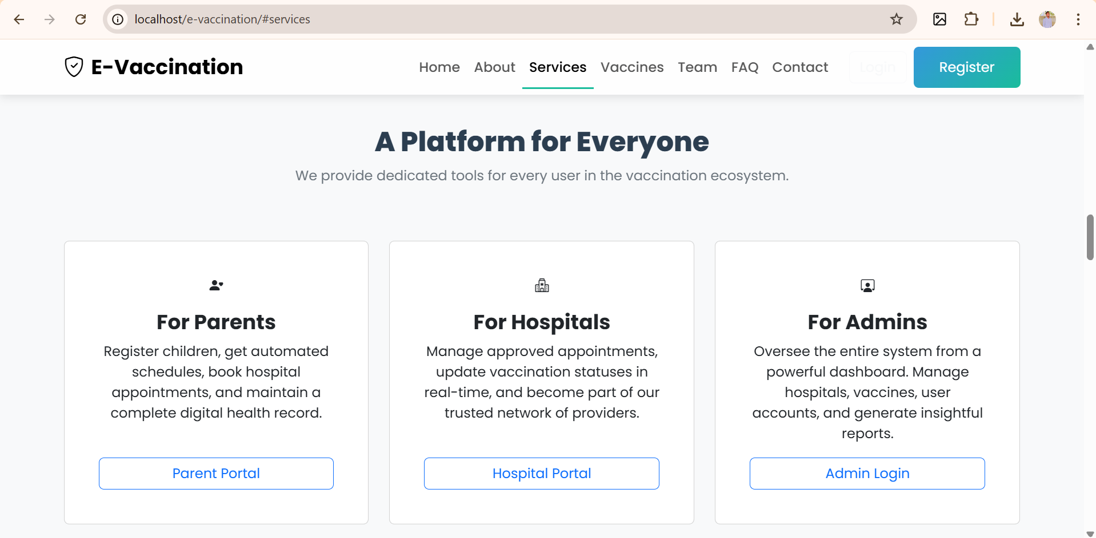

Vaccines:
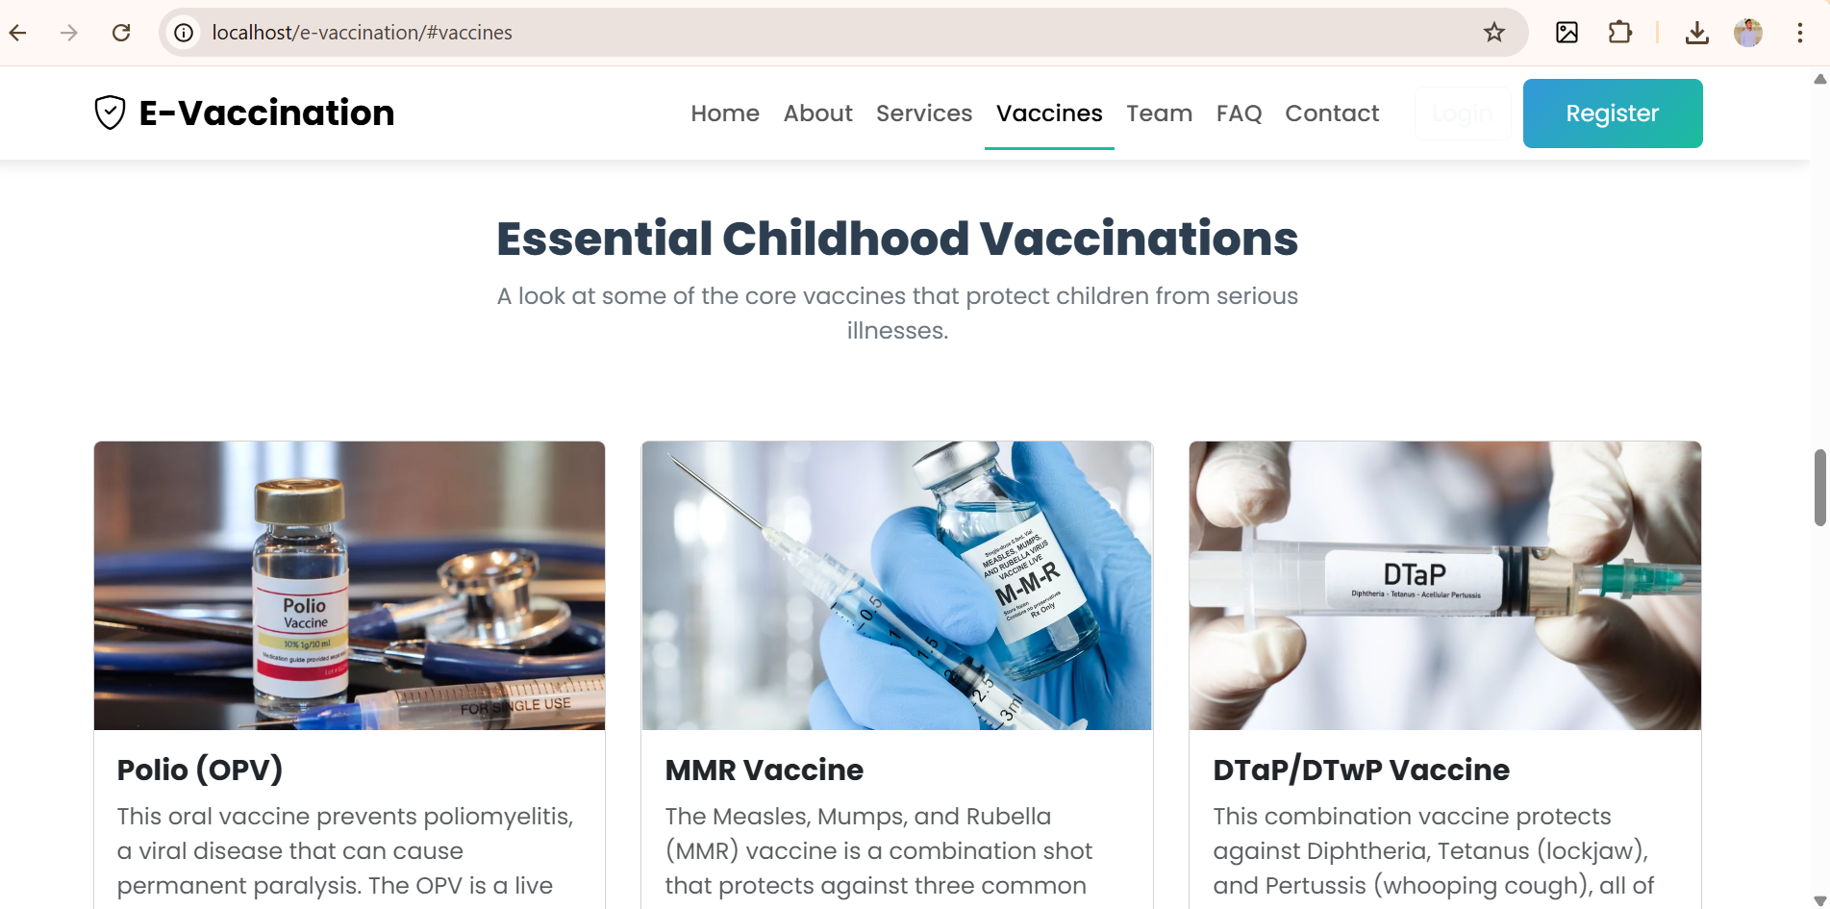
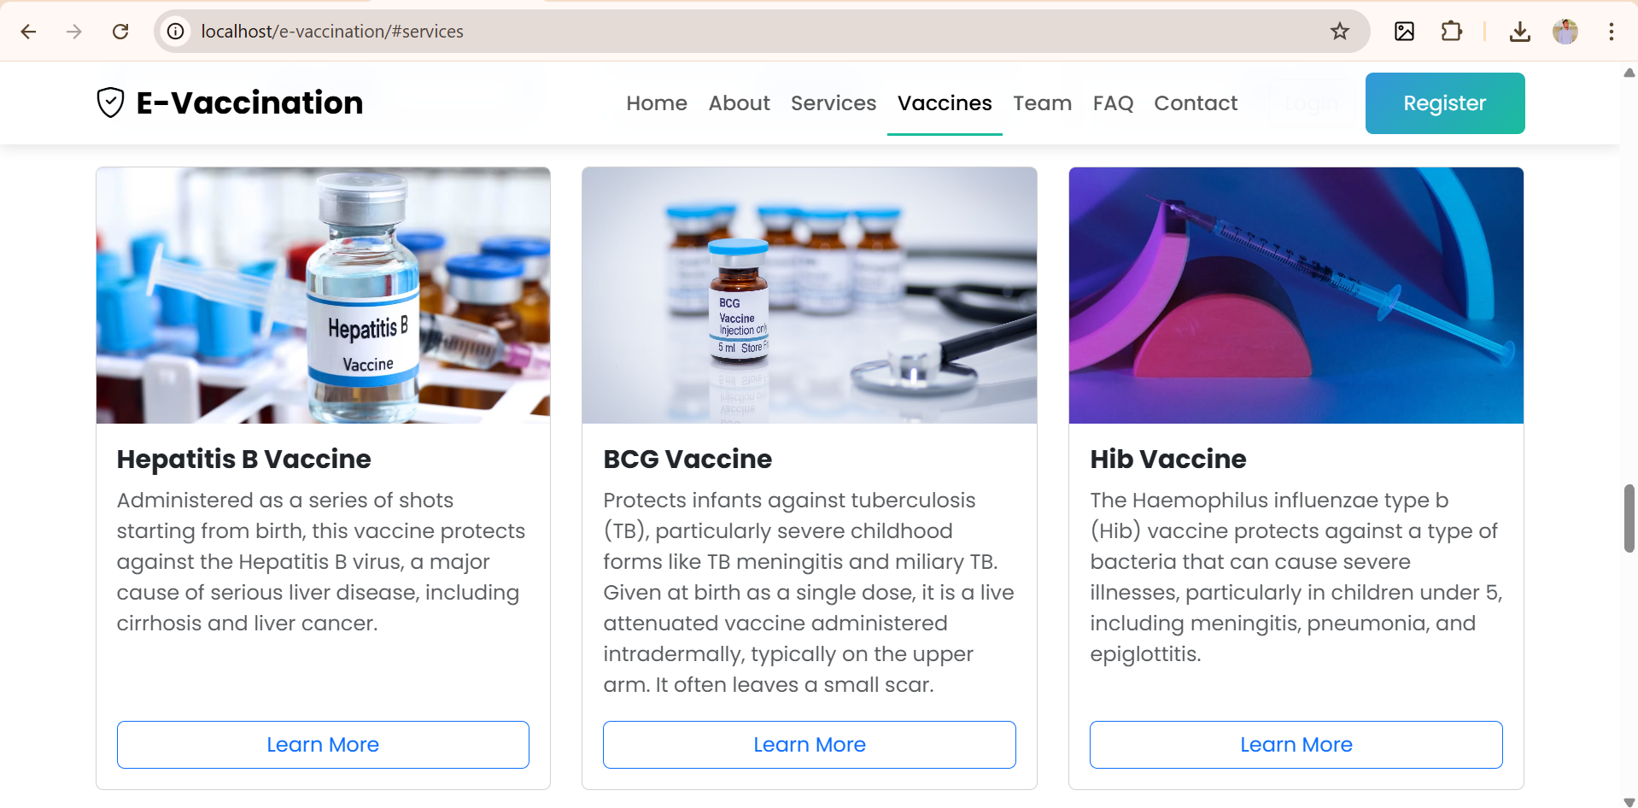

Team: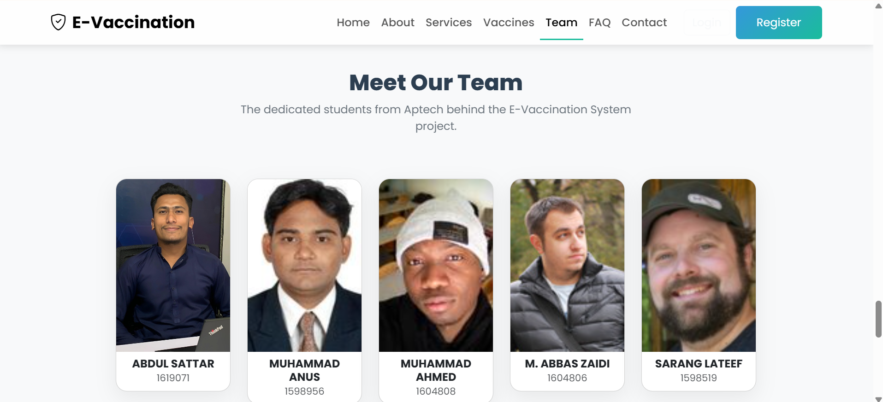

Faq:
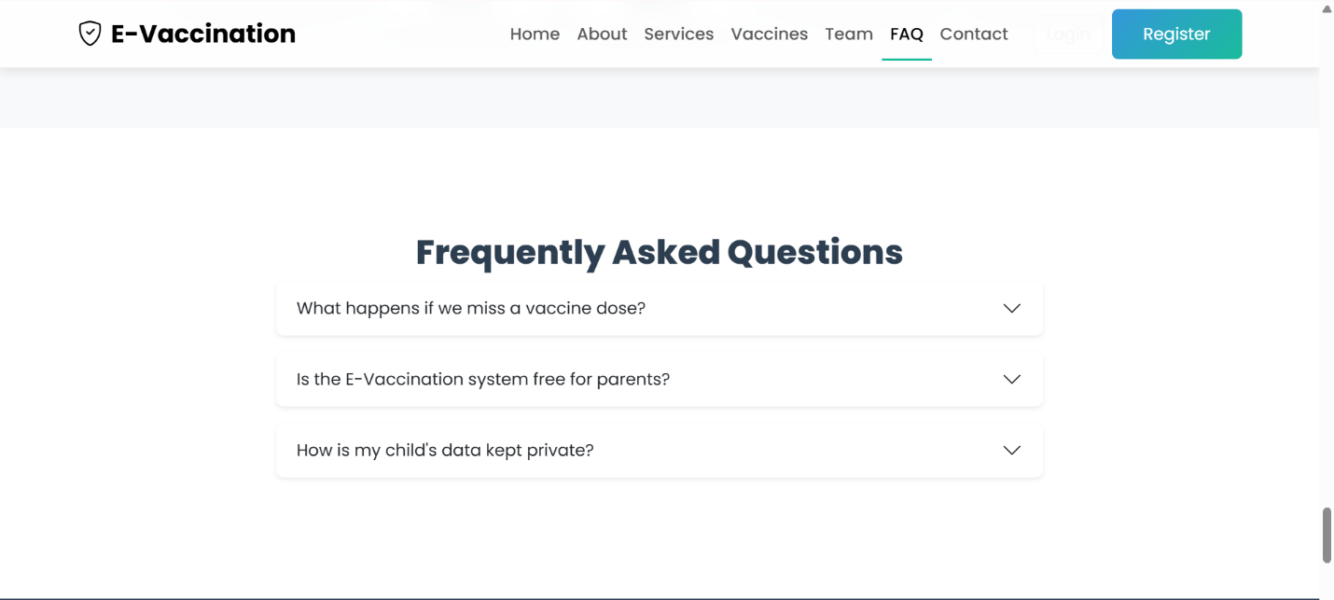

Contact:
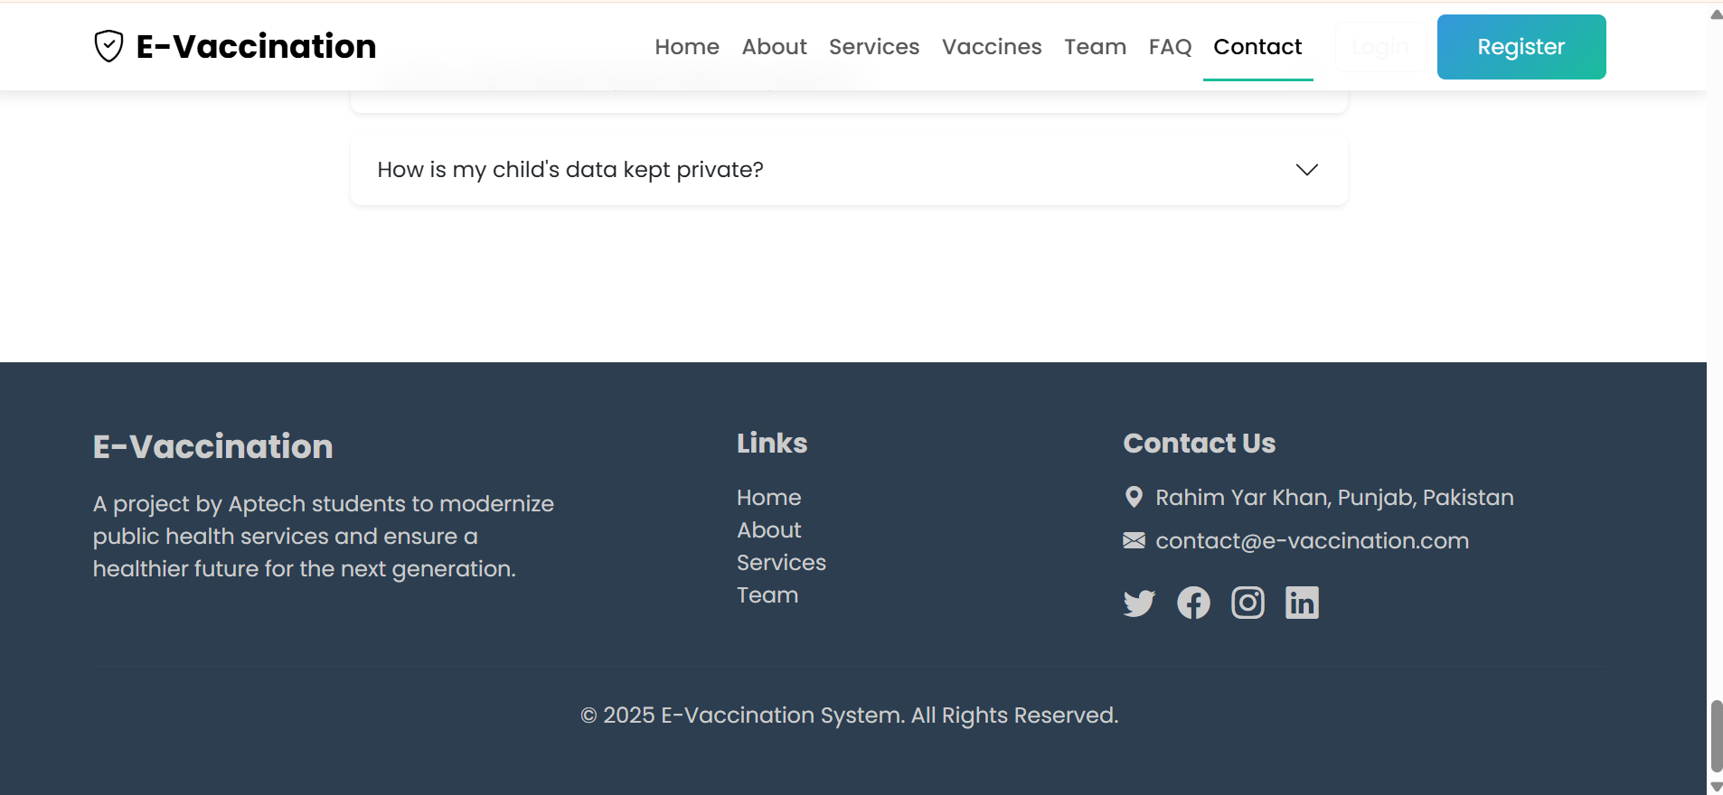

Register:
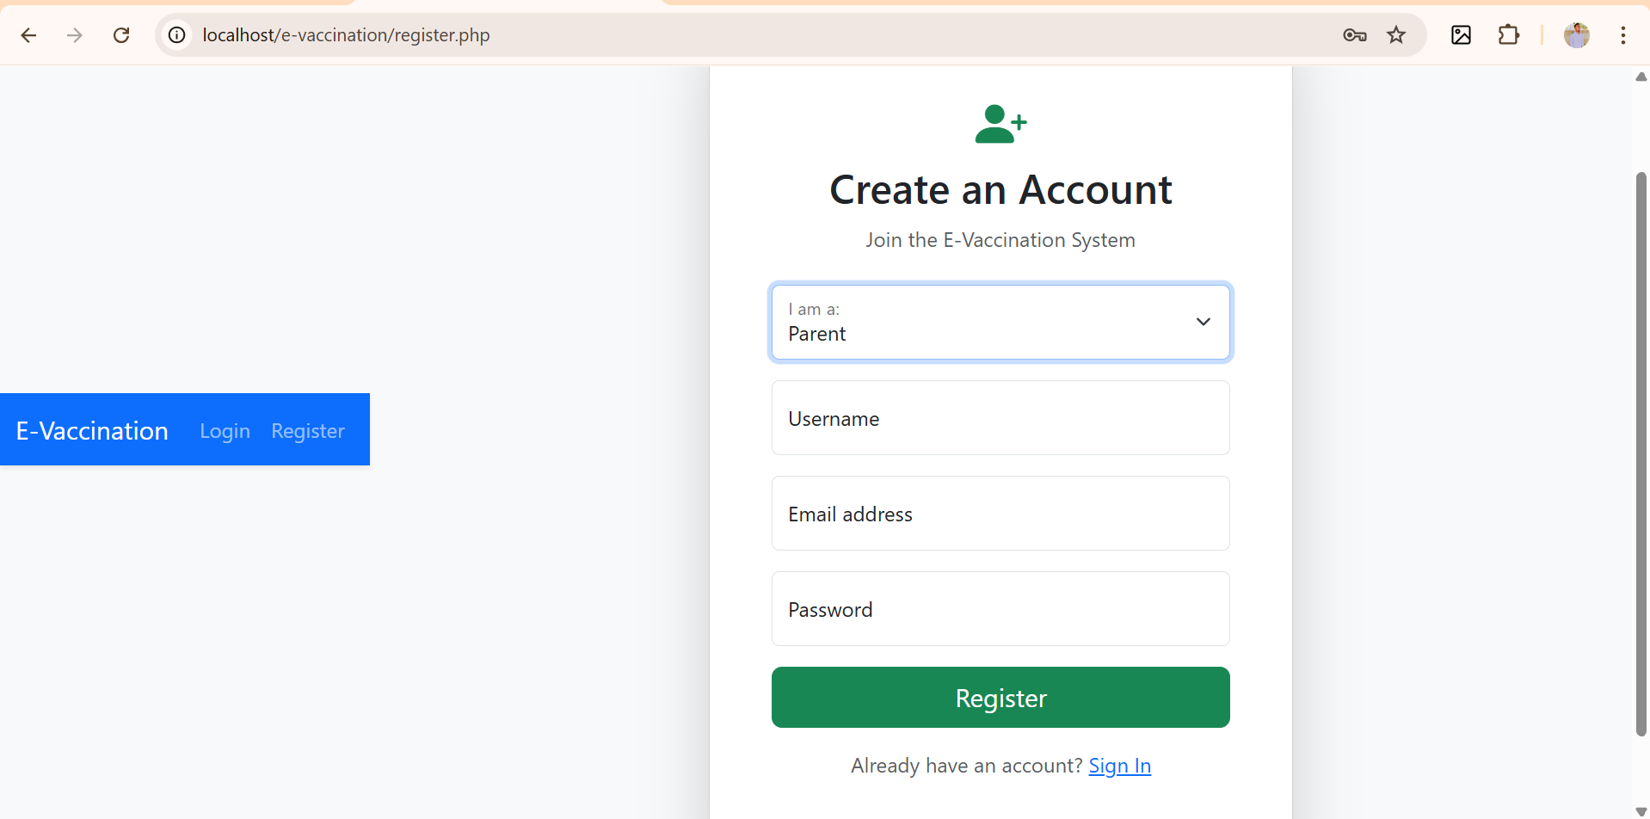

Login:
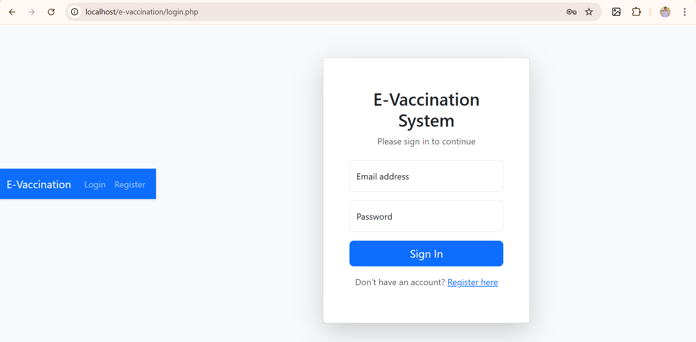

Admin Dashboard:
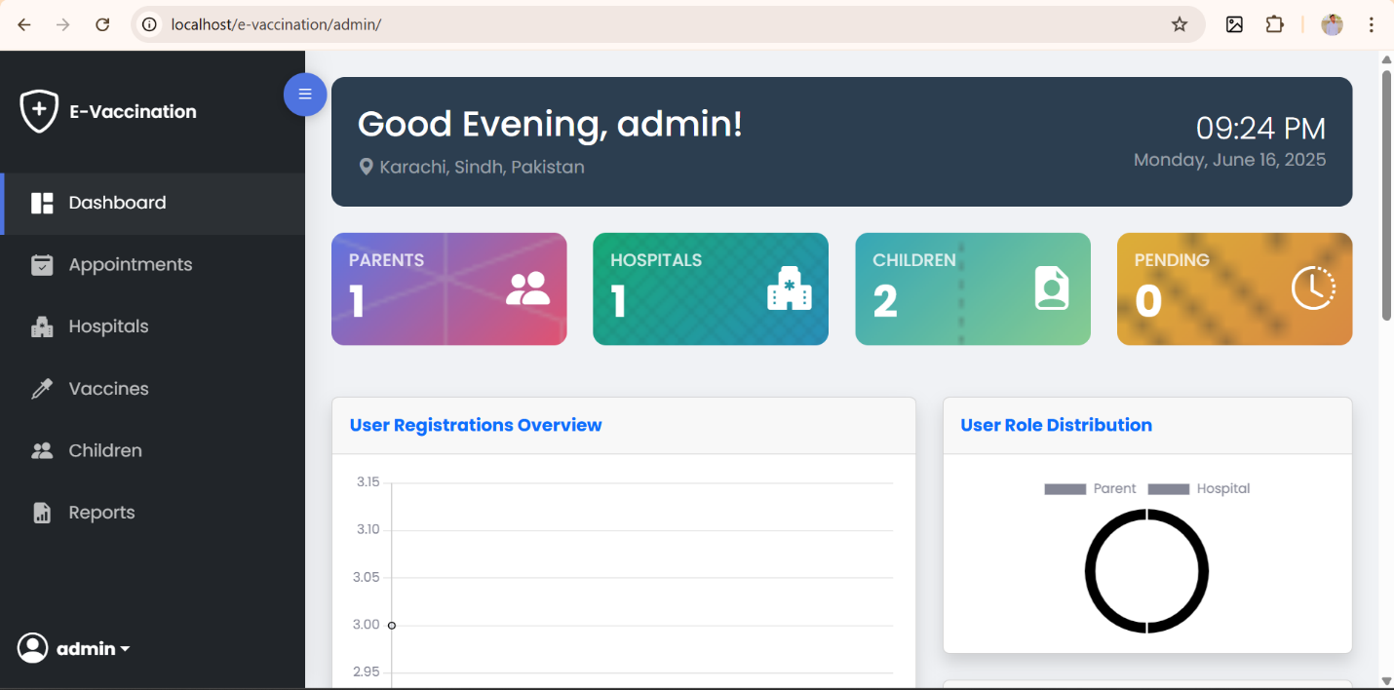

Admin Dashboard Footer:
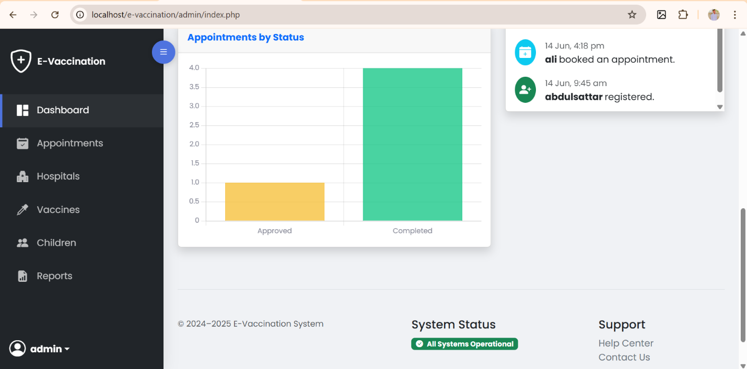

Appointments:
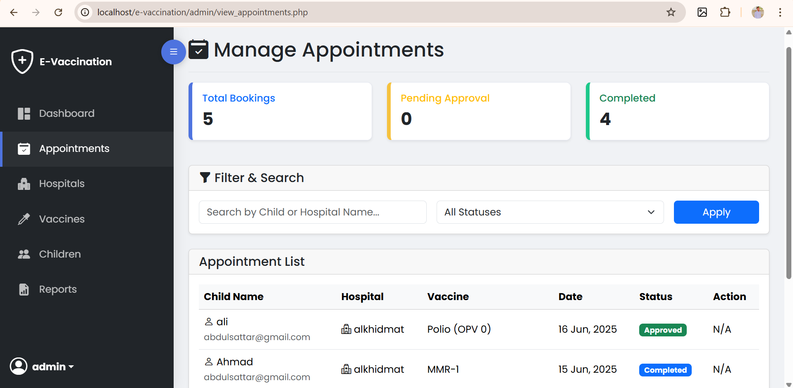

Hospitals:
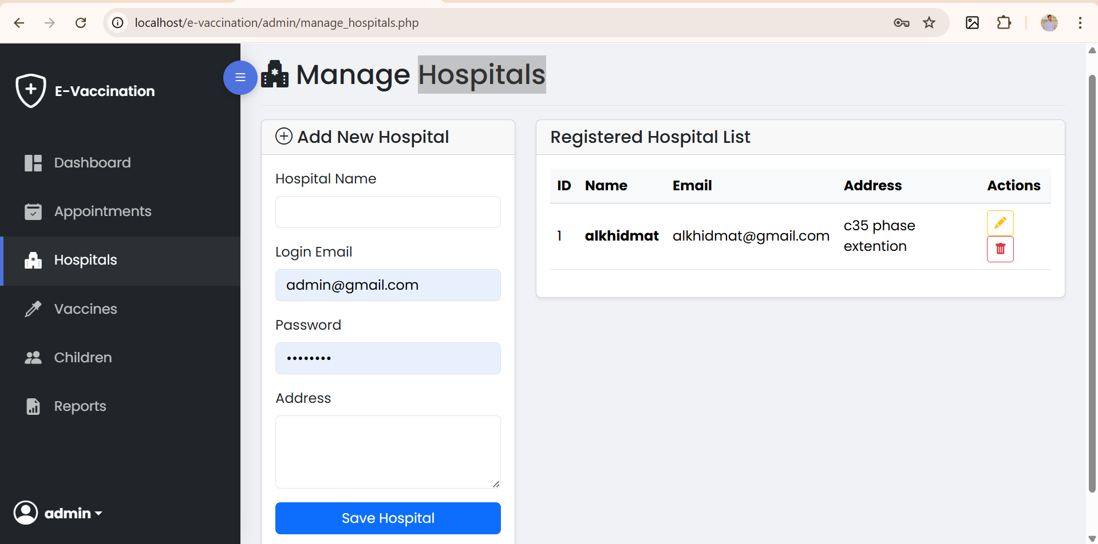

Vaccines:
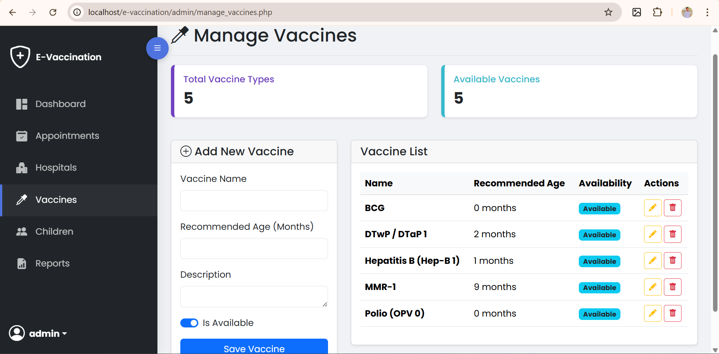

Children:
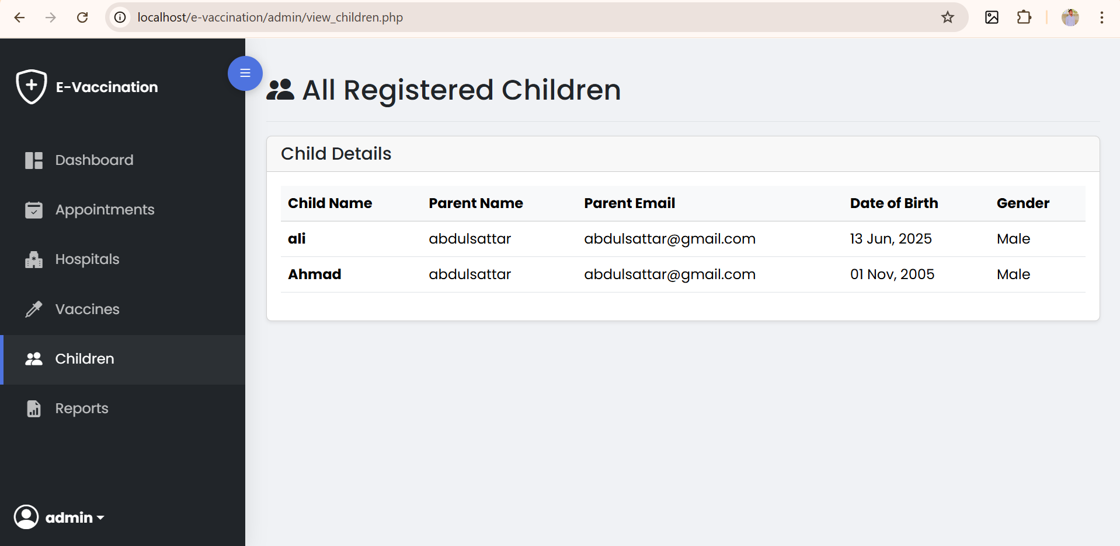

Reports:
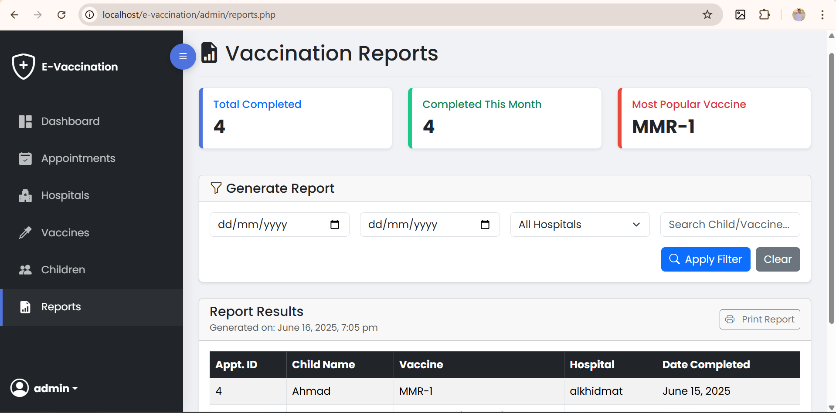

Print Reports:
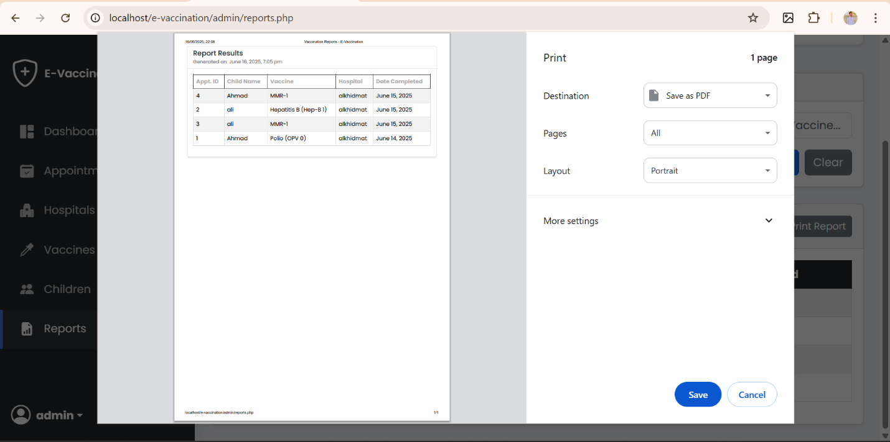

Parent Dashboard:
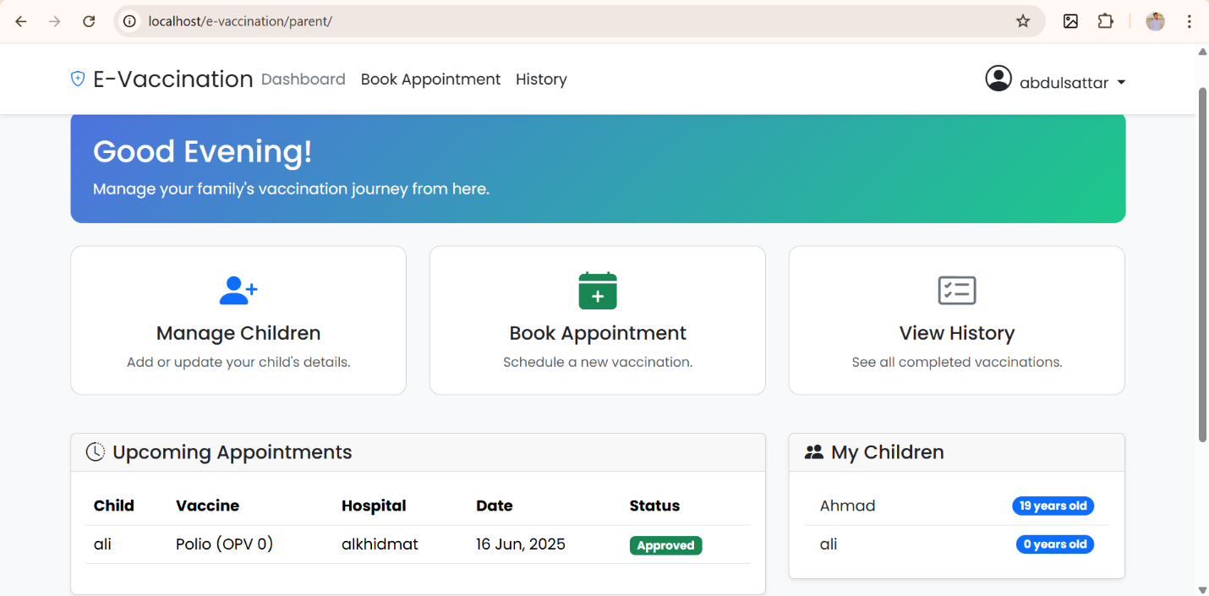

Manage Children:
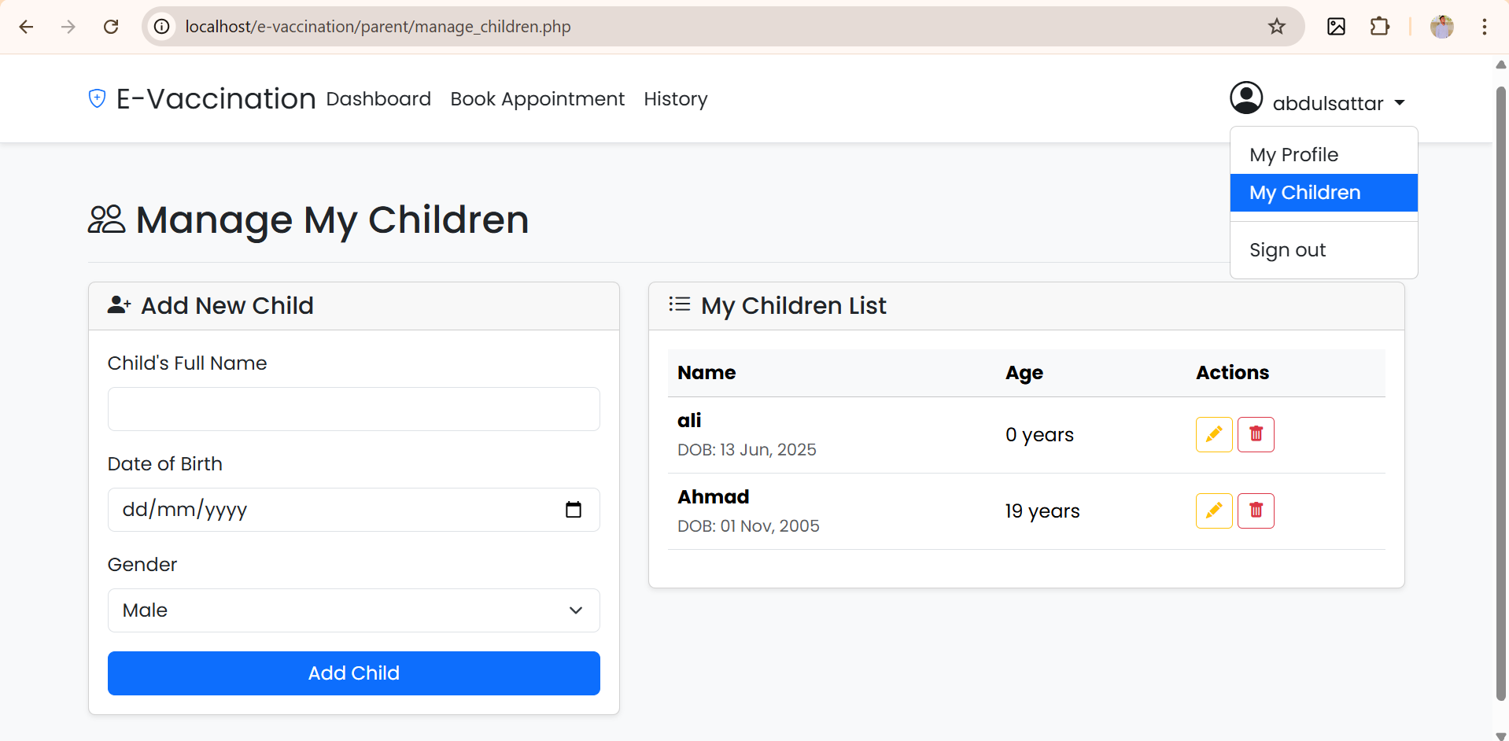

Book Appointments:
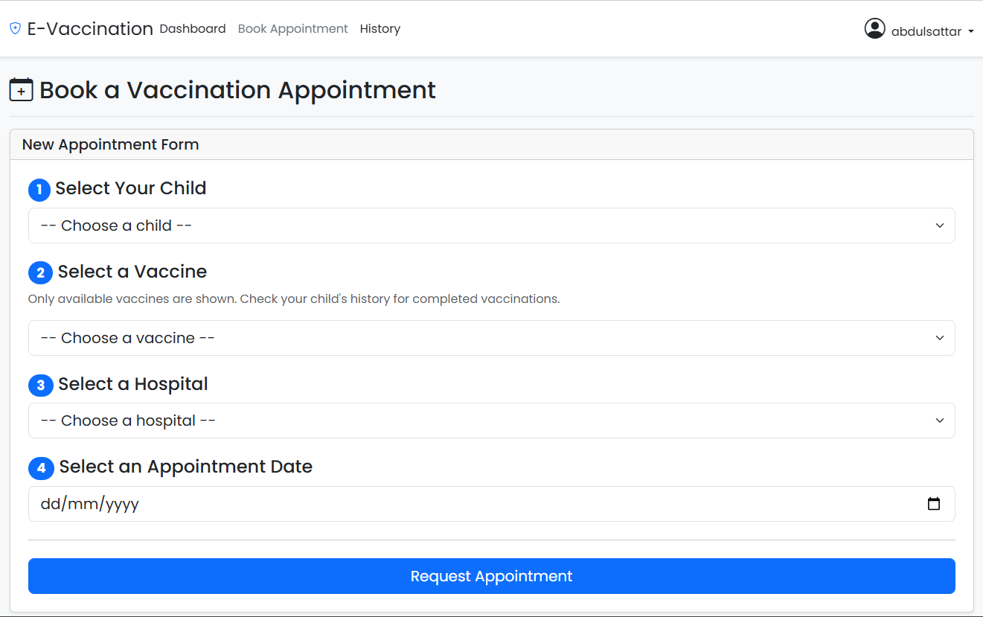

View History: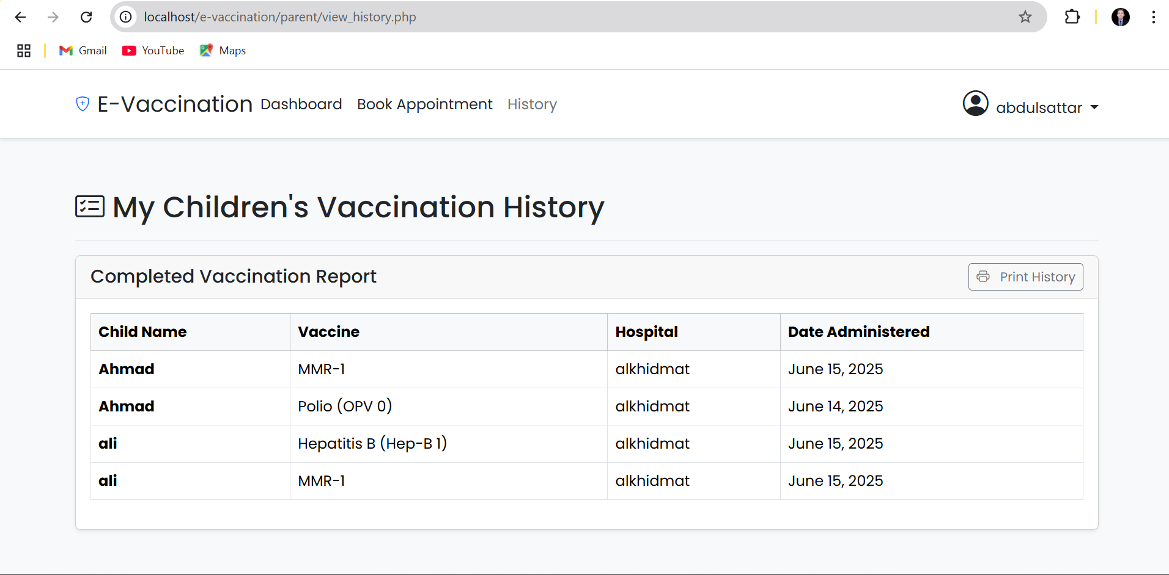
Hospital Dashboard:
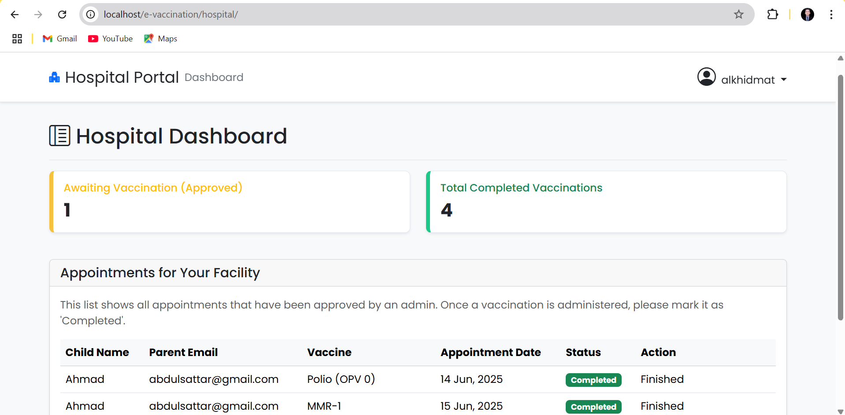

Update Vaccine Status:
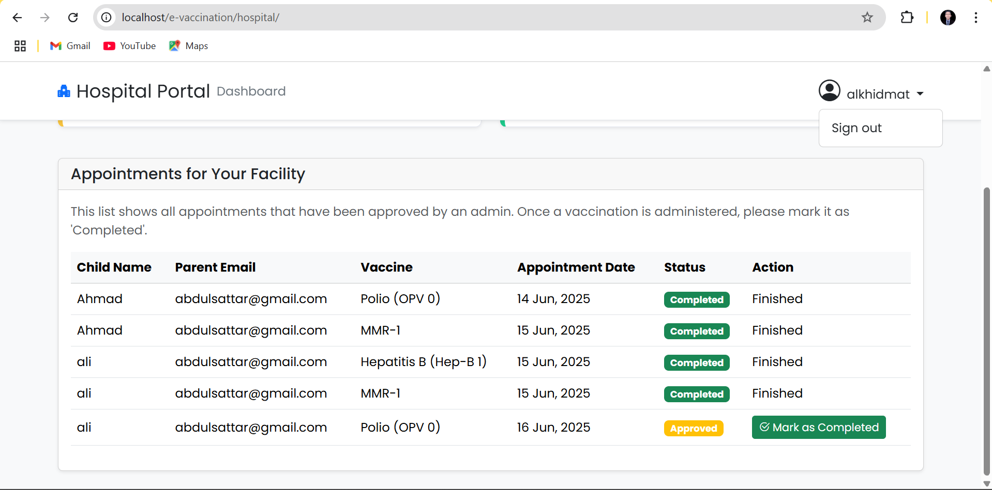

8. Source Code with Comments

`includes/db.php`
<?php
// Establishes database connection and starts session.
define('DB_HOST', 'localhost');
define('DB_USER', 'root');
define('DB_PASS', '');
define('DB_NAME', 'evaccine_system');
$conn = new mysqli(DB_HOST, DB_USER, DB_PASS, DB_NAME);
if ($conn->connect_error) {
die("Connection failed: " . $conn->connect_error);
}
if (session_status() == PHP_SESSION_NONE) {
session_start();
}
?>

`login.php`
<?php
require_once 'includes/db.php';
// Redirect if already logged in.
if (isset($_SESSION['user_id'])) {
header("Location: " . $_SESSION['role'] . "/");
exit();
}
// Handle form submission.
if ($_SERVER['REQUEST_METHOD'] == 'POST') {
$email = $_POST['email'];
$password = $_POST['password'];
// Use prepared statements to prevent SQL injection.
$stmt = $conn->prepare("SELECT id, username, password, role FROM users WHERE email = ?");
$stmt->bind_param("s", $email);
$stmt->execute();
$result = $stmt->get_result();
if ($result->num_rows === 1) {
$user = $result->fetch_assoc();
// Plain text password check for project purposes.
if ($password === $user['password']) {
$_SESSION['user_id'] = $user['id'];
$_SESSION['username'] = $user['username'];
$_SESSION['role'] = $user['role'];
header("Location: " . $user['role'] . "/");
exit();
}
}
} ?>

9. User Guide

For Parents:
- Registration & Login: Use the main page to register for a new account or log in with existing credentials.
- Manage Children: From the navigation menu, select "My Children" to add, edit, or delete your child's records.
- Book Appointment: Navigate to "Book Appointment", select your child, the required vaccine, a hospital, and a convenient date, then submit the request.
- View History: Go to the "History" page to see a complete report of all past vaccinations.

For Hospitals:
- Login: Log in using the credentials provided by the administrator.
- Dashboard: Your dashboard lists all appointments approved for your facility.
- Update Status: After a child has been vaccinated, find their appointment in the list and click "Mark as Completed".

For Admins:
- Login: Use your admin credentials to access the system.
- Dashboard: The dashboard provides a high-level overview of system statistics and recent activities.
- Management Pages: Use the sidebar to navigate to pages for managing Hospitals, Vaccines, Children, and Appointments, where you can perform all necessary CRUD operations.
- Reports: Use the "Reports" page to generate detailed, printable reports on vaccination activities.

10. Developer's Guide

Module Descriptions
`admin/` Module
This module contains all files related to the administrator's functionality. It provides a centralized control panel for system management, including user management (hospitals), vaccine inventory control, appointment approvals, and system-wide reporting. The interface is designed to be comprehensive, allowing the admin to oversee all operations.
`parent/` Module
This module is dedicated to the parent user experience. It allows parents to manage their personal and their children's information, book vaccination appointments through a guided workflow, and view historical data. The design prioritizes ease of use and clarity of information.
`hospital/` Module
This module provides a streamlined interface for hospital staff. Its primary function is to display approved appointments and allow staff to update the status of these appointments after a vaccine has been administered. It focuses on a single, critical task to ensure efficiency.

