Heart Granny Square Crochet Crop Top Pattern

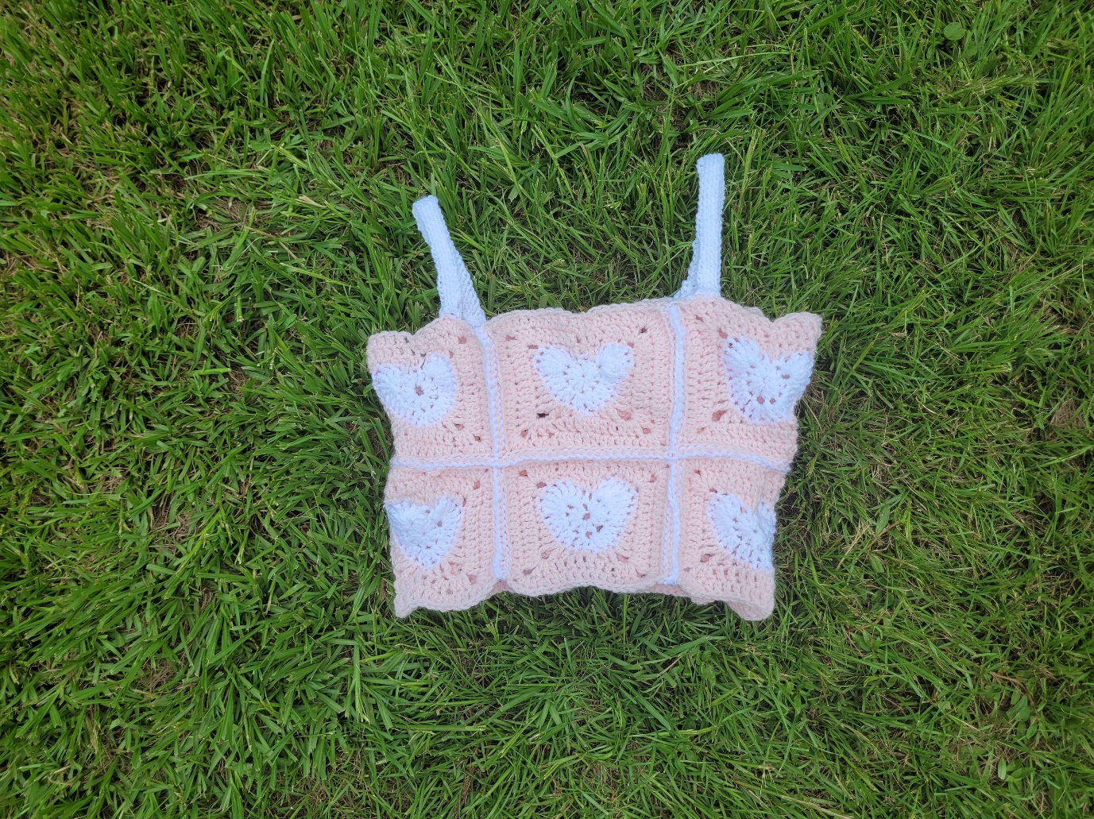

WRITTEN PATTERN:

1:48 - 8:12 Heart:

Magic ring ch 2

12 "dc" (11dc+1ch2)

Pull magic ring end tight

slot into ch 2 space

skip next st, 7 triple crochet into same stitch

dc in next st

2 dc in next st

2dc in next

5:46 2dc, ch 1, sl st into side of dc, 2dc all in same st

2dc

2dc

1dc

7 triple crochet

slst into next st and tuck in ends

13:10 - 35:58 White:

Round 1

Pull white yarn through top middle of heart

Ch with white end, push end down, chain again

dc

hdc

sc

sc and hdc in same st, ch 2

dc

sc, sc in next st

hdc, hdc in next st

dc, dc in next st

triple crochet, ch 2, triple crochet in same st

dc

sc

fit 2 sl st in funky crochet-into-side-of-dc area

sc

dc

triple crochet, ch 2, triple crochet in same st

dc, dc in next st

hdc, hdc in next st

sc, sc in next st

sc ch 2

hdc in next st

sc

hdc, hdc in next st

dc

slot into white to join rounds

20:03 round 2

ch 2

dc into next st then dc 3 more across top side

dc in pre-corner st, 2dc, ch 2, 2dc dc in post-corner st

dc across left side (13 total dc on this side)

dc in pre-corner st, 2dc, ch 2, 2dc dc in post-corner st

dc across bottom side (13 total dc on this side)

dc in pre-corner st, 2dc, ch 2, 2dc dc in post-corner st

dc across right side (13 total dc on this side)

dc in pre-corner st, 2dc, ch 2, 2dc

NO dc in post-corner st

14 total "dc" on top side (13 dc+ 1ch2)

27:50 Round 3:

ch 2

dc into next st then dc more across top side

dc in pre-corner st, 2dc, ch 2, 2dc dc in post-corner st

dc across left side (18 total dc on this side)

dc in pre-corner st, 2dc, ch 2, 2dc dc in post-corner st

dc across bottom side (18 total dc on this side)

dc in pre-corner st, 2dc, ch 2, 2dc dc in post-corner st

dc across right side (18 total dc on this side)

dc in pre-corner st, 2dc, ch 2, 2dc DO dc in post-corner st

continue dc then join round with sl st, ch 1, tie in ends

There should now be 18dc on each side.

Congrats! Now you made a crochet heart square!

Extra Notes:

•The heart takes 8min for me to make and the whole square takes me about 25min

•I used Red Heart Soft Essentials yarn and a 6.5mm hook

•The pink part uses 8yds of this yarn and the white part takes 25yds

•The squares are 6inx6in