Robotic Indoor Localization using Inertial Measurement Units (IMUs)
Group No: 50

Team Members
S.No | Reg.No | Name of the Student | Section
1 | CB.EN.U4CSE12123 | KIRAN KASSYAP S | B
2 | CB.EN.U4CSE12133 | RAGUL B | B
3 | CB.EN.U4CSE12147 | SUNDARRAJAN G | B
4 | CB.EN.U4CSE12148 | SURIYA D MURTHY | B

Table of Contents
S.NO | CONTENTS
1 | Introduction
2 | Literature Survey
3 | Data Set Description
4 | System Design
4.1 | External Architectural Design
4.2 | Internal Architectural Design
5 | Implementation
5.1 | On-Board processor
5.2 | Robot Design
5.3 | Graph Plot
6 | Workflow
7 | References

Abstract

Robotic indoor localization is a method in which the position and orientation of the mobile robot is determined with respect to the indoor environment and is an important part of any autonomous mobile robot. Autonomous robot systems are commonly being used in disaster response and rescue, in industries, as assistive robots etc. In order to support the effective functioning of the robots in such scenarios there is a need for accurate and efficient indoor localization, navigation and mapping methods. One of the primitive challenges in indoor environments is localization and this supports the other two functionalities. In this project we primarily focus on indoor localization of mobile robots. Over the past decade, there have been significant developments in the mobile robot localization but even though there are significant developments, most of the approaches are prone to errors and have less reliability. Hence goal of our project is to present an error reducing algorithm that inputs data from inertial, range finders and digital encoder sensors to effectively reduce errors that occur due to external factors.

- Introduction

Robotic indoor localization plays a major role for an autonomous mobile robot, since it is essential for a robot to answer the question “Where am I?” so that it could use the data and work effectively. Several approaches have been used for localization, which include infrastructure and non-infrastructure based approaches. Infrastructure based approaches use existing Wi-Fi or RFID installations to help localize the robot. These approaches becomes infeasible in challenging environments such as disasters, chemical spills etc. where there is no available infrastructure. Approaches that do not rely on infrastructure use laser range finders, camera and inertial sensors for localization of the robot. Laser range finder based approaches provide accuracy, but are very expensive. On the other hand, camera based approaches are computationally complex and performs poorly in low light conditions and presence of occlusions.

The use of inertial sensors and digital encoders for localization have gained more popularity because of its low cost, small dimensions and low power consumption. These sensors are commonly used in dead reckoning based localization methods. The dead reckoning method computes new state estimates with the help of previous state estimates. Accelerometers and encoders have been used for distance estimates while gyroscopes and magnetometer sensors have been used for orientation estimates. The accuracy of these methods are affected due to accumulation of noise and drift errors from accelerometers and gyroscopes respectively. Digital encoders tend to produce errors because of slippage, mechanism symmetry and sensor accuracy limitations. To overcome these errors, an error reducing sensor fusion algorithm is proposed.

2. Literature Survey

Localization techniques use RF technologies such as RFID, Wi-Fi and Bluetooth, while other prevalent techniques that operates with infrared and ultrasonic sensors rely on additional external infrastructure like RF antennas and ultrasonic transceivers placed in the environment. On the other hand, techniques that use cameras, laser range finders or inertial sensors do not rely on external infrastructure.
In the former set of approaches, RF based localization is one of the most prevalent techniques and is easy to implement. In RF based approaches, the robot requires external infrastructure like antennas/reference tags placed in the environment for communication with the tags or receiver which is carried by the robot. RF based localization techniques can be either finger printing or non-finger printing approaches. The non-finger printing approaches include the trilateration method. The trilateration method estimates the position of the target with respect to reference points using the Received Signal Strength Indication (RSSI) values. The WiFi fingerprinting technique compares the RSSI observations made by the mobile node with a trained database to determine the location of the moving object [4].The K-NN (K Nearest Neighbors)[21], Bayesian[22,23] and decision tree methods[24] are representative techniques used in the fingerprinting approach. In RFID based localization, a large number of RFID tags in the environment act as reference points. So, when a new RFID tag enters the space, the signal strength is compared with the reference points signal strength and location of the robot is determined.

Name of the paper | Author and Year of Publication | Methodology | Remarks
Positioning System for 4-Wheel Mobile Robot Data Fusion with Error Model Method | Ibrahim Zunaidi, Norihiko Kato, Yoshihiko Nomura and Hirokazu Matsui.  Artificial Life and Robotics October 2006 | IMU and encoders are filtered using Kalman Filter to reduce errors in position and orientation using a sensor fusion technique | This approach is based on sensor fusion and due to kalman filters high computational complexity is observed
Self-Contained Indoor Positioning on Off-The-Shelf Mobile Devices | Dominik Gusenbauer, Carsten Isert and Jens Krösche,(IPIN), 15-17 September 2010. | Indoor positioning is done using pedestrian dead-reckoning method, GNSS and activity based map matching algorithms to reduce errors | IMU filtering is based on smartphones.

An Indoor Dead-Reckoning Algorithm with Map Matching | Haitao Bao, Wai-Choong Wong  September 2013 | Map matching involved step counting algorithm and error reduction using Gaussian filters is proposed. | Gaussian filters have high computational complexities

3. Dataset Description

The following data sets are used for localization the robot:

- Distance of the robot:
  - Digital encoders: Two digital encoders one for each motors gives the distance travelled by the robot.

- Orientation of the robot:
  - Gyroscope: Gyroscope gives the rate of change of angular momentum at each axis of the robot. We can use it to find the change in angle of the robot with respect to previous position.
  - Digital encoders: We can also obtain orientation from digital encoders with help of comparison of distance values between two encoders.
  - Range finders: Infrared sensors and ultrasonic sensors are used for finding orientation of the robot with respect to obstacles.

- Obstacle avoidance:
  - Range finders: Infrared and ultrasonic sensors are used for detecting nearby obstacles and hence helps robot to avoid them.

- Components used for design:
  - Metallic robot chassis
  - LiPo battery
  - Bstem single chip computer
  - Adcord Board (interfacing motors and Bstem)

4. System Design
4.1 External Architectural Design
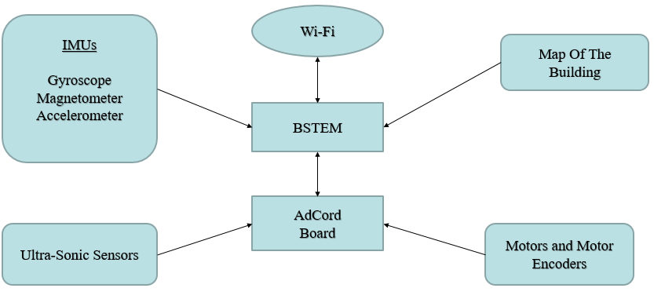

  - Internal Architectural Design
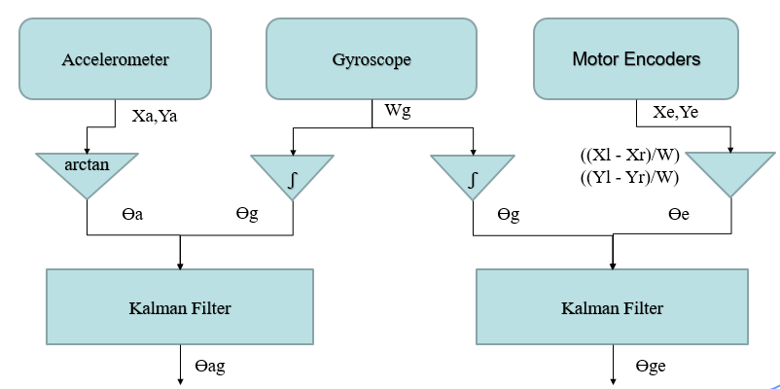
5. Implementation
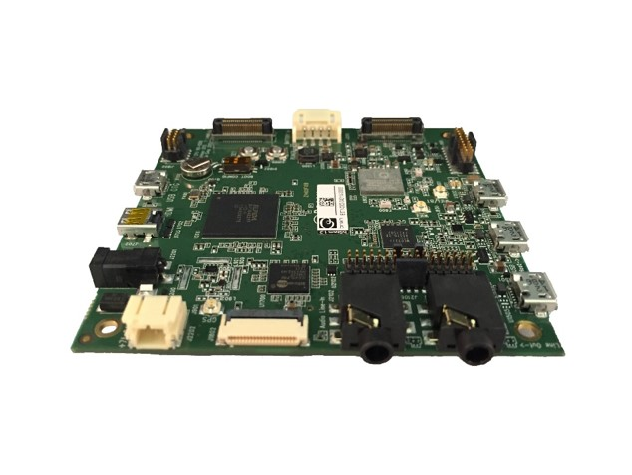
5.1 On-Board processor:
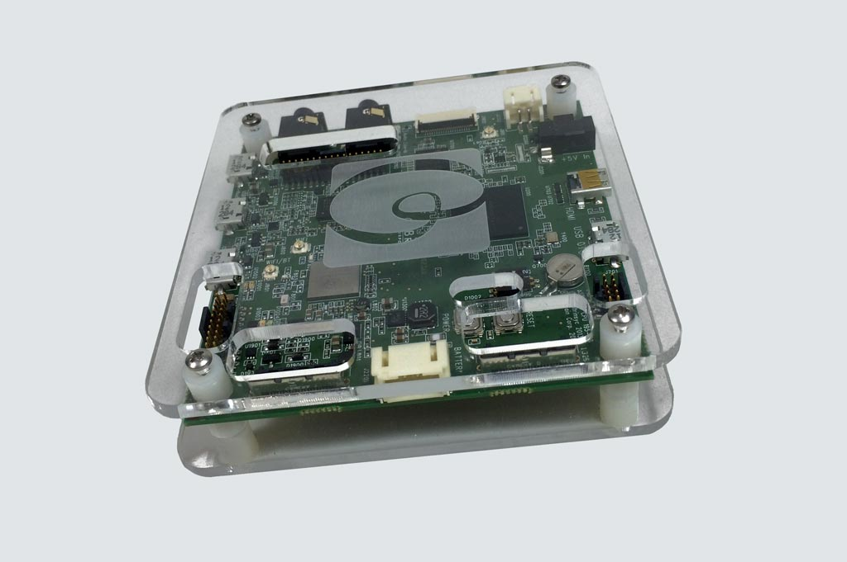
Bstem board Adcord Expansion Board

5.2 Design of robot:

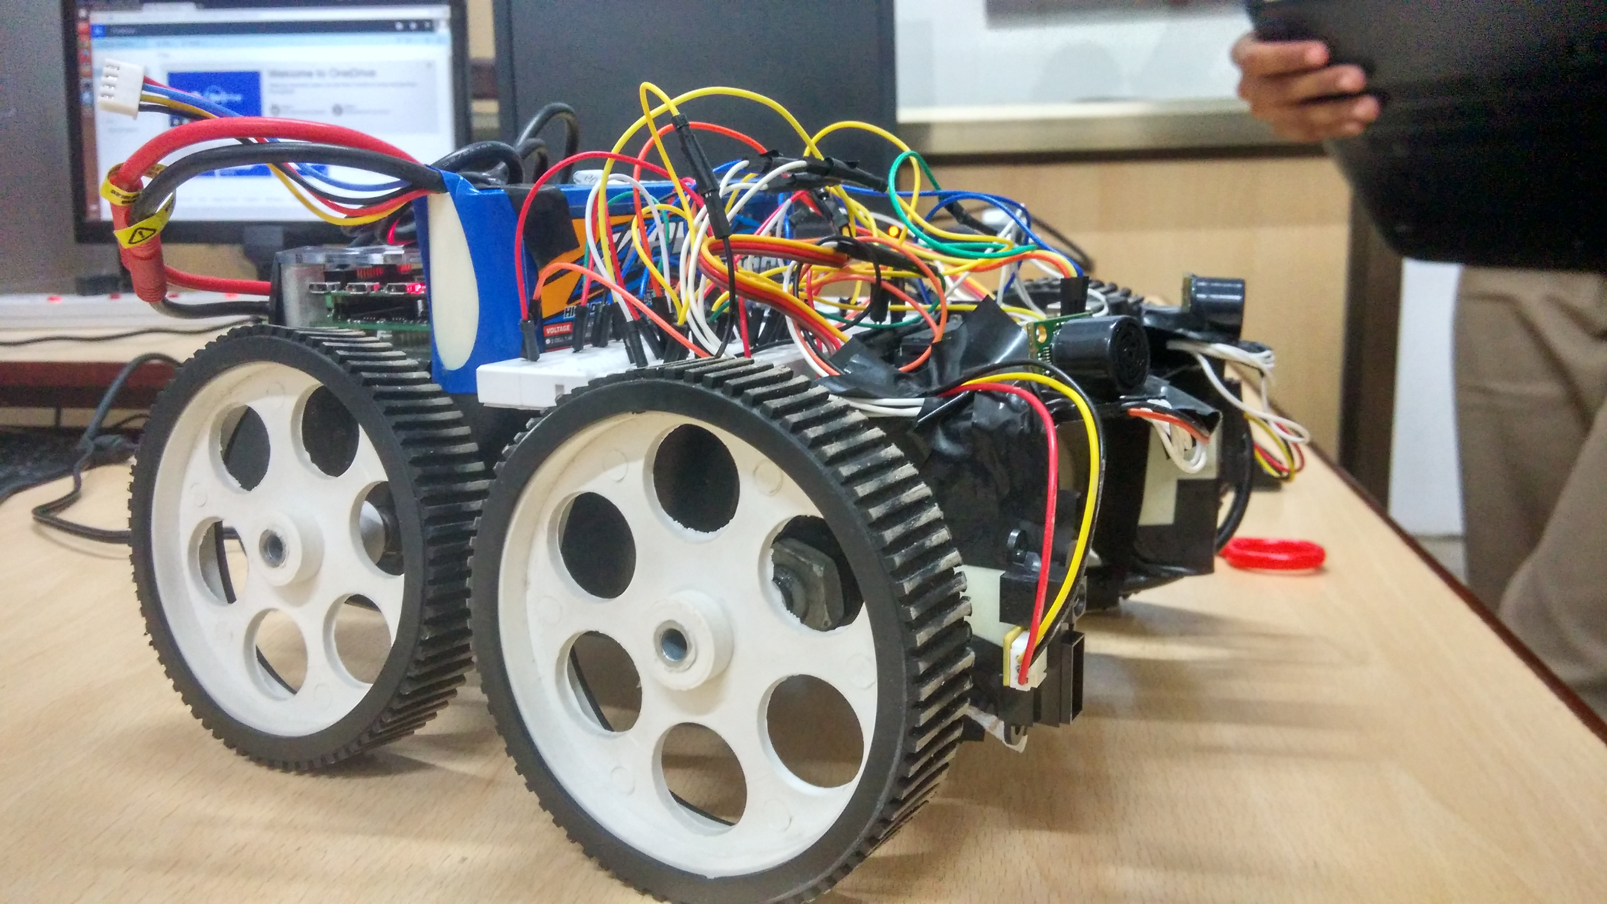

5.3 Graph plot:
5.3.1 Plotting the corridor using gyroscope*: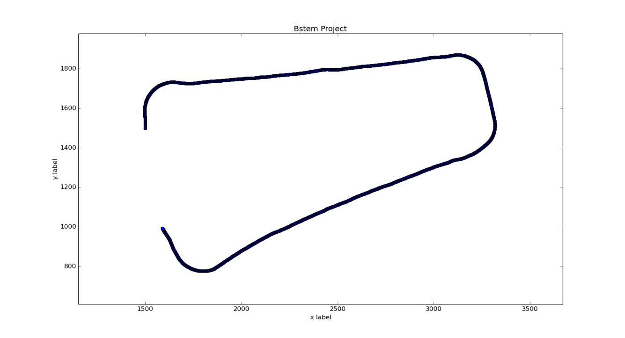
5.3.2 Plotting a simple square using gyroscope*: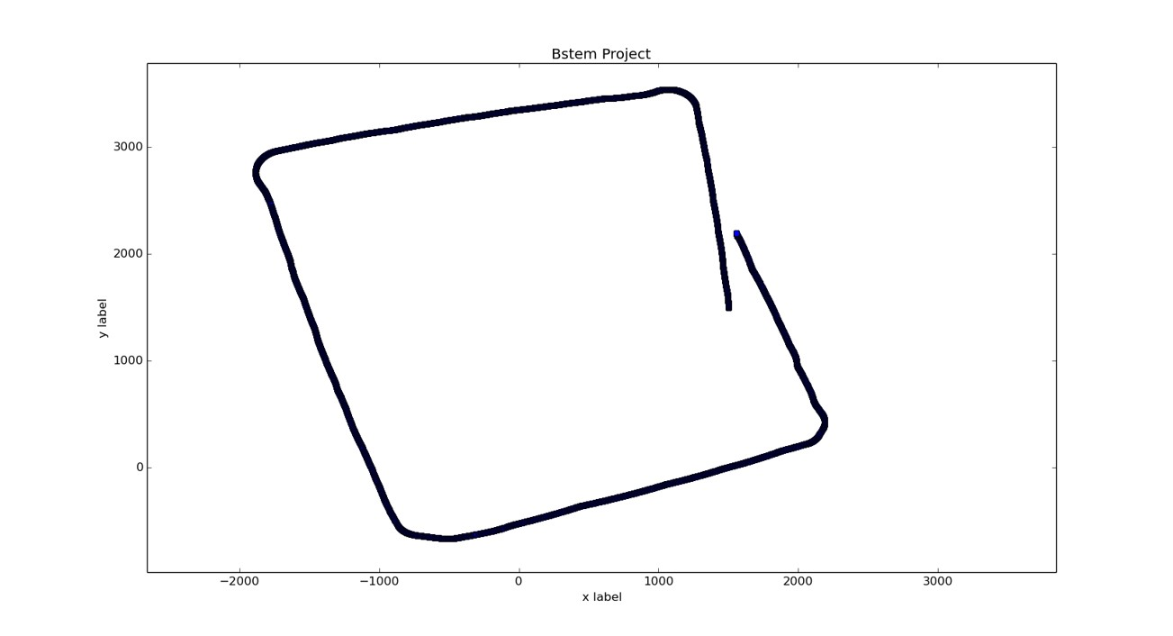
*The start point and end point are not the same. Thus proving that drift errors occur in the use of gyroscope. These errors should be minimized.
6. Work Flow

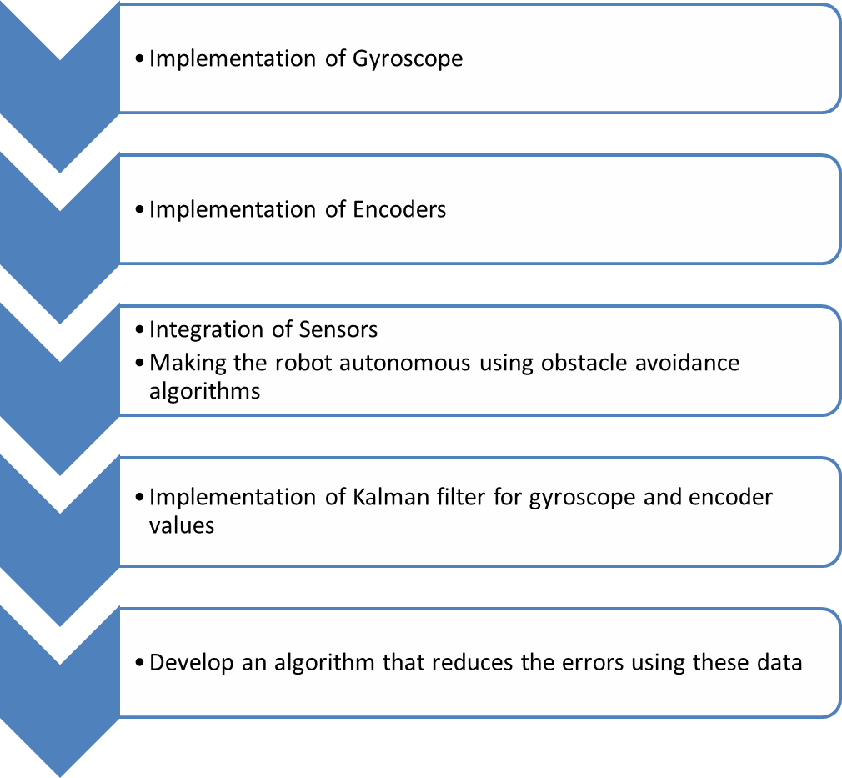

7. References
[1] Kam, Moshe “Sensor fusion for mobile robot navigation” IEEE transactions Syst., Man Cybern., vol. 85,issue 1, pp.464 -477 1995

[2] M. D. Adams, H. Hu, and P. J. Probert, "Toward a real-time architecture for obstacle avoidance and path planning in mobile robot", Proc. IEEE Int. Conf. on Robot. Automat. Pp.584 -589 1990

[3] R. C. Arkin, ”Motor schema based navigation for a mobile robot", Proc. IEEE Int. Conf. on Robot. Automat., pp.264 -271 1987

[4] R. C. Arkin and R. R. Murphy, "Autonomous navigation in a manufacturing environment", IEEE Trans. Robot. Automat., vol. 6, pp.445 -454 1990

[5] N. Ayache and O. D. Faugeras, "Building, registrating and fusing noisy visual maps", Int. J. Robot. Res., vol. 7, no. 6, pp.45 -65 1988

[6] Y. Bar-Shalom and T. E. Fortmann, Tracking and Data Association,1987:Academic

[7] H. R. Beom and H. S. Cho, "A sensor-based navigation for a mobile robot using fuzzy logic and reinforcement learning", IEEE Trans. Syst., Man Cybern., vol. 25, pp.464 -477 1995

[8] J. C. Bezdek, "Fuzziness vs. probability&ndash, the $N$th round", IEEE Transaction Fuzzy Syst., vol. 2, no. 1, 1994

