* In Edit User form, the usertype, status should be autofilled with the value selected while creating that user.

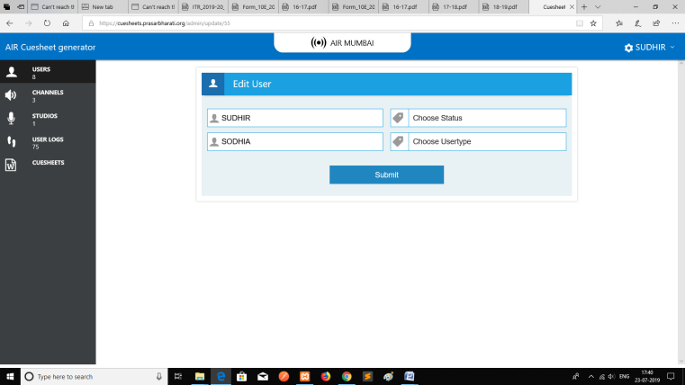

* The Edit fields for Channel/Studio etc field should be validated for maximum length and special characters restriction.

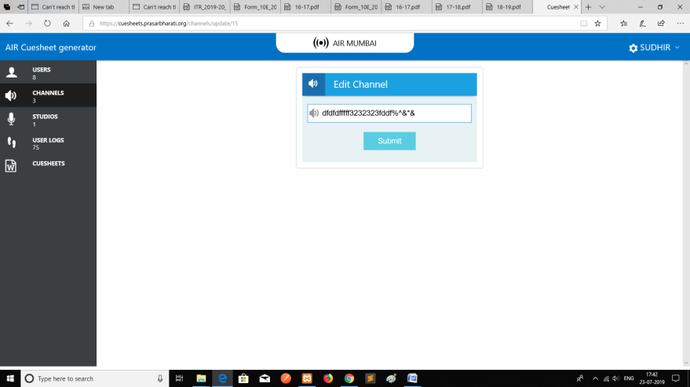

* While editing Cuesheet row, the studio selected while creation is not pre-populated currently

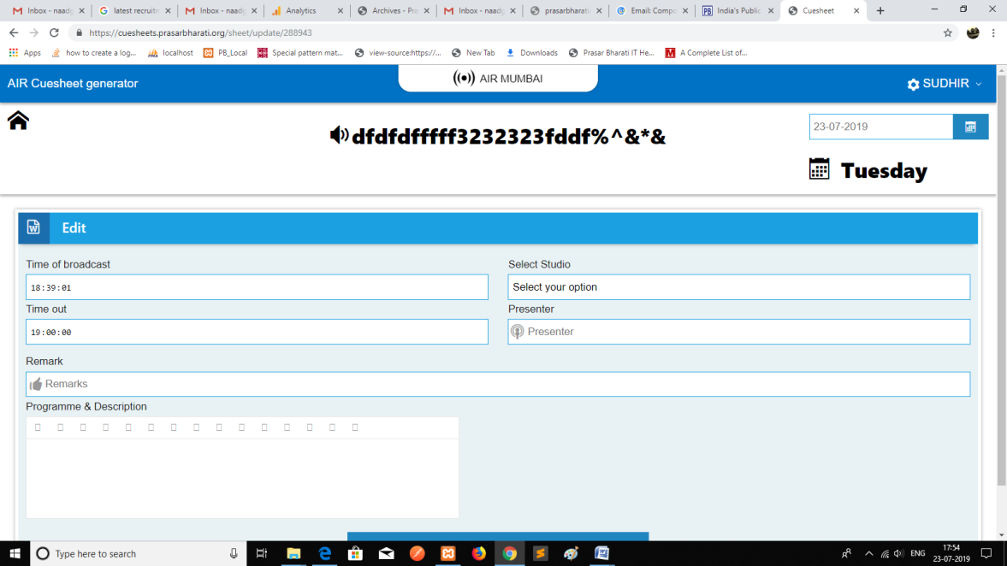

* Time of broadcast is not getting entered in Microsoft Edge Browser.

