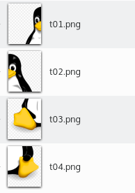
Open Custom Puzzle

Instructions

Before play with your puzzle, you’ll need follow these steps:
1-Prepare your image
2-Update your index.html (to tell in how many parts you divide your image)

1-Prepare your image
Using your prefered image editor (GIMP, Photoshop, KolourPaint or even Paint), subdivide your image in how many parts you want (max 99, for example 9x11 parts), since you create same size parts. Save each one following this pattern name: t<2 digit number>.png
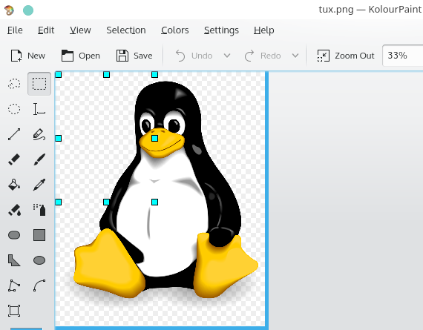
The numbers are not ramdom determined. It starts from 01 at upper left corner; and increases to the last, at bottom right corner.
You’ll need a blank t00.png image too, but you can reuse the one available in this folder.
2-Update ‘index.html’ file
Open this file with a text editor, and look for a line as below:

<script>
//image array
rows=2;
cols=2;

And change rows and cols according you image division.

3-Run!
Double click at index.html file should star the puzzle with your preferred browser.

