StockFlow
Digital Inventory & Ration Ordering System

A single, presentation-ready overview — written for a senior, non-technical audience.

Prepared by SJCEM · StockFlow v1.1.0 · 13 July 2026

1. The Problem We Are Solving
Naval mess and canteen stores today run largely on manual, paper-based processes, which creates five recurring difficulties:
# | Problem | Impact
1 | No live visibility of stock | Staff and customers cannot see what is actually left — items get over-committed after they are already exhausted
2 | Ration entitlement tracked by hand | Each officer/rating has a fixed daily ration scale (RIK — Ration in Kind). Tallying it manually per person, per week is slow and error-prone
3 | No systematic record of stock changes | Restocks, issues and adjustments are not consistently logged, making reconciliation and audit difficult
4 | Slow, informal communication | Order windows and order status are announced by word of mouth or notice boards
5 | Manual reporting | Stock, consumption and order reports are compiled by hand — time-consuming and inconsistent

StockFlow replaces this entire manual loop with one connected digital system: the admin manages stock and opens a live weekly ordering window on a website, customers order through a mobile app that automatically enforces their exact ration entitlement, and every action is recorded and reportable — instantly, transparently, without paperwork.
2. The System at One Glance
StockFlow has three connected parts working together at all times:
- The Admin Website — where the store in-charge loads stock, sets ration limits, opens the weekly ordering window, manages orders and downloads reports.
- The Customer Mobile App — where every customer gets notified, sees live stock, orders within their allowed limit, and tracks their order.
- The Central System — the invisible link between the two: it keeps the stock count live, enforces the ration limits automatically, and saves every record for reports.
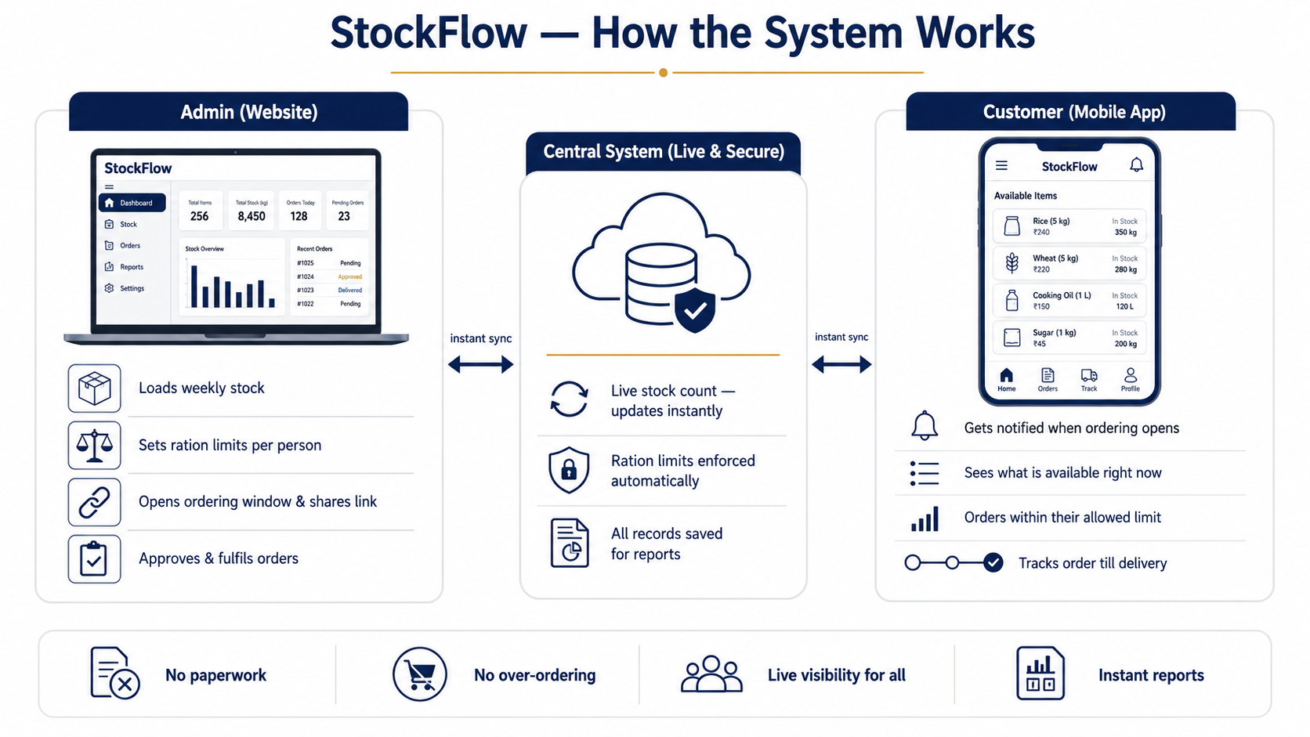
Figure 1 — The complete system at one glance.
3. Roles — Who Does What
Role | Where they work | What they do
Admin (store in-charge) | Website (full control) | Loads master stock, sets ration limits per zone, opens/closes weekly ordering links, manages users, approves & fulfils orders, sends announcements, downloads reports
Staff | Website / App (limited view) | Assists with stock updates and order handling under the admin
Customer (officer / mess / unit) | Mobile App | Receives the order notification, views live stock, places orders within their ration limit, tracks order status, views past orders

4. How the Admin Runs the Store — Website Flow
A normal week on the admin website, in six simple steps:
- Load Stock — add items one by one, or upload the entire stock sheet (Excel/CSV) in one go.
- Set Ration Limits — fix how much each person is allowed to order, exactly as per the official entitlement scale.
- Open the Order Window — generate a weekly ordering link and share it with all customers.
- Notify Everyone — one click sends the announcement through in-app alert, SMS, WhatsApp and email.
- Manage Orders Live — watch orders arrive in real time; approve, fulfil or cancel with a tap.
- Download Reports — get stock, order and shortage reports as ready PDF files.
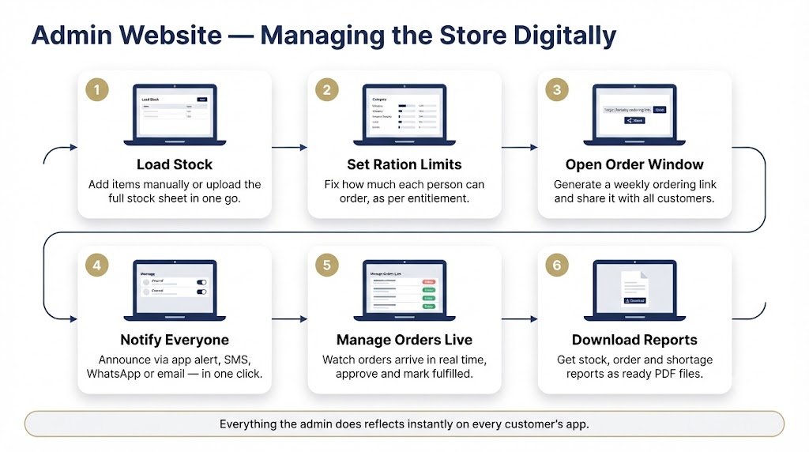
Figure 2 — Admin website flow, step by step.
5. How the Customer Orders — App Journey
The customer's experience on the mobile app, in five simple steps:
- Get Notified — the moment the admin opens the window, every customer is informed.
- See Live Stock — the app shows exactly what is available right now, updated live for everyone.
- Order Within Limit — the app itself prevents any order beyond the customer's allowed ration; a clear limit bar shows how much of the allowance is used.
- Place Order — one tap to submit. No forms, no paperwork.
- Track Till Fulfilled — the order moves visibly through Placed → Confirmed → Fulfilled, and the full week-wise history stays saved.
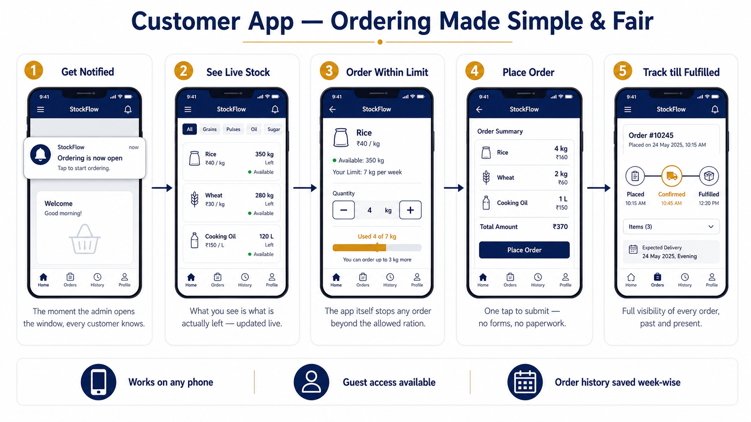
Figure 3 — Customer app journey, step by step.
6. What Is Already Built (Current Features)
6.1 Admin Website
- Live Dashboard — order-window status, stock alerts (low / out of stock), key numbers and recent orders on one screen, with a copyable order link.
- Master Stock Management — full item catalogue with search, category filters, quick restock, and reorder-level alerts.
- Bulk Excel/CSV Import — upload the entire stock sheet with a downloadable template, preview, and one-click apply.
- Ration Entitlement Engine (RIK) — the official entitlement scale (17 categories: cereals, dal, oil, sugar, milk, meat, vegetables, eggs, tea, fruit and more) is built into the system with per-person daily quantities and approved substitute ("in-lieu") articles. Admins can fine-tune overall, category-wise and item-wise limits per zone.
- Weekly Order Links — create multiple ordering windows, each optionally scoped to a ration zone; open, close or reopen anytime; see every order placed against each link.
- Order Management — all orders with status filters and one-tap transitions (pending → confirmed → fulfilled).
- User Management — add staff and customers; assign each customer to a ration zone.
- PDF Reports — stock report, low-stock/reorder report and orders report, downloadable instantly.
- One-Click Announcements — notify all customers through in-app alert, SMS, WhatsApp and email together, with delivery confirmation.
6.2 Customer Mobile App
- Simple Onboarding — guided first-run intro; register with name, unit, phone and ration scale — or continue as a guest.
- Smart Home Screen — order-window status, live catalogue preview, personal ordering insights (top items, weekly trends) and quick "order again" shortcuts.
- Ration-Aware Ordering — live stock with category filters; the master-ration bar and category quota bars make it impossible to exceed the entitlement; approved substitutes are clearly flagged.
- Order History — every order saved week-wise with live status.
- Live Sync & Alerts — stock and order status stay current automatically; notifications arrive even when the app is in the background.
7. Behind the Scenes — Simple, Secure, Reliable
The technology is kept deliberately simple to explain:
- One central database — a single source of truth for stock, orders and users; no duplicate registers.
- Live sync — any change made anywhere reaches every screen within seconds.
- Role-based access — admin, staff and customers each see only what they are permitted to; enforced at the data level, not just the screen level.
- Automatic audit record — every stock change is logged with who, what and when — ready for audit.
- One codebase, every device — the same system runs as a website for the admin and as an Android app for customers.
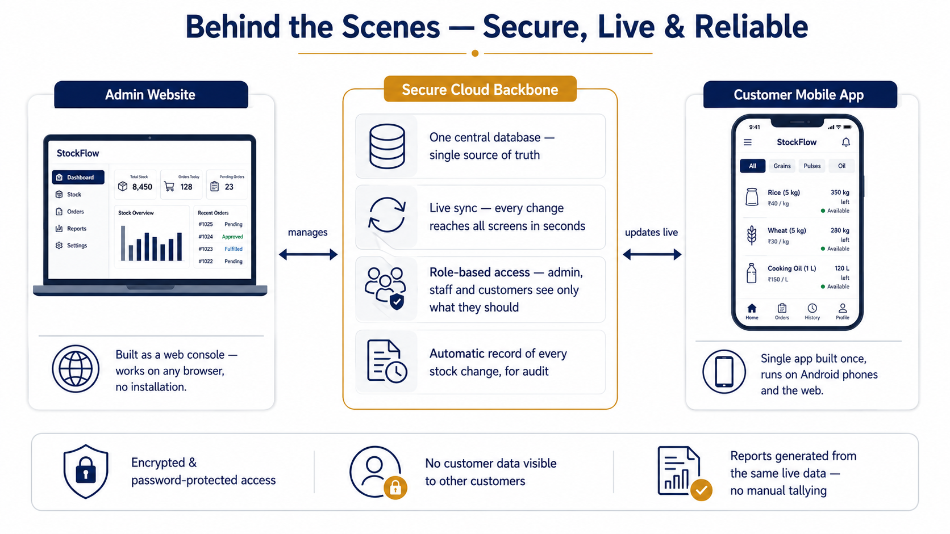
Figure 4 — Behind the scenes, kept simple.
8. The Road Ahead (Proposed Enhancements)
Priority | Enhancement | Value
High | All ration tiers/ranks — extend the entitlement engine beyond the Officers scale to every rank and mess category | Full-scale deployment readiness
High | Stock-out prediction — automatic "X will finish in Y days" alerts based on consumption rate | Prevent shortages before they happen
High | Offline mode — ordering and stock updates that work without continuous internet and sync later | Essential for ships and low-connectivity locations
Medium | Server push notifications — alerts that reach customers even when the app is fully closed | No missed order windows
Medium | OTP-based login — phone-number OTP instead of passwords for customers | Simpler and more secure onboarding
Medium | Approval workflow — supervisor sign-off for unusual or oversized orders | Extra control layer for a defence environment
Medium | Audit trail screen — full visual history of every stock change, exportable for inspections | Defence-grade accountability
Future | Multi-unit support — several messes/ships/units under one system with separate stock and reports | Scale across the organisation
Future | Advanced analytics — consumption forecasting, seasonal patterns, budget tracking | Data-driven procurement planning
Future | Hardened deployment — option to run on a restricted/local network with ID-card-based access | Meets stricter defence IT requirements

9. In One Line
StockFlow turns a paper-driven ration store into a live, fair and fully accountable digital system — stock loaded once, ordered within entitlement, tracked to the last kilogram, and reported in one click.

