- Do not edit/delete any heading or section with red text.
- Type /paste you answers in relevant sections (below Final Answer (in all questions , Approach (wherever required ) and Charts & tables (wherever required)) of the solution
- Link to submission guidelines
- Please note that submission not following the guidelines will not be accepted

OBJECTIVE QUESTIONS

Question 1: What is the total no. of attributes present in the data?

Solution:

Final Answer:
Ticket Sheet Contains 10 columns and IT Agents Sheet Contains 6 columns, Total 16 attributes are present in the dataset.

Approach:
We will use COUNTA function to count the numbers of column from the Ticket and IT Agents Sheet

Attributes:
- Ticket Sheet (10 Columns)
ID Ticket, Fecha, Employee ID, Agent ID, Requested Category, Issue Type, Severity, Priority, Resolution Time, Satisfaction Rate

- IT Agents Sheet (6 Columns):
Agent ID, Full Name, Email, Year of Birth, Month of Birth, Day of Birth

Question 2: Which columns have inconsistent or missing values, and what is the count of such values?

Solution:

Final Answer:
Neither Duplicates nor blank values found in both tickets and it agents sheet.
Severity- Replaced 4,836 instances of “Mayor” with “Major” & Replaced 356 instances of “Unclasified” with “Unclassified” in Tickets sheet.
Priority- Replaced 29,410 instances of “Unassiged” with “Unassigned” in Tickets sheet.

Approach:
Checked for duplicates and blanks value but not found any, filled Agents name column with values using XLOOKUP function, found inconsistent values in severity and priority columns, cleaned and transformed severity and priority column by removing the integer and hyphen from the text using text function, fixed spelling errors throughout the columns using Find and replace functionality

Question 3: What is the average daily ticket volume over time?

Solution:

Final Answer:
53 is the average daily tickets count

Approach:
= TOTAL TICKETS COUNT / COUNT OF UNIQUE DATES

Formulae
=ROUND(COUNTA(Table1[ID Ticket])/COUNTA(UNIQUE(Table1[Fecha])),0)

Question 4: What is the distribution of ticket categories (e.g., Login Access, System, Software)?

Solution:

Final Answer:
- System Category have the highest tickets volume, 40% of the total and 39,002 in count, followed by Login access (30%) 29,193 in count, Software (20%) 19,570 in count and Hardware (10%) 9,733 in count.
Approach:
- Created Pivot Tables for the distribution of tickets volume by requested category.
- Added Slicer for filtering data based on the years

Charts & Tables:
- Requested Category by Tickets Count
Requested Categories | Tickets Count
Hardware | 9,733
Login Access | 29,193
Software | 19,570
System | 39,002
Grand Total | 97,498

Question 5: How many tickets has each agent handled?

Solution:
Approach:
With the help of Pivot Table, we can find the total tickets each agent has handled across the five year and in a particular year. We will keep the agents name in the rows and tickets count as values.

Charts & Tables:

Agents Name | Tickets Count
A. Trejo | 1949
Alberto Casillas | 1974
Alberto Gastelum | 1889
Aldo Carrillo | 1966
Alfonso Barraza | 1984
Alfredo Barreras | 1920
Armando Sierra | 1890
Aurelio Tanori | 2027
Barbara Grijalva | 2003
Barraza Alberto | 1988
Darwin E. | 1945
Diana Rojo | 1927
Eduardo Luna | 1920
Elena Velez | 2021
Enrique Montiel | 1938
Estuardo Ocaño | 1935
EstuardoTorres | 1942
Eva Cardenas | 1943
Flores Sierra | 1963
Galindo Guadalupe | 1991
Griselda Galindo | 1856
Guadalupe Hernandez | 1915
Guadalupe Torrico | 1987
Guadalupe Villanueva | 1958
Isela Leyva | 1968
Javier D. | 1897
Jesus Contreras | 2026
Jesus Pacheco | 1931
JesusGrajeda | 1968
Leon Lourdes | 1961
Lopez Moran. | 1956
Lorena | 1966
Luis Arguello | 1929
Luis Torres | 1913
Marisol Piedrahita | 1960
Mata Lucero | 1969
Melinda | 2007
Miller Gaviria | 1892
Nurio Zepeda | 1946
Orci Carlos | 1926
Parra Luna | 1963
Ramon Macias | 1949
Reyna Santacruz | 1897
Rosa Olguin | 1950
Sandra Lujan | 1906
Segura Garcia | 1931
Silvia Morales | 1974
Velasquez Jose | 1949
Willyberto Gonzales | 2000
Yomaira Agudelo | 1933
Grand Total | 97498

Question 6: How can you extract the domain from the email addresses in the IT Agents sheet?

Solution:

Final Answer:
fp20analytics is the domain we will get of extracting from email address using the TEXTBEFORE AND TEXTAFTER FUNCTION.

Approach:
We will use this function formulae to get the domain from the email address.
=TEXTBEFORE(TEXTAFTER('IT Agents'!C2,"@"), ".")

Question 7: How can you find the full name of an agent given their Agent ID?

Solution:

Final Answer:
We Will get the Agent Name from IT Agent Sheet with the help of XLOOKUP or VLOOKUP function.

Approach:
Using this xlookup formula we will get the Agent Name in the Column
=XLOOKUP(E2,'IT Agents'!A$2:A$51,'IT Agents'!B$2:B$51)

Question 8: What is the count of each issue type (e.g., IT Error, IT Request)?

Solution:

Final Answer:
Ticket Counts for IT Request are the highest with 73,220 followed by IT Error with 24,278 tickets count throughout the five years

Approach:
The count of tickets in each issue type can be analysed using the Pivot table, taking Issue Type in rows and Tickets Count as value. We can use Slicers to get the result based on the years.

Charts & Tables:
Issue Type | Tickets Count
IT Error | 24,278
IT Request | 73,220
Grand Total | 97,498

Question 9: What is the average resolution time for tickets?

Solution:
Final Answer:
4.55 is the average resolution time for tickets

Approach:
To get the Average resolution time we can either use Average formulae or Pivot table by putting Resolution Time (Days) as Values.

=ROUND(AVERAGE(Table1[Resolution Time (Days)]),2)

Pivot Table:
Average of Resolution Time (Days)
4.55

Question 10: How has the volume of tickets changed over time?

Solution:

Final Answer:
There is significant increase in the tickets volume over the five years period with a particularly sharp rise between 2019 and 2020. The forecast trendline project a continued upward trajectory, indicating the potential further growth in ticket volume in the coming years.

Approach:
Created Pivot table with years in rows and ticket count in values.

Charts & Tables:
Year | Ticket Count
2016 | 13,051
2017 | 14,915
2018 | 18,954
2019 | 21,490
2020 | 29,088
Grand Total | 97,498

Question 11: What is the average age of the IT agents?

Solution:

Final Answer:
41 is the average age of the IT Agents.

Approach:
To Calculate the average age if the IT Agents in data we have to calculate the age of each agent first.
To get the Agent Age we will use this formula
=DATEDIF(G2,TODAY(),"y")

After Calculating Agents age We Will Then use the Average function to get the average of all IT Agents.

This formula will give the average age of IT Agents.
=ROUND(AVERAGE(Table2[Age]),2)

Question 12: Is there a correlation between the severity of issues and the resolution time?

Solution:

Final Answer:
The Correlation efficient is around -0.040536 (negative). This shows the weak correlation between the severity and resolution time.
As a result if severity increases, the resolution time tends to decrease slightly, meaning more urgent issues are being resolved faster, which is a good sign of prioritization.

Approach:
Extract the numeric value from severity column to a separate column in Tickets sheet using this formula =VALUE(LEFT(G2,FIND(“ “,G2)-1)).
Then compare the severity numeric value in column L with the resolution time column I using the CORREL function.
=CORREL(Tickets!L2:L97499,Tickets!I2:I97499)

Question 13: How many categorical columns are there in the data? [Search about categorical and continuous data, and try to answer this question]

Solution:

Final Answer:
There are 9 categorical columns and 6 numerical columns in the dataset.
Numerical Columns – Resolution Time (Days), Satisfaction Rate, Year of Birth, Month of Birth, Age, Day of Birth
Nominal- ID Ticket, Employee ID, Agent ID, Email, Full Name
Ordinal- Severity, Priority, Issue Type, Request Category

Approach:
Categorical columns are columns that contain values representing groups, categories, or labels rather than numerical measurements.

There are mainly two types of categorical columns.
Nominal: data consists of categories that have no natural ranking or order. In simple terms they are just name or labels without any ranking.

Ordinal: Data consists of categories that have a meaningful order or ranking. In simple terms, categories with a meaningful order or ranking.

SUBJECTIVE QUESTIONS

Question 1: If there is an investment, should it be used to hire more IT agents, improve training programs, or upgrade ticket management software?

Analysis: Perform a cost-benefit analysis using ticket resolution and satisfaction metrics.

Solution:

Approach:
• Analysed historical ticket volume from 2016 to 2020 to identify the trends and evaluate the projected ticket volume for upcoming years using linear forecast trendline. Evaluated the individual agent’s workload using the year over year ticket volume they have handled.
• Examined individual agents’ performance against the average performance to identify the agents who are consistently performing stable and low.

Charts & Tables:
Screenshot of Table 1: Agent workload report over five years
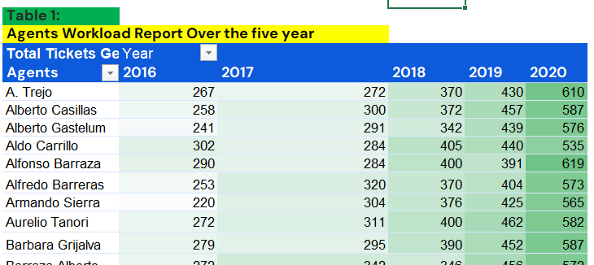

Screenshot of Table 2: Agent Performance report over the five years
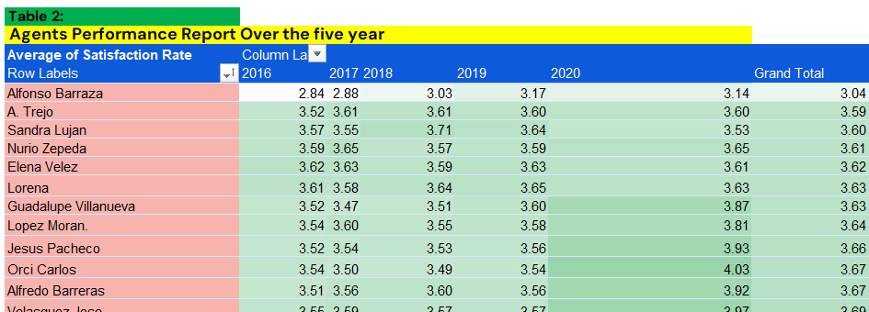

Screenshot of Table 3: Agent Ticket Resolution Statistics
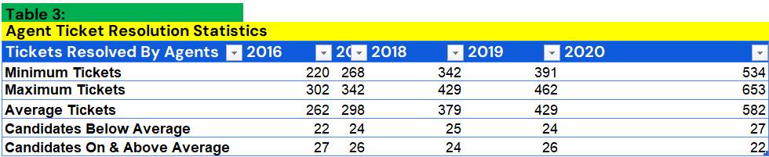

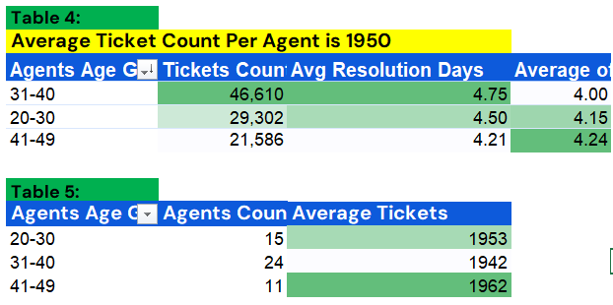

Screenshot of Chart 1: Tickets Volume over five years.
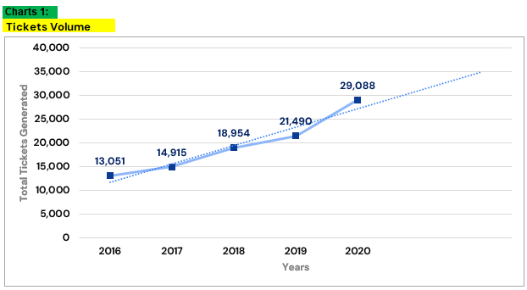

Screenshot of chart 2: Agent Performance Report over the five years.
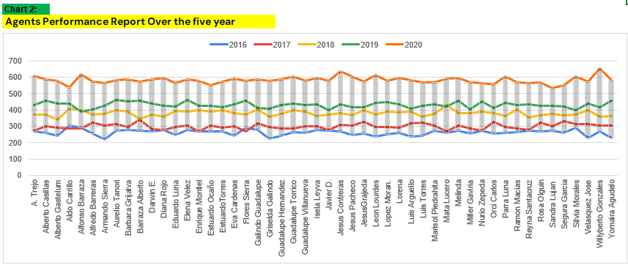

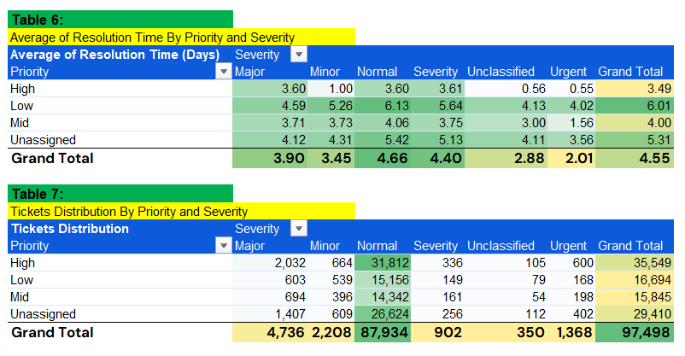

Insights:
• Since 2016 to 2020, there is substantial growth in tickets volume from 13,051 to 29,088 indicating a strong growth trend. While during time period from 2019 to 2020, there is drastic rise in the ticket volume from 21,490 to 29,088. The forecasted Trendline projecting strong growth trend in ticket volume rise in the upcoming year, This Could place additional pressure over the agents and support Operation.
• Despite the Substantial growth in ticket volume over the five years, the numbers of agents remained constant over the year.
• Across the all-age groups, the 30 to 34 age group handles the highest average tickets volume of 1,963 counts across the five years period (2016-2020), followed by 45 to 49 with 1,957 counts while age group 25 to 29 handles the lowest ticket volume of 1,889 counts.
• Across all age groups, the 25 to 29 age group records the highest average satisfaction rate of 4.99 and the lowest average resolution time of 3.71 days, while on the other hand, the 35 to 39 age group record the lowest average satisfaction rate of 3.99 and the highest resolution time of 4.84 days.
• The Agent Ticket Resolution Statistics Table shows that, approximately there 22 to 27 agents each year from 2016 to 2020 who resolve fewer tickets than yearly average ticket volume handle by agents.
• Breaking down ticket's volume distribution acrosss the priority, unassigned priority has the second highest tickets volume and second highest average resolution time across all ticket priorities.

Recommendations:
• Ticket volume is forecast to rise further beyond 2020. Over the past five years the number of agents has stayed the same while the workload has grown significantly. Without added capacity, the team will find it harder to keep resolution times and customer satisfaction at current levels.
• Some agents have consistently performed below the team average over the years. This is measured by tickets handled, average satisfaction rate, and average resolution time. Bringing these agents up to the team standard will lift overall results.
• About 30% of tickets, the second largest group by volume, have no priority assigned. Agents then have no clear way to decide what to handle first. Adding a simple, required priority option in the ticketing software would give agents better direction and help them handle tickets more efficiently.
• A balanced investment that puts hiring first, to ease the pressure on the current team. Training should follow, for both current and new agents, focused on the skills they need. The goal is for every agent to perform above the overall team averages in tickets handled, satisfaction, and resolution time.

Question 2: Which agents need additional training based on their performance metrics?

Analysis: Identify agents with the lowest satisfaction ratings and longest resolution times.

Solution:

Approach:
• Filtered the agent performance table to identify agents with below-average customer satisfaction ratings and below-average resolution times.
• Created a separate table containing the IDs, names, and ages of the identified agents to support further performance review and help determine whether additional customer service training may be beneficial.

Charts & Tables:
Screenshot of Table 1: Agents Need Training
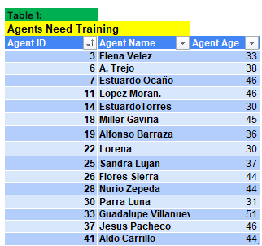

Screenshot of Table 2: Agent Performance Report over five years. 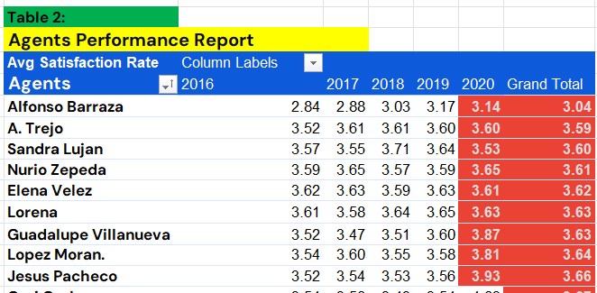

Screenshot of Table 3: Agent Workload report over the five
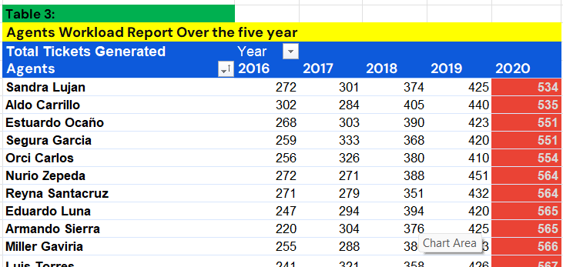

Screenshot of Table 4: Agent Ticket Resolution Statistics
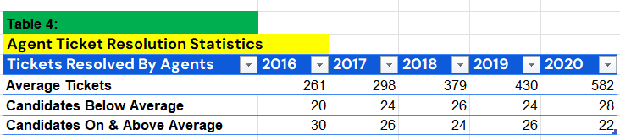

Insights:
• Evaluated agents’ performance against the overall average satisfaction ratings (4.10) and average resolution time (4.55 days) to identify the agents falling below these benchmarks. These agents were highlighted for further improvement.
• Created a separate table listing the identified agents to highlight potential areas of improvement through additional trainings to enhance their performances.

Recommendations:
• Invest first in training agents whose average satisfaction rate is below the team average of 4.10 and whose average resolution time is above the team average of 4.55 days. These agents fall short on both customer experience and speed, so targeted training on the required skills should give the biggest return. A separate list of agents meeting both conditions has been prepared to guide this.
• If more funding is available, the next group should be agents who handled fewer tickets than the team average in 2020. There are 28 such agents out of 50. Training them can help raise their output and spread the workload more evenly across the team.

Question 3: Do certain categories of requests have longer resolution times?

Analysis: Analyze the resolution times by request category.

Solution:

Approach:
- Analysed ticket volumes and average resolution times across different request categories over the five-year period (2016–2020) to identify trends and variations in workload and resolution performance.
- Conducted a deeper analysis of average resolution times by examining ticket's priority and severity within each request category to understand how these factors relate to resolution performance.

Charts & Tables:
Screenshot of Table 1:
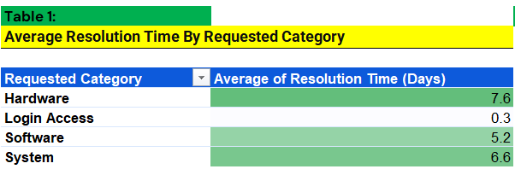

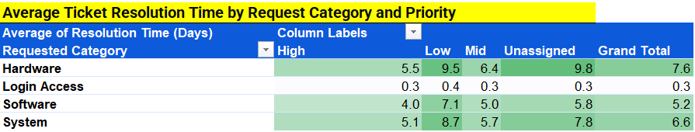

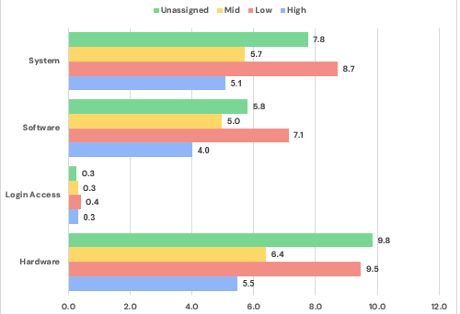

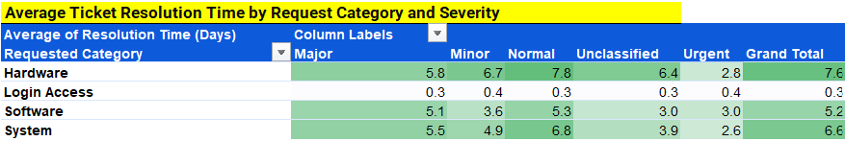

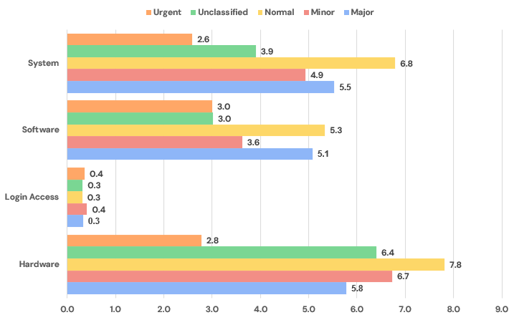

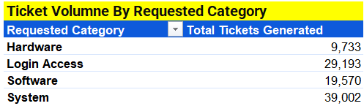

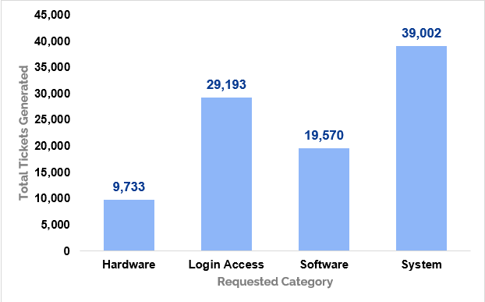

Insights:
- Despite having the lowest ticket volume over the five-year period, hardware recorded the highest average resolution time of 7.6 days among all requested categories, followed System at 6.6 days.
- A breakdown of resolution time by priority shows that Hardware and Sytem with Low and Unassigned priorities had average resolution time exceeding 7.6 days, the highest resolution time recorded across the requested categories.
- Breakdown of resolution time by severity shows that Hardware tickets with Normal priorities had average resolution time exceeding 7.6 days, the highest average resolution time recorded across all categories.

Recommendations:
- System issues (40%) and Login Access (about 30%) together generate roughly 70% of all tickets. Improving system performance will reduce System-related requests at the source, while automating Login Access tasks such as password resets and account unlocks will cut repetitive work for agents.
- Hardware and System tickets have the highest average resolution times, at 7.6 and 6.6 days respectively. Assigning more team capacity to these two categories will help bring those averages down and speed up overall resolution.
- The system should match each ticket's severity to the right priority level at intake. This ensures tickets are assigned faster, critical issues get attention first, and agents are no longer left guessing what to handle next. The result is fewer delays, quicker response times, and better overall support efficiency.

Question 4: How effective are the current software tools in managing IT tickets?

Analysis: Evaluate performance metrics before and after the implementation of new tools.

Solution:

Approach:
• Analysed individual agents’ performance over the five years period (2016-2020) using tickets volume, average satisfaction rating and average resolution time to assess the workload and performance trends.
• Examined five years trends in ticket volume, average satisfaction rating and average resolution times, considering ticket's priority and severity to identify the patterns and variations in support performances.

Charts & Tables:
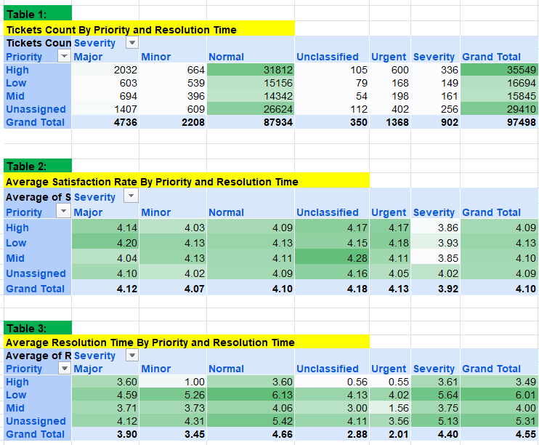

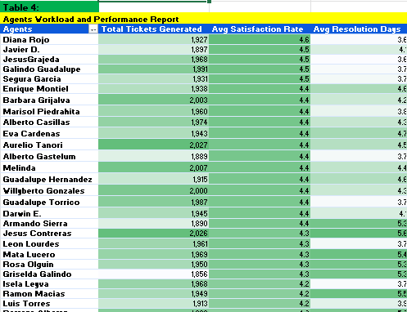

Insights:
• Unassigned priority tickets account for second highest tickets volume (29,410), with the majority of it falls under normal severity (26,624).
• Despite the substantial increase in ticket volume over the five year period (2016-2020), particularly a sharp rise between 2019 to 2020, the average satisfaction rating improved from 3.98 in 2016 to 4.16 in 2020, while average resolution time remains relatively stable throughout the five-year period (2016-2020) with minor variations at decimal level.
• The dataset doesn't contain specific information related to ticket management software tool or its implementations. Therefore it is not possible to directly assess the impact of it on overall agent's workload and performance.

Recommendations:
- About 30% of tickets, the second largest group by volume, have no priority assigned. These tickets also have the second highest average resolution time, at 5.31 days. Most of them fall under Normal severity, which is the largest severity group, and within it the biggest share of tickets has no priority set. Without a priority, agents have little guidance on what to handle first, and this likely adds to the delays.
- The system should match each ticket's severity to the right priority level at intake. This will speed up assignment, make sure critical issues get attention first, and reduce delays. The result is better response times and higher overall support efficiency.
- The dataset has little information on how the ticketing software performs or where it falls short, so it is hard to judge the tool in detail. Capturing data such as assignment time, number of reassignments, and agent feedback on the system would help measure its impact and guide future improvements.

Question 5: How has the performance of the IT support team changed over time (e.g., monthly or quarterly)?

Analysis: Trend analysis using time series charts.

Solution:

Approach:
- Analysed year-over-year, monthly, and quarterly performance trends of the IT Support Team using PivotTables and time-series charts to identify changes in ticket volume and overall performance.
- Evaluated changes in individual agent's workload and performance efficiency over the five-year period (2016–2020) using time-series charts to identify trends and variations over time.

Charts & Tables:
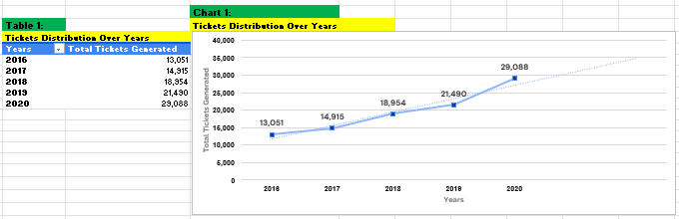
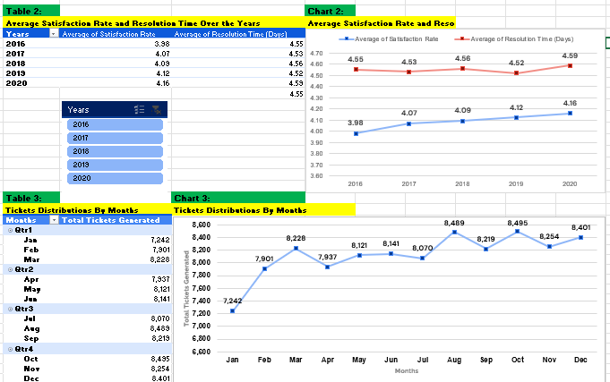

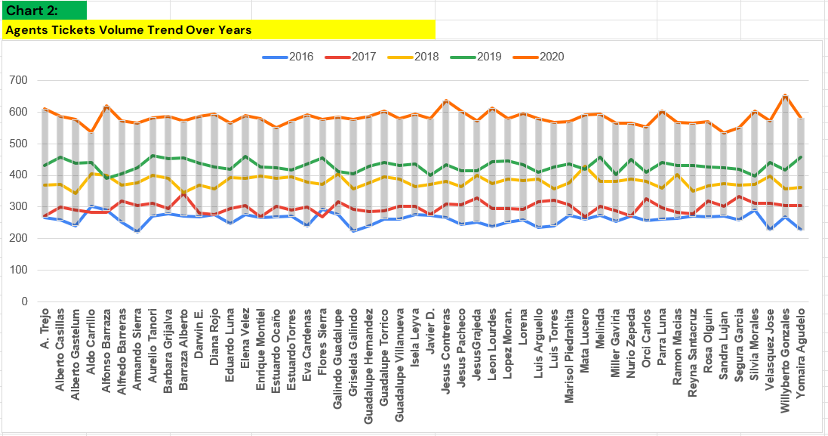
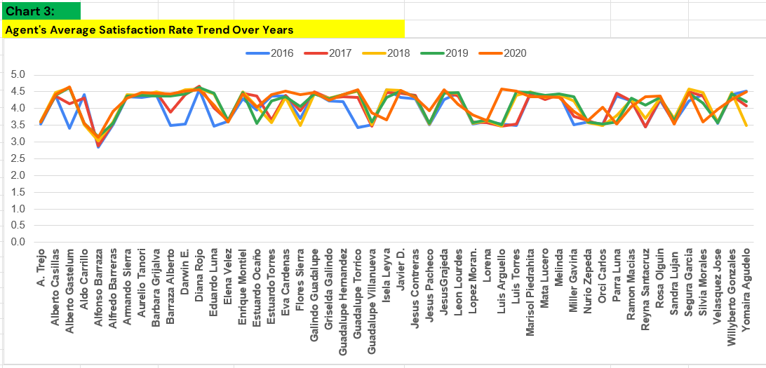
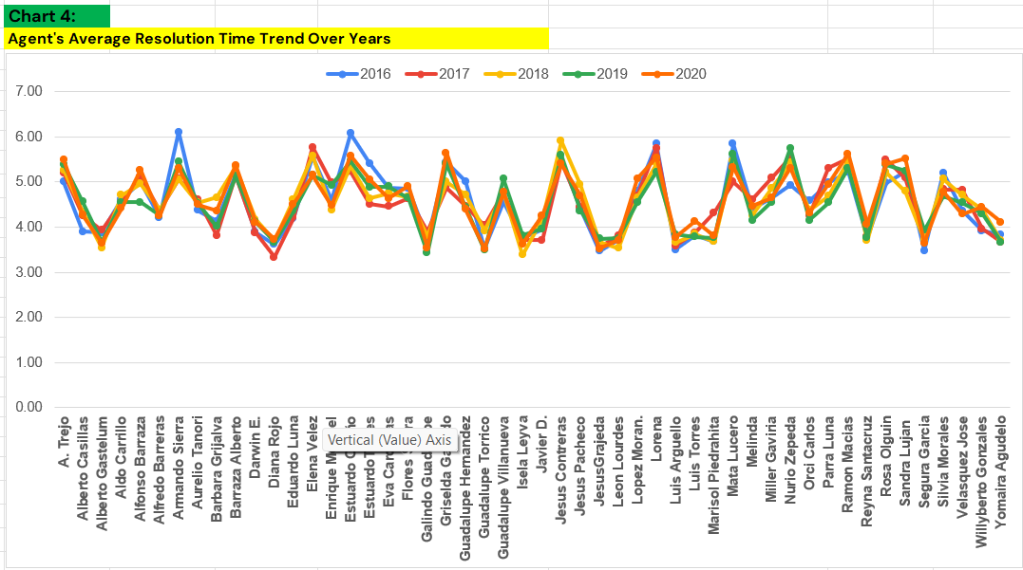

Insights:
- Ticket volume increased consistently from 2016 to 2020, with a particularly sharp rise between 2019 and 2020 compared to previous years.
- The IT Support Team maintained a relatively stable average ticket resolution time of 4.5 days throughout the five-year time period. Meanwhile, the average satisfaction rate has improved from 3.98 in 2016 to 4.16 in 2020, despite the substantial increase in workload too.
- Individual Agent's average resolution times remained relatively stable throughout the five-year period, with no significant changes observed.
- There is a substantial increase in the agent workload in 2020 compared to all previous years. Despite the rise in the tickets volume, the team achieved a higher average satisfaction rating, while maintaining stable resolution time.

Recommendations:
- Ticket volume rose substantially over the five years, with a sharp jump between 2019 and 2020. During this time the number of agents stayed the same, so each agent's workload has grown significantly. Volume is also forecast to rise further within one to two years after 2020. Hiring more agents, along with better capacity planning, will help the team handle the increase without hurting service quality.
- Each agent's average resolution time has stayed almost the same across the five years, which means the team is not getting faster on its own. We recommend bringing in agents with strong troubleshooting skills and assigning them to Hardware and System tickets, which take the longest to resolve.
- Software tickets also take a notable amount of time, at 5.2 days on average. Better guidance, clearer procedures, and support for agents on these tickets will help reduce resolution time.

Question 6: If we invest more on tech (Hardware, software, etc), do you think it will improve the ticket resolution times and employee satisfaction?

Analysis: Use historical data to project potential improvements.

Solution:

Approach:
- Analysed the historical data across five years (2016 - 2020) to evaluate average satisfaction rate and average resolution time for each requested categories.
- Examined average resolution time across different requested categories, considering ticket's priority and severity to identify and understand the variation in the performance.

Charts & Tables:
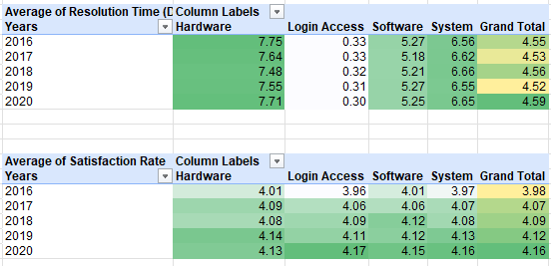

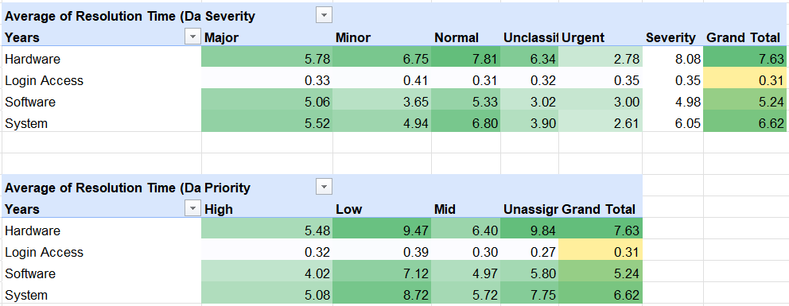

Insights:
- Hardware had the highest average resolution time of 7.71 days over the period of five year, followed by system. In contrast, Login Access had the lowest average resolution time of 0.33 days throughout the period
- There is a gradual increase in the average satisfaction rating from 2016 to 2020, with a very minor variation across all requested categories.
- Hardware had the highest average resolution time of 7.6 days. Notably tickets with normal severity in the same hardware category took even longer to resolve, average 7.81 days.
- Hardware and System with low and unassigned priority had average resolution times considerably higher than the highest average of 7.6 days (Hardware), indicating difference in resolution time across priority levels

Recommendations:
- Hardware and System drives the longest average resolution time with 7.6 and 6.6 days respectively. Better tools and infrastructure will help agents diagnose and fix issues faster, which should bring those averages down.
- Categories with high resolution times, such as Hardware and System, need more technical knowledge to fix. Hire skilled agents with strong troubleshooting abilities and assign them to Hardware and System tickets. This will speed up resolution on the categories that take the longest.
- Upgrade the ticket management software to match each ticket's severity to the right priority level at intake. This will speed up assignment, make sure critical issues get attention first, and reduce delays.

Question 7: What are the key performance metrics for IT agents, and how can they be improved, do we need to fire any agents?

Analysis: Define and analyze metrics such as average handling time, satisfaction scores, and number of tickets resolved.

Solution:

Approach:
- Evaluated agents Performance using key metrics, including tickets handled, average resolution time, and average satisfaction rate. Compared individual performance against the overall averages (4.55 days for resolution time, 4.10 for satisfaction rating, and 1,950 tickets handled) to identify agents with variations in workload and performance.

Charts & Tables:
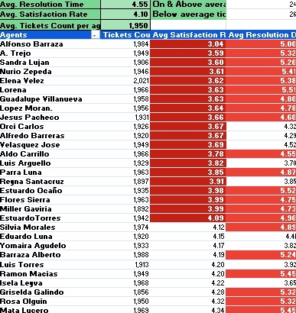

Insights:
- Among all 50 agents analysed, several agents performed below the overall averages for tickets volume, satisfaction rating, and resolution time. These agents are highlighted as red in agent performance report to flag areas for further improvement and potential training needs.
- Individual agent workload has increased significantly with a sharp rise in tickets volume during the period of 2019 to 2020.
- Agents’ performance analysis revealed a relationship between the average satisfaction rate and average resolution time. Agents with higher average satisfaction rating generally have lower resolution time while the agents with lower satisfaction rating have the higher resolution time.
- For example: Agent with lowest average satisfaction rating of 3.04 have the highest average resolution time of 5.00 days, while the highest average satisfaction rating of 4.60 has the lowest resolution time of 3.64 days.
Recommendations:
- Three metrics are used to assess each IT agent. These are average resolution time (days), average satisfaction rate, and the number of tickets resolved.
- A number of agents score below the team's average satisfaction rating and above the team's average resolution time. Training these agents improve will lift the efficiency and performance of the whole team.
- Ticket volume rose substantially over the five years and is forecast to grow further in the coming years. The number of agents did not change during this time which has increased the workload on team. Reducing the team would add more pressure and hurt service quality. We recommend upgrading the performance of current agents through focused training and hiring additional agents to share the load.

Question 8: How do employee demographics (e.g., department, seniority) impact satisfaction and ticket outcomes?

Analysis: Segment analysis using filters and pivot tables.

Solution:

Approach:
- Analysed the relationship between agent's age groups and key performance metrics, including ticket volume, average resolution time and average satisfaction rating, to identify the patterns and differences across the age groups.
- The dataset does not contain any information related to employee department and seniority. Therefore, to evaluate the potential impact on satisfaction rate and tickets outcomes is not possible.

Charts & Tables:
Table 1:
Tickets Distribution in all Age Groups
Age Group | Tickets Count
40-44 | 23,289
30-34 | 21,594
45-49 | 19,569
50-54 | 15,603
35-39 | 15,554
25-29 | 1,889

Table 2:
Average Satisfaction rate and resolution time by Age group
Age Group | Avg Satisfaction Rate | Avg of Resolution Time
35-39 | 3.99 | 4.84
45-49 | 4.04 | 4.78
40-44 | 4.05 | 4.59
30-34 | 4.19 | 4.49
50-54 | 4.20 | 4.11
25-29 | 4.40 | 3.71

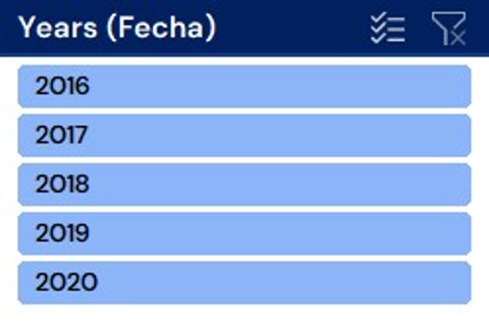

Insights:
- Across the all-age groups, the 40 to 44 age group handles the highest tickets volume of 23,289 counts across the five years period (2016-2020), followed by 30 to 34 with 21,594 counts while age group 25 to 29 handles the lowest ticket volume of 1,889 counts

- Across all age groups, the 25 to 29 age group records the highest average satisfaction rate of 4.99 and the lowest average resolution time of 3.71 days, while on the other hand, the 35 to 39 age group record the lowest average satisfaction rate of 3.99 and the highest resolution time of 4.84 days.

Recommendations:
- Agents aged 35-39 and 45-49 have the lowest average satisfaction rates (3.99 and 4.04). Additional skill training for these groups should help raise satisfaction and bring down resolution time.
- Upgrading the ticketing software and running training programs will help agents handle and prioritize tickets more efficiently. The groups to focus on are the younger group (25-29), the mid-age group (35-39), and the most senior group (50-54).
- The 40-44 and 30-34 groups handle the highest ticket volumes. Distributing tickets in more equal proportions will keep them from being overloaded and help keep performance consistent.

Question 9: Identify the trends for IT support operations based on ticket volumes and satisfaction, and mention the peak and stable times?

Analysis: Use pivot tables and charts to identify peak and off-peak hours.

Solution:

Approach:
- Analysed monthly and quarterly trends over the five years period (2016-2020) to identify the peak, stable and low workload periods based on the tickets volume. Also Evaluated the performance efficiency using the average satisfaction rate and resolution time to identify the seasonal patterns and variations.

Charts & Tables:
Table 1:
Average Satisfaction and Ticket Count By Months
Months | Avg Satisfaction Rate | Tickets Count
Qtr1
Jan | 4.15 | 7,242
Feb | 4.07 | 7,901
Mar | 4.07 | 8,228
Qtr2
Apr | 4.11 | 7,937
May | 4.11 | 8,121
Jun | 4.09 | 8,141
Qtr3
Jul | 4.12 | 8,070
Aug | 4.10 | 8,489
Sep | 4.10 | 8,219
Qtr4
Oct | 4.08 | 8,495
Nov | 4.09 | 8,254
Dec | 4.10 | 8,401

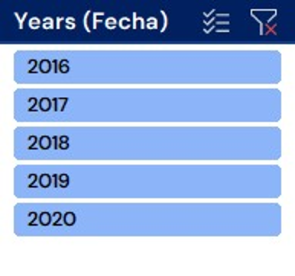

Table 2:
Average Satisfaction Rate By Months
Years | Average of Satisfaction Rate | Average of Resolution Time (Days)
Qtr1 | 4.10 | 4.57
Qtr2 | 4.11 | 4.58
Qtr3 | 4.11 | 4.52
Qtr4 | 4.09 | 4.54

Table 3:
Tickets Count By Months and Years
Tickets Count | Years
Months | 2016 | 2017 | 2018 | 2019 | 2020 | Grand Total
Jan | 1,115 | 1,125 | 1,289 | 1,522 | 2,191 | 7,242
Feb | 1,056 | 1,151 | 1,507 | 1,746 | 2,441 | 7,901
Mar | 1,105 | 1,283 | 1,470 | 1,846 | 2,524 | 8,228
Apr | 1,054 | 1,245 | 1,627 | 1,598 | 2,413 | 7,937
May | 1,160 | 1,345 | 1,653 | 1,734 | 2,229 | 8,121
Jun | 1,051 | 1,244 | 1,656 | 1,820 | 2,370 | 8,141
Jul | 1,101 | 1,233 | 1,620 | 1,885 | 2,231 | 8,070
Aug | 1,090 | 1,259 | 1,669 | 1,905 | 2,566 | 8,489
Sep | 1,061 | 1,225 | 1,638 | 1,856 | 2,439 | 8,219
Oct | 1,088 | 1,305 | 1,660 | 1,875 | 2,567 | 8,495
Nov | 1,046 | 1,243 | 1,626 | 1,831 | 2,508 | 8,254
Dec | 1,124 | 1,257 | 1,539 | 1,872 | 2,609 | 8,401

Table 3:
Tickets Count By Months and Years
Tickets Count | Years
Months | 2016 | 2017 | 2018 | 2019 | 2020 | Grand Total
Jan | 1,115 | 1,125 | 1,289 | 1,522 | 2,191 | 7,242
Feb | 1,056 | 1,151 | 1,507 | 1,746 | 2,441 | 7,901
Mar | 1,105 | 1,283 | 1,470 | 1,846 | 2,524 | 8,228
Apr | 1,054 | 1,245 | 1,627 | 1,598 | 2,413 | 7,937
May | 1,160 | 1,345 | 1,653 | 1,734 | 2,229 | 8,121
Jun | 1,051 | 1,244 | 1,656 | 1,820 | 2,370 | 8,141
Jul | 1,101 | 1,233 | 1,620 | 1,885 | 2,231 | 8,070
Aug | 1,090 | 1,259 | 1,669 | 1,905 | 2,566 | 8,489
Sep | 1,061 | 1,225 | 1,638 | 1,856 | 2,439 | 8,219
Oct | 1,088 | 1,305 | 1,660 | 1,875 | 2,567 | 8,495
Nov | 1,046 | 1,243 | 1,626 | 1,831 | 2,508 | 8,254
Dec | 1,124 | 1,257 | 1,539 | 1,872 | 2,609 | 8,401

Insights:
• There is significant increase in the tickets volume over the five-year period with a particularly sharp rise between 2019 and 2020. The forecast trendline project a continued upward trajectory, indicating the potential further growth in ticket volume in the coming years.
• January recorded the lowest tickets volume across the five-year period, while October record the highest tickets volume followed by august. This highlights variation in ticket demand across the months
• Average satisfaction rating and average resolution times remained relatively consistent across all four quarter over the five years period (2016-2020), with only minor variations up to second decimal place.
• Across the five year, November 2016 record the lowest ticket volume 1,046 counts and December 2020 record the highest ticket volume with 2,609 counts.
Recommendations:
• During peak months, Extra agents or temporary support will help the team handle the higher tickets volume and keep customer satisfaction steady.
• Planning and improvements should be made during off-peak months, such as upgrading the ticketing system, automating unassigned tickets, analyzing trends, These include:
Upgrading the ticketing system.
Automating the handling of tickets with no priority assigned.
Analysing ticket trends to plan ahead.
Clearing backlog tickets that need specialized technical skills.

Question 10: What metrics should be included in the final dashboard to provide a comprehensive view of call center performance and guide investment decisions?

Solution:
Used Multiple Pivot Tables, Charts and Slicers to create a visualized, dynamic and key operational dashboard for assessing and evaluating IT Ticket Data analysis.

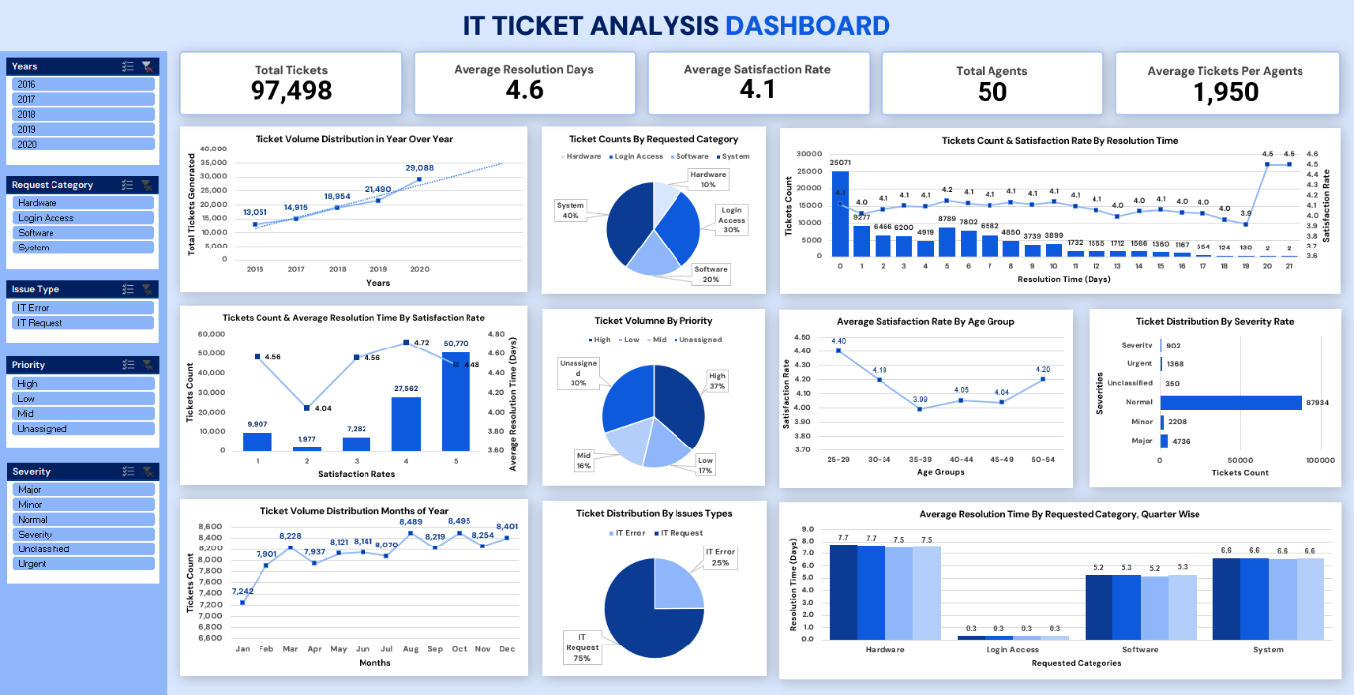
Charts & Tables:

This dashboard brings together key performance indicators (KPIs) and visualizations to help evaluate overall call center performance and guide investment decisions, It covers three areas:
- Operational efficiency: ticket volume trends, resolution times, and how workload is spread across categories and priorities.
- Customer satisfaction: satisfaction ratings and how they change by resolution time and customer age group.
- Agent productivity: tickets resolved, average resolution time, and satisfaction scores for each agent.

KPIs (Key Performance Indicators):
Total Tickets: 97,498
Average Resolution Time: 4.6 Days
Average Satisfaction Rate: 4.1
Total Agents: 50
Average Tickets Per Agents: 1950

- Ticket Volume Distribution in Year over Year: line chart displaying top ticket types over year (e.g., System issues are the highest).
- Ticket Volume Distribution Rate by Satisfaction Rate: Column Chart to display ticket Volume distribution among stars rating.
- Ticket Volume Distribution Months of Year: Line Chart to understand ticket volume distribution in all months to understand peak on and off time period.
- Ticket Counts by Requested Category: Pie Chart to understand tickets volume distribution among all requested categories.
- Ticket Volume by Priority: Pie Chart to understand tickets volume distribution among all priorities.
- Ticket Distribution By Issues Type: Column Chart to display the tickets volume distribution among both issue types.
- Average Resolution Time By Average Satisfaction Rate: Line chart to display the relation between resolution days and satisfaction rating.
- Average Satisfaction Rating By Age Group: Line chart to display relation between satisfaction rate and agent’s different age group.
- Average Resolution Time By Requested Category: Bar chart to display the relation between requested categories and average resolution time.
- Ticket Volume Distribution By Severity Rate: Bar chart to display the total tickets distributions throughout all severities.

Key Insights:
01. Demographics Overview: Youngest users (25–29) score highest CSAT at 4.40. Satisfaction drops steadily across age bands to 3.99, making the 35–39 age group the lowest-performing segment.
02. Resolution Time Trends: Average Customer Satisfaction Rate remains stable between 4.0–4.2 during the initial 12 days. The lowest satisfaction point (3.9) occurs at day 19, followed by a sharp recovery rebounding past 4.5.
03. Strategic Action Plan: Implement system automation to reduce the 6.6-day average resolution for 40% ticket volume, tailor UI/UX to resolve pain points for mid-age users, and overhaul hardware processes to eliminate peak 7.6-day delays.

Recommendations:
- Plan staffing before the busy season. August, October, and December are consistently the busiest months, and the second half of the year carries about 5% more tickets. Hiring or onboarding new agents ahead of Q4 will help the team avoid overload when volume peaks.
- Coach the agents who need it most. Targeted coaching for the lowest-performing agents is more effective than generic team-wide retraining. It should focus on improving resolution speed and customer satisfaction.
- Create a clear improvement plan for Hardware. Hardware tickets are fewer but take the longest, at 7.6 days on average. Standard operating procedures, simple triage rules, and a good knowledge base can help agents resolve them faster.
- Automate the routine work. Smart ticketing and automation tools can handle repetitive requests, such as login and access issues, and reduce manual effort. This frees agents to spend more time on complex problems.
- Focus on System tickets first. System issues make up 40% of all tickets and take 6.6 days on average to resolve. Adding resources and improving how complex cases are handled here will have the biggest impact on overall efficiency.

