Construction of a Model for Artificial Intelligence to Recognization of Dental Implant using a Radiograph

……………………………………………………………………………………………………………………………………………………………………………………………………………...

**ABSTRACT**

The goal of this research is to create a Custom model of deep convolutional neural network (CNN) that can provide different dental implant brands and models from radiographs.

To show the ability of computer vision in displaying of dental implant systems using shape-based panoramic radiographs(data-set).

To in hence the model's performance, accuracy and recovery operating characteristic (ROC) curves were computed in order to generating the graph.

We have collected total of 56 (Cowellmedi) radiographs of three different dental implant systems that are separated into training and validation(testing) dataset (76%) and test data-sets (20%) at random order. All three dental implant systems has the same shape and internal conical connectivity. We use deep-learning CNN architecture (YOLOv8) that has trained for image Pre-processing and for transfer learning. In order to describe the tested dataset's Precision, Sensitivity, Specificity, Receiver Operating Characteristic curves, and (AUC), Confusion Matrix, and deep-learning neural networks are being compared.

We introduce a machine learning method as a strategy for implant identification because the model used in the research is intelligent enough to classification dental implant systems. Machine learning can be generalized with larger datasets. But it is still in development process, AI models type implant for identification, implant successfull prediction.

The classifier used in the study has an average accuracy of 0.76, or 76%, in identifying implant systems.

**INTRODUCTION**

Dental implant surgery is a procedure that replaces the root of a tooth with a metal, silent one like a post and replaces a damaged or missing tooth with an artificial tooth that looks and functions like the original. construction of dentures or tooth replacement bridgework. Continuous fixing and new era of technology that has in hence the performance of long-term prognosis of dental implants. Due to the rising demand for dental implants, many manufacturers or companies has entered into the industry and producing more than 220 brands of implants with a large number of variety of implants bits and also it is continues to grow. Each of these implants are differs in shape size and texture, Morphology, Connection, and surface Characteristics.

Every dental implants has to follow-up and require treatment after several time due to biological or mechanical complications such as screw loosening,Implant or screw any fracture, low implant stability during peri-implants. At the time of this process, some information is required for the implant by the doctors such as, manufacturer/Company of the screw, in the implant system in fixation method and the type of abutment used. The difficulty of identifying implant systems is made when information must be exchanges in different regions of countries. Since there is no region-wide information network to identify the implant system, the problem is complicated. In an effort to identify the system and treat complications, doctors may experience invasive treatment modalities and more often make new treatment, thus increasing the cost of treatment.

This failure may be due to lack of information from surgeons who do not provide required documents to patients after the implantation, or due to the loss of these documents by patients themselves may lead to the failure. There are many reasons for not contacting or not be in touch with the implant dentist or the lack of information of product was provided by the manufacturer are other reasons that can be requested.

There are Two different types of training that are used in machine learning algorithms such as supervised and unsupervised learning Tasks such as classification (determining the category of a given data point) and regression (finding relationship between a set of data that is independent or dependent variables) are usually achieved. using supervised learning, the training in which the learning model is given a set of data training input/output pairs. The tasks like clustering and dimensionality reduction are usually performed using unsupervised training that aims only to capture only important required features in a given data set. A unique class of machine learning that is most popular is deep learning these days which is an advanced technology based on artificial neural network. Deep learning has different applications in many domains of engineering, health care, and data analytics in general due to its higher ability to generalize.

Some theories that it is only a period of time before humans are completely replaced in certain roles in medical science as ai will becoming a part in that industry. A wireless sender device sends electromagnetic waves to receiver to activate the chip which can be harmful to human health, and every doctor does not have this special device in their clinic. And also make an appropriate guess about the type of implant to use. These technique has some limitations that is dentist's knowledge of different implant systems, And the time spent in the process of implantation, with the accuracy of identification. As the rapid growth of implant dentistry as a prosthetic option, so it is needed for a suitable and fast scientific method to identify of implant.

**RELATED WORK**

The Related work for the detection of dental implants that is custom detection of model includes various use of imaging methods such as X-rays, computed tomography (CT), Cone-Beam-computed-tomography (CBCT), And Magnetic-Resonance-Imaging (MRI) to make it visualize dental implants and surrounding structure of model. Computer made design/manufacturing (CAD/CAM) technology can also used to design and manufacture custom dental implants for patients.  
In recent years, Machine-learning and Deep_learning techniques were used in dental implant detection and segmentation tasks. The methods and technologies uses an algorithm that can learn to identify and differentiates dental implants (radiographs) in medical images automatically. For example, Convolutional_neural_networks (CNN) and other Deep learning models has been trained on a variety of large datasets (dental implant Images ) that are Accurately identified and distinguish dental implants in new images.  
Another related domain of this Work is to development of new software and tools that help dentists and dental technicians in the planning of operation during dental implants. These softwares can provide good visualization of implant placement and simulate in the patients desired results of different implant configurations. Few tools also came under machine learning techniques to analyze patient data and provide recommendations to the patients for the optimal implant placement.

**MATERIALS AND METHODS**

**Image Data Set**

A set of different digital radiographs of dental implants was collected from Intraoral radiographs produced by x-ray,CT,CBCT,MRI methodology and manually cropped orthopantomograms, In order to know the region of interest that is (ROI),which is the implant. The radiographs were obtained from the bunch of collection of database and also from the database of five practitioners in private practice. All radiographs that provides observation of all implants and prosthetic parts are included in the images . Images whose quality was considered bad after checking the images by the author were not included in the graph, as well as images with implants of unknown to models.

**Preprocessing and Data Augmentation**

The data that are digitally processed by computers Each images are converted into JPEG-file extension format and then I will be converted into Gray-scale format. The maxillary implant images are rotates vertically order, and then each image is resized to 90 × 210 pixels accordingly. The durability of the learning and analysis model after testing is improved by using Data-augmentation process to increase the number of training images . Thus, the horizontal rotation, vertical rotation, Angulation, Tone, Brightness, Contrast, Blur, Sharpness, and Gamma correction are changed. After adding, As the database consists total of 56 radiographs in which 25 were tested during the research for generating the tables below down.

**Convolutional Neural Networks**

A CNN is a unique type of data processing algorithm in machine learning in which every artificial neuron is an automaton that is used to pre-processes data and communicates with each other neurons by convolutional movement, the pattern which is similar to the visual cortex of animals processe data. Having 20CNN are held together for interconnection neuron nodes, organized into different layers of mathematical calculations. Information(dataset) passes from the first layer as an input to the last layer as an output after that each filtered in layer according to its characteristics and nature. Thus the first layer will form into the general shape of the image, then the edges, and after that the angles, points and structures, etc. Until the prediction is made at the exit of the last layer in the identity of the image (implant). model).The deep-learning system is built on a system running linux based Ubuntu OS (v.22.20) LTS with 1-TB torage of memory, and the RAM of 8 GB of GPU memory (NVIDIA graphic card GeForce GTX-350-Ti). Preprocessors, which removes unusable data, is done with the GoogLeNet Inception v3 and also it can be performand on the online as well using Google colab. CNN network that is trained using the Keras-library in TensorFlow (r1.13) using Python code can be done using anaconda environment. The dataset is trained using transfer/compairing learning, which involves applying version 8 network computing which is applicable to the custom model.

**Yolov8**

Yolov8 one of the most advanced Algorithm that is used for detection of images by converting raw images into blur and black/white image. The latest version of YOLO by Ultralytics is intruduced in the tech world for fast detection of objects The Question arrises that.Why should use YOLOv8and Roboflow 100? YOLO-v8 the version 8 has come with many different developer-friendly features, such as easy-to-use different python packages that are well-structured. There is a large community of people who are actually uses python as there main language to code so YOLO has a large community around the YOLOv8 model, which creates a environment for many people in computer vision circles who can help you when you need any guidance or advice. YOLOv8 aquire a strong accuracy in COCO as well. For example, the YOLOv8 model - the medium model - obtained a map of (50.2% )when it is measured in COCO. When it is checked or tested against Roboflow 100, a dataset that discribes the performance of models in various task-specific domains, YOLOv8 scores significantly better results than YOLOv5. For More information regarding YOLOv8 is available in the performance analysis later in the article in the result section. After that as it has the developer-friendly features in YOLOv8 are one of the most important thing in the algorithm. As compare to other models having tasks are split into number of multiple executable Python files but, YOLOv8 comes with a (CLI) that makes model training more easy to use. This is an addition feature to the Python packages that provides a user friendly coding experience than the previous model i.e YOLOv5. The developer-community of YOLO is becoming famous when you use the model it easy-to-use.

**Result**

As in Figure-1 shows that ability of the neural Custom model for implant classification has been done by brand and model. For this model, diagnostic accuracy is 98% (in table / box_loss), Precision is 88.5% (in metric / precision (B)), recall is 5.2% (metric / recall (b)), dfl_loss is 58 ,6 % (train/dfl_loss). The training for detection of model using machine learning process and cross-entropy (learning loss) curves as it is trained to increments models  
Blue line descirbes the performance of model testing as it is in training phase, which has increases as the number of models increases in perticular time, with a final probability of 80% for the custom model implant systems at the final time. The blue curve-line in table/box_loss shows the performance during testing, which will increased over time, with a final accuracy of 99% for the implant systems at the final time. The blue curve represents the training and validation data sets, which have experienced significant decreases over time.

**Graphs that are generated during testing:-**

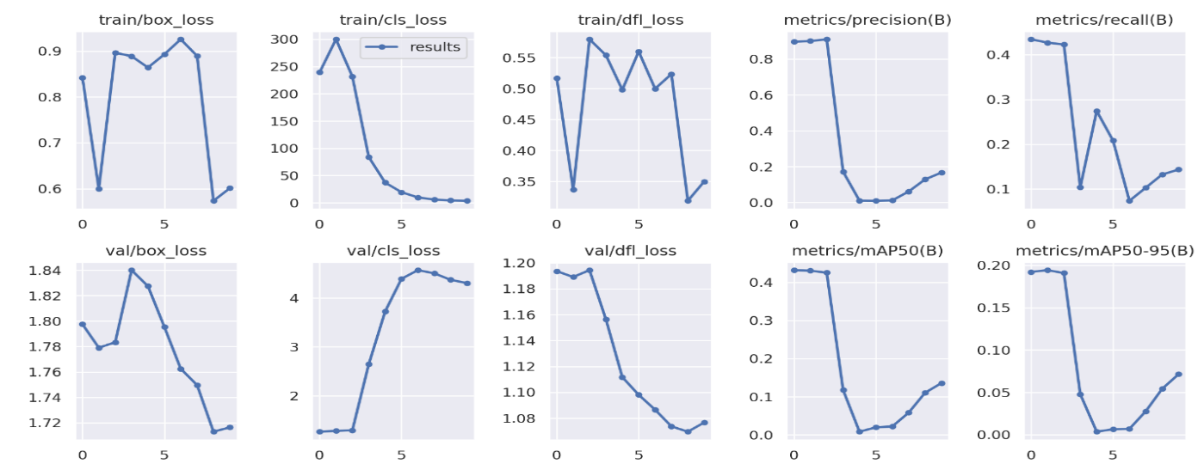

Figure 1 : Performance of the CNN mod

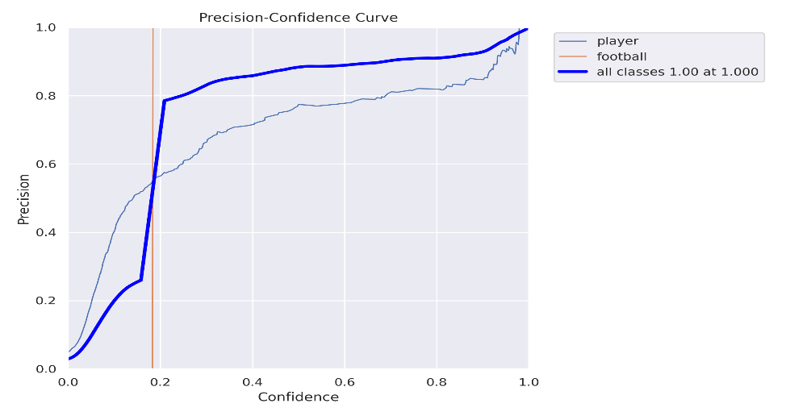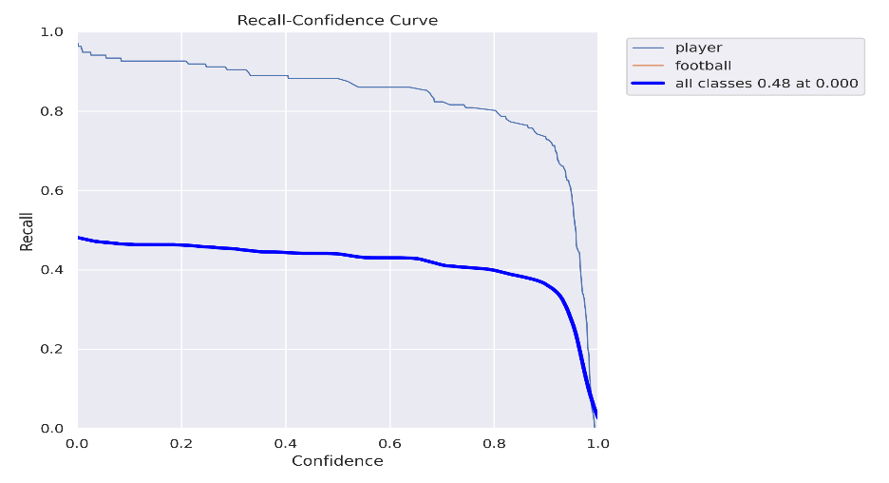

**Table1:**

|  |  |  |  |  |  |  |  |  |
| --- | --- | --- | --- | --- | --- | --- | --- | --- |
| Epoch | train/box_loss | | V train/cls_loss | | train/dfl_loss | | metrics/precision(B)_ | |
| 0 | 0.84218 | | 239.14 | | 0.51678 | | 0.89608 | |
| 1 | 0.59942 | | 299.85 | | 0.3371 | | 0.90007 | |
| 2 | 0.89638 | | 231.52 | | 0.57949 | | 0.90995 | |
| 3 | 0.88879 | | 84.001 | | 0.55368 | | 0.17151 | |
| 4 | 0.8641 | | 37.01 | | 0.49792 | | 0.01016 | |
| 5 | 0.89277 | | 19.394 | | 0.55972 | | 0.00929 | |
| 6 | 0.92567 | | 9.908 | | 0.49971 | | 0.01163 | |
| 7 | 0.8893 | | 5.8776 | | 0.52339 | | 0.06114 | |
| 8 | 0.57349 | | 4.2848 | | 0.31879 | | 0.12857 | |
| 9 | 0.60105 | | 3.6187 | | 0.34998 | | 0.16667 | |
|  |  | |  | |  | |  | |
|  |  | |  | |  | |  | |
| metric/recall(B) | | metric/mAP50(B) | | metrics/mAP50-95(B) | | val/box_loss | |  |
| 0.43439 | | 0.43168 | | 0.19215 | | 1.7975 | |  |
| 0.42685 | | 0.43021 | | 0.19425 | | 1.779 | |  |
| 0.42279 | | 0.425 | | 0.19079 | | 1.7833 | |  |
| 0.10366 | | 0.11761 | | 0.04795 | | 1.84 | |  |
| 0.27426 | | 0.00834 | | 0.00361 | | 1.8274 | |  |
| 0.20809 | | 0.01978 | | 0.00648 | | 1.7954 | |  |
| 0.07353 | | 0.022 | | 0.00694 | | 1.725 | |  |
| 0.10294 | | 0.05812 | | 0.0278 | | 1.7496 | |  |
| 0.13235 | | 0.1102 | | 0.05421 | | 1.713 | |  |
| 0.14338 | | 0.13567 | | 0.07146 | | 1.7164 | |  |

|  |  |  |  |  |
| --- | --- | --- | --- | --- |
| val/cls_loss | val/dfl_loss | ir/pg0 | ir/pg1 | irpg2 |
| 1.2655 | 1.1936 | 0.0946 | 0.0006 | 0.0006 |
| 1.2816 | 1.1891 | 0.088171 | 0.00117013 | 0.00117013 |
| 1.295 | 1.1944 | 0.81604 | 0.001604 | 0.001604 |
| 2.6439 | 11,563 | 0.074898 | 0.0018981 | 0.0018981 |
| 3.7251 | 1.1117 | 0.068054 | 0.0020536 | 0.0020536 |
| 4.3927 | 1.098 | 0.061071 | 0.0020705 | 0.0020705 |
| 4.5695 | 1.0865 | 0.053949 | 0.0019488 | 0.0019488 |
| 4.5045 | 1.0738 | 0.046689 | 0.0016885 | 0.0016885 |
| 4.3714 | 1.0695 | 0.03929 | 0.0012896 | 0.0012896 |
| 4.3044 | 1.0766 | 0.031752 | 0.0007521 | 0.0007521 |

# REFERENCES

1. Sahiwal IG, Woody RD, Benson BW, Guillen GE. Radiographic iden- tification of threaded endosseous dental implants. J Prosthet Dent 2002;87:563–577.
2. Michelinakis G, Sharrock A, Barclay CW. Identification of dental implants through the use of Implant Recognition Software (IRS). Int Dent J 2006;56:203–208.
3. Morais P, Queirós S, Moreira A, et al. Computer-aided recognition of dental implants in X-ray images. In: Hadjiiski LM, Tourassi GD (eds). Proceedings SPIE 9414, Medical Imaging 2015: Computer-Aided Diagnosis, 94142E (20 March 2015).
4. Esteva A, Kuprel B, Novoa RA, et al. Dermatologist-level classification of skin cancer with deep neural networks. Nature 2017;542:115–118.
5. Gargeya R, Leng T. Automated identification of diabetic retinopathy using deep learning. Ophthalmology 2017;124:962–969.
6. Anthimopoulos M, Christodoulidis S, Ebner L, Christe A, Mou- giakakou S. Lung pattern classification for interstitial lung diseases using a deep convolutional neural network. IEEE Trans Med Imaging 2016;35:1207–1216.
7. Arevalo J, González FA, Ramos-Pollán R, Oliveira JL, Guevara Lopez MA. Representation learning for mammography mass lesion clas- sification with convolutional neural networks. Comput Methods Programs Biomed 2016;127:248–257.
8. Fourcade A, Khonsari RH. Deep learning in medical image analysis: A third eye for doctors. J Stomatol Oral Maxillofac Surg 2019;120:279–288.
9. Gao XW, Hui R, Tian Z. Classification of CT brain images based on deep learning networks. Comput Methods Programs Biomed 2017;138:49–56.
10. Shin HC, Roth HR, Gao M, et al. Deep convolutional neural networks for computer-aided detection: CNN architectures, dataset characteris- tics and transfer learning. IEEE Trans Med Imaging 2016;35:1285–1298.
11. Matsugu M, Mori K, Mitari Y, Kaneda Y. Subject independent facial expression recognition with robust face detection using a convolu- tional neural network. Neural Netw 2003;16:555–559.
12. Sahiwal IG, Woody RD, Benson BW, Guillen GE. Radiographic iden- tification of threaded endosseous dental implants. J Prosthet Dent 2002;87:563–577.
13. Michelinakis G, Sharrock A, Barclay CW. Identification of dental implants through the use of Implant Recognition Software (IRS). Int Dent J 2006;56:203–208.
14. Morais P, Queirós S, Moreira A, et al. Computer-aided recognition of dental implants in X-ray images. In: Hadjiiski LM, Tourassi GD (eds). Proceedings SPIE 9414, Medical Imaging 2015: Computer-Aided Diagnosis, 94142E (20 March 2015).
15. Esteva A, Kuprel B, Novoa RA, et al. Dermatologist-level classification of skin cancer with deep neural networks. Nature 2017;542:115–118.
16. Gargeya R, Leng T. Automated identification of diabetic retinopathy using deep learning. Ophthalmology 2017;124:962–969.
17. Anthimopoulos M, Christodoulidis S, Ebner L, Christe A, Mou- giakakou S. Lung pattern classification for interstitial lung diseases using a deep convolutional neural network. IEEE Trans Med Imaging 2016;35:1207–1216.
18. Arevalo J, González FA, Ramos-Pollán R, Oliveira JL, Guevara Lopez MA. Representation learning for mammography mass lesion clas- sification with convolutional neural networks. Comput Methods Programs Biomed 2016;127:248–257.
19. Fourcade A, Khonsari RH. Deep learning in medical image analysis: A third eye for doctors. J Stomatol Oral Maxillofac Surg 2019;120:279–288.
20. Gao XW, Hui R, Tian Z. Classification of CT brain images based on deep learning networks. Comput Methods Programs Biomed 2017;138:49–56.
21. Shin HC, Roth HR, Gao M, et al. Deep convolutional neural networks for computer-aided detection: CNN architectures, dataset characteris- tics and transfer learning. IEEE Trans Med Imaging 2016;35:1285–1298.
22. Matsugu M, Mori K, Mitari Y, Kaneda Y. Subject independent facial expression recognition with robust face detection using a convolu- tional neural network. Neural Netw 2003;16:555–559.

23.Buser D, Dula K, Hirt HP, Schenk RK. Lateral ridge augmentation using autografts and barrier membranes:

A clinical study with 40 partially edentulous patients. J Oral Maxillofac Surg 1996;54:420–432.

24.Abrahamsson I, Berglundh T, Wennström J, Lindhe J. The peri-implant hard and soft tissues at different implant

systems. A comparative study in the dog. Clin Oral Implants Res 1996;7:212–219.

25.Sánchez AR, Sheridan PJ, Kupp LI. Is platelet-rich plasma the perfect enhancement factor? A current review. Int

J Oral Maxillofac Implants 2003;18:93–103.

26. Gapski R, Wang HL, Mascarenhas P, Lang NP. Critical review of immediate implant loading. Clin Oral Implants

Res 2003;14:515–527.

27.Pjetursson BE, Brägger U, Lang NP, Zwahlen M. Comparison of survival and complication rates of tooth

-supported fixed dental prostheses (FDPs) and implant-supported FDPs and single crowns (SCs). Clin Oral

Implants Res 2007;18(suppl 3):97–113.

28.Hermann JS, Cochran DL, Nummikoski PV, Buser D. Crestal bone changes around titanium implants. A

radiographic evaluation of unloaded nonsubmerged and submerged implants in the canine mandible. J

Periodontol 1997;68:1117–1130.

29.Meredith N, Book K, Friberg B, Jemt T, Sennerby L. Resonance frequency measurements of implant stability in

vivo. A cross-sectional and longitudinal study of resonance frequency measurements on implants in the

edentulous and partially dentate maxilla. Clin Oral Implants Res 1997;8:226–233.

30.Chiapasco M, Gatti C, Rossi E, Haefliger W, Markwalder TH. Implantretained mandibular overdentures with

immediate loading. A retrospective multicenter study on 226 consecutive cases. Clin Oral Implants Res

1997;8:48–57.