Bluetooth Serial Cable Creation

Items Needed
BlueSnap Bluetooth 2.1 to RS232 Adapter
DB9 Male Solder Connector Kit
4-40x7/8” Machine Screws (2)
4-40 Hex Nuts (2)
1' Ethernet Patch Cable
Hot Glue

Prepare Cable

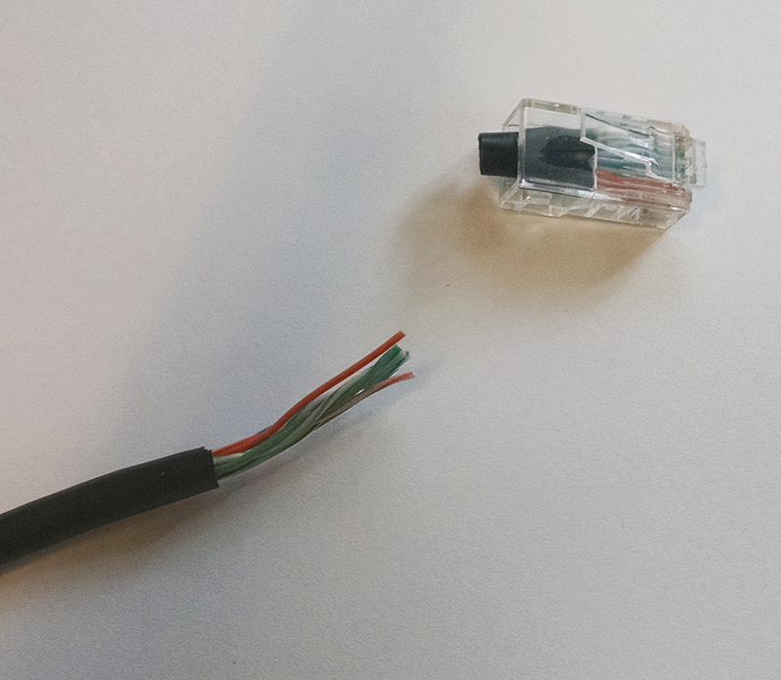
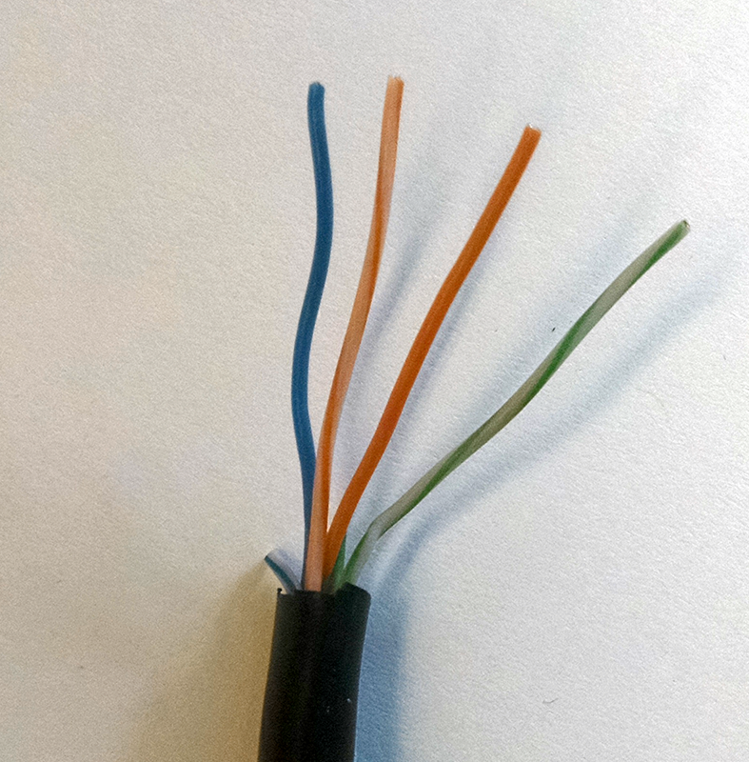

Remove RJ45 connector from one end of the ethernet patch cable. Strip cable jacket back no more than .75 inches. Trim all conductors back except Blue, Orange-White, Orange and Green-White.

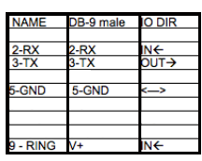
Assemble Cable
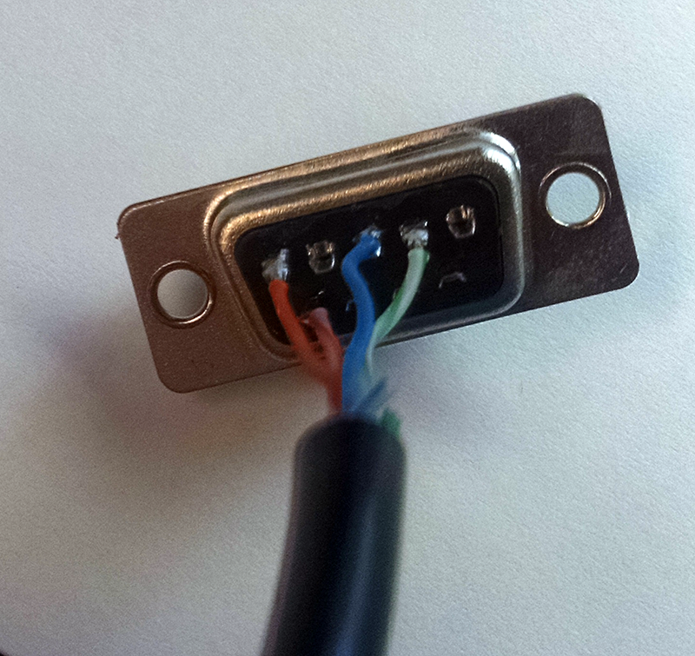
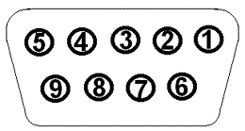

Solder conductors to pins 2, 3, 5 and 9 as shown above.

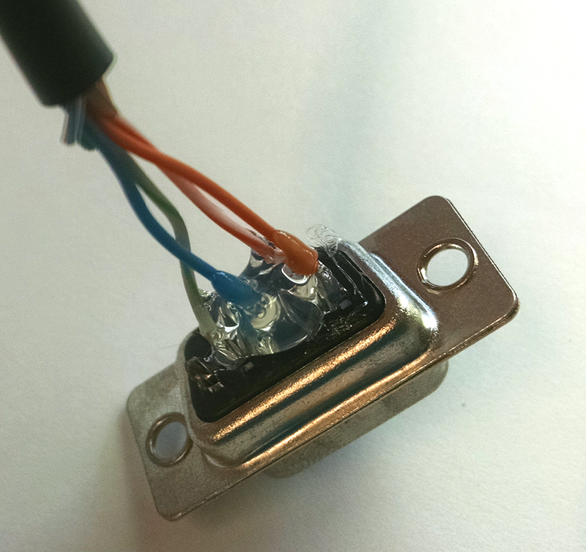

Isolate and reinforce soldered conductors by application of hot glue between and around solder welds.

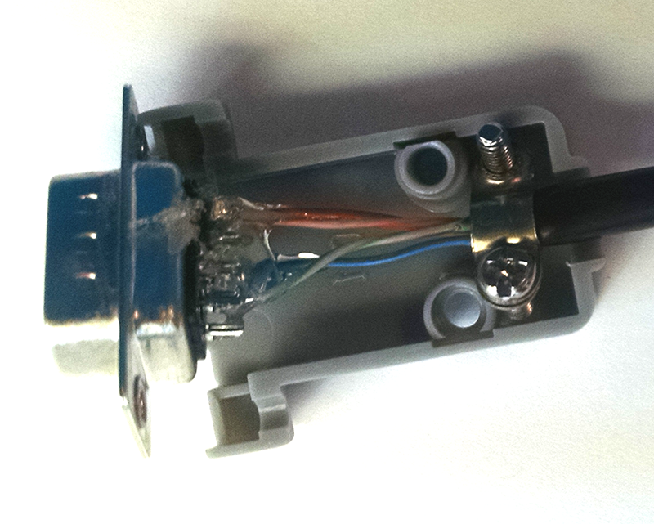
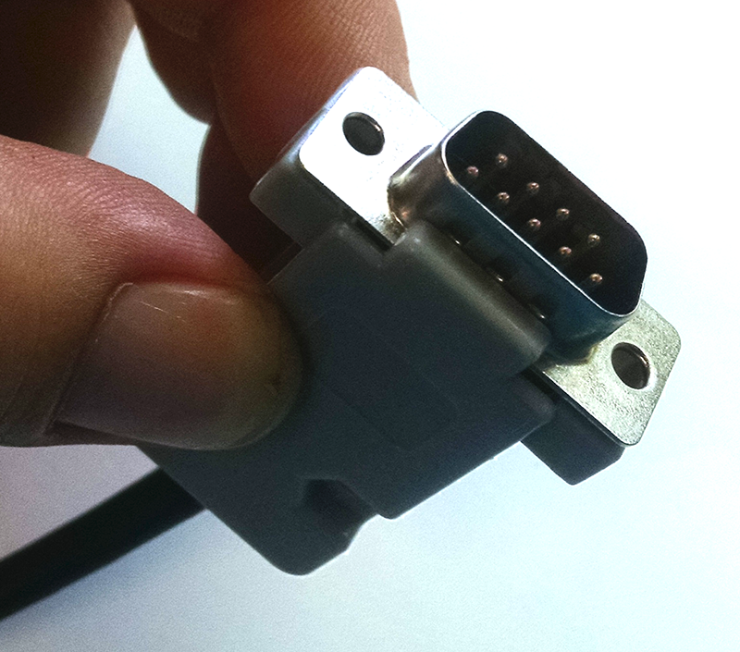

Assemble connector housing.

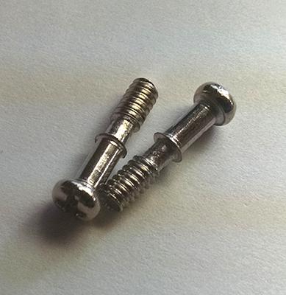
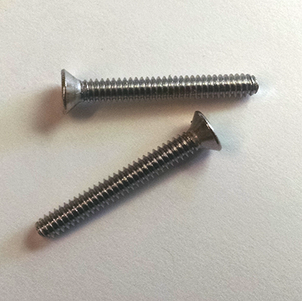
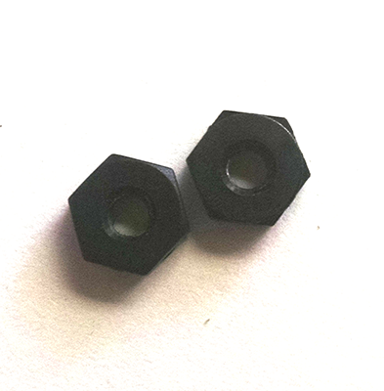

Discard self tightening screws provided in connector kit and replace with 4-40 x 7/8” flat head or pan head screws and 4-40 hex nuts.

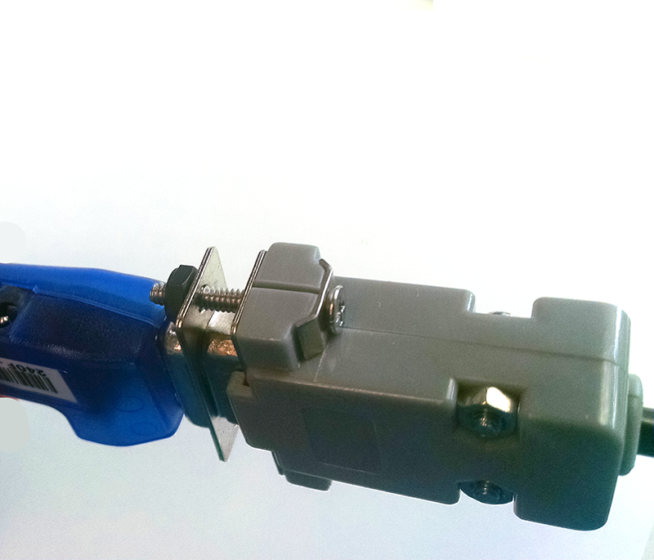

Attach cable to BlueSnap Dongle and secure with 4-40 screws and nuts.

