BT Serial Dongle Configuration and QuickConnect Creation

Items Needed
BlueSnap Bluetooth 2.1 to RS232 Adapter
Worldlabel water proof labels – item number WL-1100LP (https://www.worldlabel.com/Pages/wl-ol1100.htm)
quickconnect_BT_ID.csv (Editable data file from Codeshelf)
quickconnect.btw (BarTender barcode file from Codeshelf)

Configure BlueSnap Adapter

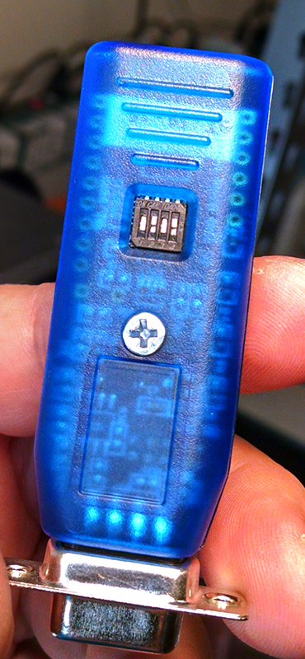
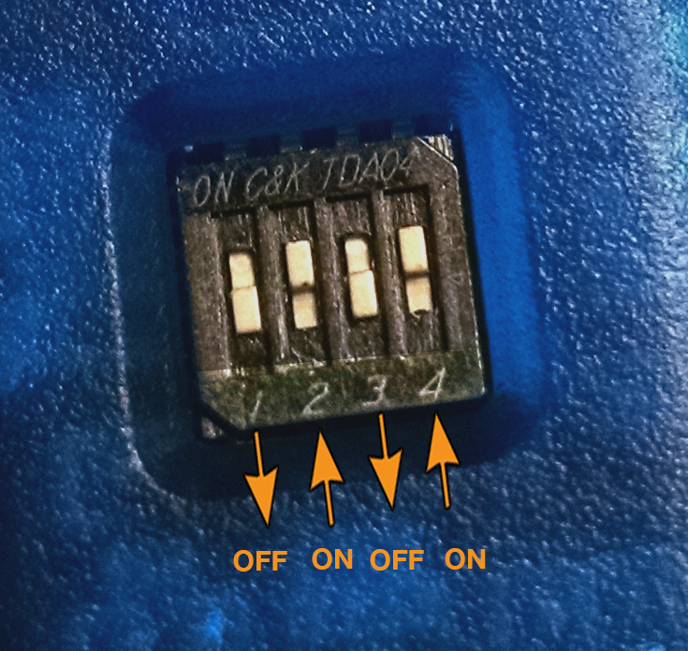

The BlueSnap Adapter has 4 dipswitches that can be turned on (up position) or off (down position) depending upon the desired configuration.
Position the switches as shown above:
1=OFF (Factory Defaults OFF)
2=ON (Auto Discover Mode ON)
3=OFF (Auto Master Mode OFF)
4=ON (Default Baud Rate 9600)

Prepare QuickConnect Barcode creation data
Open the ID data file: “quickconnect_BT_ID.csv.” File should be located in the “BarTender/Batch Files” directory. If you have received this file via download, please copy the file into the correct directory before opening.
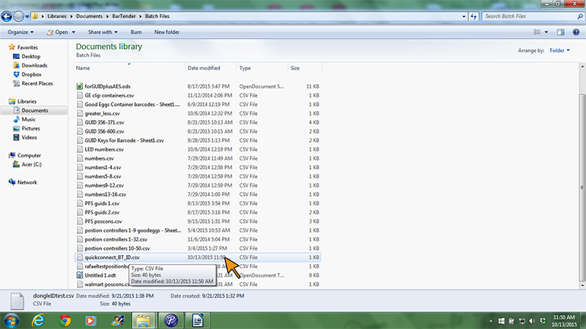

Under the DONGLID heading, enter the last 6 characters of the Bluetooth Dongle, separated by “%” as shown below. Make one entry for every Dongle to be associated.
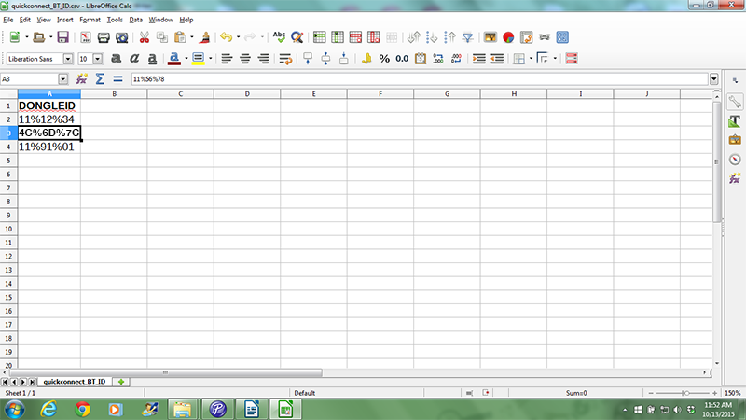
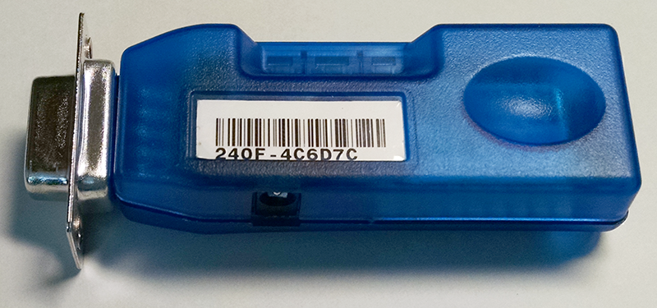

Save and close “quickconnect_BT_ID.csv.” Do NOT rename the file.

Print QuickConnect Barcodes
Open Bartender and select “Open Existing File.”

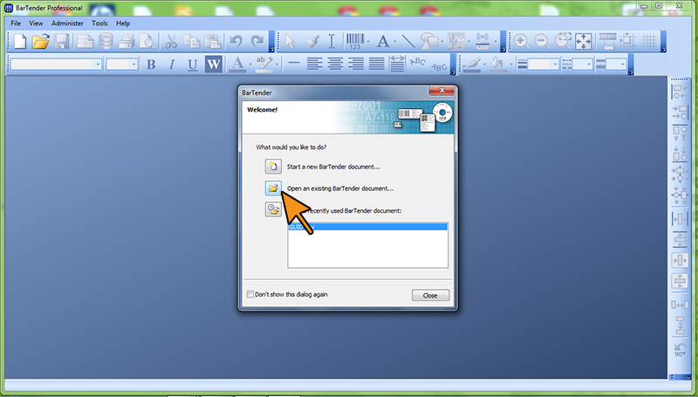

Open the BarTender file: “quickconnect.btw.” File should be located in the “BarTender/BarTender Documents” directory. If you have received this file via download, please copy the file into the correct directory before opening.

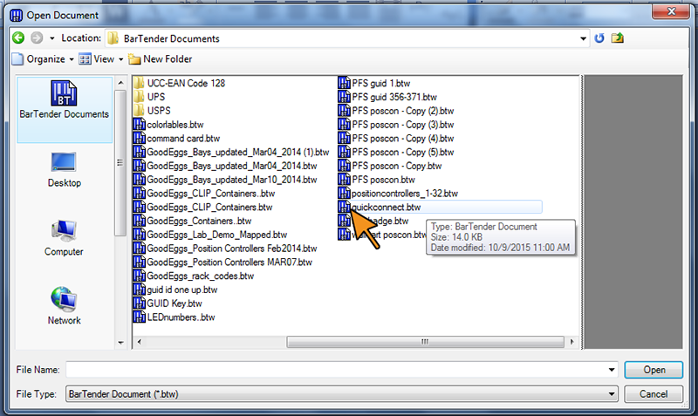

QuickConnect barcode file will open, displaying the first encoded barcode.
NOTE: The BarTender file contains the last current QC encoding. Please check for updates before printing barcodes. QC encoding can be accessed in the barcode creation menu (double click label).

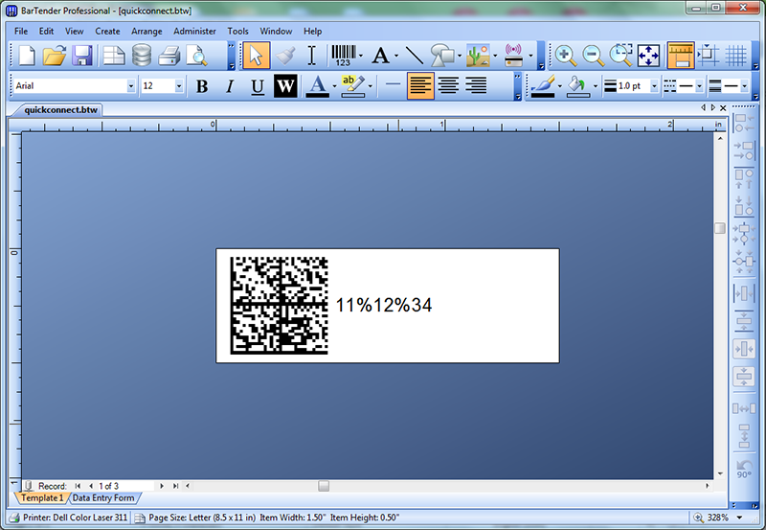

All barcodes created from the IDs input into the .csv data file can be viewed together by selecting “Print Preview.”
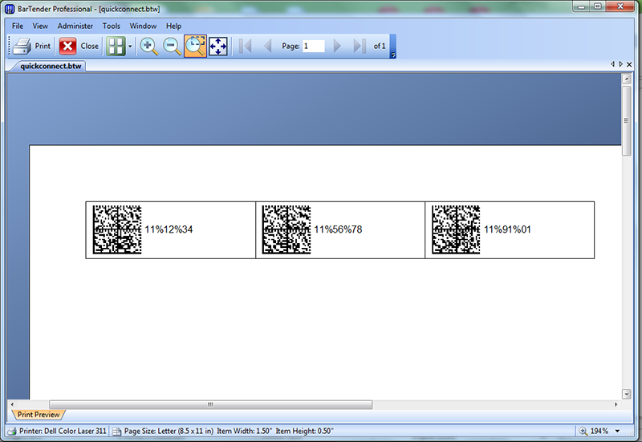

Select “Print” and print to WL-1100LP labels.
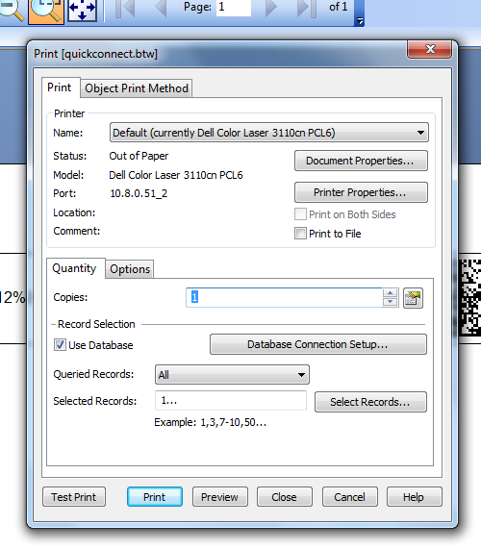

Match QuickConnect label ID to Dongle ID.
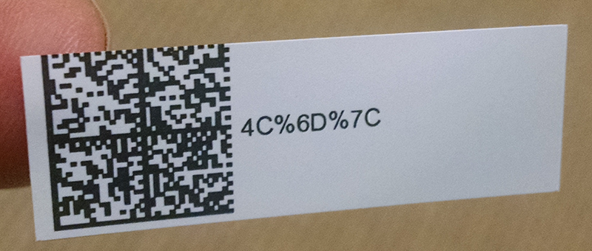

Orient label as shown below. Affix label (will cover the dipswitches).
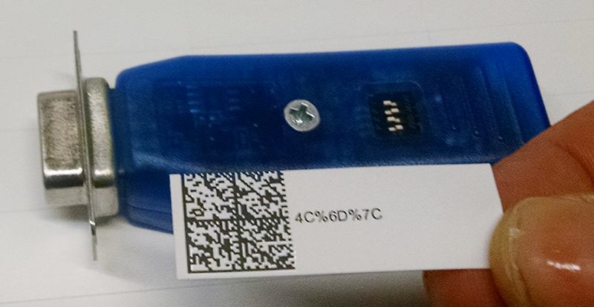
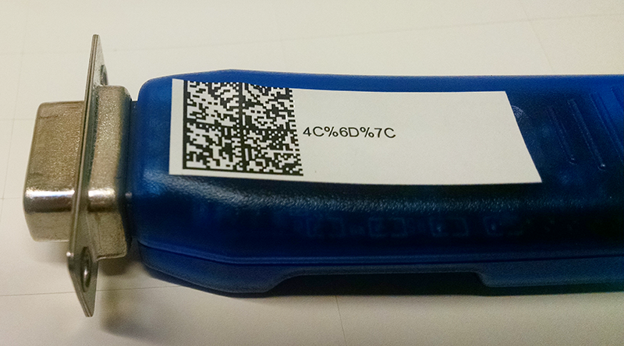

---------------------------------------------------------------------------------------------------------------------------
QuickConnect Barcode encoding (as of this document, check repository for updates): SOH,X,GS,STX,P,A,7,EOT,SOH,X,GS,STX,P,ESC,4,EOT,SOH,X,GS,STX,P,%B2,0,EOT,SOH,X,GS,STX,P,BS,1,EOT,SOH,X,GS,STX,:,BEL,%00%06%66%__%__%__,EOT

