CR3600 Kit Packaging

Items Needed
CR3600 Kit Components(CR36KT)
15x12x4 Shipping Carton
Anti-Static Bubble Bag
GreenWrap
Kraft Paper Sealing Tape"
Packing Label

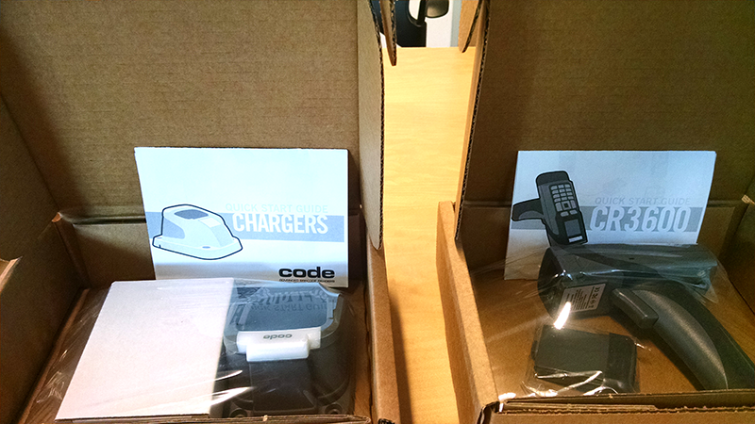
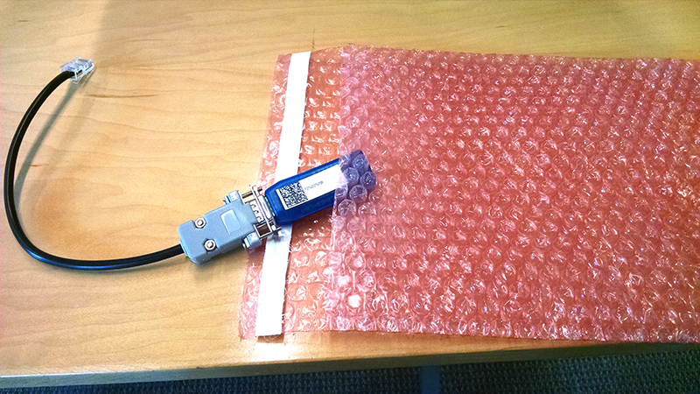
Repack CodeCorp CR3600 Reader with battery and custom JavaScript and Rules in original packaging. Package BlueTooth Serial Dongle with custom cable in bubblewrap envelope.

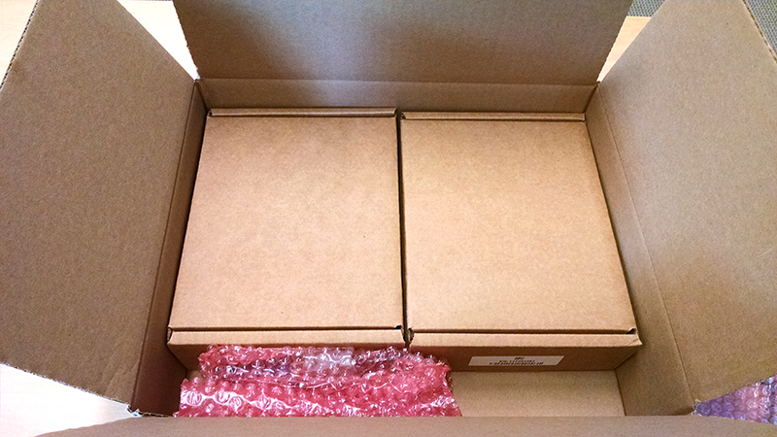
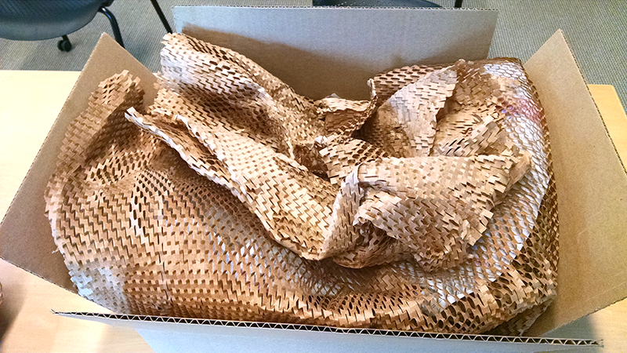

Pack CR3600 Kit into designated carton and fill all voids with Greenwrap.
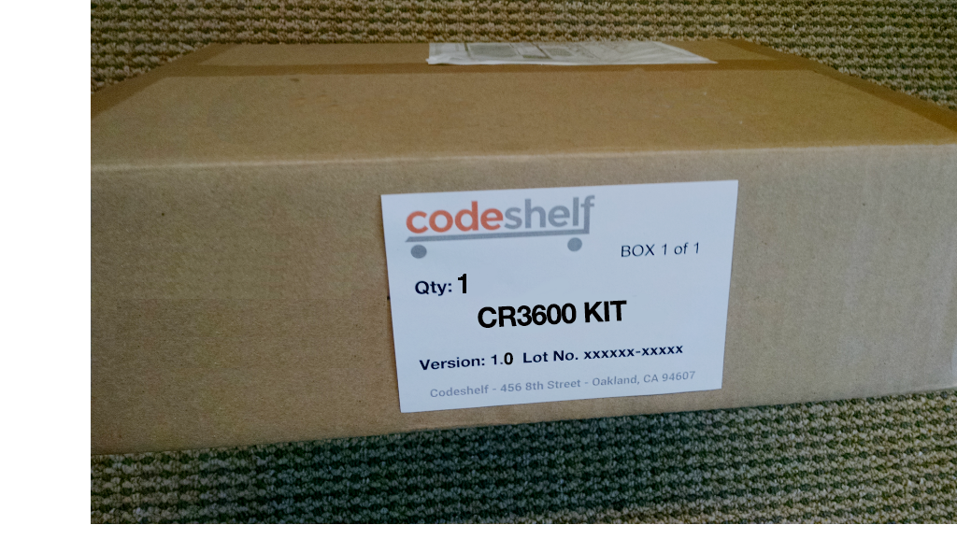
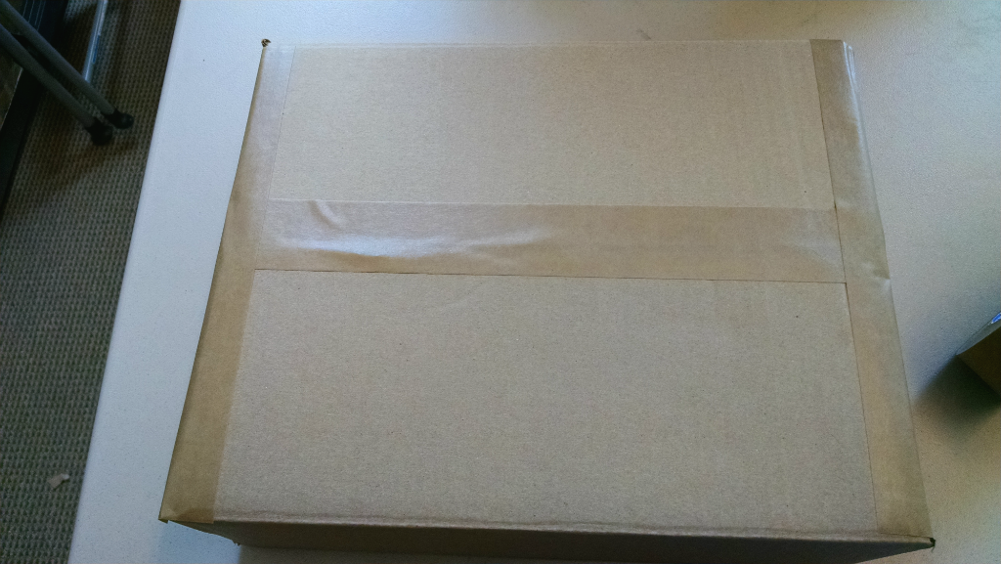

Seal with kraft sealing tape and apply Packing Label. Apply Shipping Label to top as required.

