CR3600 Kit Installation

Items Needed
CR3600 Kit Components (CR36KT)
CR3600 Disconnect Barcode

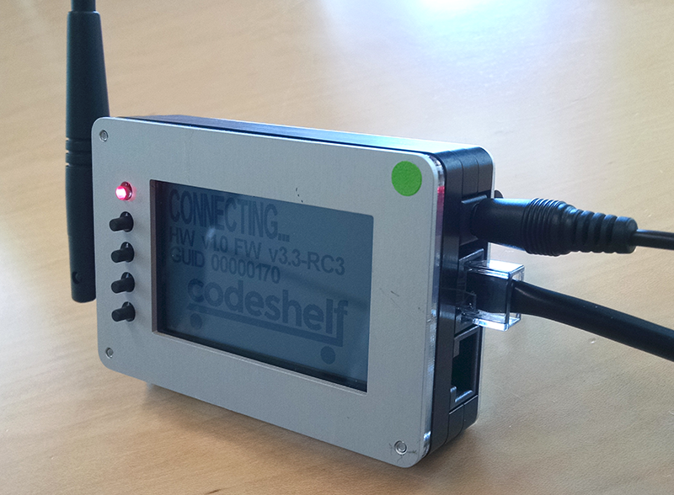
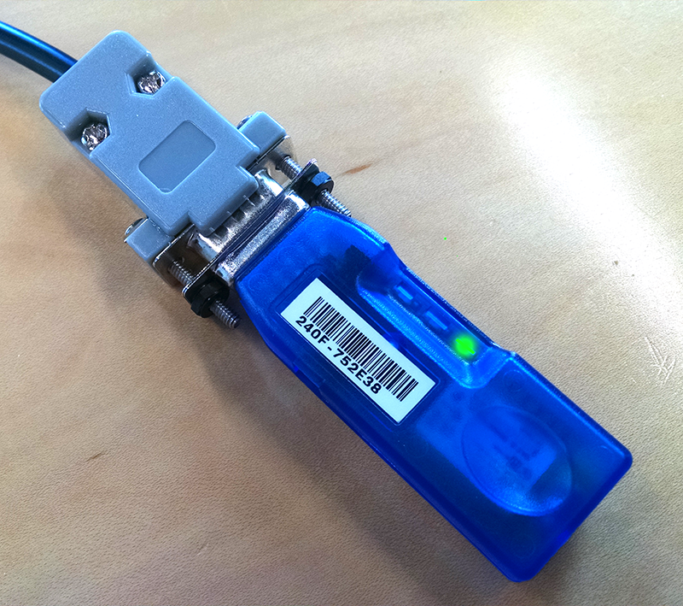

Plug RJ45 end of Dongle to top port on CHECON. Green light will flash on Dongle when successfully connected.

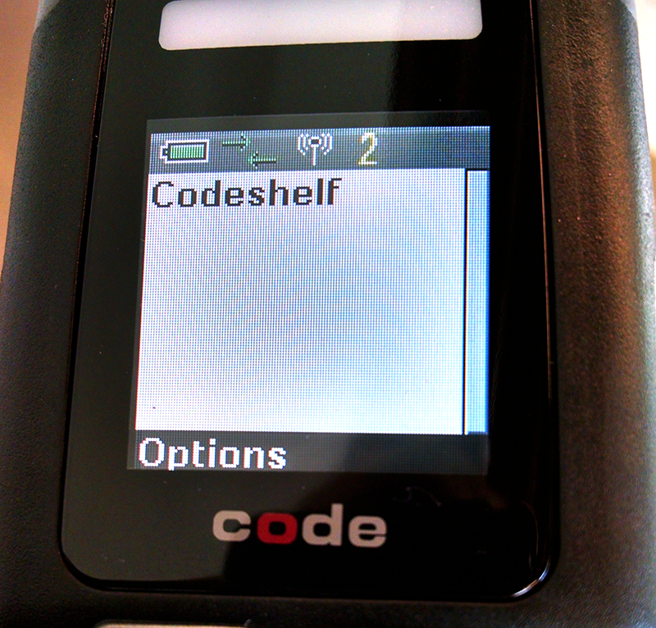

Turn on CR3600 Reader. Scan Scan Unlink Barcode (below), then scan QuickConnect Barcode on BlueTooth Dongle. Green arrows in message bar will animate while Reader attempts to link with BlueTooth Dongle. When linking is successful, 2 beeps will sound, arrows on the Reader will become static and light will show on BlueTooth Dongle as steady green. If the linking is unsuccessful, 5 beeps will sound and arrows will disappear from Reader Screen. Scan Disconnect Barcode below to reset Reader and reattempt link.

