CodeCorp 3600 Barcode Reader Setup

Parts Required
CR3600 Reader
Cradle
CortexTools software. Software is PC only. (Can be downloaded at: http://www.codecorp.com/downloads.php)
Windows PC with USB port
Codeshelf.js (File provided by Codeshelf)
This Configuration Document

Start up
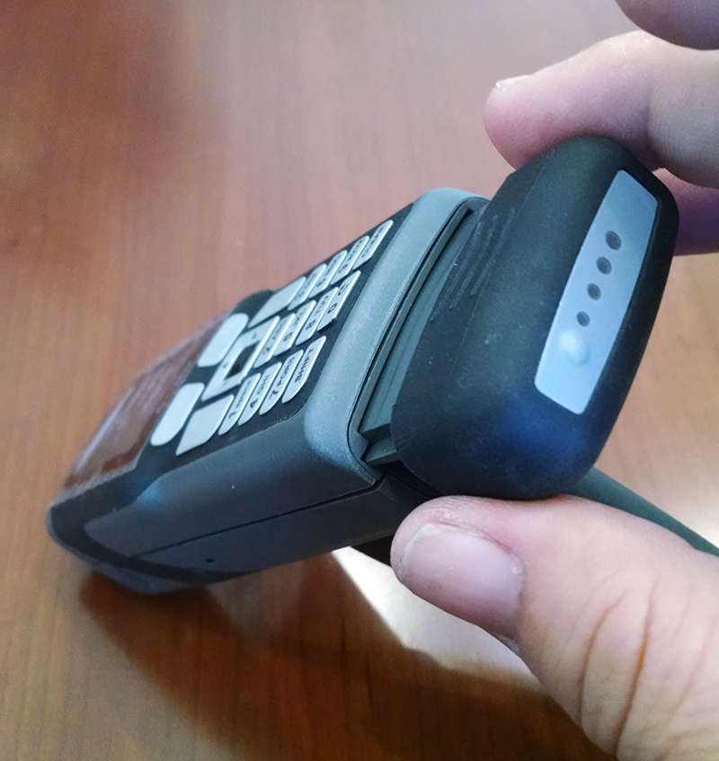
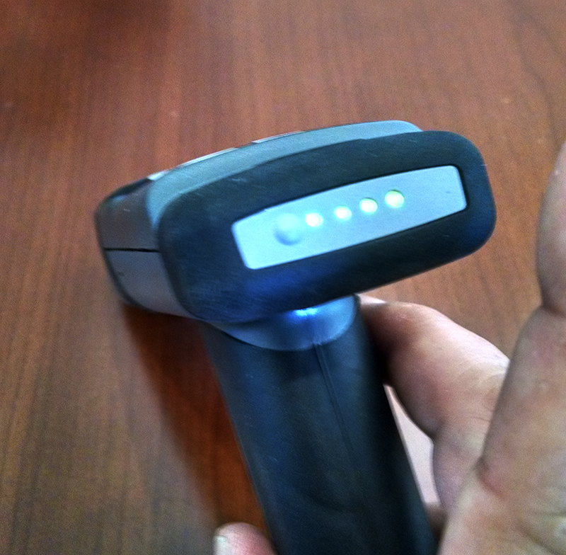

Insert the battery into the reader and press until it's seated firmly. Green lights on the back of the battery will light, depending upon battery charge (1 light for low charge, 4 for high). If no lights appear, swap the battery for one with a charge.

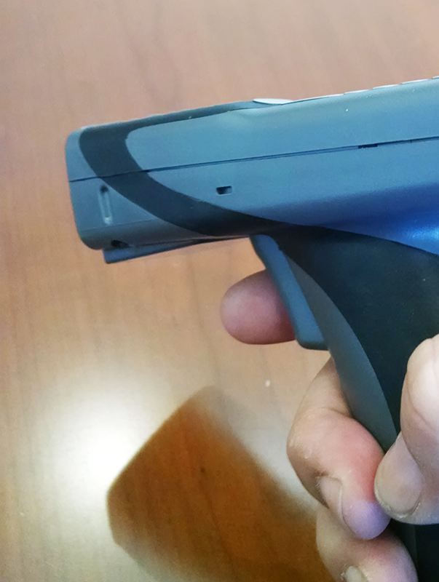
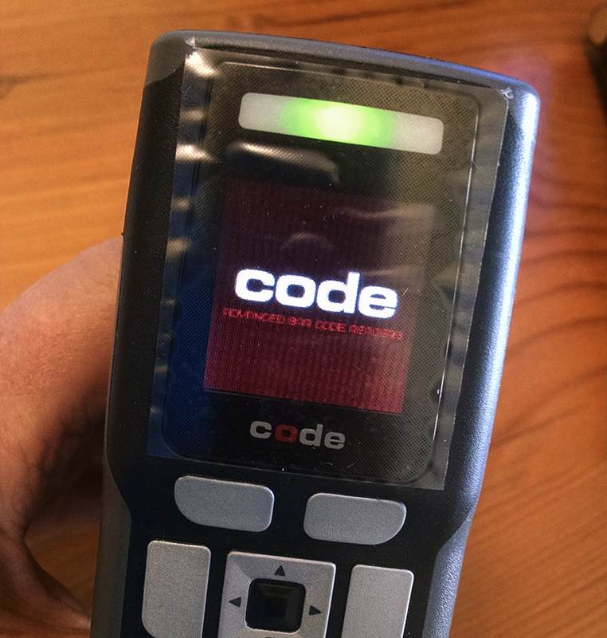

Squeeze the trigger once to power on the reader. Indicator light will first shine red, then green as the reader boots.

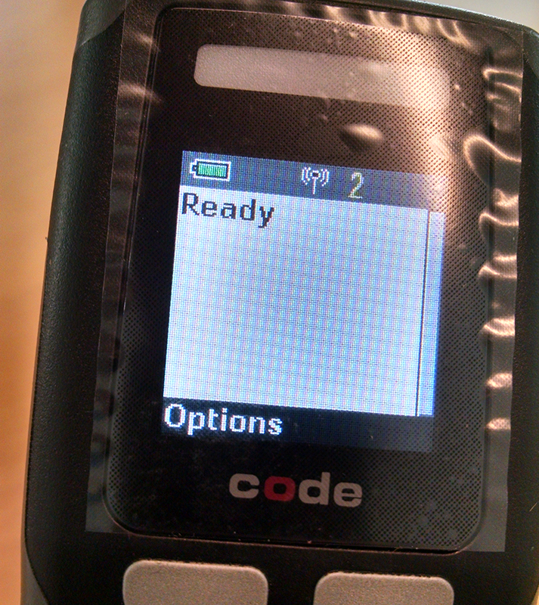
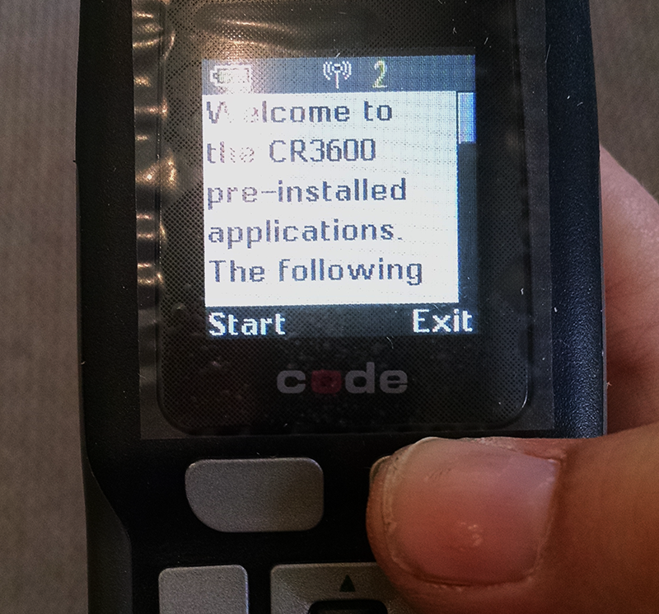

Readers without custom applications will boot to a Welcome Screen. Exit the Welcome Screen by pressing the selection button below the “Exit” menu option. Reader screen will show “Ready.”

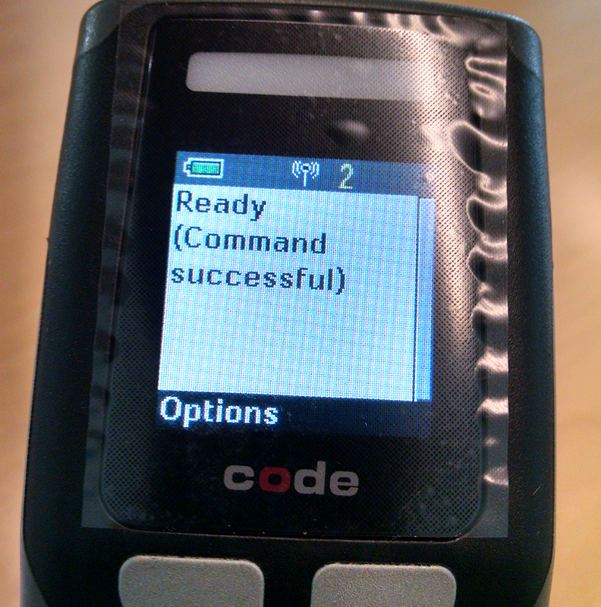

Configuration and Programming

Barcode 1 (Packet Mode)

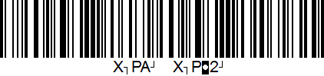
Put reader into Packet Mode by scanning Barcode 1. After successful scan, screen will read “Ready (command successful).”

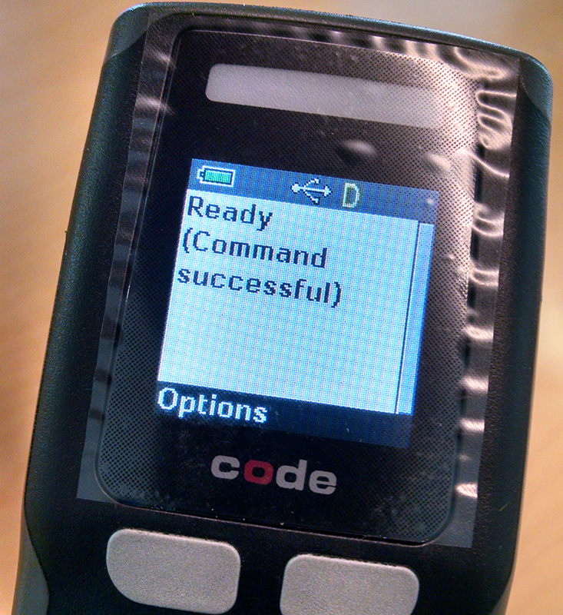
Barcode 2 (USB Download Mode)

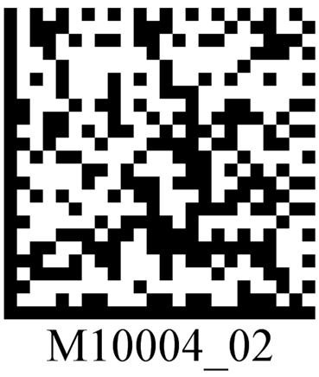

Put reader in USB Download Mode by scanning barcode 2. After successful scan, Communication Mode Display will change to “D” with a USB symbol.

Plug Reader Cradle into PC USB port.

Open CortexTools
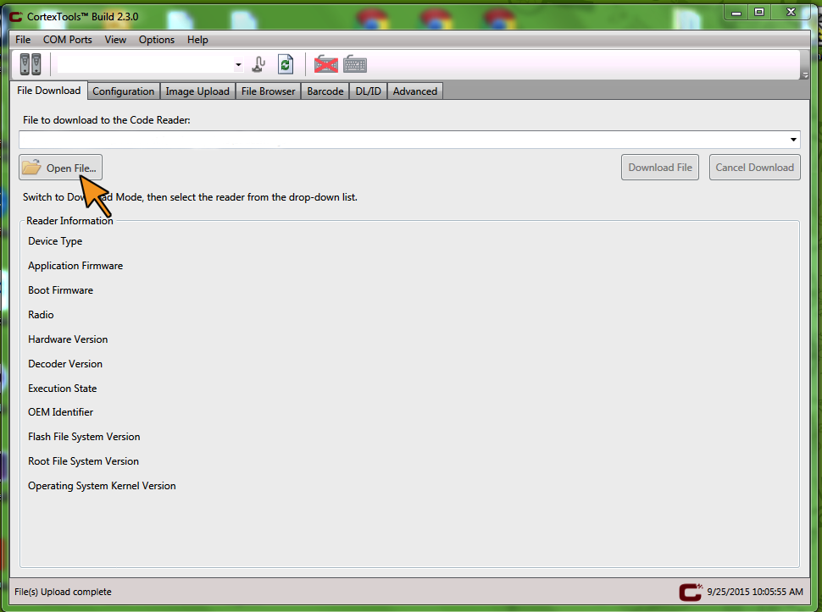

Open the “File Download” tab in the CortexTools window. Click “Open File” and select Codeshelf.js as the “File to download to the Code Reader.”

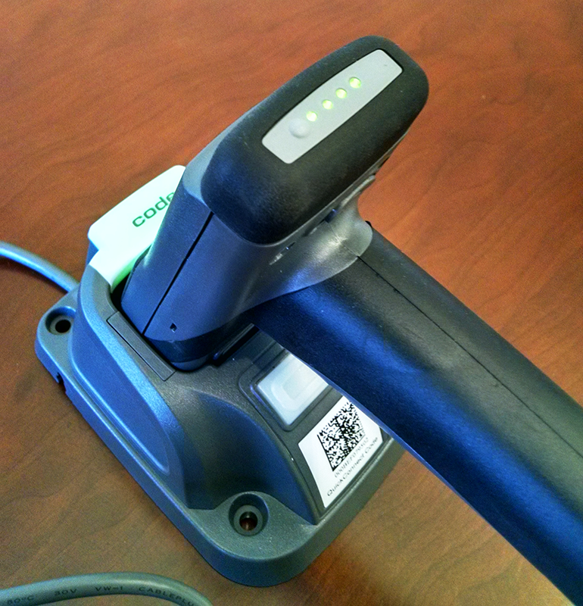

Seat reader into cradle. Green lights will appear on the reader battery and the cradle when successfully connected.

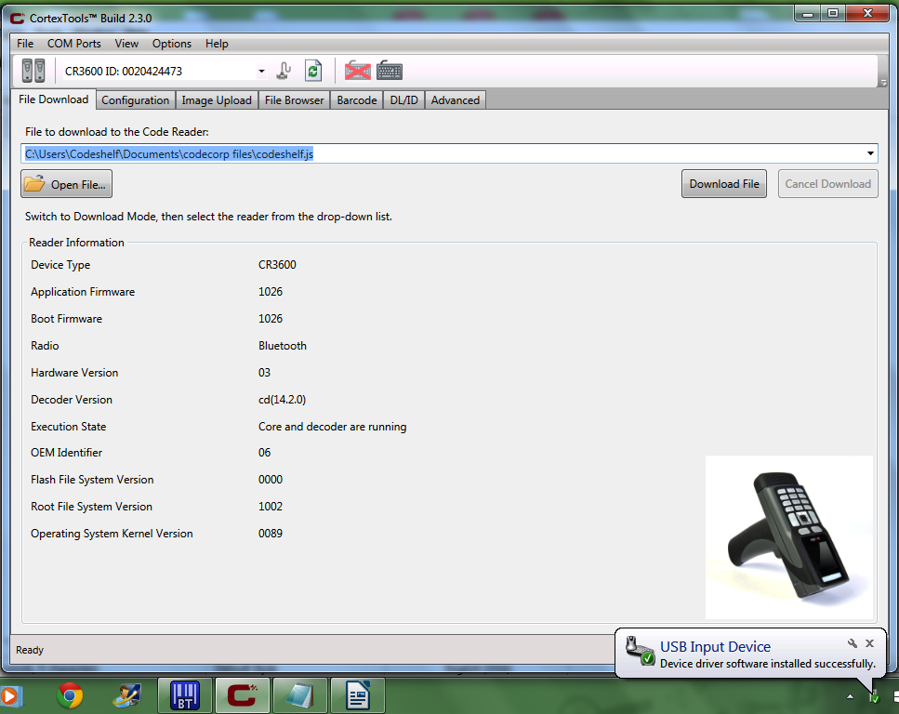

Wait as the reader is recognized as a USB Input Device and associates with CortexTools. When association is complete, the CR3600 ID is shown in the top left corner of the window, and an image of the reader will appear in the bottom right corner.

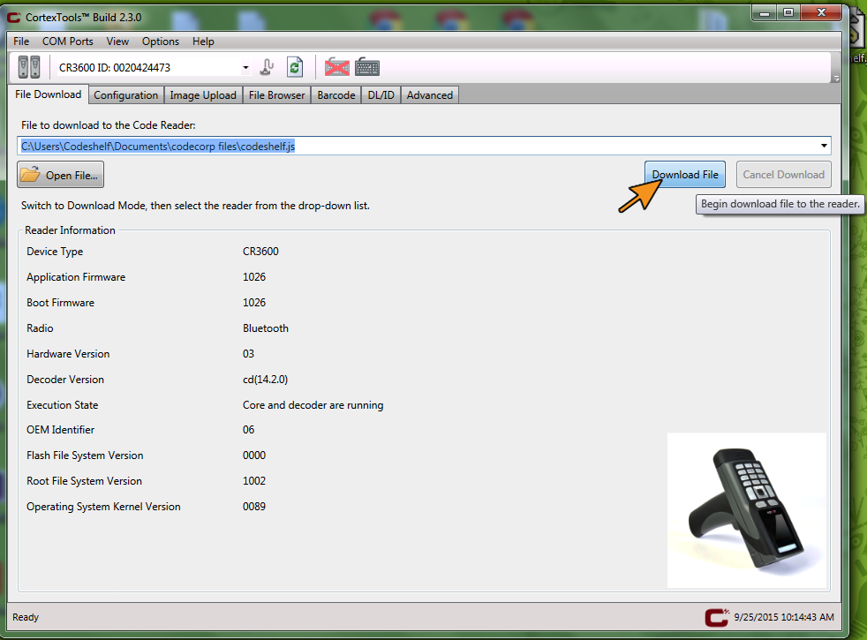

Verify that Codeshelf.js is listed as the file to download to the reader and then click the “Download” button.
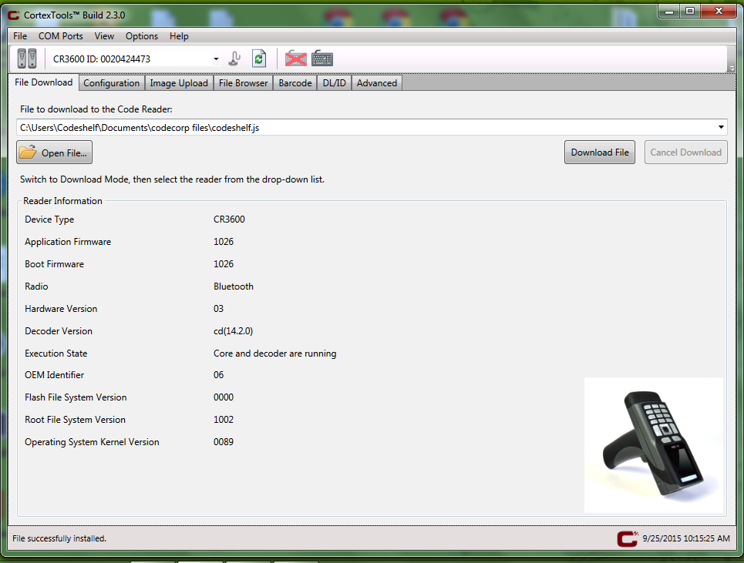

When download has completed, remove reader from cradle.

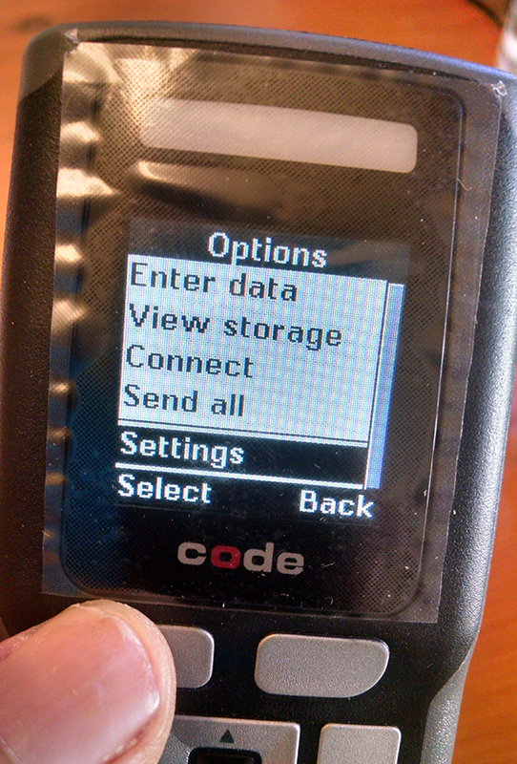
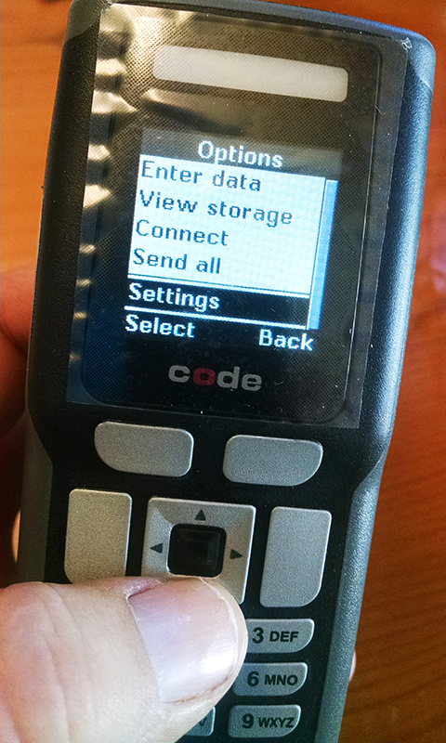
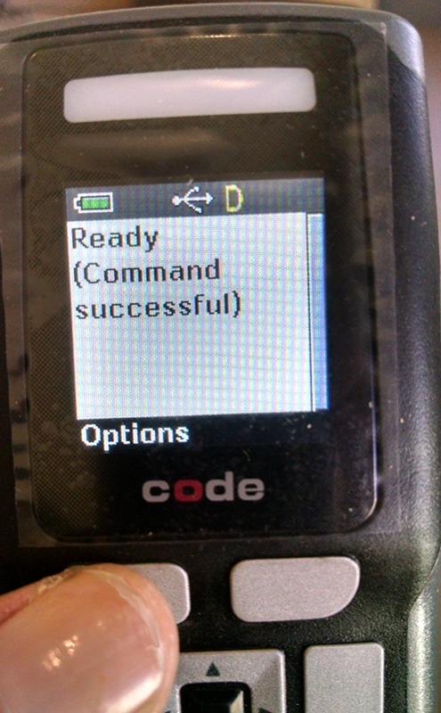

Select Options. Select “Settings.”
Navigate the Options Menu by using the “Down” arrow on the reader keypad.

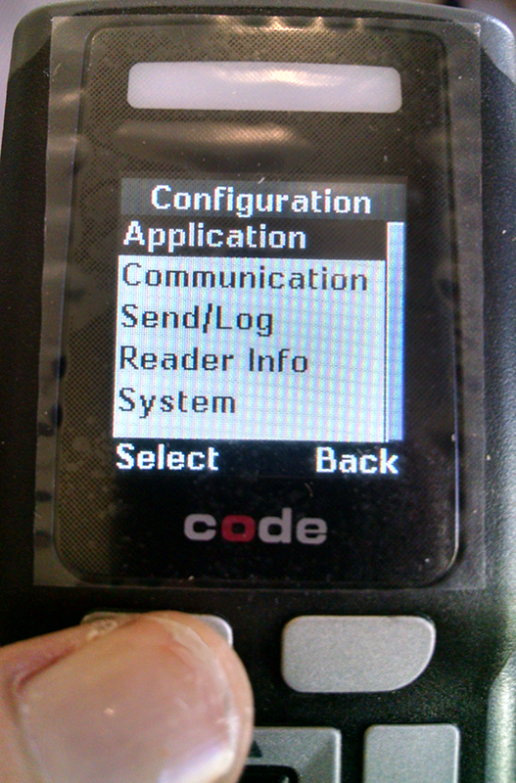
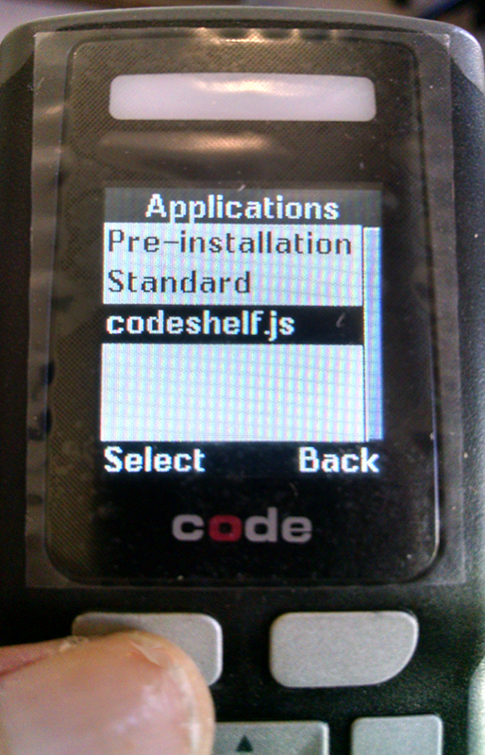
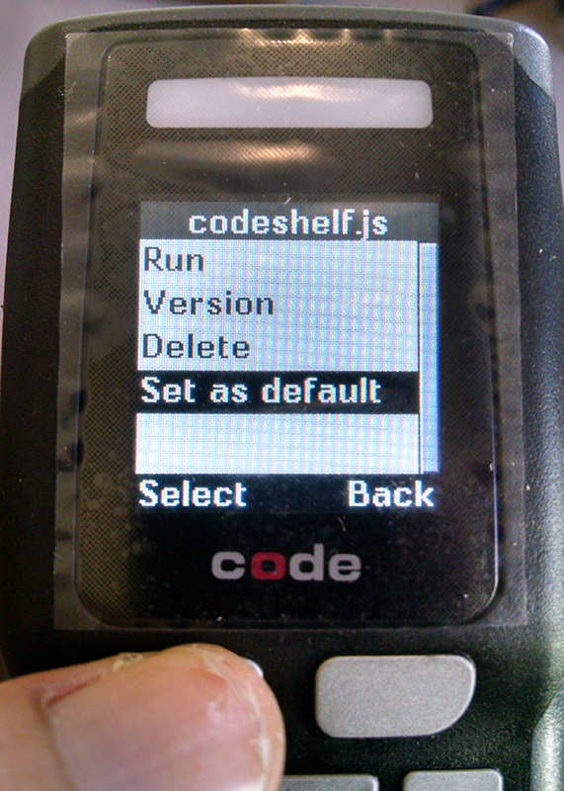

Select “Application.” Select “Codeshelf.js” Select “Set as Default.”

Barcode 4 (Save Settings)
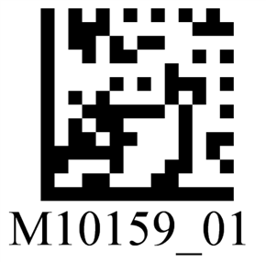
Barcode 3 (Text Mode)

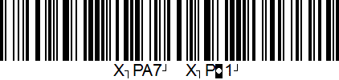
Put reader into text mode by scanning Barcode 3 Save reader settings by scanning Barcode 4

Barcode 5 (Final Rules) – Get latest version of Rules Barcode (codeshelf-rules.tif.)

DO NOT

Add final rules settings to the reader by scanning Barcode 5: codeshelf-rules.tif.

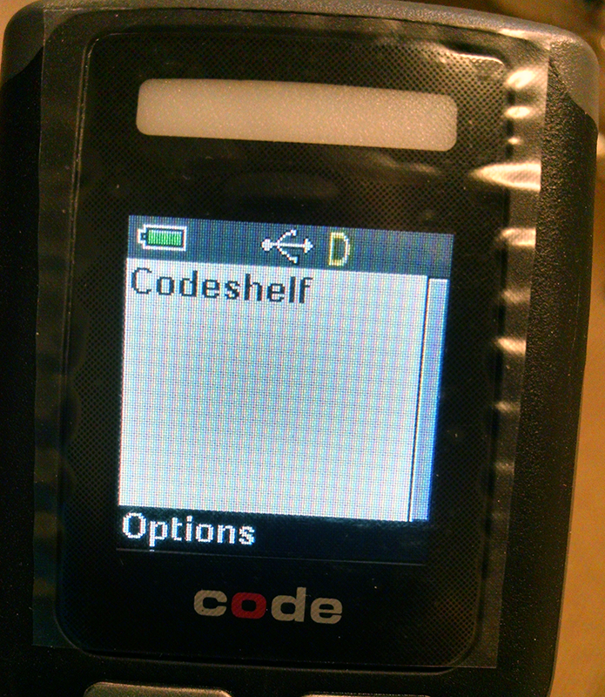

Restart the reader by removing and re-inserting the battery and then pressing the trigger. “Codeshelf” should be displayed on the screen.

