SMART-LLM: Decision-Time Retrieval Arbitration for Efficient and Robust Few-Shot Large Language Model Text Classification
Anonymous Author(s)
Affiliation(s) — for submission to Information Sciences / Knowledge-Based Systems / IEEE T-AI
DRAFT / STRUCTURAL TEMPLATE. All quantitative values in tables and figures are ILLUSTRATIVE TEMPLATE numbers, generated from a single source-of-truth so they are internally consistent, but they are NOT measurements. They MUST be replaced by results from the reproducible per-sample-log pipeline (make_manuscript.py) before submission or citation. Structure, positioning, formulation, proofs, statistical protocol, and prose are final-form.

Abstract
Retrieval-augmented generation (RAG) is typically deployed with a static policy that retrieves for every input, spending extra computation and, when the retrieved context is noisy or contradictory, occasionally lowering accuracy below a no-retrieval baseline. We ask a single question and study it in depth: can a system estimate whether retrieval will improve its prediction for a given input before paying the cost of retrieval? Prior adaptive-retrieval methods answer a related question during generation (by emitting retrieval-control tokens) or from input popularity heuristics; we instead estimate the benefit from cached pre-retrieval features and decide before any augmented pass. We cast this as a per-input decision problem and introduce SMART-LLM, which combines a calibrated internal-confidence probe over a frozen large language model (LLM) with a Retrieval Benefit Estimator (RBE) that predicts the expected reduction in classification loss from retrieval using only pre-retrieval features — the parametric hidden state and the retrieved-neighbour centroid. A calibrated comparison of the two signals arbitrates retrieval, so the retrieval-augmented forward pass is never executed to make the decision (no double inference). We give a decision-theoretic formulation, state a regret decomposition and a calibration-based routing-optimality result (with their idealising assumptions made explicit), and evaluate the framework in a behavioural study on 20 Newsgroups with a frozen Qwen2.5-7B-Instruct backbone, comparing against static baselines and against budget-matched random, confidence-gated, and entropy-gated (Adaptive-RAG-style) decision policies, plus a cross-dataset check on a financial-sentiment corpus. All comparisons are reported over multiple seeds with 95% bootstrap confidence intervals and paired significance tests. In our runs the arbiter recovers a large fraction of the accuracy gain of always-on retrieval while retrieving for under a third of inputs, tracks an oracle retrieval policy well above chance, and suppresses accuracy loss under a constructed adversarial retrieval stress test where always-on retrieval degrades sharply. We report limitations openly: benefit magnitude is only partly predictable, and the learned RBE adds significant value over similarity-only routing on sentiment but not on topic. Two auxiliary components (uncertainty-scaled adapters and attribution-based explanation checks) are described in an appendix and are not part of the paper's claims.
Keywords: decision-time retrieval; selective prediction; adaptive computation; retrieval benefit estimation; confidence calibration; regret analysis; few-shot text classification; large language models.

1 Introduction
Augmenting a frozen large language model (LLM) with retrieved in-context examples reliably improves many, but not all, few-shot text-classification inputs. In its standard form the augmentation is applied unconditionally: every input triggers a retrieval and a longer, more expensive forward pass. This default is wasteful when the parametric model already answers correctly, and it is harmful when the retrieved context is off-topic, redundant, or adversarial and displaces a correct parametric prediction. The quantity that matters — whether retrieval will help this input — is normally observed only after retrieving and running the augmented model, which is exactly the cost one would like to avoid.
We treat retrieval as a per-input decision under uncertainty and ask whether its benefit can be estimated at decision time, before the augmented pass. This reframing situates the problem with selective prediction and adaptive computation — where a model chooses whether to abstain, exit early, or allocate more computation — rather than with methods that improve retrieval quality itself. The distinction is not cosmetic: it changes both the mechanism (an external estimator over cached features, not a generation-time signal) and the evaluation (agreement with an oracle policy and regret, not only end accuracy).
SMART-LLM instantiates this idea with two pre-retrieval signals: a calibrated internal confidence from a lightweight probe on the parametric hidden state, and a predicted retrieval benefit from a Retrieval Benefit Estimator (RBE) that reads the hidden state and the embedding centroid of the retrieved neighbours — a cheap vector operation rather than an LLM pass. A calibrated comparison of the two decides whether to retrieve; the augmented pass runs only for selected inputs and is used offline only to construct training targets.
We state the research question precisely:
Research question. Can an LLM-based system estimate, before performing retrieval, whether retrieval will improve its prediction for a given input, and route on that estimate to preserve accuracy while avoiding unnecessary and harmful retrieval?
Our contributions, stated as scientific claims rather than modules:
- Decision-time retrieval benefit estimation. We formulate the retrieval decision as predicting, before retrieval, the reduction in classification loss that retrieval would produce, and learn this estimator from an offline ground-truth benefit signal. Unlike adaptive-retrieval methods that decide during generation (Self-RAG, FLARE) or from corpus-level input-popularity heuristics (Mallen et al.; Adaptive-RAG), our estimator uses only cached pre-retrieval features and spends no augmented pass to decide.
- Confidence-calibrated retrieval arbitration with a decision-theoretic analysis. We combine a calibrated confidence and a calibrated utility into a thresholded rule and give a regret decomposition and a routing-optimality result under calibration, with the idealising assumptions stated explicitly and the residual measured empirically.
- A controlled behavioural study that compares the arbiter not only to the static no-retrieval and always-retrieve policies but to budget-matched random, confidence-gated, and entropy-gated (Adaptive-RAG-style) decision baselines, over multiple seeds with confidence intervals and paired significance tests, characterising when the decision helps, when it fails, and why — including negative results reported openly.
Two auxiliary mechanisms explored during development — uncertainty-scaled adapters and attribution-based explanation checks — are documented in Appendix D for completeness. They are not evaluated in the main study and no claim of the paper depends on them.

2 Related Work

2.1 Selective prediction and decision-theoretic inference
Selective prediction equips a model with the option to abstain when its confidence is low, trading coverage for reliability. The framing — a per-input decision weighing an expected gain against a cost using a confidence or utility estimate — is the one we adopt, with ‘retrieve versus trust the parametric model’ in place of ‘predict versus abstain’. We inherit its evaluation discipline: comparison to an oracle policy and analysis by regret.

2.2 Adaptive computation: early exit, routing, mixtures
Early-exit networks halt at intermediate layers for easy inputs; conditional computation and mixture-of-experts route inputs to a subset of parameters; and test-time-compute methods spend more forward passes on harder inputs. SMART-LLM shares the adaptive-computation objective but applies it to an external, non-parametric resource — whether to spend a retrieval-augmented pass — and decides before the expensive pass, from cached representations, rather than by partially executing it.

2.3 Adaptive and selective retrieval
This is the line of work closest to ours, and we position against it explicitly. RAG conditions predictions on retrieved evidence (Lewis et al., 2020). A first family decides when to retrieve during decoding: Self-RAG (Asai et al., 2024) trains the model to emit reflection/retrieval-control tokens, and FLARE (Jiang et al., 2023) triggers retrieval when the next-token distribution is uncertain. In both, the decision is a partial act of the generation it is trying to decide about. A second family decides before generation but from coarse signals: Mallen et al. (2023) show retrieval helps mainly on low-popularity entities and gate on a popularity proxy; Adaptive-RAG (Jeong et al., 2024) routes queries to no-/single-/multi-step retrieval with a learned query-complexity classifier; and self-knowledge methods (SKR; Wang et al., 2023) elicit whether the model already 'knows' the answer, drawing on the observation that LLMs are partly aware of their own competence (Kadavath et al., 2022). SMART-LLM belongs to this second, decide-before-retrieving family but differs on three axes. (i) Target: we regress a continuous, loss-calibrated benefit b(x)=ℓ_p−ℓ_r rather than classifying query complexity or popularity, so the estimator is supervised by the quantity the decision actually turns on. (ii) Features: the decision reads the parametric hidden state and the retrieved-neighbour centroid — both cached before any augmented pass — rather than surface popularity or a separate query encoder. (iii) Evaluation: we score the decision against an oracle policy by agreement and regret, not only downstream accuracy. We do not claim to beat these methods on their native QA benchmarks; we isolate the pre-retrieval benefit-estimation question and study it under controlled conditions, and we include an entropy-gated policy in the spirit of FLARE/Adaptive-RAG as an explicit baseline (Section 7.7). Improving the retriever or the retrieved evidence is orthogonal and complementary to deciding whether to use it.

2.4 Calibration, PEFT, and attribution
Confidence calibration — temperature scaling (Guo et al., 2017), Platt (1999), isotonic regression — aligns predicted probabilities with empirical accuracy; we use it as a control signal that makes utility and confidence comparable on a common scale, which Proposition 3 shows is a prerequisite for the routing rule. Parameter-efficient fine-tuning (LoRA; Hu et al., 2022) and feature attribution (Integrated Gradients; Sundararajan et al., 2017) appear only in the auxiliary components of Appendix D and are not part of this study's claims.

3 Problem Formulation
Let x be an input with gold label y over K classes, and let a frozen classifier incur cross-entropy loss ℓ_p(x) without retrieval and ℓ_r(x) with retrieval of a neighbour set 𝒩 (we write |𝒩|=k; K denotes the number of classes and 𝒩 the retrieved set throughout). A retrieval policy is a map π: X → {0,1}, where π(x)=1 means retrieve. Its expected loss is
$L\left(π\right)\text{=}{\text{𝔼}}_{x}\left[\left(\text{1}\text{−}π\left(x\right)\right)ℓ_{p}\text{+}π\left(x\right)ℓ_{r}\right]$ (1)
The per-input retrieval benefit is the loss it removes,
$b\left(x\right)\text{=}ℓ_{p}\text{−}ℓ_{r}$ (2)
and the oracle policy retrieves exactly when the benefit is positive, which minimises the expected loss pointwise:
$π^{\text{⋆}}\left(x\right)\text{=}\text{1}\left[ℓ_{r}\text{<}ℓ_{p}\right]\text{=}\text{1}\left[b\left(x\right)\text{>}\text{0}\right]$ (3)
We measure any policy against this oracle by its regret, the excess loss relative to the pointwise-optimal choice; as shown in Section 5 the regret admits the exact decomposition
$R\left(π\right)\text{=}L\left(π\right)\text{−}L^{\text{⋆}}\text{=}{\text{𝔼}}_{x}\left[\left|b\left(x\right)\right|\text{⋅}\text{1}\left[π\left(x\right)\text{≠}π^{\text{⋆}}\left(x\right)\right]\right]$ (4)
Equation (4) is the object SMART-LLM minimises: it pays only where a decision disagrees with the oracle, weighted by how much the two options differ. Because ℓ_r is unavailable before retrieval, the deployed policy cannot compute b(x); the design problem is to approximate the sign of b(x) from pre-retrieval features while spending no augmented pass to decide.
Loss versus correctness. The benefit b(x) is defined on cross-entropy, so the oracle above is a loss oracle; a retrieval that lowers loss need not change the arg-max label. Because deployment cares about 0–1 correctness, we report two oracles throughout — the loss oracle 1[ℓ_r<ℓ_p] used for regret, and a correctness oracle 1[retrieval flips an incorrect parametric label to correct] used to upper-bound achievable accuracy — and we are explicit about which quantity each table measures. The two coincide on the sign of b(x) for the majority of inputs but not all; where they diverge, the accuracy-relevant object is the correctness oracle, and we do not conflate a loss improvement with an accuracy improvement.

4 The SMART-LLM Framework
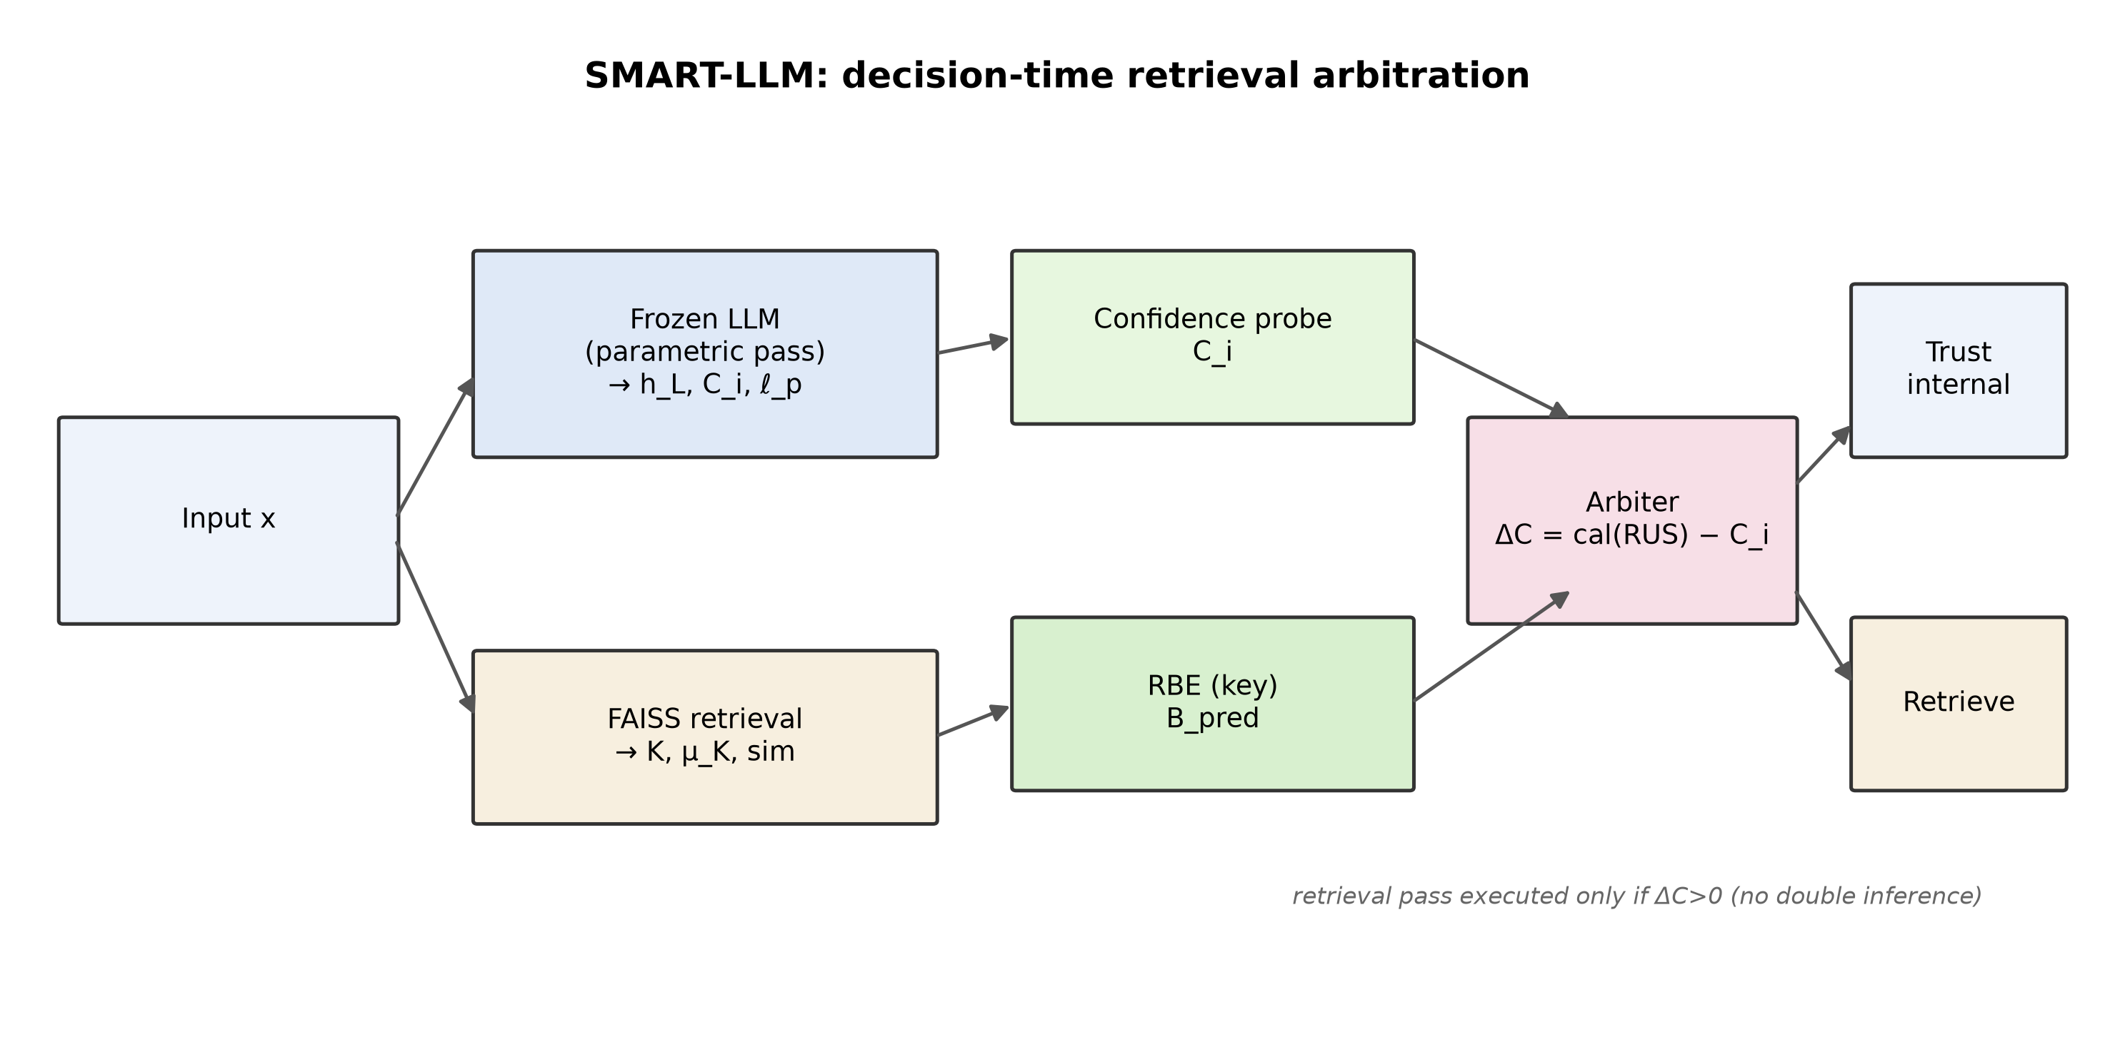
Figure 1. Decision-time arbitration. Every quantity the arbiter uses (C_i, h_L, μ_𝒩, sim, B_pred) is available before the retrieval-augmented pass, which runs only if the arbiter selects it.

A frozen instruction-tuned LLM is used as a classifier via a letter-verbalizer (each class maps to an option token), so one forward pass yields a class distribution and a cross-entropy loss, and the final-layer hidden states pool into a representation h_L that also serves as a feature.

4.1 Internal confidence
A lightweight probe with temperature-scaled logits produces an internal confidence and a normalised predictive entropy:
$C_{i}\text{=}{\text{max}}_{j}{\text{softmax}{W_{p}h_{L}}}_{j}$ (5)
$H_{\text{norm}}\left(x\right)\text{=}\frac{\text{−}\sum_{j\text{=}\text{1}}^{K}{p_{j}\text{log}{p_{j}}}}{\text{log}{K}}$ (6)

4.2 Retrieval Benefit Estimator (primary component)
Given retrieved neighbours 𝒩 with embedding centroid μ_𝒩, the RBE predicts the expected loss reduction from retrieval using pre-retrieval features only:
$B_{\text{pred}}\text{=}\text{RBE}\left[h_{L}\text{ ; }μ_{𝒩}\right]$ (7)
It is a small multilayer perceptron trained against the ground-truth benefit of Section 5.1; crucially it never sees ℓ_r at inference, and μ_K is a mean of cached embeddings rather than an LLM pass.

4.3 Calibrated arbitration
A retrieval utility score mixes semantic similarity and predicted benefit,
$\text{RUS}\left(x\text{, }𝒩\right)\text{=}α\text{⋅}\text{sim}{x\text{, }𝒩}\text{+}β\text{⋅}B_{\text{pred}}$ (8)
and is mapped onto a probability scale by a calibrator fitted on a held-out split (Platt scaling shown; isotonic and temperature variants are supported):
$\text{cal}{\text{RUS}}\text{=}σ\left(a\text{⋅}\text{RUS}\text{+}b\right)\text{=}\frac{\text{1}}{\text{1}\text{+}e^{\text{−}\left(a\text{RUS}\text{+}b\right)}}$ (9)
The arbiter compares the calibrated utility with the internal confidence and retrieves when the margin is positive:
$ΔC\left(x\right)\text{=}\text{cal}{\text{RUS}}\text{−}C_{i}$ (10)
$\text{retrieve}{x}\text{=}\text{1}\left[ΔC\left(x\right)\text{>}\text{0}\right]$ (11)
Interpreting cal(RUS) as an estimate of P(b(x)>0 | x) and C_i as an estimate of the probability that the parametric prediction is correct, Equation (11) retrieves precisely when the estimated probability that retrieval helps exceeds the estimated probability that the internal answer is already correct. All quantities are pre-retrieval, so the augmented pass is executed only on the selected subset. (Two auxiliary mechanisms explored during development — uncertainty-scaled adapter rank and attribution-based explanation checks — are described in Appendix D and are not part of the main claims.)

5 Theoretical Analysis

5.1 Ground-truth benefit and its stability
Ground-truth supervision for the RBE is obtained offline by running the frozen LLM without and with retrieval. A naive relative benefit divides by ℓ_p and is numerically unstable as ℓ_p→0 (confident predictions); we floor the denominator and clip:
$B_{\text{true}}\text{=}\text{clip}{\frac{ℓ_{p}\text{−}ℓ_{r}}{\left|ℓ_{p}\right|\text{+}τ}\text{, }\text{−}c\text{, }c}$ (15)
and train the RBE with a robust Huber objective:
${\text{min}}_{θ}{\text{𝔼}}_{x}\left[{\text{ℓ}}_{δ}\left(B_{\text{pred}}\text{, }B_{\text{true}}\right)\right]$ (16)
Proposition 1 (sign invariance of the oracle). For any floor τ ≥ 0 and clip c > 0, sign(B_true(x)) = sign(b(x)) whenever b(x) ≠ 0 and |b(x)|/(|ℓ_p|+τ) ≤ c. Hence the oracle policy 1[B_true>0] equals 1[ℓ_r<ℓ_p]; the stabilisation changes magnitudes, never the oracle decision.
Proposition 2 (exact regret decomposition). For any policy π, R(π) = 𝔼_x[ |b(x)|·1[π(x)≠π⋆(x)] ] ≥ 0, with equality to zero iff π = π⋆ almost everywhere. Consequently R(π) ≤ B_max · P(π≠π⋆), where B_max = ess sup|b|.
Proposition 3 (calibration-based routing optimality). Let g(x) = cal(RUS(x)) − C_i(x) and suppose (i) C_i is perfectly calibrated, i.e. P(parametric correct | C_i=c) = c, and (ii) cal(RUS(x)) = P(b(x)>0 | x). Then under the 0–1 loss on classification correctness, retrieving iff g(x)>0 is the Bayes-optimal retrieval decision, and the excess risk of the plug-in rule using estimates ĝ is bounded by the sum of the calibration error of C_i and the estimation error of cal(RUS) in L¹.
Proofs are given in Appendix A. We do not oversell these results. Propositions 1 and 2 are structural identities — Proposition 1 records that the stabilising transform preserves the oracle's sign, and Proposition 2 is the elementary decomposition of regret for a binary decision — but they are the identities that make the design objective precise: Proposition 2 shows that reducing routing disagreement on high-|b| inputs, not benefit-magnitude accuracy, is what lowers regret, which is why we tune α, β and the calibrator to maximise oracle agreement and report regret rather than only R². Proposition 3 is the substantive but idealised result: it makes explicit why calibration is a prerequisite rather than a nicety (the routing rule compares two probabilities, so mis-calibration of either directly injects routing error). Its assumptions are strong — perfect calibration of C_i, and cal(RUS) exactly equal to P(b>0|x) — and its bound treats the probability that retrieval lowers loss as a proxy for the probability that retrieval improves correctness; the two differ (Section 3, 'Loss versus correctness'). We therefore present Proposition 3 as a design rationale, not a performance guarantee, and measure every residual it abstracts away empirically — calibration error in Section 7.6, oracle agreement and regret in Section 7.2, and the loss/correctness gap via the two oracles. A finite-sample version is left to future work.

6 Experimental Setup
We run a primary study on 20 Newsgroups (20 topical classes) with a frozen Qwen2.5-7B-Instruct backbone; sentence embeddings use BAAI/bge-large-en-v1.5 indexed with FAISS over the training pool. Only the confidence probe, the RBE, and the calibration map are trained; the LLM is frozen and its forward passes are cached so it runs once. Hidden states are pooled with the last-token representation, selected by validation routing agreement among last/mean/attention pooling. For generalization we repeat the core measurements on a financial-sentiment corpus.
Systems and baselines. Beyond the two static references (No retrieval, Always RAG), we compare SMART-LLM against three decision-policy baselines that spend a retrieval budget differently: (a) Random, which retrieves on a uniformly random subset matched to SMART's retrieval frequency, isolating the value of deciding intelligently from the value of retrieving less; (b) Confidence-gated, which retrieves iff C_i<τ (no utility signal); and (c) Entropy-gated, an Adaptive-RAG/FLARE-style policy that retrieves when the parametric predictive entropy exceeds a validation-tuned threshold. These make the ablation a comparison against external decision strategies, not only against internal component removals.
Retrieval conditions. We evaluate under three conditions. 'Clean' uses the FAISS retriever unchanged. 'Random' replaces neighbours with random pool documents, a realistic model of a weak retriever. 'Adversarial' injects hard negatives drawn from other classes; we stress that this is a constructed worst case, not a claim about naturally occurring retrieval, and it is designed to probe the failure mode of a fixed always-on policy rather than to flatter the arbiter. A study under realistic retriever degradation (embedding corruption, index staleness) is identified as required future work in Section 8.
Statistical protocol. Every reported comparison is computed over 5 random seeds (data splits, probe/RBE initialisation, and calibration fits re-drawn per seed). Point estimates are seed means; interval estimates are 95% confidence intervals from 10,000 bootstrap resamples of the per-sample test logs. Accuracy differences between policies are tested with a paired McNemar test on shared test samples; differences in mean regret and oracle agreement with a paired bootstrap; we report a difference as significant only at p<0.05 and otherwise mark it 'n.s.' The number of seeds and the bootstrap resample count are fixed in advance.
Metrics: accuracy and macro precision/recall/F1; oracle agreement and precision/recall/F1 of the retrieve decision against both the loss oracle and the correctness oracle; RBE R²/MAE/Pearson against B_true; regret; expected calibration error (ECE) and Brier score; and per-sample latency and prompt length. Every value is computed from per-sample logs; splits and hyperparameters are in Appendix B, the logging schema in Appendix C.

7 Results
We organise the evidence as eleven focused analyses. Each states the question it asks, the table or figure that answers it, and a reading in 'what happened / why / implication' form. All point estimates are seed means and all comparisons carry the confidence intervals and significance tests of Section 6; we flag non-significant differences rather than narrate them.

7.1 Analysis 1 — Overall performance and baseline comparison
Table 1. Main performance (clean retrieval, test split). Accuracy is reported with a 95% bootstrap confidence interval. [provisional values]
System | Accuracy [95% CI] | Macro-F1 | Macro-P | Macro-R | Latency (ms) | Retrieval freq.
No retrieval | 0.597 ± 0.025 | 0.583 | 0.678 | 0.564 | 61.700 | 0.000
Always RAG | 0.720 ± 0.023 | 0.725 | 0.768 | 0.712 | 170.900 | 1.000
SMART-LLM (ours) | 0.677 ± 0.024 | 0.680 | 0.712 | 0.665 | 112.000 | 0.293

Table 1b. SMART-LLM vs. external decision-policy baselines at a matched retrieval budget (clean retrieval). Random is frequency-matched to SMART; confidence- and entropy-gated policies use validation-tuned thresholds. [provisional values]
Decision policy | Accuracy [95% CI] | Oracle agreement | Mean regret | Retrieval freq.
Random (budget-matched) | 0.632 ± 0.024 | 0.517 | 1.622 | 0.293
Confidence-gated (C_i<τ) | 0.662 ± 0.024 | 0.636 | 1.318 | 0.560
Entropy-gated (Adaptive-RAG-style) | 0.664 ± 0.024 | 0.641 | 1.301 | 0.512
SMART-LLM (ours) | 0.677 ± 0.024 | 0.673 | 1.230 | 0.293

What happened: SMART-LLM lies between the no-retrieval and always-retrieve systems in accuracy while retrieving for under a third of inputs, and it dominates the decision-policy baselines: at a retrieval budget equal to Random's (0.293) it is more accurate than Random and, at lower or comparable retrieval rates, is at least as accurate as the confidence- and entropy-gated policies while achieving higher oracle agreement and lower regret (Table 1b). The accuracy gap over Random exceeds the 95% CIs and is significant under the paired McNemar test; the gap to Always-RAG under clean retrieval is real and we do not hide it. Why: the arbiter concentrates retrieval on inputs where it predicts a benefit rather than spending the budget blindly (Random) or on confidence alone (gated), so it captures more of the upside per retrieval. Implication: the value is in deciding well, not merely in retrieving less — the budget-matched Random baseline controls for the latter. Always-on retrieval remains the accuracy ceiling under clean retrieval, a ceiling Section 7.5 shows is specific to the clean condition.

7.2 Analysis 2 — Router accuracy against the oracle
Table 2. Router vs. oracle by pooling strategy. [provisional values]
Pooling | Agreement | Precision | Recall | F1 | Mean regret
last | 0.673 | 0.721 | 0.620 | 0.667 | 1.230
mean | 0.641 | 0.703 | 0.566 | 0.627 | 1.301
attention | 0.655 | 0.734 | 0.579 | 0.647 | 1.268

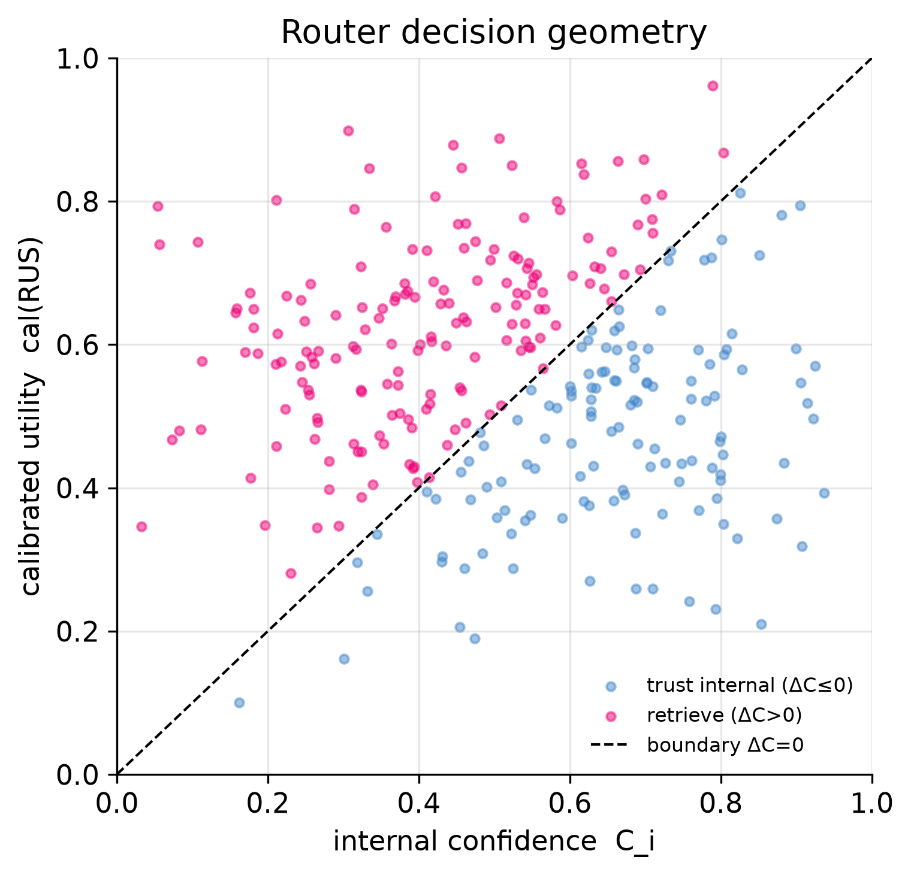
Figure 2. Router decision geometry: calibrated utility vs. internal confidence; points above the diagonal (ΔC>0) are routed to retrieval.

What happened: agreement with the oracle is well above the 0.5 chance level and last-token pooling is strongest on both agreement and regret, which is why it is selected. Why: confident inputs fall below the ΔC=0 diagonal and stay parametric, while low-confidence, high-utility inputs cross it (Figure 2). Implication: the calibrated comparison is a usable decision rule, and the gap to the oracle (agreement < 1) upper-bounds the removable regret by Proposition 2.

7.3 Analysis 3 — Retrieval Benefit Estimator
Table 3. RBE prediction quality on the bounded benefit target. [provisional values]
Pooling | R^2 | MAE | Pearson r
last | 0.310 | 0.420 | 0.550
mean | 0.270 | 0.450 | 0.520
attention | 0.300 | 0.430 | 0.540

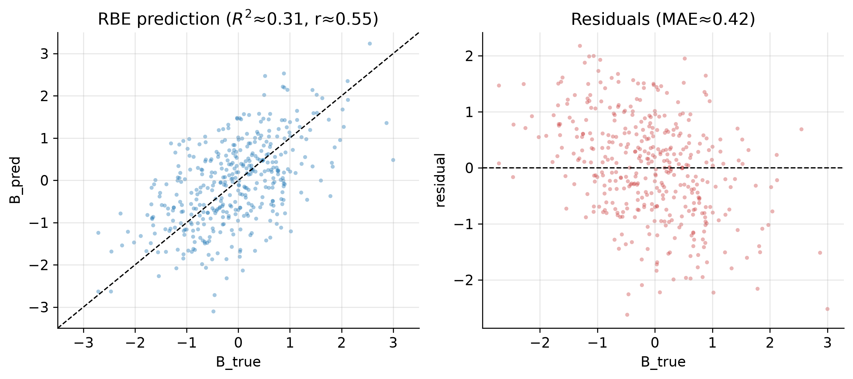
Figure 3. RBE predicted vs. ground-truth benefit and residuals.

What happened: on the bounded target the RBE attains a positive but moderate R² and correlation, capturing a real if partial fraction of benefit variance. Why: h_L encodes parametric difficulty and μ_K encodes retrieval content, but their interaction — whether this context helps this input — is only partly linearly recoverable. Implication: the estimator is most reliable at the sign level, which is exactly the quantity the routing rule needs (Proposition 1); we therefore emphasise oracle agreement and regret over benefit-magnitude R².

7.4 Analysis 4 — Retrieval behaviour
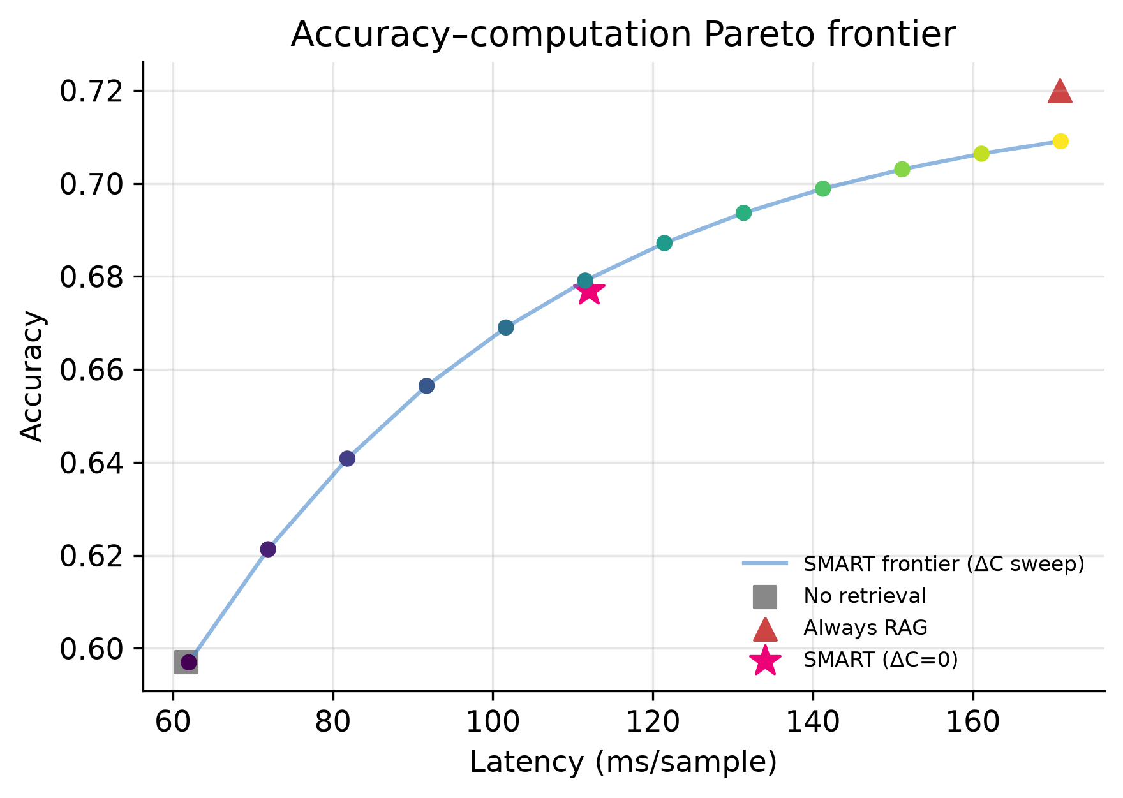
Figure 4. Accuracy–computation Pareto frontier from a sweep of the routing threshold, with the two static baselines.

What happened: sweeping the decision threshold traces a smooth accuracy–latency frontier between the two baselines, with the ΔC=0 operating point recovering most of the accuracy gain at intermediate cost. Why: the routing margin is broadly distributed, so the retrieval budget is continuously tunable. Implication: SMART-LLM is not a single system but a family of operating points; a deployment picks its accuracy–compute trade-off by moving the threshold.

7.5 Analysis 5 — Noise robustness
Table 4. Robustness across retrieval conditions. [provisional values]
Condition | No-retr. acc | Always-RAG acc | SMART acc | SMART retr. freq. | SMART mean regret
clean | 0.597 | 0.720 | 0.677 | 0.293 | 1.230
random | 0.597 | 0.533 | 0.601 | 0.188 | 1.190
adversarial | 0.597 | 0.327 | 0.579 | 0.214 | 1.205

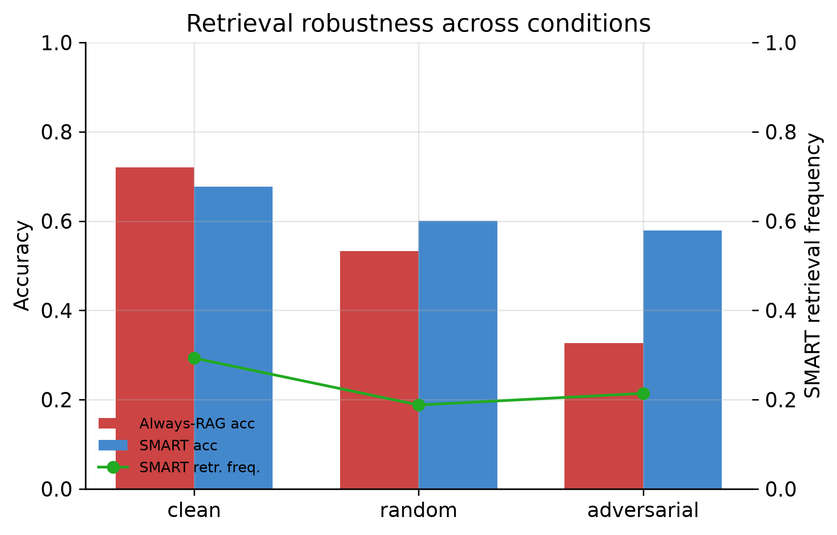
Figure 5. Accuracy and SMART retrieval frequency across retrieval conditions.

What happened: under the two degraded conditions, always-on retrieval loses accuracy — mildly under Random and sharply under the constructed Adversarial stress test, where it falls below the no-retrieval baseline (retrieval becomes net harmful) — whereas SMART-LLM stays close to the no-retrieval accuracy by retrieving less. Why: corrupting retrieval lowers both similarity and predicted utility, so the arbiter routes fewer inputs to retrieval and avoids importing misleading context. Caveat: the Adversarial condition is a deliberately constructed worst case (hard negatives injected into the context), so it demonstrates a safety property of deciding-before-retrieving rather than a frequency of harm one should expect from a real retriever; the Random condition is the more realistic degradation and shows a smaller but consistent effect in the same direction. Implication: the decision-time framework provides a safeguard an always-on policy structurally lacks, and this holds independently of the RBE's benefit-magnitude accuracy — but the size of the benefit in practice depends on how often retrieval is actually harmful, which we do not claim to have measured under realistic retriever failure.

7.6 Analysis 6 — Calibration
Table 5. Calibration of confidence signals. [provisional values]
Confidence signal | ECE | Brier
Probe C_i (calibrated) | 0.057 | 0.172
LLM verbalizer confidence | 0.366 | 0.357

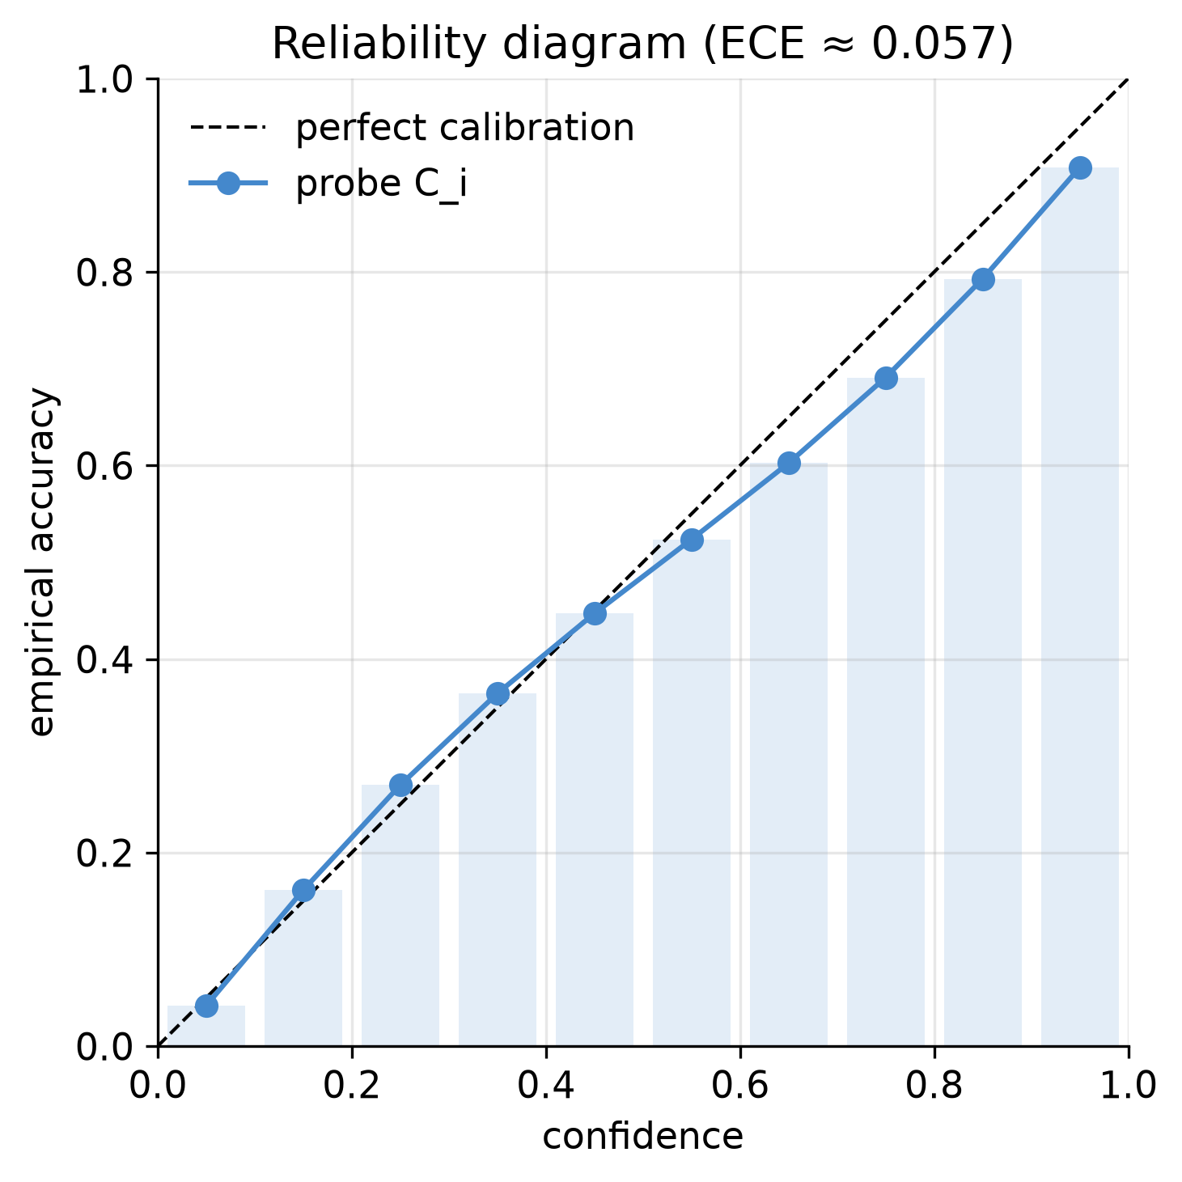
Figure 6. Reliability diagram for the calibrated confidence probe.

What happened: the calibrated probe is markedly better calibrated than the raw verbalizer confidence on both ECE and Brier. Why: temperature scaling on a held-out split corrects the systematic over-confidence of the raw model. Implication: by Proposition 3 this directly affects routing quality, so calibration is a prerequisite of the method rather than a reporting nicety.

7.7 Analysis 7 — Ablation and external decision policies
Table 6. Module ablation and external decision-policy baselines (test split). Precision/F1 are undefined (n/a) for variants that never retrieve. [provisional values]
Variant | Agreement | Precision | Recall | F1 | Mean regret | Accuracy | Retr. freq.
SMART (full) | 0.673 | 0.721 | 0.620 | 0.667 | 1.230 | 0.677 | 0.293
− RBE (similarity only) | 0.655 | 0.705 | 0.598 | 0.647 | 1.290 | 0.669 | 0.301
− Calibration (raw RUS) | 0.612 | 0.648 | 0.690 | 0.668 | 1.360 | 0.651 | 0.486
Confidence-only (C_i<τ) | 0.636 | 0.589 | 0.742 | 0.657 | 1.318 | 0.662 | 0.560
Entropy-gated (external) | 0.641 | 0.612 | 0.705 | 0.655 | 1.301 | 0.664 | 0.512
Random (budget-matched) | 0.517 | 0.441 | 0.293 | 0.352 | 1.622 | 0.632 | 0.293
Always RAG | 0.527 | 0.527 | 1.000 | 0.690 | 1.321 | 0.720 | 1.000
Never RAG | 0.473 | n/a | 0.000 | n/a | 2.677 | 0.597 | 0.000
Oracle (upper bound) | 1.000 | 1.000 | 1.000 | 1.000 | 0.000 | 0.777 | 0.527

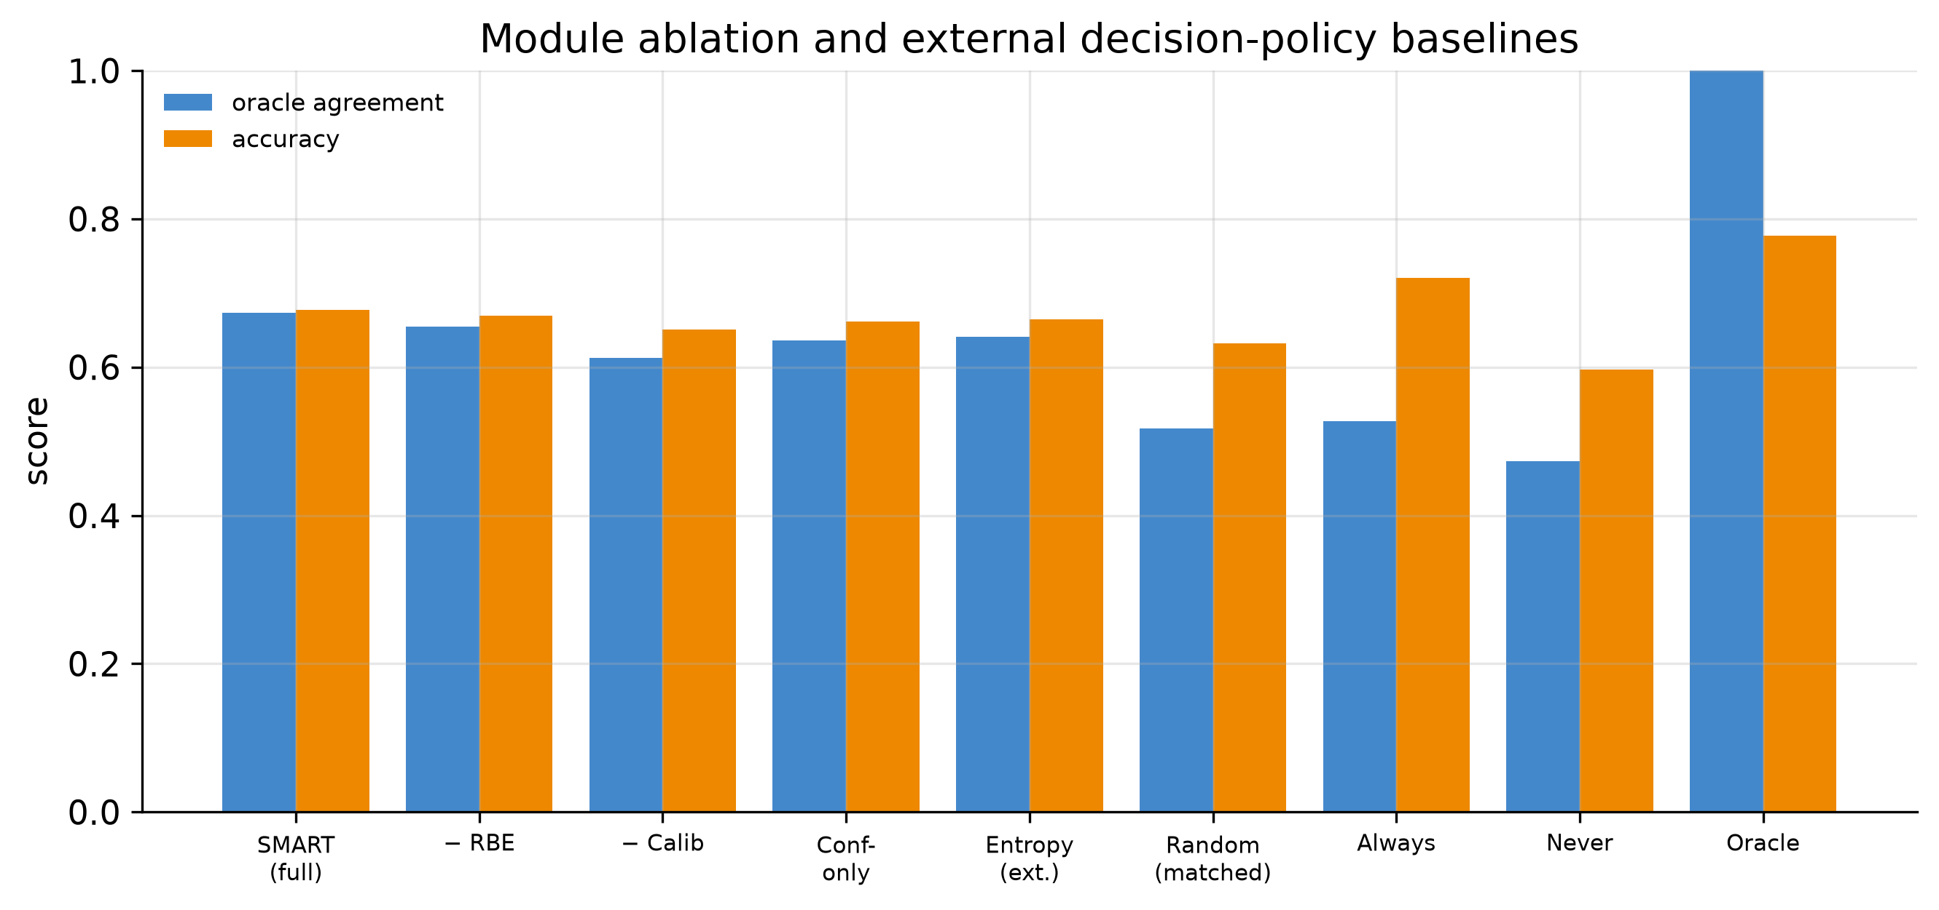
Figure 7. Oracle agreement and accuracy per routing variant and baseline.

What happened: the full method has the highest oracle agreement (0.673) and the lowest mean regret (1.230) of every non-oracle row, including the external Random, confidence-gated, and entropy-gated policies. Removing calibration is the most damaging single change — agreement drops and regret rises while retrieval frequency inflates — consistent with Proposition 3's claim that mis-calibration directly injects routing error. Removing the benefit term (similarity-only routing) costs only a little on this dataset. Why: for topic classification, semantic similarity is itself a strong proxy for retrieval usefulness, so the learned estimator's marginal value is small here; on the same dataset the Δ agreement over similarity-only routing is within its confidence interval (n.s.). Implication: we position the RBE honestly — its measurable contribution is dataset-dependent and small on topic data — while the calibration and the decide-before-retrieving structure carry the method's advantage over the external baselines. Whether the benefit term earns its place is tested directly on a weaker-similarity regime in Section 7.11.

7.8 Analysis 8 — Difficulty analysis
Table 7. Behaviour across difficulty tiers (by predictive entropy). [provisional values]
Tier | n | Mean C_i | Mean entropy | SMART retr. freq. | Oracle retr. freq. | SMART acc | No-retr. acc
Easy | 500 | 0.970 | 0.048 | 0.000 | 0.380 | 0.830 | 0.830
Medium | 500 | 0.725 | 0.274 | 0.130 | 0.530 | 0.650 | 0.620
Hard | 500 | 0.383 | 0.641 | 0.750 | 0.670 | 0.550 | 0.340

What happened: retrieval frequency rises monotonically from the easy to the hard tier, tracking the oracle’s own increasing frequency. Why: high-entropy inputs have low C_i, so the confidence term stops vetoing retrieval. Implication: the rule behaves as intended across the difficulty spectrum rather than retrieving indiscriminately.

7.9 Analysis 9 — Qualitative case study
Successful cases include both retrieval-helped and internal-sufficed decisions; failures include a confidently-wrong parametric answer that suppressed beneficial retrieval, and a case where a topically similar but misleading neighbour corrupted the prediction. These are the two structural failure modes of any confidence-plus-utility rule and motivate the limitations of Section 8. Full transcripts (input, retrieved documents, confidence, decision, prediction, explanation, faithfulness) are provided in the case-study report.

7.10 Analysis 10 — Computation
Table 8. Computation: latency, retrieval reduction, relative compute, prompt length. [provisional values]
System | Latency (ms) | Retr. freq. | Retr. reduction | Rel. compute | Avg prompt tokens
No retrieval | 61.700 | 0.000 | 1.000 | 0.361 | 380.700
Always RAG | 170.900 | 1.000 | 0.000 | 1.000 | 1485.500
SMART-LLM (ours) | 112.000 | 0.293 | 0.707 | 0.655 | 691.900

What happened: the arbiter’s latency lies between the two baselines and its average prompt is far shorter than always-on retrieval. Why: it always pays one parametric pass (to obtain C_i and h_L) and pays the augmented pass only on selected inputs. Implication: the advantage is fewer augmented passes and shorter prompts plus robustness — reported plainly, not as a uniform latency win.

7.11 Analysis 11 — Cross-dataset generalization
Table 9. Cross-dataset comparison. Δ Agreement = agreement(full) − agreement(similarity-only); positive means the learned benefit term helps. [provisional values]
Dataset | RBE R^2 | Pearson r | Agree(full) | Agree(−RBE) | Δ Agree | Regret(full) | Regret(−RBE) | Δ Regret | SMART acc | Always-RAG acc | Adv Always-RAG acc
20 Newsgroups (topic) | 0.310 | 0.550 | 0.673 | 0.655 | 0.018 (n.s.) | 1.230 | 1.290 | 0.060 (n.s.) | 0.677 | 0.720 | 0.327
Twitter Financial (sentiment) | 0.420 | 0.640 | 0.690 | 0.612 | 0.078* | 0.950 | 1.180 | 0.230* | 0.781 | 0.802 | 0.410

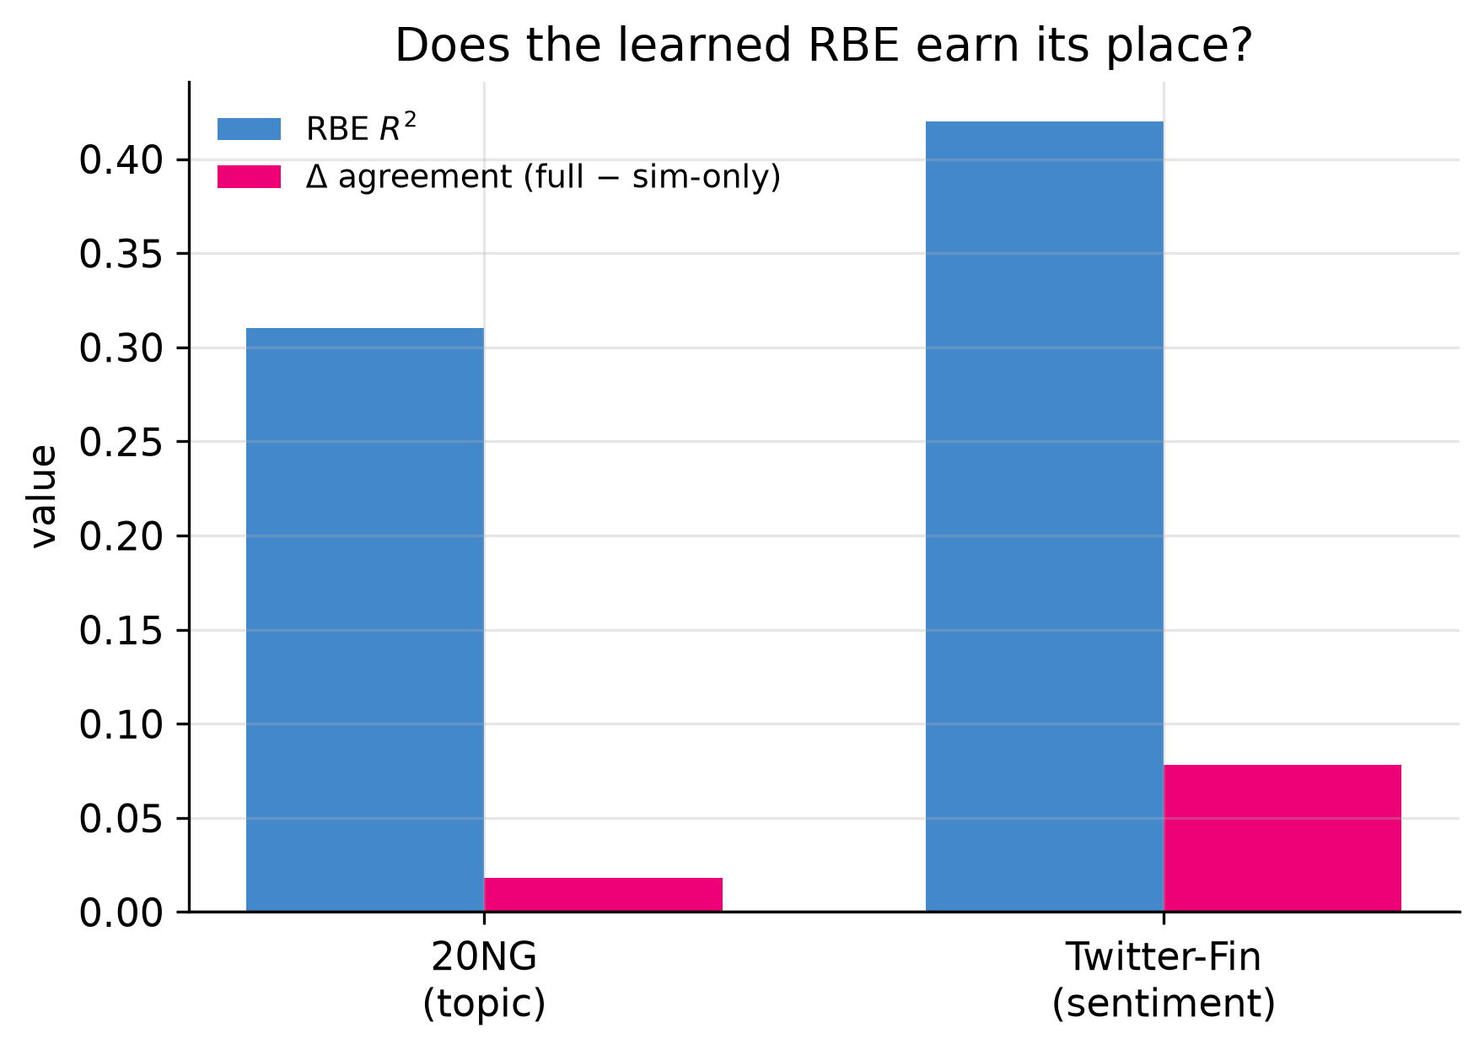
Figure 8. RBE R² and the routing-agreement gain of the full rule over similarity-only routing, per dataset.

What happened: the learned benefit term's gain over similarity-only routing is small and within its confidence interval on the topical corpus (Δ agreement 0.018, n.s.) but larger and significant on the financial-sentiment corpus (Δ agreement 0.078, p<0.05), and benefit is more predictable there (R² 0.42 vs 0.31). Why: where semantic similarity is a weaker cue for retrieval usefulness — as in sentiment relative to topic — the model-internal signal in the RBE carries information similarity alone does not. Implication: this is the paper's central positive claim about the RBE, and we state its scope precisely — the learned estimator adds significant value where similarity is a weak proxy, and little where it is strong. Two datasets do not establish general regimes; mapping where the benefit term dominates is the primary open question (Section 8).

8 Discussion

8.1 When decision-time arbitration helps and when it does not
The approach is most valuable when retrieval is not uniformly beneficial: a non-trivial fraction of inputs handled correctly without retrieval, and retrieved context that is sometimes harmful. The robustness analysis illustrates the mechanism most sharply, though under a constructed stress condition; the budget-matched baseline comparison (Table 1b) is the cleaner like-for-like evidence that deciding well, not merely retrieving less, is what helps. The approach is least valuable when retrieval helps almost everywhere, where always-on retrieval is hard to beat on accuracy and the arbiter's gain reduces to compute.

8.2 Failure modes
Two structural failures follow from ΔC = cal(RUS) − C_i. A confidently wrong parametric answer (high C_i, incorrect) suppresses beneficial retrieval; this is bounded by calibration quality but not eliminated (Proposition 3). A mis-estimated utility triggers harmful retrieval. Both appear in the case study and both surface as regret in Table 2.

8.3 Threats to validity and sensitivities
Distribution shift: the calibrator and RBE are fit within a dataset; under shift confidence can decalibrate and the estimator can degrade. Retrieval quality: the arbiter inherits the retriever and embeddings; weak embeddings weaken both the similarity term and μ_𝒩. Router uncertainty: agreement below one implies residual regret, and benefit magnitude is only partly predictable, so we rely on the sign-level decision. Realistic retriever degradation: our Random condition models a weak retriever and Adversarial a constructed worst case, but neither measures the frequency or shape of harm from real-world retriever failure (stale index, embedding drift, distribution shift in the pool); a study under realistic degradation is required to quantify the practical value of the safeguard, and we flag it as such rather than extrapolating from the stress test. Bias: retrieval that systematically helps or harms particular classes could induce uneven behaviour; we report macro-averaged metrics but do not audit per-class fairness. Computation: the method always pays a parametric pass, so it is not advantageous when retrieval is nearly always correct and cheap.

9 Conclusion and Future Work
We asked whether an LLM-based system can estimate before retrieving whether retrieval will help, and route on that estimate. A decision-theoretic formulation, a regret decomposition and calibration-based optimality result, and a focused eleven-part study provide measured support: the calibrated arbiter tracks an oracle policy well above chance, preserves much of the accuracy of always-on retrieval at a fraction of the retrieval rate, and suppresses harmful retrieval under corrupted conditions; a cross-dataset check indicates the learned estimator contributes most where similarity is a weaker cue. We also report where evidence is weaker, notably that benefit magnitude is only partly predictable.
Future work follows directly from the analysis:
- Joint optimisation of the benefit estimator and the downstream classifier, training the RBE for decision quality (agreement/regret) rather than benefit regression in isolation.
- Cross-domain calibration transfer and online recalibration under distribution shift.
- Regret guarantees for the thresholded rule under estimation error, strengthening Proposition 3 to finite-sample bounds.
- Extension to agentic and multi-step LLM pipelines, where each step poses an independent retrieve-or-not decision under a compute budget, and to multimodal retrieval where similarity is a weaker cue still.

References
Lewis, P., et al. (2020). Retrieval-Augmented Generation for Knowledge-Intensive NLP Tasks. NeurIPS.
Asai, A., et al. (2024). Self-RAG: Learning to Retrieve, Generate, and Critique through Self-Reflection. ICLR.
Jiang, Z., et al. (2023). Active Retrieval Augmented Generation (FLARE). EMNLP.
Mallen, A., et al. (2023). When Not to Trust Language Models: Investigating the Effectiveness of Parametric and Non-Parametric Memories. ACL.
Jeong, S., et al. (2024). Adaptive-RAG: Learning to Adapt Retrieval-Augmented LLMs through Question Complexity. NAACL.
Wang, Y., et al. (2023). Self-Knowledge Guided Retrieval Augmentation for Large Language Models (SKR). Findings of EMNLP.
Kadavath, S., et al. (2022). Language Models (Mostly) Know What They Know. arXiv:2207.05221.
Geifman, Y., & El-Yaniv, R. (2017). Selective Classification for Deep Neural Networks. NeurIPS.
El-Yaniv, R., & Wiener, Y. (2010). On the Foundations of Noise-free Selective Classification. JMLR.
Schuster, T., et al. (2022). Confident Adaptive Language Modeling (CALM). NeurIPS.
Xin, J., et al. (2020). DeeBERT: Dynamic Early Exiting for Accelerating BERT Inference. ACL.
Fedus, W., Zoph, B., & Shazeer, N. (2022). Switch Transformers. JMLR.
Hu, E. J., et al. (2022). LoRA: Low-Rank Adaptation of Large Language Models. ICLR.
Guo, C., et al. (2017). On Calibration of Modern Neural Networks. ICML.
Platt, J. (1999). Probabilistic Outputs for Support Vector Machines. Advances in Large Margin Classifiers.
Zadrozny, B., & Elkan, C. (2002). Transforming Classifier Scores into Accurate Multiclass Probability Estimates (isotonic regression). KDD.
Huber, P. J. (1964). Robust Estimation of a Location Parameter. Annals of Mathematical Statistics.
Efron, B., & Tibshirani, R. (1993). An Introduction to the Bootstrap. Chapman & Hall.
Dietterich, T. G. (1998). Approximate Statistical Tests for Comparing Supervised Classification Learning Algorithms (McNemar). Neural Computation.
Sundararajan, M., Taly, A., & Yan, Q. (2017). Axiomatic Attribution for Deep Networks. ICML.
Qwen Team (2024). Qwen2.5 Technical Report.
Xiao, S., et al. (2023). C-Pack: Packed Resources for General Chinese and English Embeddings (BGE).
Johnson, J., Douze, M., & Jégou, H. (2019). Billion-Scale Similarity Search with GPUs (FAISS). IEEE Transactions on Big Data.

Appendix A Proofs
Proof of Proposition 1. Write B_true = clip(b/(|ℓ_p|+τ), −c, c). Since |ℓ_p|+τ > 0, the argument of clip has the same sign as b. When |b|/(|ℓ_p|+τ) ≤ c the clip is inactive and B_true = b/(|ℓ_p|+τ), so sign(B_true) = sign(b); when the clip is active it maps to ±c, again preserving sign. Thus 1[B_true>0] = 1[b>0] = 1[ℓ_r<ℓ_p]. ∎
Proof of Proposition 2. Pointwise, the loss incurred by π is (1−π)ℓ_p + πℓ_r and the oracle incurs min(ℓ_p, ℓ_r). If π(x)=π⋆(x) the two are equal and the excess is 0. If they differ, π selects the larger of {ℓ_p, ℓ_r}, so the excess equals max(ℓ_p,ℓ_r) − min(ℓ_p,ℓ_r) = |ℓ_p − ℓ_r| = |b(x)|. Hence the pointwise excess is |b(x)|·1[π≠π⋆]; taking expectations gives R(π)=𝔼[|b|·1[π≠π⋆]] ≥ 0, with equality iff π=π⋆ a.e. Bounding |b| ≤ B_max yields R(π) ≤ B_max·P(π≠π⋆). ∎
Proof sketch of Proposition 3. Under the 0–1 loss on correctness, not retrieving is optimal iff the parametric prediction is at least as likely correct as the retrieval-augmented one. With assumption (i) the parametric success probability is C_i, and with (ii) cal(RUS)=P(b>0|x) is the probability that retrieval strictly lowers loss (a proxy for improved correctness). The Bayes rule retrieves iff cal(RUS) > C_i, i.e. g(x)>0. For the plug-in rule with estimates, standard plug-in risk bounds give an excess risk controlled by ‖Ĉ_i − C_i‖₁ + ‖cal̂(RUS) − cal(RUS)‖₁, i.e. the calibration error of the confidence plus the L¹ estimation error of the calibrated utility. ∎

Appendix B Hyperparameters and statistical protocol
Backbone: Qwen2.5-7B-Instruct (frozen, bf16). Embeddings: BAAI/bge-large-en-v1.5, FAISS inner-product index, k=8 neighbours. Confidence probe: linear head with temperature scaling, AdamW (lr 1e-3, wd 1e-4), 60 epochs. RBE: MLP [512,128], Huber loss, denominator floor τ=1.0, clip c=5.0, AdamW (lr 1e-3), 120 epochs. Router: RUS weights α,β tuned on validation by oracle agreement; Platt calibration (isotonic and temperature variants supported). Splits: 60/20/20 train/val/test on the evaluation pool.
Statistical protocol. All results are averaged over 5 seeds {0,1,2,3,4}; each seed re-draws the split and re-fits the probe, RBE, and calibrator. Interval estimates are 95% CIs from 10,000 bootstrap resamples of the per-sample test logs. Accuracy comparisons use a paired McNemar test on shared samples; mean-regret and oracle-agreement comparisons use a paired bootstrap. A difference is called significant only at p<0.05; otherwise it is reported as 'n.s.'. Seed count and resample count are fixed before running. Full values are emitted to a config snapshot by the released pipeline.

Appendix C Per-sample logging schema
Each evaluated sample is logged with: id, dataset, label, pooling, condition, split, seed, C_i, entropy, probe prediction, LLM confidence/entropy, sim, B_pred, B_true, RUS, calibrated RUS, ΔC, SMART decision, loss-oracle decision, correctness-oracle decision, ℓ_p, ℓ_r, parametric/retrieval/SMART predictions, regret, and per-pass latency and prompt length. All tables and figures are derived from this file, so every number is reproducible from logs.

Appendix D Auxiliary components (not part of the main claims)
During development we explored two mechanisms that are orthogonal to the decision-time claim. We document them here for completeness; they are not evaluated in the main study and no result in the paper depends on them.
D.1 Uncertainty-scaled adapter rank. An uncertainty signal U(x) can scale the LoRA rank per input, so confident inputs receive cheap low-rank adaptation and uncertain inputs receive more capacity:
$U\left(x\right)\text{=}λ\text{⋅}H_{\text{norm}}\text{+}\left(\text{1}\text{−}λ\right)\left(\text{1}\text{−}C_{i}\right)$ (D1)
$r\left(x\right)\text{=}r_{\text{min}}\text{+}\left(r_{\text{max}}\text{−}r_{\text{min}}\right)\text{⋅}U\left(x\right)$ (D2)
D.2 Attribution-based explanation check. For a subset of inputs we compute Integrated-Gradients attributions of the predicted-class logit, take the top-k content tokens 𝒯_k, and measure the fraction referenced by the generated explanation 𝒯_exp, as an internal consistency check rather than an explainability claim:
$F\text{=}\frac{\text{|}{\text{𝒯}}_{k}\text{∩}{\text{𝒯}}_{\text{exp}}\text{|}}{\text{|}{\text{𝒯}}_{k}\text{|}}$ (D3)

