01 | Product and Engineering Design
  - Industry-Specific Lead-to-Order Agent | Developer implementation specification
Brilliant Brains | Experiment 5 | 20 October 2026 | 1.0 - Approval Candidate
DECISION STATUS: Proposed technical/commercial specification; no build, deployment or customer commitment is implied.

1. What the product builds and why
A configurable, multi-tenant application for small and mid-sized UK service operators to convert incoming customer enquiries into structured sales cases, qualified requirements, an indicative or approved quotation, an appointment or handover, and a CRM record. Enquiries may originate from a website form or an opted-in WhatsApp Business conversation. The application does not promise autonomous sales or immediate pricing for every sector. It reduces lost enquiries, slow responses, missing requirements and repetitive data entry while keeping prices, outbound messages and bookings behind explicit business rules and human controls.

2. MVP boundary and selected initial vertical
Build one reference vertical, recommended pilot: facilities or field-service providers offering inspection, maintenance and small quoted jobs. Configure services, territories, opening hours and qualification questions. MVP: website lead form; optional inbound WhatsApp integration after approved provider setup; case list; qualification; AI-assisted classification; rule-based indicative pricing; staff quote approval; manual/approved send; CRM CSV export or one approved CRM connector; activity log; admin settings; synthetic demo tenant. Exclude payments, inbound telephony, fully autonomous final quotes, direct ERP writeback, marketing blasts, and live multi-sector optimisation.

3. Roles and journeys
Visitor -> submit enquiry -> consent and privacy notice -> receive acknowledgement if authorised. Agent -> classify need, request missing structured fields via authorised channel, suggest service and urgency. Staff -> review facts, quote breakdown, eligibility and exclusions -> approve/revise/reject -> send through approved channel. Customer -> accept/reject quote or request clarification. Staff -> confirm appointment in authorised calendar or CRM; case is resolved, escalated or closed. Tenant admin -> configure service catalogues, workflow questions, role permissions, message templates, budgets and rules; platform admin -> audit cross-tenant operations without reading tenant content by default.
Journey | Trigger | Acceptance
J1 Lead capture | POST form or validated inbound webhook | One lead ID; duplicate retries do not duplicate cases
J2 Qualification | New lead | Required fields and evidence links; missing fields asked, never invented
J3 Quote draft | Qualified lead | Deterministic fee rules; itemised taxes/exclusions
J4 Approval | Quote ready | Staff approval and immutable rule version before send
J5 Scheduling | Approved accepted quote | No calendar side effect without approval; time zone correct
J6 Exception | Low confidence, disallowed request | Human review; clear failure reason
J7 Admin | Tenant settings | Versioned catalog, price rules and approved templates

4. Architecture
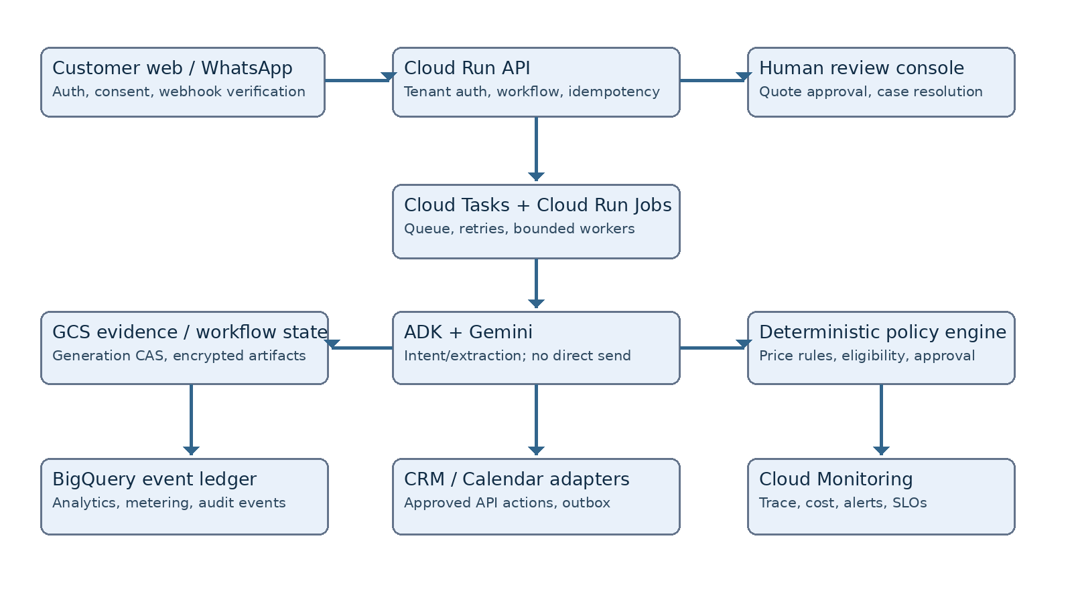
Design basis: Google Cloud serverless services and ADK agent patterns. Cloud Storage holds object-based operational state with generation-match compare-and-swap; BigQuery holds append-only events and analytics, not synchronous OLTP. Cloud Tasks handles bounded asynchronous work. This is a consciously constrained MVP: users need no arbitrary transactional joins or high-frequency mutation.

5. Component contracts and responsibilities
Frontend: React or Next.js behind Cloud Run, authenticated tenant UI. API: FastAPI, OIDC token validation, tenant scoping, request IDs, rate limits, schema validation. Agent: structured intent classification and field extraction, fixed allow-listed tools, schema-constrained output. Business rules: deterministic qualification completeness, territory, service catalogue matching, VAT, pricing and exclusion engine. Connectors: Meta WhatsApp Cloud API and a single CRM connector behind feature flags. Staff review is mandatory for every externally sent quote until a separately approved risk gate.
API / event | Contract summary | Expected failures
POST /v1/leads | tenant; channel; external_ref; message; consent; idempotency_key -> lead_id | 400 schema; 401/403 auth; 409 conflicting idempotency
GET /v1/leads/{id} | tenant-scoped status, facts, history, quotes | 404 hidden across tenants
POST /v1/leads/{id}/qualify | creates queued qualification job -> 202 job_id | 429 quota; 422 missing source
POST /v1/leads/{id}/quotes | catalogue_version, line-items, quote draft | 422 non-eligible service
POST /v1/quotes/{id}/approve | expected_generation + reviewer ID | 409 stale; 403 wrong role
POST /v1/quotes/{id}/send | approved quote + permitted channel | 409 not approved; 503 provider down
POST /v1/webhooks/whatsapp | signature + provider event ID -> ack | 401 signature failure; duplicate accepted
GET /v1/jobs/{id} | state, errors, trace, safe retry metadata | 404 inaccessible job

6. Data model
GCS: tenants/{tenant}/leads/{lead}/state.json; immutable input payload objects; quotes/{quote}/vN.json; event export partitions; reports. Each state write requires ifGenerationMatch and returns conflict on stale versions. Events have event_id, tenant_id, actor_id, entity_id, action, timestamp, correlation_id, policy_version, content_hash and result, buffered via Cloud Tasks into BigQuery. BigQuery datasets for events, usage, funnel_metrics and reconciliation. PII encrypted and access-controlled; retention periods configurable and verified in tests. No Cloud SQL or PostgreSQL.

7. Pricing and operational separation
Application implements feature entitlements, quotas, tenant plans, price catalogue version selection and metering via configuration interfaces; commercial tier values belong exclusively to the Business Model document. Quotation prices for the customers' services are tenant-owned catalogue values, distinct from the subscription price charged for this application.

8. AI guardrails and security
Treat all inbound content as untrusted, never execute model-generated code or URLs, prevent prompt instructions from invoking unrestricted tools, redact unnecessary PII from traces, validate webhook authenticity, include spam/abuse throttles, require human sign-off on outbound quotes and appointments, and capture evidence for every generated qualification. Show a clear “AI suggestion” badge and confidence reason in the reviewer UI.

9. End-to-end test matrix
Synthetic positives: normal service request, multi-message clarification, in-territory job, VAT-exempt policy case, approved quote. Negatives: malformed webhook, spoofed signature, repeated provider delivery, out-of-area address, disallowed service, injected instruction, inconsistent fee catalogue, simultaneous approval, vendor timeout, cross-tenant data request, missing consent. Verify all without external production messages.

10. Seven-day engineering implementation plan
Day 1: repo, auth contracts, UI shell, schema. Day 2: lead capture, state CAS, workflow status. Day 3: qualification and agent structured outputs. Day 4: deterministic quote rules, catalogue, permissions. Day 5: reviewer UI, approved send sandbox, one CRM export. Day 6: E2E, negative, tenant isolation and idempotency tests. Day 7: staging demonstration, defect closure, production candidate only if gates pass.

11. Developer backlog and definition of done
Work packages DEV-01 frontend and auth, DEV-02 lead API, DEV-03 inbound adapter, DEV-04 qualification rules and prompt schema, DEV-05 quote engine, DEV-06 approval and outbox, DEV-07 history and exports, DEV-08 dashboards and tests. Each PR must include typed contracts, runnable tests, observability tags, mock fixtures, threat-case coverage and deployment documentation. Done = reproducible staging demonstration plus acceptance evidence, not just a UI screenshot.

12. Technical risks and launch blockers
WhatsApp template approval and business account setup can exceed seven days, so website-first is the mandatory launch path. GCS state can become a throughput bottleneck for hot records; measure contention and plan an alternative state store if product needs outgrow CAS. BigQuery ingestion is eventually consistent and cannot anchor online approval decisions. Provider rate limits, customer consent and calendar side effects must be verified before enabling live integrations.

13. Relevant technical references
Google Cloud Run agents: https://cloud.google.com/run/docs/ai-agents ; Google Cloud architecture: https://cloud.google.com/architecture ; Cloud Storage object preconditions: https://cloud.google.com/storage/docs/request-preconditions ; Google Cloud Tasks: https://cloud.google.com/tasks/docs ; BigQuery: https://cloud.google.com/bigquery/docs ; Meta WhatsApp Cloud API: https://developers.facebook.com/docs/whatsapp/cloud-api/

Authorisation and sign-off
Role | Decision | Owner / date
Product sponsor | Approve / revise / reject | ________________
Technical lead | Approve / revise / reject | ________________
Security / compliance | Approve / revise / reject | ________________

