02 | DevOps, Terraform and Production Release
  - Experiment 5 | Platform ownership and operational runbook
Brilliant Brains | Experiment 5 | 20 October 2026 | 1.0 - Approval Candidate
DECISION STATUS: Proposed technical/commercial specification; no build, deployment or customer commitment is implied.

1. Infrastructure outcomes
DevOps provisions reproducible dev, staging and production environments with independent secrets, service accounts, data resources, quotas and budgets. Use workload identity federation for GitHub rather than long-lived JSON service-account keys. Never allow a staging deployment to access live WhatsApp/CRM credentials. All changes go through reviewed Terraform and GitHub workflows.

2. Resource topology
Per environment: GCP project, Cloud Run web/API and worker, Artifact Registry, Cloud Tasks queues, GCS evidence and state buckets, BigQuery datasets, service identities, Secret Manager, Cloud Logging/Monitoring, budgets/alerts. Domains, TLS and ingress security must be staged. Production GCS uniform bucket-level access, retention and lifecycle policies; deny public access. Use Europe region selection consistent with customer data residency commitments, validated with selected model processing locations.
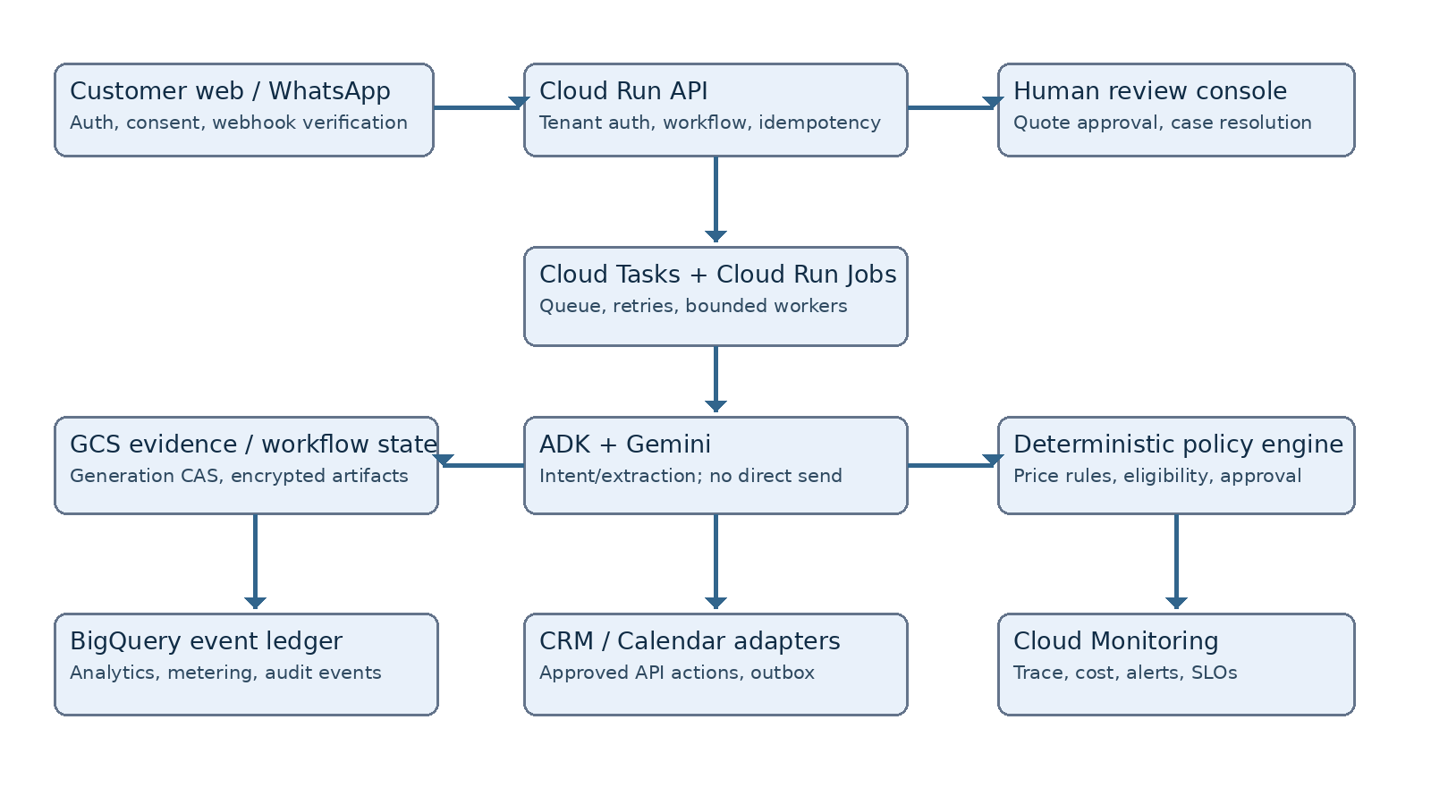

3. Terraform repository layout
infra/bootstrap for state bucket and WIF; infra/modules/{iam,run,tasks,gcs,bq,secrets,monitoring,budget}; infra/environments/{dev,staging,prod}. Pin providers and modules; remote backend per environment; terraform fmt/validate/plan on PR and controlled apply with separate approvals. Keep environments in distinct GCP projects, not a shared dataset with a string prefix.
Resource | Production control | Verification
Cloud Run | minimum instances 0 initially; concurrency and max instances bounded | cold-start and load exercise
GCS state | generation preconditions and versioning; encryption | concurrent state-write test
BigQuery | partition, retention, authorised service principals | cross-tenant access test
Cloud Tasks | OIDC invocation and retry caps | duplicate / dead letter test
Secret Manager | least-privilege access, rotation schedule | secret-scanner and runtime check
GitHub OIDC | WIF, branch protection, required reviews | negative unauthorised deploy test

4. CI pipeline
Pull request: lint, typecheck, unit tests, contract tests, SAST, dependency scan, IaC validation, container build, SBOM and image vulnerability scan. Merge to main: artifact digest build and deploy to dev. Promote same immutable digest to staging, run smoke tests, tenant isolation tests, agent fixture tests, synthetic webhook tests and perf budget checks. Production workflow requires owner approval, successful staging attestation and explicit release record.

5. Release and rollback
Use image digest promotion, not rebuild by environment. Deploy Cloud Run revision, run post-deploy smoke checks, gradually shift traffic when supported. Roll back to last known healthy revision on elevated error rate or failed post-deploy check. Terraform rollback must be planned separately for destructive changes. Configure backward-compatible event schemas and versioned GCS state. Preserve customer cases and export audit events during a failed release.

6. SLOs and alerting
Pilot targets (to validate): API availability 99.5% measured monthly; p95 basic API latency under 1.5s excluding async jobs; 99% accepted jobs finish or reach a human-readable terminal exception within 10 min; zero cross-tenant leaks; 100% price sends linked to approvals. Instrument provider failures, queue age, rejected signatures, CAS conflict rate, AI tokens/cost, BigQuery ingestion lag, outbox stuck count, webhook duplicates and spend by tenant.

7. Security and privacy gates
IAM boundary review, OWASP API checks, safe redirect/url allow-lists, webhook signature verification, replay protection, penetration-test findings triage, data retention tests, DPA with model/provider, documented processor/subprocessor map, deletion path, consent state proof, DSAR/export handling and breach-response contact. No production tenant is onboarded until security owner approves these gates.

8. Recovery exercises
Test cloud task retry storm, expired credential, unavailable WhatsApp provider, broken CRM adapter, corrupted state generation, BigQuery ingestion outage and a bad deployment. Define recovery point objective based on immutable GCS events and effective write durability; rehearse restore from version history in staging. Record incident runbooks and escalation owners.

9. Seven-day DevOps workstream
D1 bootstrap, projects, WIF, repo policies. D2 Cloud Run, IAM, GCS, BQ, queues. D3 CI/test workflows, secrets. D4 staging, synthetic callbacks and smoke. D5 security policies, monitoring and budgets. D6 disaster rehearsal, load and recovery. D7 controlled promotion assessment, runbook handover, BA-led UAT evidence and go/no-go.

10. Mandatory acceptance artifacts
terraform plan/apply logs; infrastructure outputs inventory; service account access matrix; staging/test and prod URL (when released); CI job links; digest manifest; release approval record; smoke and security test report; rollback rehearsal video/log; runbook; budget dashboard; owner roster. Production is blocked if any critical evidence is missing.

11. Official reference links
Cloud Run https://cloud.google.com/run/docs ; Cloud Tasks https://cloud.google.com/tasks/docs ; GCS https://cloud.google.com/storage/docs ; BigQuery https://cloud.google.com/bigquery/docs ; Terraform Google provider https://registry.terraform.io/providers/hashicorp/google/latest/docs ; GCP security foundations https://cloud.google.com/architecture/security-foundations

Authorisation and sign-off
Role | Decision | Owner / date
Product sponsor | Approve / revise / reject | ________________
Technical lead | Approve / revise / reject | ________________
Security / compliance | Approve / revise / reject | ________________

