PROJECT DOCUMENTATION

**PROJECT ISSUE**

|  |  |  |  |
| --- | --- | --- | --- |
| **Project: ‘MasterSab’** |  |  |  |
| Release: |  |  |  |
| Date: 2020-03-18 |  |  |  |
| Project Issue No: 1.1 |  |  |  |
|  |  |  |  |
| **PRINCE2** |  |  |  |
|  |  |  |  |
| Author: Project Manager |  |  |  |
| Owner: Group 1 |  |  |  |
| Client: Patan college for professional studies |  |  |  |
| Document Ref: |  |  |  |
| Version No: 1.1 |  |  |  |

# 1 Project Issue History

## 1.1 Document Location

The source of the document will be found on the project's PC in location and google drive.

## 1.2 Approvals

This document requires the following approvals.

Signed approval forms are filed in the Management section of the project files.

|  |  |  |  |  |
| --- | --- | --- | --- | --- |
| **Name** | **Signature** | **Title** | **Date of Issue** | **Version** |
| Ajay Kumar Yadav |  | Unit Coordinator | 2020-03-18 | 1.0 |
| Lokendra Dangi |  | Project Manager | 2020-03-19 | 1.0 |

## 1.3 Distribution

This document has been distributed to:

|  |  |  |  |
| --- | --- | --- | --- |
| **Name** | **Title** | **Date of Issue** | **Version** |
| Kumod Khadka | Documenter | 2020-03-19 | 1.0 |

# 2 Table of Contents

Page

### 1 Project Issue History 1

1.1 Document Location 1

1.2 Approvals

1.3 Distribution

### 2 Table of Contents

### 3 Purpose

### 4 Description

### 5 Priority

### 6 Impact Analysis

### 7 Decision

# Project Issue

## 3 Purpose

The main purpose of this document is to provide short brief about the issues that might occurred during project development life-cycle with its negative and positive impact.

## 4 Description

Project development lifecycle includes various phases which in results may show various issues. Initially project plan was prepared but various issue may occur due to various circumstances. Various risk were predicted and planned for mitigation but some uncertain risk may occur like COVID-19 which may create to unpredicted loss in project. Business case was prepared by understanding simple market which mightn’t be fully realistic and can cause economic disadvantages. Similarly misunderstanding on acceptance criteria, improper quality plan may also lead to project issue.

## 5 Priority

Those risks which are mention in our risk plan are the priorities for our project issues. The screenshot of the risk plan is below:

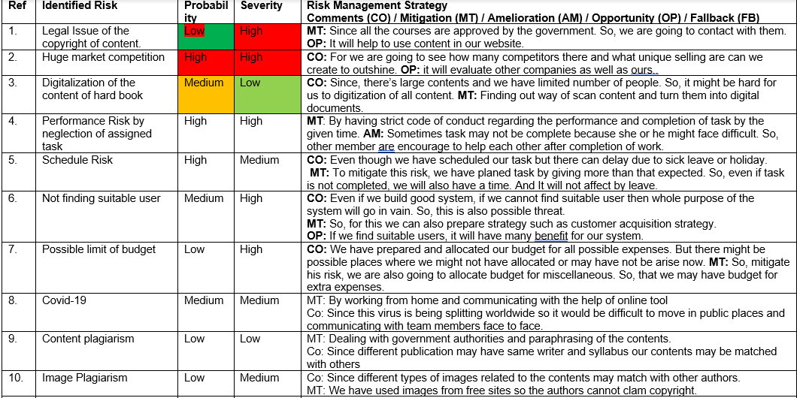

## 6 Impact Analysis

Every small or big issues are the hinderances of our project. Quality risk, budget risk, HR risk etc might cause huge loss in the project. So, based on the loss that may created in our project severity or impact of issue will be calculated by our team.

## 7 Decision

The following are the decisions that we have made:

1. Legal permission through concern authorities regarding to our content.
2. Due to the COVID-19 scenario we have made decision that we will used online communication platform for discussion.
3. Acceptance criteria will be highly analysed and followed so that quality expected by client will be fulfilled this issue.