**Matriculas:** 2022-0457

**Estudiante:** Stiven De La Rosa Brito

**Carrera:** Desarrollo de software.

**Materia:** Programación 1

**Sección:** Virtual

**Profesor/a:** Freidy Nunez Perez

**Trabajo :** tarea java windows buldier

**Fecha:** 28/10/2022

**Ejercicio 1-----------------------------------**

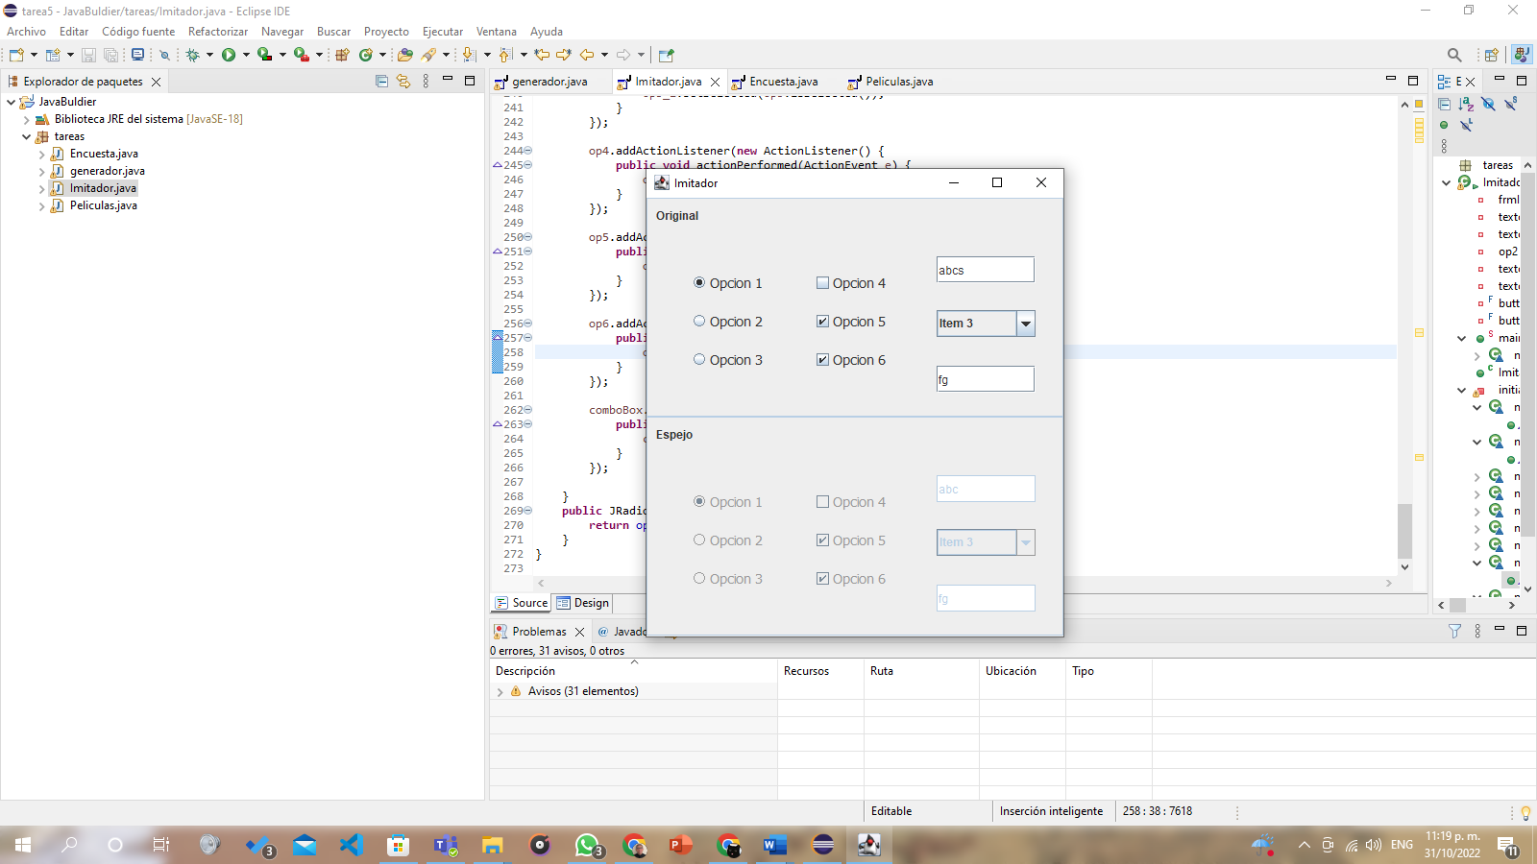

**Código**

**package** tareas;

**import** java.awt.EventQueue;

**import** javax.swing.JFrame;

**import** java.awt.Window.Type;

**import** java.awt.FlowLayout;

**import** javax.swing.JPanel;

**import** javax.swing.border.BevelBorder;

**import** javax.swing.border.TitledBorder;

**import** javax.swing.BoxLayout;

**import** java.awt.Component;

**import** javax.swing.JLabel;

**import** javax.swing.JRadioButton;

**import** java.awt.BorderLayout;

**import** java.awt.Font;

**import** javax.swing.SwingConstants;

**import** javax.swing.JCheckBox;

**import** javax.swing.JTextField;

**import** javax.swing.JComboBox;

**import** javax.swing.DefaultComboBoxModel;

**import** javax.swing.ButtonGroup;

**import** java.awt.event.ActionListener;

**import** java.awt.event.ActionEvent;

**import** java.awt.event.KeyAdapter;

**import** java.awt.event.KeyEvent;

**import** java.awt.event.ItemListener;

**import** java.awt.event.ItemEvent;

**public** **class** Imitador {

**private** JFrame frmImitador;

**private** JTextField texto1;

**private** JTextField texto2;

**private** JRadioButton op2;

**private** JTextField texto1_1;

**private** JTextField texto2_1;

**private** **final** ButtonGroup buttonGroup = **new** ButtonGroup();

**private** **final** ButtonGroup buttonGroup_1 = **new** ButtonGroup();

/**

* Launch the application.

*/

**public** **static** **void** main(String[] args) {

EventQueue.*invokeLater*(**new** Runnable() {

**public** **void** run() {

**try** {

Imitador window = **new** Imitador();

window.frmImitador.setVisible(**true**);

} **catch** (Exception e) {

e.printStackTrace();

}

}

});

}

/**

* Create the application.

*/

**public** Imitador() {

initialize();

}

/**

* Initialize the contents of the frame.

*/

**private** **void** initialize() {

frmImitador = **new** JFrame();

frmImitador.setTitle("Imitador");

frmImitador.setBounds(100, 100, 450, 496);

frmImitador.setDefaultCloseOperation(JFrame.***EXIT_ON_CLOSE***);

frmImitador.getContentPane().setLayout(**new** BoxLayout(frmImitador.getContentPane(), BoxLayout.***Y_AXIS***));

JPanel panel_up = **new** JPanel();

panel_up.setAlignmentY(0.0f);

panel_up.setAlignmentX(0.0f);

panel_up.setBorder(**new** TitledBorder(**null**, "", TitledBorder.***LEADING***, TitledBorder.***TOP***, **null**, **null**));

frmImitador.getContentPane().add(panel_up);

panel_up.setLayout(**null**);

JLabel text1 = **new** JLabel("Original");

text1.setBounds(10, 11, 46, 14);

panel_up.add(text1);

JPanel panel = **new** JPanel();

panel.setBounds(42, 61, 85, 150);

panel_up.add(panel);

FlowLayout fl_panel = **new** FlowLayout(FlowLayout.***CENTER***, 10, 15);

panel.setLayout(fl_panel);

JRadioButton op1 = **new** JRadioButton("Opcion 1");

buttonGroup_1.add(op1);

op1.setFont(**new** Font("Tahoma", Font.***PLAIN***, 14));

panel.add(op1);

op2 = **new** JRadioButton("Opcion 2");

buttonGroup_1.add(op2);

op2.setFont(**new** Font("Tahoma", Font.***PLAIN***, 14));

panel.add(op2);

JRadioButton op3 = **new** JRadioButton("Opcion 3");

buttonGroup_1.add(op3);

op3.setFont(**new** Font("Tahoma", Font.***PLAIN***, 14));

panel.add(op3);

JPanel panel_1 = **new** JPanel();

panel_1.setBounds(162, 61, 103, 150);

panel_up.add(panel_1);

panel_1.setLayout(**new** FlowLayout(FlowLayout.***CENTER***, 10, 15));

JCheckBox op4 = **new** JCheckBox("Opcion 4");

op4.setFont(**new** Font("Tahoma", Font.***PLAIN***, 14));

panel_1.add(op4);

JCheckBox op5 = **new** JCheckBox("Opcion 5");

op5.setFont(**new** Font("Tahoma", Font.***PLAIN***, 14));

panel_1.add(op5);

JCheckBox op6 = **new** JCheckBox("Opcion 6");

op6.setFont(**new** Font("Tahoma", Font.***PLAIN***, 14));

panel_1.add(op6);

texto1 = **new** JTextField();

texto1.addKeyListener(**new** KeyAdapter() {

@Override

**public** **void** keyTyped(KeyEvent e) {

texto1_1.setText(texto1.getText());

}

});

texto1.setBounds(302, 61, 103, 28);

panel_up.add(texto1);

texto1.setColumns(10);

JComboBox comboBox = **new** JComboBox();

comboBox.setModel(**new** DefaultComboBoxModel(**new** String[] {"Item 1 ", "Item 2", "Item 3", "Item 4"}));

comboBox.setBounds(302, 117, 103, 28);

panel_up.add(comboBox);

texto2 = **new** JTextField();

texto2.addKeyListener(**new** KeyAdapter() {

@Override

**public** **void** keyTyped(KeyEvent e) {

texto2_1.setText(texto2.getText());

}

});

texto2.setColumns(10);

texto2.setBounds(302, 175, 103, 28);

panel_up.add(texto2);

JPanel panel_Down = **new** JPanel();

panel_Down.setAlignmentY(0.0f);

panel_Down.setAlignmentX(0.0f);

panel_Down.setBorder(**new** TitledBorder(**null**, "", TitledBorder.***LEADING***, TitledBorder.***TOP***, **null**, **null**));

frmImitador.getContentPane().add(panel_Down);

panel_Down.setLayout(**null**);

JLabel lblEspejo = **new** JLabel("Espejo");

lblEspejo.setBounds(10, 11, 46, 14);

panel_Down.add(lblEspejo);

JPanel panel_2 = **new** JPanel();

panel_2.setBounds(42, 61, 85, 150);

panel_Down.add(panel_2);

panel_2.setLayout(**new** FlowLayout(FlowLayout.***CENTER***, 10, 15));

JRadioButton op1_1 = **new** JRadioButton("Opcion 1");

buttonGroup.add(op1_1);

op1_1.setEnabled(**false**);

op1_1.setFont(**new** Font("Tahoma", Font.***PLAIN***, 14));

panel_2.add(op1_1);

JRadioButton op2_1 = **new** JRadioButton("Opcion 2");

buttonGroup.add(op2_1);

op2_1.setEnabled(**false**);

op2_1.setFont(**new** Font("Tahoma", Font.***PLAIN***, 14));

panel_2.add(op2_1);

JRadioButton op3_1 = **new** JRadioButton("Opcion 3");

buttonGroup.add(op3_1);

op3_1.setEnabled(**false**);

op3_1.setFont(**new** Font("Tahoma", Font.***PLAIN***, 14));

panel_2.add(op3_1);

JPanel panel_1_1 = **new** JPanel();

panel_1_1.setBounds(162, 61, 103, 150);

panel_Down.add(panel_1_1);

panel_1_1.setLayout(**new** FlowLayout(FlowLayout.***CENTER***, 10, 15));

JCheckBox op4_1 = **new** JCheckBox("Opcion 4");

op4_1.setEnabled(**false**);

op4_1.setFont(**new** Font("Tahoma", Font.***PLAIN***, 14));

panel_1_1.add(op4_1);

JCheckBox op5_1 = **new** JCheckBox("Opcion 5");

op5_1.setEnabled(**false**);

op5_1.setFont(**new** Font("Tahoma", Font.***PLAIN***, 14));

panel_1_1.add(op5_1);

JCheckBox op6_1 = **new** JCheckBox("Opcion 6");

op6_1.setEnabled(**false**);

op6_1.setFont(**new** Font("Tahoma", Font.***PLAIN***, 14));

panel_1_1.add(op6_1);

texto1_1 = **new** JTextField();

texto1_1.setEnabled(**false**);

texto1_1.setColumns(10);

texto1_1.setBounds(302, 61, 103, 28);

panel_Down.add(texto1_1);

JComboBox comboBox_1 = **new** JComboBox();

comboBox_1.setModel(**new** DefaultComboBoxModel(**new** String[] {"Item 1 ", "Item 2", "Item 3", "Item 4"}));

comboBox_1.setEnabled(**false**);

comboBox_1.setBounds(302, 117, 103, 28);

panel_Down.add(comboBox_1);

texto2_1 = **new** JTextField();

texto2_1.setEnabled(**false**);

texto2_1.setColumns(10);

texto2_1.setBounds(302, 175, 103, 28);

panel_Down.add(texto2_1);

op1.addActionListener(**new** ActionListener() {

**public** **void** actionPerformed(ActionEvent e) {

op1_1.setSelected(op1.isSelected());

}

});

op2.addActionListener(**new** ActionListener() {

**public** **void** actionPerformed(ActionEvent e) {

op2_1.setSelected(op2.isSelected());

}

});

op3.addActionListener(**new** ActionListener() {

**public** **void** actionPerformed(ActionEvent e) {

op3_1.setSelected(op3.isSelected());

}

});

op4.addActionListener(**new** ActionListener() {

**public** **void** actionPerformed(ActionEvent e) {

op4_1.setSelected(op4.isSelected());

}

});

op5.addActionListener(**new** ActionListener() {

**public** **void** actionPerformed(ActionEvent e) {

op5_1.setSelected(op5.isSelected());

}

});

op6.addActionListener(**new** ActionListener() {

**public** **void** actionPerformed(ActionEvent e) {

op6_1.setSelected(op6.isSelected());

}

});

comboBox.addItemListener(**new** ItemListener() {

**public** **void** itemStateChanged(ItemEvent e) {

comboBox_1.setSelectedItem(comboBox.getSelectedItem());

}

});

}

**public** JRadioButton getOp2() {

**return** op2;

}

}

**Ejercicio 2-----------------------------------**

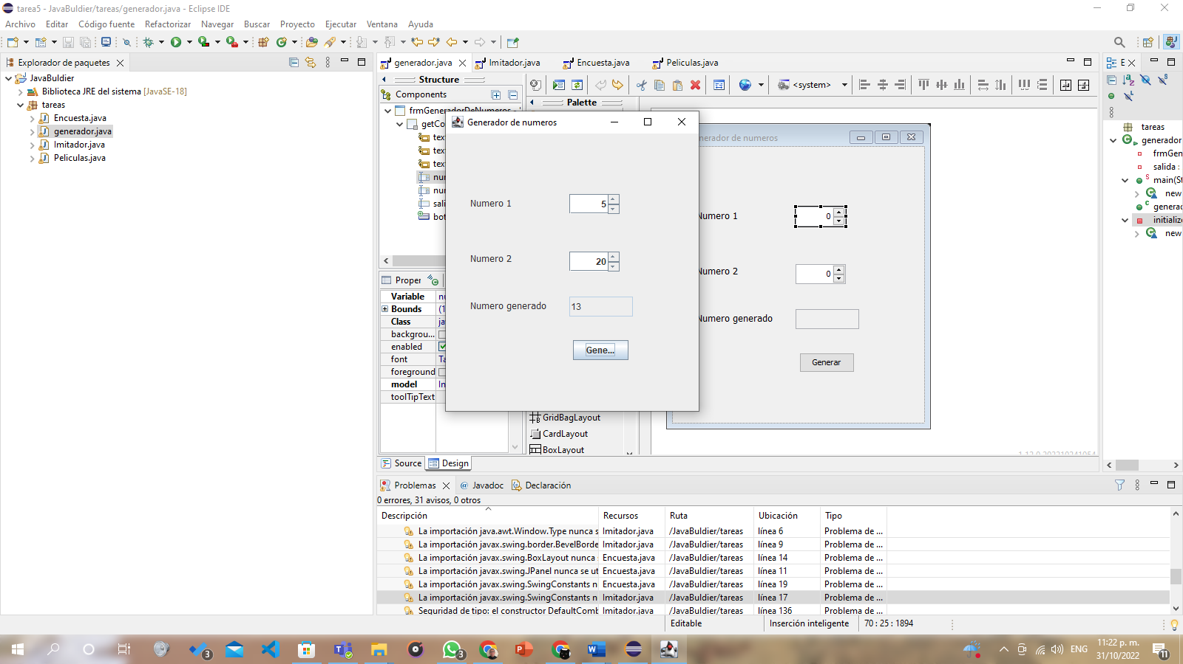

**Código**

**package** tareas;

**import** java.awt.EventQueue;

**import** javax.swing.JFrame;

**import** java.awt.Window.Type;

**import** java.awt.FlowLayout;

**import** javax.swing.JPanel;

**import** javax.swing.border.BevelBorder;

**import** javax.swing.border.TitledBorder;

**import** javax.swing.BoxLayout;

**import** java.awt.Component;

**import** javax.swing.JLabel;

**import** javax.swing.JRadioButton;

**import** java.awt.BorderLayout;

**import** java.awt.Font;

**import** javax.swing.SwingConstants;

**import** javax.swing.JCheckBox;

**import** javax.swing.JTextField;

**import** javax.swing.JComboBox;

**import** javax.swing.DefaultComboBoxModel;

**import** javax.swing.ButtonGroup;

**import** java.awt.event.ActionListener;

**import** java.awt.event.ActionEvent;

**import** java.awt.event.KeyAdapter;

**import** java.awt.event.KeyEvent;

**import** java.awt.event.ItemListener;

**import** java.awt.event.ItemEvent;

**public** **class** Imitador {

**private** JFrame frmImitador;

**private** JTextField texto1;

**private** JTextField texto2;

**private** JRadioButton op2;

**private** JTextField texto1_1;

**private** JTextField texto2_1;

**private** **final** ButtonGroup buttonGroup = **new** ButtonGroup();

**private** **final** ButtonGroup buttonGroup_1 = **new** ButtonGroup();

/**

* Launch the application.

*/

**public** **static** **void** main(String[] args) {

EventQueue.*invokeLater*(**new** Runnable() {

**public** **void** run() {

**try** {

Imitador window = **new** Imitador();

window.frmImitador.setVisible(**true**);

} **catch** (Exception e) {

e.printStackTrace();

}

}

});

}

/**

* Create the application.

*/

**public** Imitador() {

initialize();

}

/**

* Initialize the contents of the frame.

*/

**private** **void** initialize() {

frmImitador = **new** JFrame();

frmImitador.setTitle("Imitador");

frmImitador.setBounds(100, 100, 450, 496);

frmImitador.setDefaultCloseOperation(JFrame.***EXIT_ON_CLOSE***);

frmImitador.getContentPane().setLayout(**new** BoxLayout(frmImitador.getContentPane(), BoxLayout.***Y_AXIS***));

JPanel panel_up = **new** JPanel();

panel_up.setAlignmentY(0.0f);

panel_up.setAlignmentX(0.0f);

panel_up.setBorder(**new** TitledBorder(**null**, "", TitledBorder.***LEADING***, TitledBorder.***TOP***, **null**, **null**));

frmImitador.getContentPane().add(panel_up);

panel_up.setLayout(**null**);

JLabel text1 = **new** JLabel("Original");

text1.setBounds(10, 11, 46, 14);

panel_up.add(text1);

JPanel panel = **new** JPanel();

panel.setBounds(42, 61, 85, 150);

panel_up.add(panel);

FlowLayout fl_panel = **new** FlowLayout(FlowLayout.***CENTER***, 10, 15);

panel.setLayout(fl_panel);

JRadioButton op1 = **new** JRadioButton("Opcion 1");

buttonGroup_1.add(op1);

op1.setFont(**new** Font("Tahoma", Font.***PLAIN***, 14));

panel.add(op1);

op2 = **new** JRadioButton("Opcion 2");

buttonGroup_1.add(op2);

op2.setFont(**new** Font("Tahoma", Font.***PLAIN***, 14));

panel.add(op2);

JRadioButton op3 = **new** JRadioButton("Opcion 3");

buttonGroup_1.add(op3);

op3.setFont(**new** Font("Tahoma", Font.***PLAIN***, 14));

panel.add(op3);

JPanel panel_1 = **new** JPanel();

panel_1.setBounds(162, 61, 103, 150);

panel_up.add(panel_1);

panel_1.setLayout(**new** FlowLayout(FlowLayout.***CENTER***, 10, 15));

JCheckBox op4 = **new** JCheckBox("Opcion 4");

op4.setFont(**new** Font("Tahoma", Font.***PLAIN***, 14));

panel_1.add(op4);

JCheckBox op5 = **new** JCheckBox("Opcion 5");

op5.setFont(**new** Font("Tahoma", Font.***PLAIN***, 14));

panel_1.add(op5);

JCheckBox op6 = **new** JCheckBox("Opcion 6");

op6.setFont(**new** Font("Tahoma", Font.***PLAIN***, 14));

panel_1.add(op6);

texto1 = **new** JTextField();

texto1.addKeyListener(**new** KeyAdapter() {

@Override

**public** **void** keyTyped(KeyEvent e) {

texto1_1.setText(texto1.getText());

}

});

texto1.setBounds(302, 61, 103, 28);

panel_up.add(texto1);

texto1.setColumns(10);

JComboBox comboBox = **new** JComboBox();

comboBox.setModel(**new** DefaultComboBoxModel(**new** String[] {"Item 1 ", "Item 2", "Item 3", "Item 4"}));

comboBox.setBounds(302, 117, 103, 28);

panel_up.add(comboBox);

texto2 = **new** JTextField();

texto2.addKeyListener(**new** KeyAdapter() {

@Override

**public** **void** keyTyped(KeyEvent e) {

texto2_1.setText(texto2.getText());

}

});

texto2.setColumns(10);

texto2.setBounds(302, 175, 103, 28);

panel_up.add(texto2);

JPanel panel_Down = **new** JPanel();

panel_Down.setAlignmentY(0.0f);

panel_Down.setAlignmentX(0.0f);

panel_Down.setBorder(**new** TitledBorder(**null**, "", TitledBorder.***LEADING***, TitledBorder.***TOP***, **null**, **null**));

frmImitador.getContentPane().add(panel_Down);

panel_Down.setLayout(**null**);

JLabel lblEspejo = **new** JLabel("Espejo");

lblEspejo.setBounds(10, 11, 46, 14);

panel_Down.add(lblEspejo);

JPanel panel_2 = **new** JPanel();

panel_2.setBounds(42, 61, 85, 150);

panel_Down.add(panel_2);

panel_2.setLayout(**new** FlowLayout(FlowLayout.***CENTER***, 10, 15));

JRadioButton op1_1 = **new** JRadioButton("Opcion 1");

buttonGroup.add(op1_1);

op1_1.setEnabled(**false**);

op1_1.setFont(**new** Font("Tahoma", Font.***PLAIN***, 14));

panel_2.add(op1_1);

JRadioButton op2_1 = **new** JRadioButton("Opcion 2");

buttonGroup.add(op2_1);

op2_1.setEnabled(**false**);

op2_1.setFont(**new** Font("Tahoma", Font.***PLAIN***, 14));

panel_2.add(op2_1);

JRadioButton op3_1 = **new** JRadioButton("Opcion 3");

buttonGroup.add(op3_1);

op3_1.setEnabled(**false**);

op3_1.setFont(**new** Font("Tahoma", Font.***PLAIN***, 14));

panel_2.add(op3_1);

JPanel panel_1_1 = **new** JPanel();

panel_1_1.setBounds(162, 61, 103, 150);

panel_Down.add(panel_1_1);

panel_1_1.setLayout(**new** FlowLayout(FlowLayout.***CENTER***, 10, 15));

JCheckBox op4_1 = **new** JCheckBox("Opcion 4");

op4_1.setEnabled(**false**);

op4_1.setFont(**new** Font("Tahoma", Font.***PLAIN***, 14));

panel_1_1.add(op4_1);

JCheckBox op5_1 = **new** JCheckBox("Opcion 5");

op5_1.setEnabled(**false**);

op5_1.setFont(**new** Font("Tahoma", Font.***PLAIN***, 14));

panel_1_1.add(op5_1);

JCheckBox op6_1 = **new** JCheckBox("Opcion 6");

op6_1.setEnabled(**false**);

op6_1.setFont(**new** Font("Tahoma", Font.***PLAIN***, 14));

panel_1_1.add(op6_1);

texto1_1 = **new** JTextField();

texto1_1.setEnabled(**false**);

texto1_1.setColumns(10);

texto1_1.setBounds(302, 61, 103, 28);

panel_Down.add(texto1_1);

JComboBox comboBox_1 = **new** JComboBox();

comboBox_1.setModel(**new** DefaultComboBoxModel(**new** String[] {"Item 1 ", "Item 2", "Item 3", "Item 4"}));

comboBox_1.setEnabled(**false**);

comboBox_1.setBounds(302, 117, 103, 28);

panel_Down.add(comboBox_1);

texto2_1 = **new** JTextField();

texto2_1.setEnabled(**false**);

texto2_1.setColumns(10);

texto2_1.setBounds(302, 175, 103, 28);

panel_Down.add(texto2_1);

op1.addActionListener(**new** ActionListener() {

**public** **void** actionPerformed(ActionEvent e) {

op1_1.setSelected(op1.isSelected());

}

});

op2.addActionListener(**new** ActionListener() {

**public** **void** actionPerformed(ActionEvent e) {

op2_1.setSelected(op2.isSelected());

}

});

op3.addActionListener(**new** ActionListener() {

**public** **void** actionPerformed(ActionEvent e) {

op3_1.setSelected(op3.isSelected());

}

});

op4.addActionListener(**new** ActionListener() {

**public** **void** actionPerformed(ActionEvent e) {

op4_1.setSelected(op4.isSelected());

}

});

op5.addActionListener(**new** ActionListener() {

**public** **void** actionPerformed(ActionEvent e) {

op5_1.setSelected(op5.isSelected());

}

});

op6.addActionListener(**new** ActionListener() {

**public** **void** actionPerformed(ActionEvent e) {

op6_1.setSelected(op6.isSelected());

}

});

comboBox.addItemListener(**new** ItemListener() {

**public** **void** itemStateChanged(ItemEvent e) {

comboBox_1.setSelectedItem(comboBox.getSelectedItem());

}

});

}

**public** JRadioButton getOp2() {

**return** op2;

}

}

**Ejercicio 3-----------------------------------------**

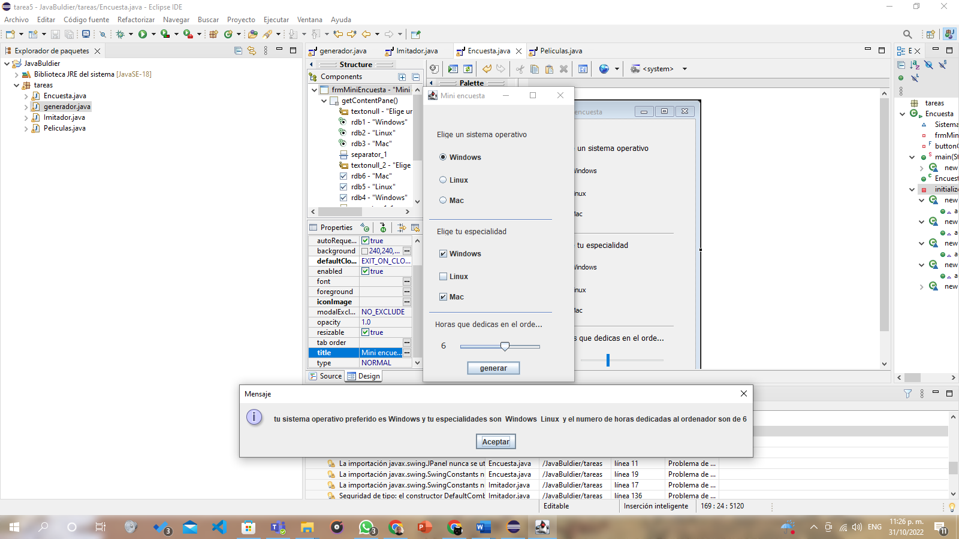

**Código**

**package** tareas;

**import** java.awt.EventQueue;

**import** javax.swing.JFrame;

**import** javax.swing.JLabel;

**import** javax.swing.JOptionPane;

**import** java.awt.BorderLayout;

**import** java.awt.Font;

**import** javax.swing.JPanel;

**import** javax.swing.JRadioButton;

**import** java.awt.FlowLayout;

**import** javax.swing.BoxLayout;

**import** java.awt.CardLayout;

**import** java.awt.Component;

**import** javax.swing.JSeparator;

**import** java.awt.Color;

**import** javax.swing.SwingConstants;

**import** javax.swing.JCheckBox;

**import** javax.swing.JSlider;

**import** javax.swing.JButton;

**import** javax.swing.event.ChangeListener;

**import** javax.swing.event.ChangeEvent;

**import** java.awt.event.ActionListener;

**import** java.awt.event.ActionEvent;

**import** javax.swing.ButtonGroup;

**public** **class** Encuesta {

String Sistema = "ninguno";

**private** JFrame frmMiniEncuesta;

**private** **final** ButtonGroup buttonGroup = **new** ButtonGroup();

/**

* Launch the application.

*/

**public** **static** **void** main(String[] args) {

EventQueue.*invokeLater*(**new** Runnable() {

**public** **void** run() {

**try** {

Encuesta window = **new** Encuesta();

window.frmMiniEncuesta.setVisible(**true**);

} **catch** (Exception e) {

e.printStackTrace();

}

}

});

}

/**

* Create the application.

*/

**public** Encuesta() {

initialize();

}

/**

* Initialize the contents of the frame.

*/

**private** **void** initialize() {

frmMiniEncuesta = **new** JFrame();

frmMiniEncuesta.setTitle("Mini encuesta");

frmMiniEncuesta.setBounds(100, 100, 268, 501);

frmMiniEncuesta.setDefaultCloseOperation(JFrame.***EXIT_ON_CLOSE***);

frmMiniEncuesta.getContentPane().setLayout(**null**);

JLabel textonull = **new** JLabel("Elige un sistema operativo");

textonull.setFont(**new** Font("Tahoma", Font.***PLAIN***, 13));

textonull.setBounds(23, 42, 180, 14);

frmMiniEncuesta.getContentPane().add(textonull);

JRadioButton rdb1 = **new** JRadioButton("Windows");

rdb1.addActionListener(**new** ActionListener() {

**public** **void** actionPerformed(ActionEvent e) {

Sistema = "Windows";

}

});

buttonGroup.add(rdb1);

rdb1.setBounds(23, 76, 134, 23);

frmMiniEncuesta.getContentPane().add(rdb1);

rdb1.setAlignmentY(0.0f);

JRadioButton rdb2 = **new** JRadioButton("Linux");

rdb2.addActionListener(**new** ActionListener() {

**public** **void** actionPerformed(ActionEvent e) {

Sistema = "Linux";

}

});

buttonGroup.add(rdb2);

rdb2.setBounds(23, 114, 154, 23);

frmMiniEncuesta.getContentPane().add(rdb2);

JRadioButton rdb3 = **new** JRadioButton("Mac");

rdb3.addActionListener(**new** ActionListener() {

**public** **void** actionPerformed(ActionEvent e) {

Sistema = "Mac";

}

});

buttonGroup.add(rdb3);

rdb3.setBounds(23, 148, 134, 23);

frmMiniEncuesta.getContentPane().add(rdb3);

JSeparator separator_1 = **new** JSeparator();

separator_1.setBounds(10, 191, 205, 2);

frmMiniEncuesta.getContentPane().add(separator_1);

JLabel textonull_2 = **new** JLabel("Elige tu especialidad");

textonull_2.setFont(**new** Font("Tahoma", Font.***PLAIN***, 13));

textonull_2.setBounds(23, 204, 180, 14);

frmMiniEncuesta.getContentPane().add(textonull_2);

JCheckBox rdb6 = **new** JCheckBox("Mac");

rdb6.setBounds(23, 309, 134, 23);

frmMiniEncuesta.getContentPane().add(rdb6);

JCheckBox rdb5 = **new** JCheckBox("Linux");

rdb5.setBounds(23, 275, 154, 23);

frmMiniEncuesta.getContentPane().add(rdb5);

JCheckBox rdb4 = **new** JCheckBox("Windows");

rdb4.setAlignmentY(0.0f);

rdb4.setBounds(23, 237, 134, 23);

frmMiniEncuesta.getContentPane().add(rdb4);

JSeparator separator_1_1 = **new** JSeparator();

separator_1_1.setBounds(10, 346, 205, 2);

frmMiniEncuesta.getContentPane().add(separator_1_1);

JLabel textonull_3 = **new** JLabel("Horas que dedicas en el ordenador");

textonull_3.setFont(**new** Font("Tahoma", Font.***PLAIN***, 13));

textonull_3.setBounds(20, 359, 180, 14);

frmMiniEncuesta.getContentPane().add(textonull_3);

JSlider slider = **new** JSlider();

slider.setValue(4);

slider.setMinimum(1);

slider.setMaximum(10);

slider.setBounds(55, 393, 148, 23);

frmMiniEncuesta.getContentPane().add(slider);

JButton boton = **new** JButton("generar");

boton.addActionListener(**new** ActionListener() {

**public** **void** actionPerformed(ActionEvent e) {

String especialidades ="";

**if**(rdb6.isSelected()) {

especialidades = especialidades + " Windows ";

}

**if**(rdb4.isSelected()) {

especialidades = especialidades + " Linux ";

}

**if**(rdb3.isSelected()) {

especialidades = especialidades + " Mac ";

}

String salida = "tu sistema operativo preferido es " + Sistema + " y tu especialidades son " + especialidades + " y el numero de horas dedicadas al ordenador son de " + slider.getValue();

JOptionPane.*showMessageDialog*(boton, salida);

}

});

boton.setBounds(73, 428, 89, 23);

frmMiniEncuesta.getContentPane().add(boton);

JLabel con = **new** JLabel("4");

con.setFont(**new** Font("Tahoma", Font.***PLAIN***, 14));

con.setBounds(30, 387, 19, 29);

frmMiniEncuesta.getContentPane().add(con);

slider.addChangeListener(**new** ChangeListener() {

**public** **void** stateChanged(ChangeEvent e) {

con.setText( String.*valueOf*(slider.getValue()));

}

});

}

}

**Ejercicio 4-----------------------------------------**

**Código**

**package** tareas;

**import** java.awt.EventQueue;

**import** javax.swing.JFrame;

**import** javax.swing.JLabel;

**import** java.awt.BorderLayout;

**import** java.awt.Font;

**import** javax.swing.JTextField;

**import** javax.swing.JButton;

**import** javax.swing.JComboBox;

**import** javax.swing.DefaultComboBoxModel;

**import** java.awt.event.ActionListener;

**import** java.awt.event.ActionEvent;

**public** **class** Peliculas {

**private** JFrame frmPeliculas;

**private** JTextField input;

/**

* Launch the application.

*/

**public** **static** **void** main(String[] args) {

EventQueue.*invokeLater*(**new** Runnable() {

**public** **void** run() {

**try** {

Peliculas window = **new** Peliculas();

window.frmPeliculas.setVisible(**true**);

} **catch** (Exception e) {

e.printStackTrace();

}

}

});

}

/**

* Create the application.

*/

**public** Peliculas() {

initialize();

}

/**

* Initialize the contents of the frame.

*/

**private** **void** initialize() {

frmPeliculas = **new** JFrame();

frmPeliculas.setTitle("Peliculas");

frmPeliculas.setBounds(100, 100, 535, 254);

frmPeliculas.setDefaultCloseOperation(JFrame.***EXIT_ON_CLOSE***);

frmPeliculas.getContentPane().setLayout(**null**);

JLabel texto = **new** JLabel("Escribe el titulo de una pelicula");

texto.setFont(**new** Font("Arial", Font.***BOLD***, 12));

texto.setBounds(24, 31, 265, 32);

frmPeliculas.getContentPane().add(texto);

JLabel texto2 = **new** JLabel("Peliculas");

texto2.setFont(**new** Font("Arial", Font.***BOLD***, 12));

texto2.setBounds(299, 31, 178, 32);

frmPeliculas.getContentPane().add(texto2);

input = **new** JTextField();

input.setBounds(34, 83, 142, 26);

frmPeliculas.getContentPane().add(input);

input.setColumns(10);

JButton boton = **new** JButton("Añadir");

boton.setBounds(57, 135, 77, 23);

frmPeliculas.getContentPane().add(boton);

JComboBox combo = **new** JComboBox();

combo.setModel(**new** DefaultComboBoxModel(**new** String[] {"Quantum of solace", "Avatar"}));

combo.setBounds(282, 84, 142, 25);

frmPeliculas.getContentPane().add(combo);

boton.addActionListener(**new** ActionListener() {

**public** **void** actionPerformed(ActionEvent e) {

combo.addItem( input.getText() );

input.setText("");

}

});

}

}