AT&T Inc. (also stylized as ATT and at&t) is an American multinational telecommunications.It is the largest provider both of mobile telephony and of fixed telephony^{[5]} in the United States, and also provides broadband subscription television services. As of 2012, AT&T is the seventh largest company in the United States by total revenue.

AT&T Inc. Historical chart
) Review the last 3 years of dividend payments - note any increases, decreases, stock splits, stock dividends, and news about the company that affected dividend payments Assess the prospects for the companies to continue or increase their dividends in the future (concentrate on future cash flows)

The company kept dividends pay amount almost constant at 2%. Positive thing is company did not reduce the amount of dividends paid out.

Possible company took conservative outlook, lacking confidence to generate target cash flows as recent years have seen global market slow down weakening investors sentiment and so kept low dividend payout. Retained earnings on the other hand compounded 13.54% since 2009.
Dividend yield despite a downfall has remained above 5%, fluctuating between 5.85% December ’09 to at present yield of 5.32% in Jan’13. Other important observation is company’s huge free cash flow (FCF). It signals that AT&T company is positive to pay debt, pay dividends, buy back stock and facilitate the growth of business all important undertakings from an investor's perspective.
On few occasions in order to boost its share price, company opted for 2-to-1 common stock split.
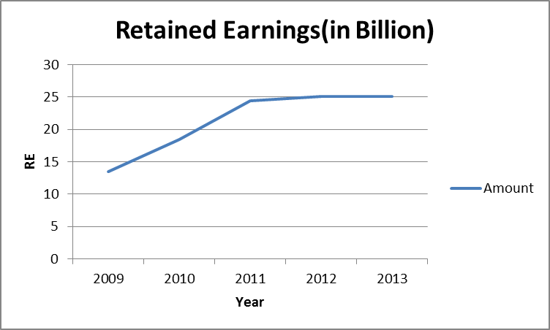 | 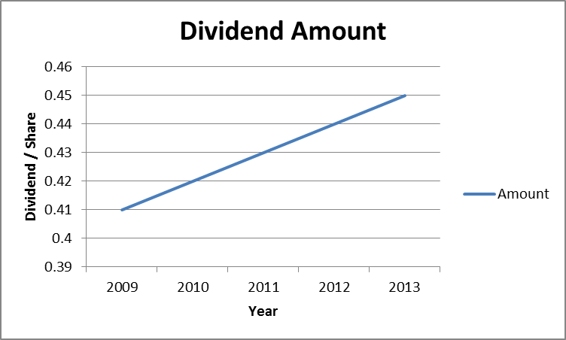
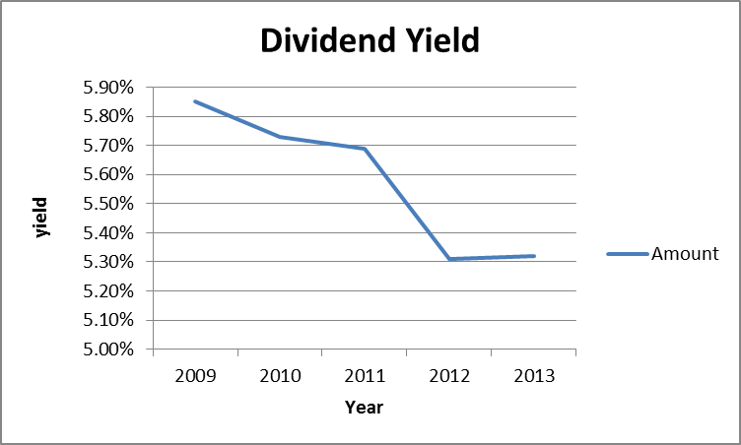 | 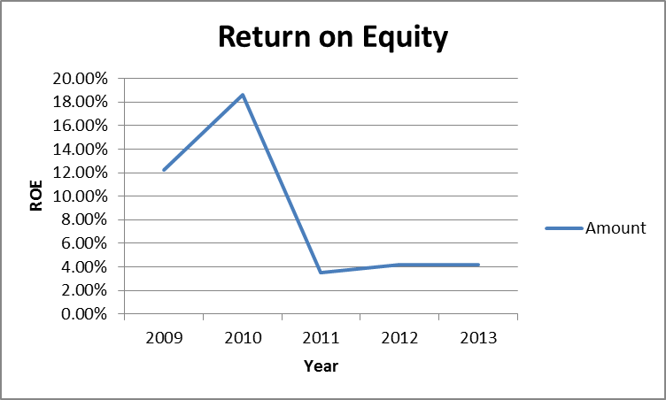
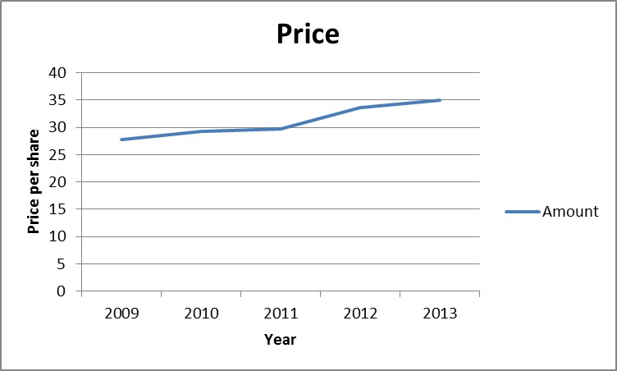 | 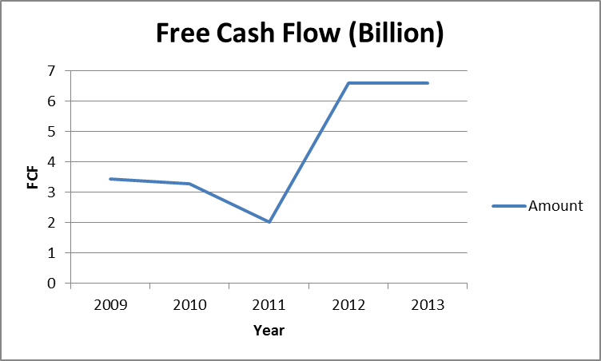

AT&T Inc. Historical Split Data
(formerly SBC Communications Inc./Southwestern Bell Corporation)
Year | Split Information
1998 | March 19 — 2-for-1 common stock split
1993 | May 25 — 2-for-1 common stock split
1987 | May 22 — 3-for-1 common stock split

Present Performance provides a positive future outlook for investors:
- 10% Increase in Earning Per Share: $0.66 compared to $0.60 diluted EPS in the year 2011
- 0.3% Increase in consolidated sales revenues of $31.6 billion
- Operating income margin of 30.3 percent
- $2.5 billion in stock buybacks; 75.8 million shares repurchased
- Huge Free cash flow of 6.608Billion
All the above numbers shows strong financial position and robust cash generation which are good indicator in terms of the future growth prospects of the company. Improved revenue margin in the Wireless, its core business, gives investors and consumer confidence that company going stable and strong.
Expected Stock Price (sub-question 2):
Using the Dividend Discount Model, -
- P0 = $33.66
- D0 = $0.44
- R = Return on equity = 4.36%
- D1 = D0 * (1 + g)
- P0 = D1 / (r - g)
- g = 3.0%
- P1 = D0* (1 + g)(1 + g) / (r - g)
- Expected stock price = $34.66
AT&T’s stock’s estimated price at the end of 2nd quarter of year 2013 is $34.66

