Bugs Fixed in MP_MIPS_CMP

Bug 1

Phenomenon
After the threads are forked, the program cannot go through (no PC value printed in ruu_dispatch function). Meanwhile, a lot of IL1_MISS events generated.

Reason
Tracing the code, ruu_fetch cannot fetch instructions due to Icache miss (this is correct, initially, there are a lot of Icache misses). In Yuan Xin’s Maya_SIM, the function cache_miss is used to test whether the delay slot of branch instructions are missed. However, each time cache_miss calls cache_access, which generate an IL1_MISS event. Thus, initially, in each for loop in ruu_fetch, a lot of IL1_MISS events are generated while the delay slot instruction cannot be fetched.

Solution
In the original CMP_SIM, in the for loop of ruu_fetch, there is a condition, current-> ruu_fetch_issue_delay. This variable makes sure that, if there is Icache miss, the Icache is not accessed to avoid excessive events. ruu_fetch_issue_delay is set to be the latency of Icache miss, and reset to 0 when ACK_DIR_IL1 message is received (in dir_operation). So the flow of the instruction fetch is as in Fig. 1.
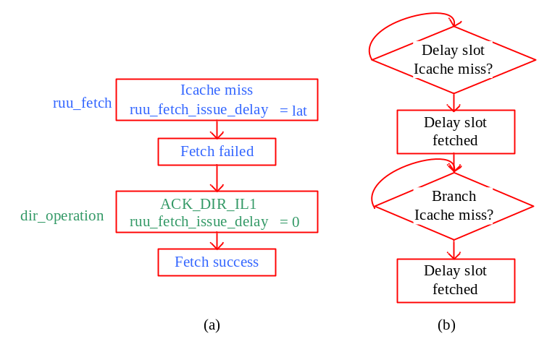
Fig. 1 (a) the flow of Icache miss and fetch success for one instruction. (b) the flow for the bundle of branch and delay slot instructions.
Fig. 1 shows the flow for the branch instructions. Both of the delay slot and the branch should be Icache hit, before the fetch could proceed. The cache_miss function written by Yuan Xin is actually the same as the cache_access function calls in the ruu_fetch function. The return value of cache_miss function is modified to be lat -1.
if (lat != cache_il1_lat)
{
/* I-cache miss, block fetch until it is resolved */
return (lat - 1);
}

The code of ruu_fetch function is modified as follows.

for (... && !current->ruu_fetch_issue_delay &&
...
{
if (MD_OP_FLAGS(op) & F_CTRL)
{ ...
if (!current->wait_for_fetch)
{
int lat_wxh = cache_miss(current->fetch_regs_PC + sizeof(md_inst_t),
current->id);
if(lat_wxh)
{
current->ruu_fetch_issue_delay += (lat_wxh - 1);
current->wait_for_fetch = 2;
break;

Bug 2

Phenomenon
When running the MP_MIPS benchmark, the output is messy.

Reason
It must be the problem of the locks. Tracing LL and SC implementation, in the function completeStore, the return value of sc t, o(b), should be 0 (register t).

Solution
The index of the register should be,

current->regs.regs_R[((inst >> 16) & 0x1f)] = 0;

