Bugs Fixed in Single-core MIPS_CMP

Bug 1

Phenomenon
Panic DIR fifo full.

Reason
This panic is quite odd. Cannot easily locate which instruction causes the panic. It appears in dir_fifo_enqueue function in cache.c. This function tries to enqueue the L1 miss event into L2 directory.
When the benchmark uses malloc function, this panic shows up with –O, -O3, or no optimization option. However, with –O2, the empty routine in EEMC does not show the panic, it will finish normally. When the panic shows up, it seems to appear in the very beginning of the benchmark, i.e., the printfs above the malloc function or data chunk operation also does not show.
Later I write a test benchmark. It mallocs an array of a structure with large integer array. The benchmark is compiled with –O2. The weird thing is that, if the for statement is added, the panic shows up. Without the for statement, everything goes well. Even if the loop is unfolded, the routine also goes well. So, the problem is not the functional model of the simulator.
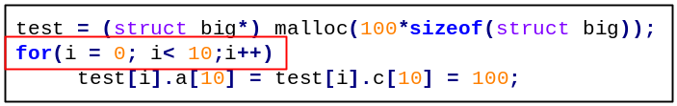

Solution
Set the directory FIFO port to a large number or remove the bound of it.
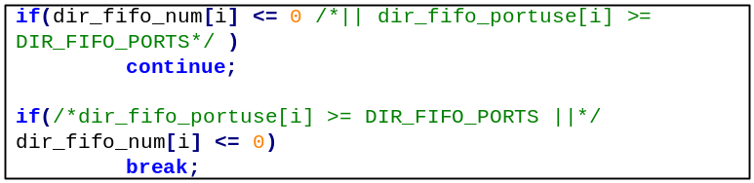

Bug 2

Phenomenon
Panic: write buffer miss-alignment.

Reason
When traced the instructions, it is found that the SDC1 instruction causes the panic. Two structures cause this panic, i.e., m_L1WBuf and WBtable.
- In ruu_commit, m_L1WBuf[][]->addr is set to be the addr of rs->PC. Then the function completeStore is called according to this address. In completeStore, MEM_WRITE_* is called which finally write the data into memory.
- In the machine.def, where each instruction is implemented, SCD1 instruction will call WRITE_WORD twice to write a 64-bit double float. WRITE_WORD calls WB1_access or spec_mem_access. WB1_access calls mem_access (spec_mem_access is similar). Inside mem_access, WBtable entry ent stores the SDC1 store value for a short time.
Thus, in Yuan Xin’s implementation, where SCD1 calls WRITE_WORD twice, there will be two WBtable entries but only one m_L1WBuf[][]->addr committed, so is the difference.

Solution
- Change the SDC1 implementation in machine.def into WRITE_QWORD.
- According to mem_access, the MD_SWAPQ macro (risc.h) should be the parameter itself, i.e., no swap. Because, in mem_access, the qword are actually write twice.
#define MD_SWAPQ(X) (X)

- In machine.def, follow the way in mem_access, a word_t * pointer is used to assemble the two parts of the qword_t.
qword_t wxh_q; \
word_t*wxh_ptr = (word_t*)&wxh_q; \
if ((FT) & 01) \
DECLARE_FAULT(md_fault_alignment); \
*wxh_ptr = FPR_L(FT) ;\
wxh_ptr++;\
*wxh_ptr = FPR_L((FT)+1); \
WRITE_QWORD(wxh_q, GPR(BS) + OFS, _fault); \

- Set SDC1 to 8 in GetMemAcc (instManip.c). completeStore uses this function to write a qword.
- In sim-outorder.c, set the HOST_HAS_QWORD macro to allow WRITE_QWORD and temp_qword be defined.

Bug 3

Phenomenon
Panic: inst completed and !ready, !issued, or completed. (in ruu_writeback)
When running cjpeg.out, the panic is caused by an SLL instruction at 0x4005e54. This instruction enters the ruu_writeback three times. At the last time on entering ruu_writeback, rs->queued is 1, issued 0, and complete 0. However, they should be 0, 1, 0 (running in Yuan Xin’s simulator).
In Yuan Xin’s MAYA_SIM, the event corresponding to the rs of SLL should be readyq_enqueue’ed in ruu_writeback by it’s predecessor instruction LW. The LW instruction checks the odep in ruu_writeback and enqueues the event related to the rs of SLL. However, in my simulator, the event corresponding to rs of SLL could be enqueued in ruu_dispatch, and even in ruu_issue(function units are not sufficient).

Solution
Change the ALU number in the config file (config_mesh_ooo) to match the issue and decode width.

Bug 4

Phenomenon
When running EEMBC benchmarks like rgbhpg01.out, no instruction execution progress prompt shows up for a long time.

Reason
After running the benchmark and simulator in gdb, it is found that, the sim_num_inst never changes after reaching a certain value. Later, by stepping into the pipeline, I found that in ruu_dispatch, the following if condition is satisfied, the waitForSTLC is 1 and thus, the following instructions cannot be dispatched.

if ((thecontexts[threadid]->waitForBranchResolve == 1) || (thecontexts[threadid]->waitForSTLC))
{
stallCause[threadid] = StallSTLC;
break;
}

Searching for all the occurrence of waitForSTLC, it is set in the WB1_access function.
if (op == 35)
{
thecontexts[threadID]->waitForSTLC = 1;
}

Solution
Change the condition into SC.
if (op == SC)

