Multi-core Programming in Alpha-CMP

Introduction
In this document, I will introduce the paradigm of the multi-core programming in Alpha-CMP and how the Alpha-CMP simulator support multi-core programming. I will use the word benchmark as the multi-core program. To program, two files are needed, i.e., barrier.h and func.s. These two files define the APIs like in Pthread, e.g., barrier and locks. Fig. 1 shows the interaction of the benchmark and the simulator.

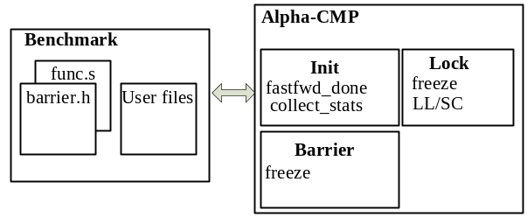
Fig. 1 Interaction of the benchmark and the simulator.

Programming the benchmarks
There are two files needed in programming, i.e., barrier.h and func.s. In func.s, the APIs are defined. These APIs are,
- MTA_fork, creates new threads, uses syscall fork,
- MTA_getthreadID, return thread ID, uses syscall getthreadID
- MTA_Stats, signifying the start and end of real execution, uses syscall Stats,
- MTA_Bar_Stats, used together with the function barrier, uses syscall Bar_Stats,
- MTA_Lock_Stats, uses syscall Lock_Stats,
- MTA_Lock_Acquire, used together to get a lock, uses syscall Acquiesce,
- MTA_Lock_Release, used to release a lock, no syscall,
- MTA_acquiesce, used in the function barrier, uses syscall Acquiesce,
- MTA_Bar_Instr. the function barrier, uses syscall Bar_Instr,
- MTA_wait, end the program, uses syscall Wait.
To program, the user needs to write in the following paradigm.
Barrier init;
Fork all the threads;
Barrier;
MTA_Stats(1);
Computing kernel, may include locks
MTA_Stats(0);
MTA_wait

Next, an example is shown. In this case, the real work horse uses the my_id, which is the local variable of main().
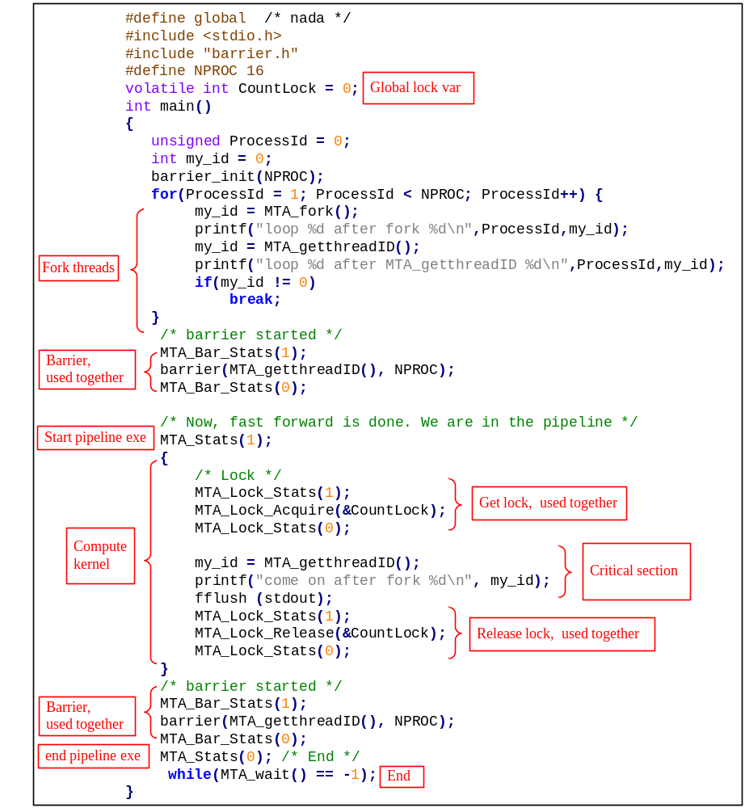

The critical section could be replaced to the following code. In this case, the return value function MTA_getthreadID() is used.
printf("and you after fork %d\n", MTA_getthreadID());

The compute kernel could be function calls as follows. We can update both local variables and global arrays in the critical section.

volatile int test_id[100] = {0};
void Work()
{
MTA_Lock_Stats(1);
MTA_Lock_Acquire(&CountLock);
MTA_Lock_Stats(0);

test_id[MTA_getthreadID()] = MTA_getthreadID();
printf("wxh after fork %d\n", test_id[MTA_getthreadID()]);
fflush (stdout);

MTA_Lock_Stats(1);
MTA_Lock_Release(&CountLock);
MTA_Lock_Stats(0);
}
void Work1()
{
int test_id;
MTA_Lock_Stats(1);
MTA_Lock_Acquire(&CountLock);
MTA_Lock_Stats(0);

test_id = MTA_getthreadID();
printf("heihei after fork %d\n", test_id);
fflush (stdout);

MTA_Lock_Stats(1);
MTA_Lock_Release(&CountLock);
MTA_Lock_Stats(0);
}

Synchronization in Alpha CMP simulator
To support the thread creation and management in CMP simulator, several mechanisms are used in the simulator. Fig. 2 shows the overall flow of a benchmark running in the simulator. The first one is the fast forward mode, where threads are created before entering the pipeline.

Fast forward mode
In fast forward mode, the simulator only acts as an instruction interpreter, instead of entering the pipeline execution. In this mode, the threads must be forked and the first barrier be reached. After the fast forward mode, the simulator enters the normal mode, where the instructions are run in the pipeline.
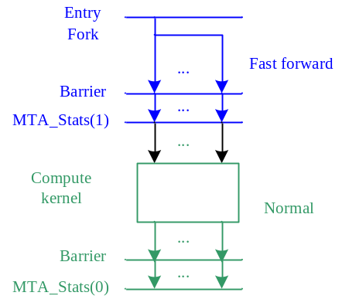
Fig. 2. Execution flow of the benchmarks.

There are two variables signifying the status in the fast forward mode. They are the fastfwd_done and collect_stats. fastfwd_done is set by MTA_Barrier_Stats(1), and collect_stats by MTA_ Stats(1). fastfwd_done is used to indicate that threads creation is done. collect_stats is used to indicate that the first barrier is reached and we can start the normal mode to enter the compute kernel. Fig. 3(a) shows the flow of the fast forward mode. Fig. 3(b) shows the relationship of the stacks of different threads.
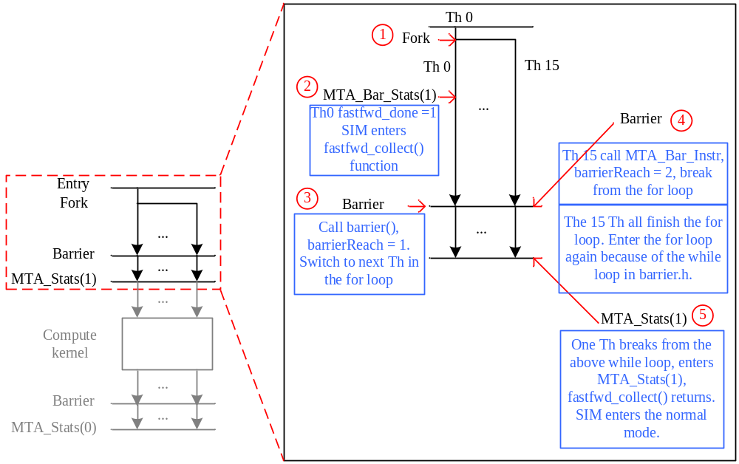
(a)
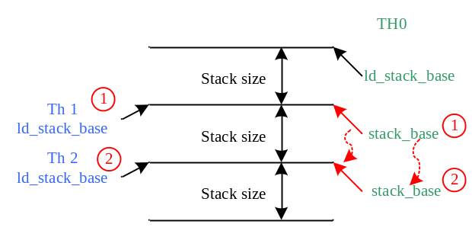
(b)
Fig. 3 (a). The flow of fast forward mode. (b) Relationship of the stacks of the threads.

Syscalls
Fig. 4 shows the relationships of the syscalls and APIs. In the following sections, some important syscalls will be introduced.

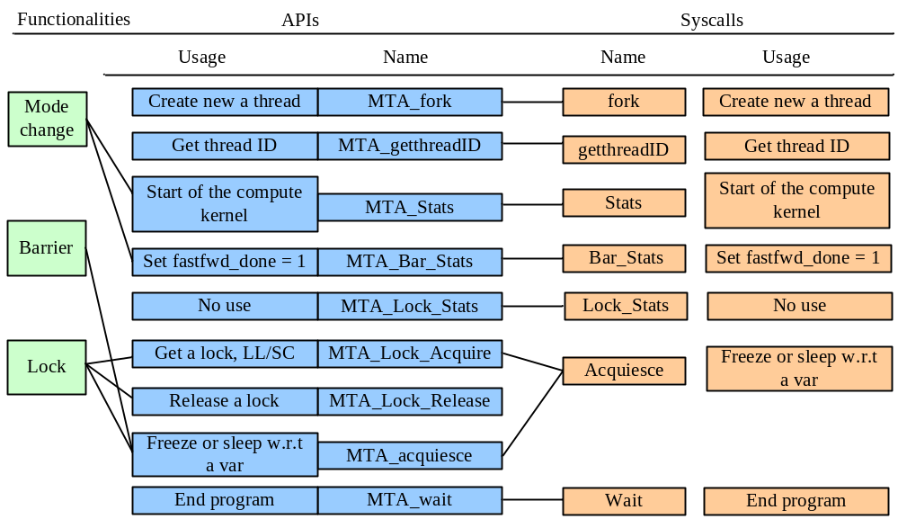
Fig. 4. the relationship of APIs and syscalls

- fork, creates new threads, should be done in the fast forward mode,
- getthreadID, return thread ID,
- Stats, signifying the start and end of real execution. When the parameter is 1, the compute kernel is started, and the fast forward mode is finished. Threads must be all forked before calling this syscall.
- Bar_Stats, set fastfwd_done to be 1, to signify that the threads are all forked. Just ignore the other variables, they are useless. The parameter value of 0 is also useless.
- Lock_Stats, useless, neither of the variables are used.
- acquiesce, the parameter is an address addr. The thread simply freeze (freeze =1 and running = 0) in the normal mode. Note that in the fast forward mode, the thread will keep going. addr is recorded in quiesceAddr. The function of acquiesce is to accelerate simulation, i.e., to replace the while spin in the benchmark. There are two cases that a thread can be out of freeze and run again,
  - in cache_access function, if another thread writes the address matched in quiesceAddr, which means that the other thread release the lock or barrier. This thread is waken up. The flow can be shown as in Fig. 5.

if (cmd == Write)
{
for (cnt = 0; cnt < numcontexts; cnt++)
{
if ((quiesceAddrStruct[cnt].address == addr))
{
thecontexts[cnt]->freeze = 0;
thecontexts[cnt]->running = 1;
quiesceAddrStruct[cnt].address = 1;
quiesceAddrStruct[cnt].threadid = -1;

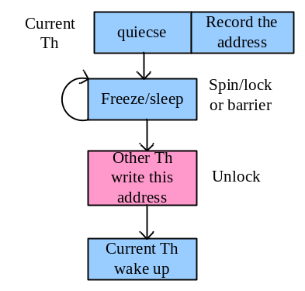
Fig. 5. Flow of thread freeze (by acquiesce) and wakeup.

  - in sim_main, some threads are waken up randomly, so that they can pass the barrier/lock.
- Bar_Instr, set BarrierReached variable, to break from the for loop in fastfwd_done.
- wait, end the program.

Barrier
The principal of the barrier implementation is from the book “Parallel computer architecture”, section 7.10 (or 7.9 in Chinese translation). The barrier follows the idea of “combining tree with local spins”.

    - Principal
Each thread corresponds to a node in the tree. Logically, there are two trees, i.e., an arrival tree (child_ready) and wakeup tree (wkup_child_flags). In the arrival tree, the children tell their parents that they’ve arrived. In the wakeup tree, the parents tell their children, it’s time to go. Fig. 6(a) shows how the two tree work and Fig. 6(b) illustrates the flow of the barrier.
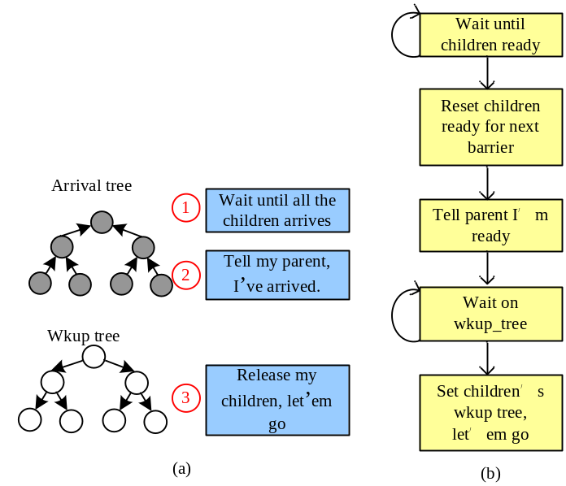
Fig. 6 (a) Two trees in barrier. (b) work flow of the barrier.

    - Tree setup
Assume there are tree nodes, we have a 2-level 8-radix tree. Fig. 7 shows the tree structure. The arrive tree tree[i].child_ready[j] is shown as in Table I. Table II shows the node and entry variable for different tree nodes.

Table I. The tree[i].child_ready[j] value of different nodes.
i | tree[i].child_ready[j]
0 | 1 1 1 1 1 1 1 1
1 | 1 1 1 1 1 1 1 1
2 | 1 1 1 1 1 1 1 1
3 | 0 0 0 1 1 1 1 1
4 | 1 1 1 1 1 1 1 1
5 | 1 1 1 1 1 1 1 1
6 | 1 1 1 1 1 1 1 1
7 | 0 0 0 1 1 1 1 1
8 | 1 1 1 1 1 1 1 1
9 | 1 1 1 1 1 1 1 1
10 | 1 1 1 1 1 1 1 1
11 | 0 0 0 1 1 1 1 1
12 | 1 1 1 1 1 1 1 1
13 | 1 1 1 1 1 1 1 1
14 | 1 1 1 1 1 1 1 1
15 | 0 0 0 1 0 0 0 1

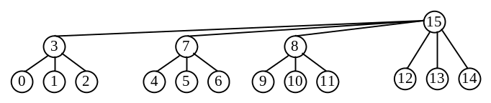
Fig. 7. The tree with 16 nodes.

    - Flow of barrier in barrier.h
Fig. 8 shows the flow of the barrier() function. Fig. 8 can be compared with Fig. 6. The implementation follows exactly the way introduced in the book. The only difference from the book is that, some threads can be randomly selected to cross the barrier as introduced in section 3.2.
The tree buildup part is not very clear. However, we can print the entry and node variables to find the structure of the tree by copying the code into Visual Studio and run.

Table II. The node and entry value of different nodes.
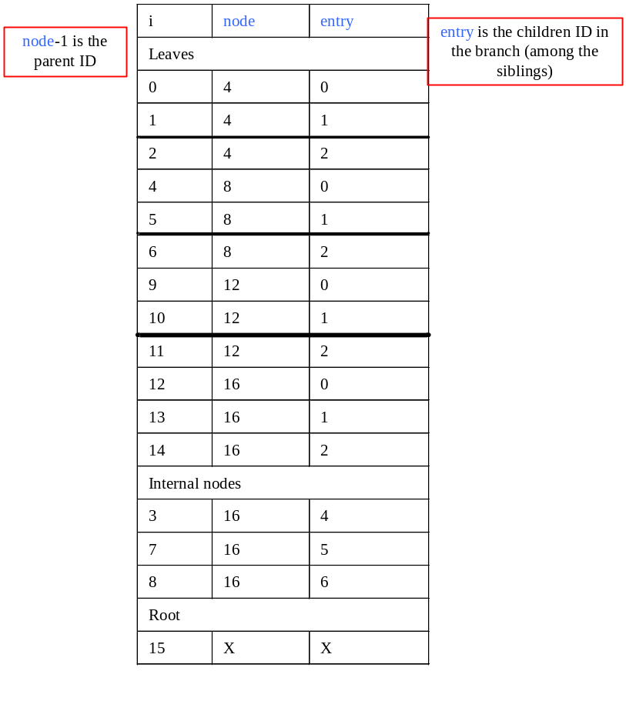

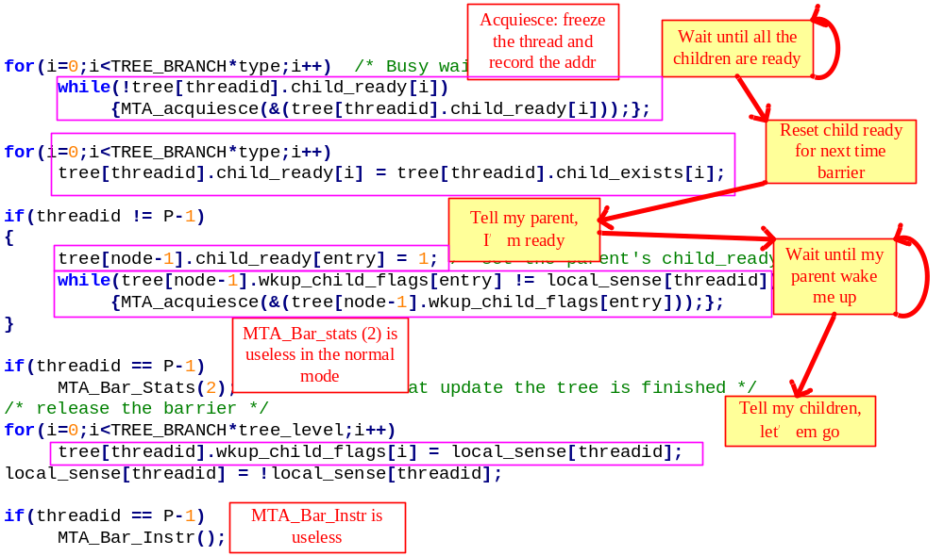
Fig. 8. The flow of barrier in the function barrier().

Locks
Implementation of locks is based on the instructions LL/SC. There are many variables related to STL_C. However, most of these variables are only used in statistics. The functional model for LL/SC is in LL implementation in machine.def and completeStore function.

    - Lock API
The lock API is exactly the same as in the book of “Computer architecture: a quantitative approach” (section 4.5, 4th Ed).
Lock:
$L1: ldl_l V0, 0(A0)
beq V0, $L2
syscall Quiecse
br $L1
$L2:
bis V0, 1, V0
stl_c V0, 0(A0)
beq V0, $L1
ret

Release Lock:
stl $31, 0(A0)
ret

    - LL instruction
In machine.def, the LL instruction is implemented. The difference of LL from normal load instruction is that, LL will record the address of the lock into common_regs_s[][].Address and set common_regs_s[][].regs_lock to 1 (1 is free and 0 is locked up). Thus, common_regs_s[][].regs_lock acts as a global synchronization variable.

    - SC instruction
In machine.def, SC is the same as normal store instructions. In the completeStore function,
  - If the address matches common_regs_s[][].Address, common_regs_s[][].regs_lock is 1 (get the lock) and isFall is 0, set common_regs_s[][].regs_lock of other competing threads to 0 (lock’em up). Then write memory.
  - Otherwise, this thread fails in competition. Set the return value to 0. (It needs to be updated for MIPS).
The isFall parameter of the completeStore function is set to 0 in ruu_commit. It is set to be 1 if L1 cache misses, which will make the thread fails in SC.

    - Flow of the lock
Fig. 9 shows the lock competition.
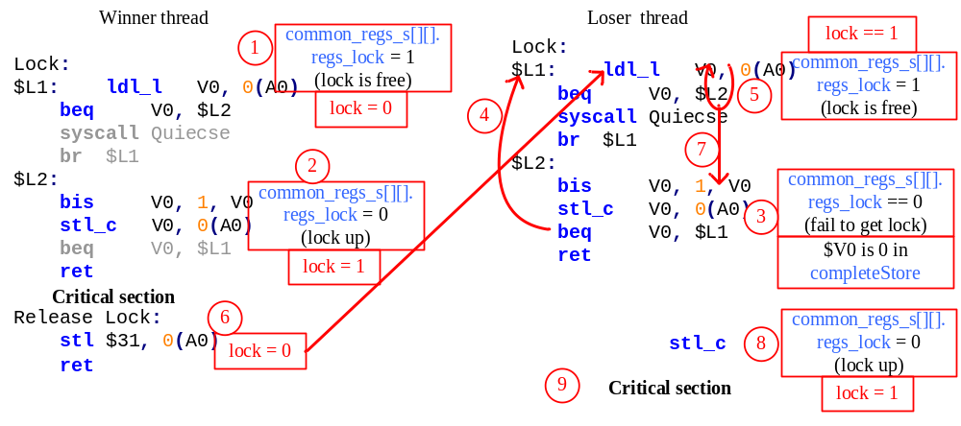
Fig. 9 Flow of the lock competition.

Porting to MIPS CMP simulator
There are several modules need to be changed in the Alpha_CMP simulator.
- Benchmark
  - Change func.s to be MIPS instructions,
- Simulator
  - Add delay_slot to the fast forward mode. MIPS CMP simulator should run the single core program in the fast forward mode.
  - LL/SC instruction in machine.def.
  - op == 35 is also a STL_L operation.
  - Various parts of code modified when porting single core MIPS simulator (documented as question marks in another doc.).

