Networking in the CMP Simulator

Introduction
In this document, the network-on-chip module and the messaging protocols will be introduced. In the simulator, the messages are inserted to the network by the cache system. Fig. 1 shows the overview of the messaging and networking system.
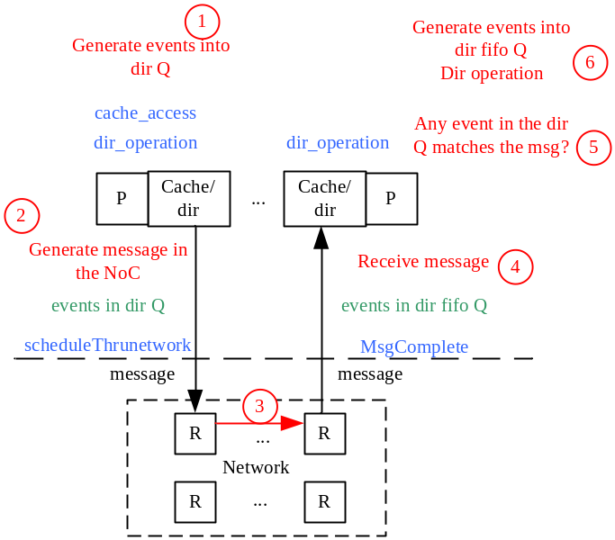
Fig1. Overview of the messaging and networking system

Interface between the memory and NoC system
Logically, the cache system generates messages according to the protocol (e.g., MESI). Then the messages are injected into the network. In the simulator, the cache system and the network have different event queues. Fig. 1 shows the cooperation of the event queues.
- The dir events are generated when accessing cache or in directory operations.
- These dir events are inserted into the dir queue and messages with EVG_ type are inserted into the network.
- The EVG_ type messages will be used to generate ROUTER_ type messages and traverse in the network.
- After the destination router receives the flit, the events in the dir queue are compared against the flit info (e.g., the source, destination ID, message No. etc). If one of the event matches, the event will be popped from the dir event and put into the dir fifo event queue.
- The dir fifo event queue is checked to perform the necessary operation.

The network-on-chip module

The message types
There are four types of messages as follows.
EVG_: the highest level message,
- Production. Messages of this type are produced by the caches and directories.
- Consumption. Function receive_packet calls inject_packet, to generate flits and put them into the input buffers of routers (input_module_).
ROUTER_: in the network, messages of this type is generated to trigger the polling of events (messages) of the routers.
- Production. Messages of this type are produced once a previous ROUTER_ type message is consumed.
- Consumption. Start the traversal of the five pipeline stages of the router.

WIRE_: simulate the link traversal.
- Production. Messages of this type are produced in the flit_traversal stage.
- Consumption. On reception of messages of this type, function receive_flit is called so that, flits are put into the upstream routers’ input buffer.
CREDIT_: indicate the (output) buffer status, could be used as in adaptive routing.
- Production. In flit_outbuffer and routing_decision stage.
- Consumption. Increase the upstream routers’ output_module_.counter_.

Router pipelines
A router has five pipeline stages, i.e., routing decision, VC arbitration, SW arbitration, flit outbuffer, and flit traversal. The input_module_ has a member variable state_, indicating which stage the head flit is in.

3.2.1 Routing decision
The input_module_.states_[in port #][vc #] could be ROUTING_, indicating the head flit; or HOME_, indicating the body or tail flit; or INIT_, indicating empty buffer.
A routing function(e.g., XY ) is called to find out the output port #. If the destination of the flit equals to the ID of current node, the function accept_flit is called. The function accept_flit calls popMsgComplete to find an event in the dir event queue to match the message. This flit will no long enter the following stages.
A CREDIT_ type message will be generated to inform the upstream router about the buffer status of the current router.
input_module_.states_ is updated to VC_AB_.

3.2.2 VC arbitration
The input to this stage is input_module_.states_.routing[][], indicating the (output port #, vc) request.
- Call vc_selection function, select a free (output port #, vc) pair according to output_module_.usage_[][];
- Set up the STL<map> variable vc_o_i_map: (output port #, vc) → vector of (input port #, vc). Find a vc_win among the (input port #, vc)’s;
- The winner sets input_module_.crouting_[input port #][vc #] to be (output port #, vc);
- output_module_.usage_[output port #][vc #] is set to be USED;.
- output_module_.assign_[output port #][vc #] is set to be (input port #, vc) ;
- input_module_.states_[][] is updated to SW_AB_.

3.2.3 SW arbitration
- Check the output_module_.counter_ (whether the downstream router has sufficient buffers);
- The variable vc_i_t records all the input ports that requesting for this output port;
- Find a crouting_[][] in the input_module_ and fill in the variable vc_o_map: output port # → vector of (input port #, vc). Find a vc_win among the (input port #, vc)’s;
- Find the flit in the input_module_ according to vc_win;
- input_module_.states_[][] is updated to SW_TR_.

3.2.4 flit outbuffer
- Find the crouting_[][] in the input_module_ in last stage to get the (input port #, vc) → (output port #, vc) map;
- Decrease output_module_.counter_[][] and generate a CREDIT_ type message;
- Remove the flit in the input buffer and add to the output buffer;
- Add (output port #, vc) to output_module_.outaddr: output port # →(output port #, vc);
- If the flit is TAIL, delete the flit in the output buffer;
- input_module_.states_[][] is updated to
            - ROUTING_, if the input buffer is not empty and the first flit is HEAD,
            - SW_AB_, if the input buffer is not empty and the first flit is BODY,
            - INIT_, if the input buffer is empty

3.2.5 flit traversal
A message of WIRE_ type is generated. The output buffer is deleted.

Code to change topologies
Fig. 2 shows the IDs of the directions in each router. There are three locations related to the topologies, which are very similar in the code structure.
- In the routing decision stage, when the routing function is called. The indices of routing_[][] variable could be understood with the help of Fig. 2.
- In the flit traversal stage, when updating the value of wire_pc_t and wire_add_t.
- In the routing decision stage and the flit outbuffer stage, when updating the value of credit_pc_t and credit _add_t.

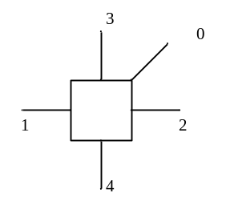
Fig. 2. The IDs of the direction of each router in a 2D mesh.

