Three Dimension Mesh Implementation in MP_MIPS_SIM

Introduction
This document introduces how to implement the 3D mesh topology in the simulator. As in the original simulator, the messages use 2D coordinates (e.g., src1, src2) to describe the source and destinations in the cache.c file, we would leave most of the code unchanged in files like cache.c or network.c. In summary, we only change the code inside the network, where most of the work is to build a resource/processor-to-network map table.

Processor/resource-to-network map table
The processor-to-network map table (P2NMT) is used to convert the coordinates of the processors to the network coordinate as in Fig. 1. P2NMT is stored by the variable MappingTable and generated in function Generate3DMeshProcNetworkID.
- The 2D coordinate of the processors are generated by UR in a (y, x) manner, i.e., the same as in a matrix.
- Proc ID is the original threadid, which calculated as
  - (y - MEM_LOC_SHIFT)*mesh_size+x for cache/processors, and
  - -1 for memory controllers.
- The network ID is related to the 3D coordinate (x, y, z) which is calculated as z* DIM_X*DIM_Y + y*DIM_X+ x. We need to map the ProcID to the
- The network (x, y, z) is the desired coordinate, it is used in the routing, wiring, etc.
- The network (y, x) in the original Popnet is also in the (y, x) manner.
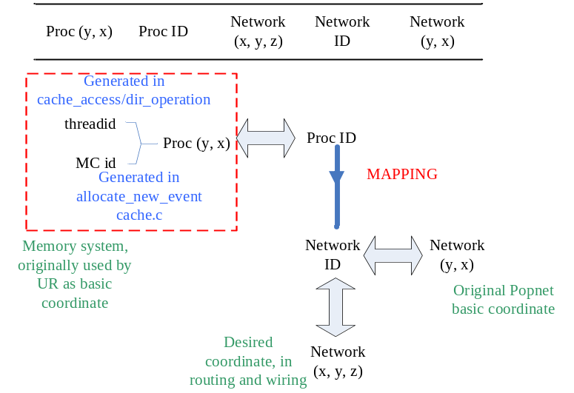
Fig. 1 the processor/resource-to-network map table
Fig. 1 shows the usage and relationships of the coordinates. In the following, we will discuss each of the coordinates and the IDs.

Coordinate in the memory system (UR)
The memory system assumes the underlying topology is a 2D mesh. In functions like cache_access and dir_operation, the threadid is converted to the coordinate as (c1, c2) which is (y, x). This coordinate is like the indexing in a matrix.
The processors/caches are shifted one row below as,
c1 = threadid/mesh_size+MEM_LOC_SHIFT;
c2 = threadid%mesh_size

The memory controllers are distributed to the first and the last two rows as,
if((c1-MEM_LOC_SHIFT)/(mesh_size/2))
new_event->c1 = mesh_size+1; /* each column has a memory access port */
else
new_event->c1 = 0;
switch(c2/(mesh_size/(mem_port_num/2))) /* right side memory port */
{
case 0:
c2 = mesh_size/(mem_port_num/2) - 1;

Fig. 2 shows how the (y, x) coordinates distributed. A processor with a threadid is converted to the region represented by the rectangular. MEM_LOCL_SHIFT is added to the y coordinate of the threadid. The memory controllers have y coordinate of either 0 or mesh_size +1, i.e., in the first and last row. Finally, the dashed columns are not used.
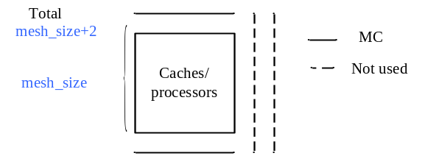
Fig. 2 the coordinate distribution in the memory system.

Coordinate in the Popnet
Popnet uses (y, x) to index each node. To support 3D coordinate, we have to first convert the network (y, x) to network ID by setting it as y *ary_size + x. ary_size* ary_size is the size of the network. Thus, the 3D coordinate can be calculated as

z = NetworkID / (DIM_X*DIM_Y);
y = ( NetworkID / (DIM_X*DIM_Y) ) / DIM_X;
x = ( NetworkID / (DIM_X*DIM_Y) ) % DIM_X;

Mapping of the processor ID to the network ID
We use the function Generate3DMeshProcNetworkID to map the processor ID to the network ID as in Fig. 3. Specifically, the cache/processor nodes(with a threadid) are mapped to the 1~DIM_Z-1 layers, while the memory controllers are mapped to the bottom layer.

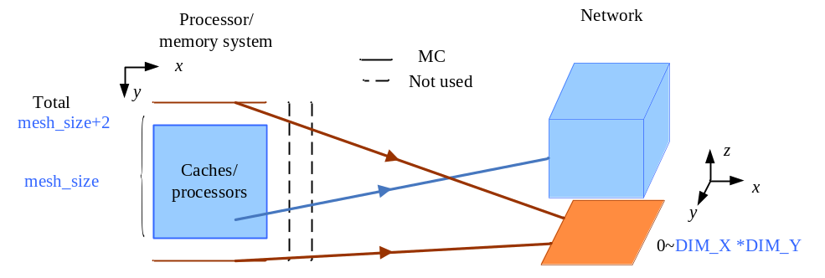
Fig. 3 mapping of the Proc ID to the network ID.

- The processor/cache nodes are restored to ProcID = (i - MEM_LOC_SHIFT)*mesh_size+j. Then the network (x, y, z) are calculated with network_z increased by 1.
new_z = ProcID / ( DIM_X*DIM_Y) +1 ; // let the bottom layer be the memory
new_y= (ProcID % (DIM_X*DIM_Y) )/ DIM_X;
new_x = (ProcID % (DIM_X*DIM_Y) )% DIM_X;

- The MCs are distributed to the bottom layer. We simply increase the network ID of the MCs.
new_z = 0;
NetworkID = MC_index++;
new_y = (NetworkID %(DIM_X*DIM_Y)) /DIM_X;
new_x = (NetworkID %(DIM_X*DIM_Y)) %DIM_X;

Interfacing the memory and network
To avoid confusion, we use the Proc ID and Proc coordinate in the memory system, and the network ID, network (y, x) and network (x, y, z) in the Popnet.
- The messages with Proc (y, x) are transformed into the network (y, x). The Proc (y, x) are not carried in the flits.
- The routing, wiring, and credit-based flow control are performed based on the network (x, y, z). The network (y, x) is the vehicle of carrying the info in the network, i.e., the sor_add_t or des_add_t of the flits in the router pipeline are the transformed network (y, x).
- The network (y, x) is transformed back to the Proc (y, x).
To interface these two systems, Table I lists where the transforms are performed.

Table I the interface of the memory/network systems.
Proc (y, x) to network (y, x) | network (y, x) to Proc (y, x)
popnetBufferSpace | accept_flit
insertMsg*

Modifications of the router to support new topologies
The routing computation function and the wiring/credit-based flow control (the ConnectionDownStream function) need to be updated to accommodate the new topology. To support concentration, we need to use the unused routers (not listed in the P2NMT) to represent the cluster routers, or the tree routers in the AFN network. We can use tables when finding the output channel in routing computation.

