Overview of the MP_MIPS_CMP simulator

Introduction

In this document, the MP_MIPS_CMP simulator will be briefly introduced. The simulator is composed of three major components, i.e., the processor model, the cache mode, and the NoC model. The processor model has five pipeline stages, i.e., fetch, dispatch, issue, write back, and commit. The cache model uses MESI protocol. Fig. 1 shows the overview of the simulator. The simulator has a complete compiler tool chain, APIs to support thread management. We hope this simulator could be a research base to study topics like memory system, NoC, parallel programming, etc.

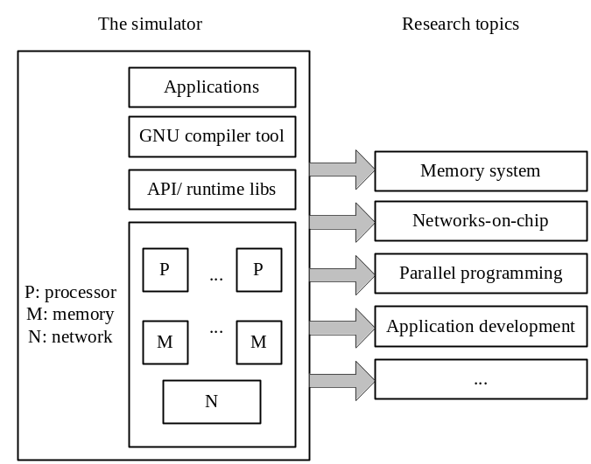
Fig. 1 overview of the simulator.

Processor model
The processor model is derived from the Simplescaler model. Generally, there are five pipeline stages, i.e., fetch, dispatch, issue, write back, and commit..
- Fetch. The instructions are fetched from memory into the Icache.
- Dispatch. The instructions are “executed” in the functional model.
- Issue. For memory access instructions, the memory requests are generated and processed.
- Write back. The values are written back to the register/memory.
- Commit. The instructions are commit to retire from the pipeline stages.
In the processor model, the RUU_station plays a role both as reorder buffer and rename register. For further details, please read the SingleCore.pdf file.

Cache model
The simulator uses MESI as the cache coherence protocol. The state machine of the protocol is implemented in the cache_access and dir_operation functions. The document about the cache system is yet to be updated.

NoC model
The NoC model is based on popnet. It is easy to change the NoC model or even replace it. For further detail, please read the Network.pdf.

Benchmarks
Now, we have 15 single-threaded EEMBC benchmarks validated (the simulator is configured to be single-core mode). We also tested 19 multi-threaded benchmarks (the simulator is configured to be 64-core, each benchmark is configured to be 16 threads).

Table I Benchmarks run in the simulator
Name | Description
Barnes, fmm, ocean, radiosity, raytrace, water-spatial, cholesky, fft, lu, radix | From splash-2
Fluidanimate, blackscholes | From parsec
em3d, ILINK, jacobi, mp3d, shallow, tspo, tspuo | Others
matrix01.out, pktflowb512k.out, rgbyiq01.out, cjpeg.out, ospf.out, pntrch01.out, routelookup.out, djpeg.out, pktflowb1m.out puwmod01.out, rspeed01.out, empty.out, pktflowb2m.out, rgbcmy01.out, tblook01.out, iirflt01.out, pktflowb4m.out, rgbhpg01.out, ttsprk01.out | From EEMBC

