MIPS_CMP Running Single Thread

Introduction
This document introduces how to port the CMP_SIM to run a single-thread “Hello world” program on MIPS_CMP. Originally, CMP_SIM has Alpha 21264 as its processors. The processor model is replaced to be MIPS 32 ISA. Thus, this work is combined by two parts, 1) replace the front end of processor module (e.g. the elf parsing, instruction definitions, register definitions, system calls, etc.) to be an MIPS 32 ISA core (developed by Yuan Xin), and 2) the memory and network modules in the original Alpha-based CMP_SIM. To put it in summary, Fig. 1 shows the relationship of the simulators.
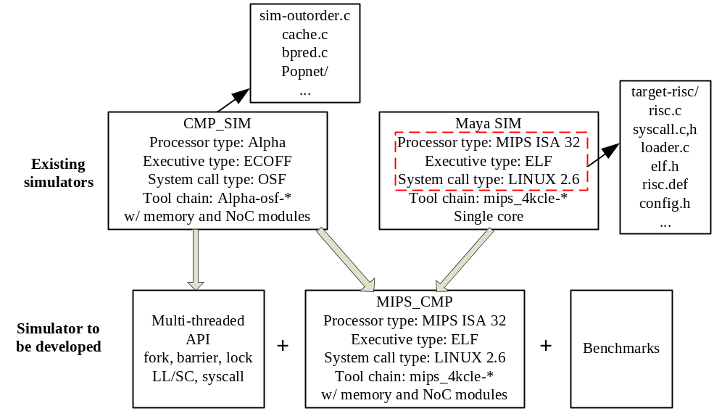
Fig. 1. Overview of the work of MIPS_CMP simulator porting.

Files changed from Maya SIM
The files from Maya SIM includes the directory of target-risc/. There are a few changes need to be made. The change mainly includes extending single thread to multi-core configuration, e.g., thecontext[threadid]. For example,
- In loader.c, symbol.c and syscall.c/h, the function calls need to include threadid and the program and data should be loaded into a thread current, i.e., current = thecontexts[threadid].
- In risc.c, the code related to #ifdef SMT_SS should be included.
- In risc.def, the LL and SC instruction implementation are included. LL and SC are actually the same as LW and SW. The code is copied and modified according to alpha.def.

Files changed from CMP_SIM
The remaining files are from CMP_SIM. There are a few changes made to network.c, sim-outorder.c, cache.c and bpred.c.
- Changes to network.c and cache.c are trivial, e.g., just replace the Alpha STL_C and LD_C to be MIPS LL and SC.
- Changes to bpred.c includes removing the branch prediction code written by UR, i.e., just use the original simplescaler branch predictor.
- In file sim-outorder.c, a few changes are made, including,
  - Global variables delay_slot_pc and delay_slot_mark to deal with delay slot based on Maya SIM implementation.
  - The parameter of bpred_update() are changed to be 2*sizeof (md_inst_t)).
  - Some code with SEXT(OFS) changed to OFS (done).
  - Some code with LDS/LDT changed to LDC1 (?).
  - Macros like DGPR(N).
  - Add int delay_slot_ruu = 0, delay_slot_lsq = 0; to ruu_dispatch(). These two variables must be auto, not static. Because the branch instruction and the delay slot are guaranteed to be dispatched in the same while loop. Thus, the value of the two variables are kept during the while loop.
  - Add the following code to ruu_dispatch(). This part of code is vital! This code makes sure that, the branch instruction and the delay slot must be dispatched in the same while loop.
if ((MD_OP_FLAGS (op) & F_CTRL )&&
!((iissueq_cl[threadid] <= (IIQ_size - resource_need[0]-1)) &&
(fissueq_cl[threadid] <= (FIQ_size - resource_need[1]))))
{
break; //
}

  - LDL_c and STL_C are changed to LL and SC.
  - In ruu_dispatch(), some code with val_ra, val_rb, val_rc and val_ra_result are not sure (useless).
  - In ruu_dispatch(), use the code from Maya SIM to update current->fetch_pred_PC. Thus, the branch prediction and update are the same as in Maya SIM.
  - Add the following code to ruu_dispatch(). Copied from Maya SIM. It is to make sure that, the rs of delay slot are inserted before the rs of branch.

if (MD_OP_FLAGS(op) & F_CTRL)
{
MD_FETCH_INST(delay_slot_inst,
current->mem, current->regs.regs_PC + sizeof(md_inst_t));
if(delay_slot_inst != MD_NOP_INST)
{
delay_slot_ruu =1;
rs = &current->RUU[(current->RUU_tail+1)%RUU_size];
}
}
else if(delay_slot_ruu)
{
delay_slot_ruu =0;
delay_slot_lsq =1;
rs = &current->RUU[(current->RUU_tail+RUU_size-1)%RUU_size];
}

  - Delete some second_run in if condition(useless)
  - Add delay_slot() function.
  - In ruu_fetch() function, the codes related to delay_slot_mark and break_mark are added to make sure delay slot and branch are fetched together.
  - Comment the following code in ruu_fetch(), not sure the meaning.
if (!j)
fetch_set = CACHE_SET (cache_il1[threadid], current->fetch_regs_PC);
inst_set = CACHE_SET (cache_il1[threadid], current->fetch_regs_PC);
if (fetch_set != inst_set)
break;

  - Comment the btarget related code, this variable is calculated in ruu_dispatch().
  - Remove the fast forward part code. Delay slots are not well treated in the fast forward part.

Important data structures
RUU_station is a data structure to hold the info of dispatched instructions. For load/store instructions, the rs->op is ADD, and rs->odep_list[opnum]->rs is an lsq item with lsq->op = LW/SW. In the function ruu_link_idep(), the register used by current instruction are located. Then the rs of first instruction that precede current instruction which also uses this register is found.
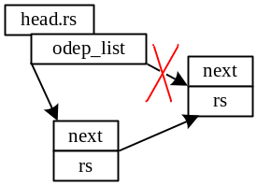
Fig. 2. ruu_link_idep() operation.

