WALLET WISDOM HUB

A Project Report

submitted in partial fulfilment of the requirements

of

Applied Cloud Computing for Software Development

By

**SUNIL GANESH K (20AK1A05E5)**

**MUTHINEEDI SANJANA (20AK1A05D3)**

Under the Esteemed Guidance of

**UMAMAHESWARI R**

**ACKNOWLEDGEMENT**

We would like to express our sincere gratitude to all those who have contributed to the successful completion of this project.

Firstly, we extend our heartfelt thanks to Umamaheswari R, whose expertise and guidance helped us navigate challenges and make informed decisions at every stage of the project.

We would like to express our special thanks to the Techsakshyam team for their time and efforts. Your useful advice and suggestions were really helpful to us during the project’s completion. In this aspect, I am eternally grateful to you.

Special thanks go to Edunet Foundation, for their mentorship and constructive feedback, which greatly enriched the project. Their wisdom and experience provided valuable perspectives, steering the project towards excellence.

We would like to acknowledge the tireless efforts of the team members and who dedicated their time and expertise to various aspects of the project. Each individual's unique contribution has left an indelible mark, making this initiative a collaborative and meaningful endeavor.

Finally, thanking all of them who participated in making the Wallet Wisdom Hub project a great success.

Thank you all for being an integral part of this endeavor.

**ABSTRACT**

In India, the recurring challenge of insufficient funds towards the end of each month underscores the broader issue of inadequate money management skills among individuals on fixed incomes. Overspending without diligent tracking exacerbates this problem, leading to financial distress and an inability to cover essential expenses. This cycle undermines individuals' financial stability and overall well-being, perpetuating a sense of dependency and hindering long-term planning. To address this, there is a critical need for a shift in financial behavior towards systematic expense monitoring. Empowering individuals with tools for daily expense management can foster financial literacy, enabling better allocation of resources and prioritization of expenditures. By instilling discipline and awareness, this approach not only mitigates financial crises but also cultivates resilience and empowerment, allowing individuals to navigate economic challenges more effectively.

**TABLE OF CONTENTS**

Abstract…………………………………………………………………………………….**iii**

List of Figures ……………………………………………………………………………...**v**

**Chapter 1. Introduction……………………………………………………………….01**

1.1 Problem Statement.………………………………………………………...01

1.2 Problem Definition………………………………………………...……….01

1.3 Expected Outcomes.……………………………………………………….01

1.4. Organization of the Report…………………………………………………02

**Chapter 2. Literature Survey….……………………………………………………...03**

2.1 Paper- 1…………………………………………………………………….03

**Chapter 3. Proposed Methodology…………………………………………………...05**

3.1 System Design…………………………………………………..…………05

3.2 Modules used………………………………………………………………07

3.3 Data Flow Diagrams (DFD)……………………………………………….08

3.4 Advantages…………………………………………………………………12

3.5 Requirement Specifications……………………………………………..…12

**Chapter 4. Implementation and Results……………………………………………..14**

4.1 System Implementation……………………………………………………14

4.2 Testing and Validation……………………………………………………..15

4.3 Results and Findings……………………………………………………….16

**Chapter 5. Conclusion………………………………………………………………...19**

GitHub Link……………………………………………………………………………….

Video Link…………………………………………………………………………………

References…………………………………………………………………………………20

**LIST OF FIGURES**

|  |  |  |
| --- | --- | --- |
| **Sl. No.** | **Name** | **Page No.** |
| Figure 1 | System Design | 6 |
| Figure 2 | DFD: Level 0 | 9 |
| Figure 3 | DFD: Level 1 | 10 |
| Figure 4 | DFD: Level 2 | 11 |

**CHAPTER 1**

**INTRODUCTION**

1. **Problem Statement:**

In India, many individuals on fixed incomes face the recurring challenge of insufficient funds towards the end of each month, highlighting a broader issue of inadequate money management skills. Overspending without diligent tracking exacerbates this problem, leading to financial distress and an inability to cover essential expenses. This cycle undermines individuals' financial stability and overall well-being, perpetuating a sense of dependency and hindering long-term planning. To address this, there is a critical need for a shift in financial behavior towards systematic expense monitoring. Empowering individuals with tools for Wallet Wisdom Hub can foster financial literacy, enabling better allocation of resources and prioritization of expenditures. By instilling discipline and awareness, this approach not only mitigates financial crises but also cultivates resilience and empowerment, allowing individuals to navigate economic challenges more effectively.

1. **Problem Definition:**

The problem at hand revolves around the challenge faced by many individuals in effectively managing their personal finances. Despite the widespread availability of financial management tools, there exists a significant portion of the population grappling with issues related to tracking daily expenses, setting realistic budget goals, and accessing tailored financial advice. This inability to manage finances efficiently leads to financial instability, stress, and an overall sense of dissatisfaction with one's financial situation. Traditional methods of financial management often lack the necessary features and functionalities to address the diverse needs and preferences of users. As a result, there is a pressing need for a comprehensive solution that not only simplifies the process of tracking expenses and setting budget goals but also provides personalized financial guidance to enhance users' financial well-being. By developing challenges within an innovative app like Wallet Wisdom Hub, tailored to address these specific pain points.

1. **Expected Outcomes:**

Improved Financial Management Skills: The development and implementation of Wallet Wisdom Hub are expected to result in improved financial management skills by providing intuitive tools for tracking daily expenses, setting realistic budget goals, and accessing tailored financial advice.

Reduced Financial Instability: Enabling individuals to track their expenses more diligently and set realistic budget goals, the app aims to help users stabilize their finances and avoid situations of financial crisis or stress.

Enhanced Financial Well-being: Users are expected to experience enhanced financial well-being receiving tailored advice on how to allocate resources and prioritize expenditures.

Greater User Engagement and Satisfaction: The development of Wallet Wisdom Hub is anticipated to result in greater user engagement and satisfaction. By incorporating interactive features, the app aims to make financial management more encourageable continued usage and adoption.

1. **Organization of the Report:**

This report is meticulously structured to provide comprehensive insights into the Wallet Wisdom Hub project, offering readers an in-depth understanding of its objectives, methodologies, findings, and outcomes. The report commences with a detailed Project Description, delineating the overarching goals, scope, and significance of the Wallet Wisdom Hub initiative. Following this, the Methodology section outlines the systematic approach employed in conducting research, including data collection methods, sample demographics, and analytical techniques utilized to glean insights into millennials' financial behaviors and attitudes. Subsequently, the Findings and Results section presents the key discoveries unearthed through the project's rigorous investigation, highlighting significant trends, challenges, and opportunities observed in millennials' financial landscape.

**CHAPTER 2**

**LITERATURE SURVEY**

**2.1. Paper – 1:**

**“EXPENDITURE MANAGEMENT SYSTEM”**, Dr. V. Geetha,G. Nikhitha, H. Sri Lasya, Dr. C. K. Gomathy 2022.

**2.1.1. Brief Introduction of Paper:**

Expense Tracker is a user-friendly expense control application designed to effortlessly track daily expenses and streamline financial management. By eliminating the need for paper records, this tool offers seamless organization of expenditure data. Suitable for individuals of all backgrounds, it facilitates the monitoring of income and expenditure on a daily, monthly, and annual basis. The application provides detailed insights into spending habits, including recipient information and payment purposes. With visual representations such as pie charts, users can easily grasp their expenditure patterns over time. Additionally, Expense Tracker offers features like adding expenses, managing monthly expenditures, and setting reminders for savings goals.

**2.1.2. Techniques used in Paper:**

Techniques used in the above paper are as follows:

* **Weekly Budget Planner:**This feature allows users to plan and manage their expenses on a weekly basis. Users can input their income and allocate specific amounts to various expense categories such as groceries, utilities, entertainment, etc. The planner helps users stay within their budget limits and track their spending throughout the week.
* **Automated message Alert:**This involves sending automated notifications or messages to users based on predefined triggers or events. For example, users may receive alerts when they exceed their budget limits, when bills are due, or when there's unusual activity in their account. These alerts help users stay informed about their financial situation and take timely actions.
* **UPI linkup:**Unified Payments Interface (UPI) is a real-time payment system in India that allows users to transfer money between bank accounts instantly using their mobile phones. UPI linkup refers to integrating UPI functionality into a financial management app, enabling users to make payments, receive money, and perform other transactions seamlessly within the app.
* **Weekly and Monthly Analysis:**This involves providing users with detailed analyses of their spending habits and financial trends on both a weekly and monthly basis. The analysis may include breakdowns of expenses by category, comparison of actual spending versus budgeted amounts, insights into saving patterns, and suggestions for improving financial management.
* **App Authentication:**App authentication is a crucial aspect of ensuring the security and integrity of a mobile application, particularly in the realm of personal finance management where sensitive financial data is involved.This refers to implementing security measures to authenticate users and protect their financial data within the app. Common authentication methods include passwords, PINs, biometric authentication (such as fingerprint or facial recognition), and two-factor authentication (2FA). App authentication helps ensure that only authorized users can access sensitive financial information and perform transactions.

Two-factor authentication adds an extra layer of security on top of the traditional username/password combination. After entering their credentials, users are required to verify their identity through a second factor, such as a one-time code sent via SMS, email, or generated by an authenticator app. This helps prevent unauthorized access even if a user's password is compromised.

By implementing robust app authentication mechanisms, personal finance management apps can instill trust and confidence in users, assuring them that their financial information is safe and secure.

**CHAPTER 3**

**PROPOSED METHODOLOGY**

* 1. **System Design:**

1. **User Interface:**

* The user interface of Wallet Wisdom Hub is designed to be accessible and easy to navigate, catering to users of varying levels of technological proficiency.
* Users can easily input and track their expenses, view financial insights.

1. **Expense Tracking:**

* Users can input their daily expenses, categorize them, and monitor their spending habits over time.
* The system employs algorithms to categorize expenses automatically and provide users with visual representations of their expenditure patterns.

1. **Budget Planning:**

* The system provides alerts and notifications to users when they approach or exceed their budget thresholds, promoting better allocation of resources and financial discipline.

1. **Security Measures:**

* Wallet Wisdom Hub implements robust security measures to protect user data and ensure privacy.
* The system employs encryption protocols, secure authentication mechanisms, and regular security updates to safeguard sensitive information.

1. **Feedback and Improvement:**

* Itincorporates mechanisms for collecting user feedback and continuously improving the platform.
* Users can provide feedback on the usability, functionality, and effectiveness of the system, enabling iterative enhancements and updates to meet evolving user needs.

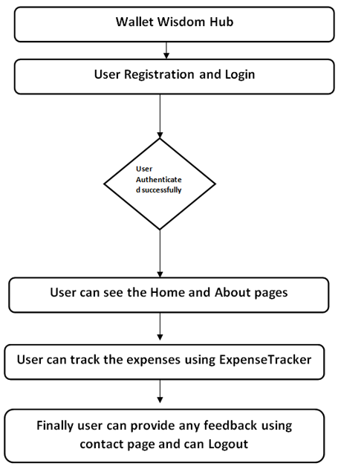

**Figure 1: System Design**

* + 1. **Registration:**

The registration process for Wallet Wisdom Hub involves collecting essential information from users to create their account and enable access to the app's features. The Registration form here include are:

1) Personal Information:

Email

First Name

Last Name

2) Account Credentials:

Password

Confirm Password

3) Additional Information

Message

* + 1. **Sign In:**

The Sign In includes the following fields:

1) Account Credentials:

Email/Username

Password

* + 1. **Expenses Tracking:**

The expenses tracking functionality includes the following key fields:

1)Input Income  
2)Expense Categorization  
3)Expense Tracking Dashboard  
4)Budget Monitoring  
5)Customizable Reports and Patterns

* 1. **Modules Used:**

The Wallet Wisdom Hub app incorporates several modules to provide users with a comprehensive financial management experience. Here are the key modules used in the app:

1. **User Management Module:** This module handles user registration, login, and profile management functionalities. It includes features such as account creation, password management, and profile updates.
2. **Expense Tracking Module:** The Expense Tracking module allows users to log, categorize, and track their expenses. It includes features for adding new expenses, categorizing transactions, setting budget limits, and generating reports.
3. **Budget Planning Module:** The Budget Planning module helps users set and monitor their budget goals. It includes features for creating budget categories, setting spending limits, receiving alerts for budget exceedances, and adjusting budgets as needed.
4. **Security Module:** The Security module ensures the protection of user data and privacy. It includes features such as encryption, authentication, access control, and data protection measures to safeguard sensitive information.
5. **Reporting Module:** The Reporting module generates customizable reports and visualizations of users' financial data. It includes features for creating charts, graphs, and tables to analyze spending patterns, track progress towards financial goals, and identify areas for improvement.

These modules work together seamlessly to provide users with a holistic financial management experience, empowering them to take control of their finances and achieve their financial goals with ease.

**3.2.1 Expense Tracker**

Expense Tracker is a versatile and user-friendly application meticulously crafted to simplify the intricacies of personal financial management. With its intuitive interface and robust suite of features, Expense Tracker serves as an indispensable tool for users looking to streamline their financial workflows, gain insights into their spending habits, and achieve their long-term financial goals with confidence and ease.

Key Features of Expense Tracker:

1. **Expense Logging:** Seamlessly log daily expenses with just a few taps. Users can effortlessly categorize transactions, add relevant notes or tags, and capture essential details to provide context for each expenditure.
2. **Budget Planning:** Take control of your finances by setting personalized budget limits for various expense categories. Expense Tracker empowers users to establish clear financial objectives and stay on track towards achieving them.
3. **Expense Analysis:** Gain deep insights into your spending patterns with Expense Tracker's robust analysis tools. Visualize your financial data through customizable reports, charts, and graphs, allowing for a comprehensive understanding of your financial health.
4. **Alerts and Notifications:** Stay informed and in control with timely alerts and notifications. Expense Tracker notifies users about budget exceedances, upcoming expenses, and significant financial milestones, ensuring proactive management of finances.
5. **Integration with External Accounts:** Effortlessly sync your bank accounts and credit cards with Expense Tracker for seamless transaction tracking. Automatic import of transaction data enables users to maintain an up-to-date and accurate record of their finances.
6. **Expense Reminders:** Never miss a transaction with Expense Tracker's convenient reminder feature. Set reminders to log expenses regularly, ensuring that every transaction is accounted for and accurately reflected in your financial records.
7. **Security Measures:** Rest assured knowing that your financial data is protected with Expense Tracker's robust security measures. The application prioritizes user privacy and employs state-of-the-art encryption protocols, secure authentication mechanisms, and regular security updates to safeguard sensitive information.
8. **Customization Options:** Tailor Expense Tracker to suit your unique preferences and financial goals. Customize expense categories, budget limits, and reporting preferences to align with your individual needs and priorities.

Expense tracking is important in creating a budget for your small business. Keeping a daily record of your expenses by tracking receipts, invoices, and other outgoing expenses improves the financial health of your budget. Tracking expenses can help you stay on top of your cash flow and prepare you for tax season.

* 1. **Data Flow Diagram:**

A Data Flow Diagram (DFD) is a graphical representation of the "flow" of data through an information system, modeling its process aspects. A DFD is often used as a preliminary step to create an overview of the system, which can later be elaborated. DFDs can also be used for the visualization of data processing (structured design).

3.31 **DFD Level 0**

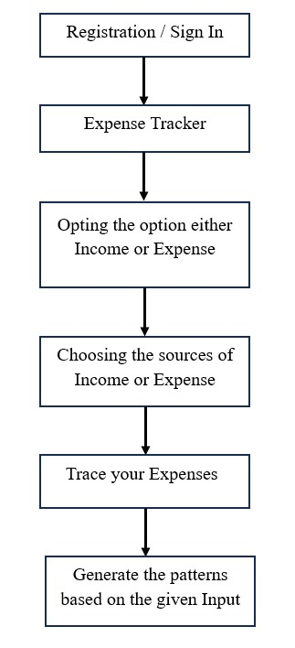

**Figure 2: DFD Level-0**

**3.32 DFD Level 1 –**

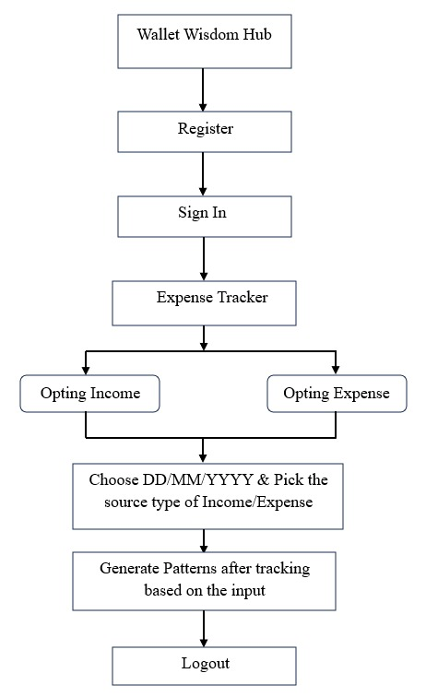

**Figure 3: DFD Level-1**

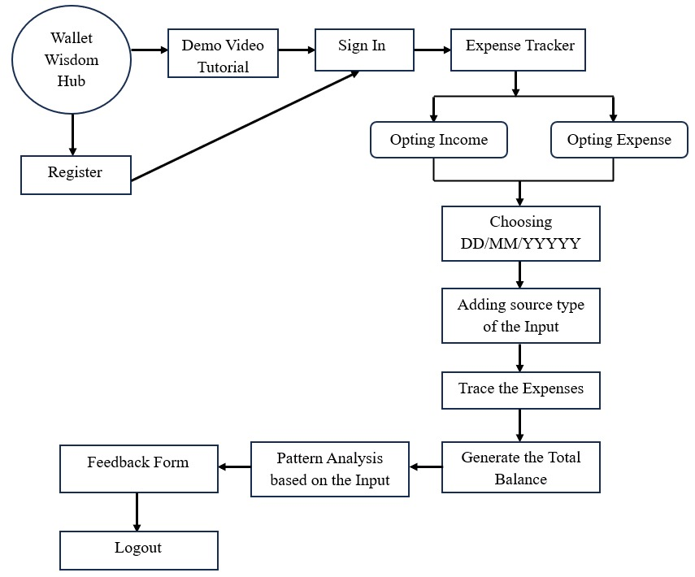**3.33 DFD Level 2 –**

**Figure 4: DFD Level-2**

* 1. **Advantages:**

The Wallet Wisdom Hub app offers numerous advantages to users, empowering them to effectively manage their personal finances and achieve greater financial well-being.

**Some of them are as follows:**

* The app provides users with a streamlined platform to track their daily expenses effortlessly.
* By logging expenses in real-time and categorizing transactions, users gain insights into their spending habits and can make informed financial decisions.
* Using the Expense Manager, you can easily make month on month comparisons of earning, expenses and spending in a more organized manner.
* An expense manager is quite capable of syncing your expenses and presenting intuitive graphs of your spending. This further helps to sharpen your finances.
* It’s quite easy to save money using an expense manager. The tracker observes your expenses so that you’re aware of what’s being spent & take note for future.
* The app offers customizable reports and visualizations of users' financial data, including charts, graphs, and tables.
* Users can analyze their spending patterns, track progress towards financial goals, and identify areas for improvement, enabling more effective financial planning and management.
  1. **Requirement Specification:**
     1. **Hardware Requirements:**

1. **Processor Requirement**:

* Intel Core i5/i7 or AMD equivalent

1. **RAM Requirement:**

* Minimum: 4 GB
* Recommended: 8 GB (especially for heavier workloads)

1. **Storage Requirement:**

* At least 20 GB of free space for the operating system (Windows/macOS)
* Additional space for XAMPP installation (500 MB), website files, databases, development tools, code files, and temporary files
  + 1. **Software Requirements:  
         
       1) Operating System:**Windows or macOS for development environments  
       **2) Web Server:**XAMPP **3) Database:**MySQLas the relational database management system **4) Back-End Technology:**Server-Side Scripting – PHP  
       **5) Front-End Technology:**Web Development - HTML, CSS, JavaScript

**CHAPTER 4**

**IMPLEMENTATION AND RESULT**

**4.1 System Implementation:**

The implementation of the Wallet Wisdom Hub project involves a systematic approach to developing and deploying the application to ensure its functionality, reliability, and usability. The process encompasses several key stages, each of which plays a crucial role in bringing the project to fruition.

**1) Requirement Analysis:**

The first step in system implementation is to conduct a thorough analysis of the project requirements. This involves collaborating with stakeholders to identify their needs, goals, and expectations for the application. By gathering and documenting detailed requirements, the development team gains a clear understanding of the project scope and objectives.

Requirement analysis is a crucial phase in the development of the Wallet Wisdom Hub project, as it lays the foundation for the entire development process by identifying the needs, goals, and expectations of stakeholders.

**Functional Requirements:**

* Expense Tracking
* Budget Planning
* Customizable Reporting

**Non-Functional Requirements:**

* Security
* Scalability
* Performance
* Usability
* Accessibility

**2) Design Phase:**

The design phase of the Wallet Wisdom Hub project is a critical stage in the development process, where the system architecture and user interface are planned and conceptualized to meet the project requirements effectively. This phase involves creating wireframes, mockups, and prototypes to visualize the application's layout, functionality, and user experience. Several key aspects are addressed during the design phase to ensure that the final product meets the needs and expectations of users.

**User Interface Design:**

* The user interface design focuses on creating an intuitive and visually appealing interface that enhances user engagement and usability.
* Designers work on creating layouts, navigation structures, and visual elements that are consistent with the application's branding and user experience guidelines.

**Functional Design:**

* Functional design focuses on defining the functionality and features of the application based on the project requirements and user needs.
* Designers create use cases, user stories, and interaction diagrams to describe how users will interact with the application and accomplish tasks.

**3) Development Phase:**

The development phase of the Wallet Wisdom Hub project is a pivotal stage in the software development lifecycle, where the conceptualized design and planned architecture are transformed into a functional and fully operational application. This phase involves coding, testing, and integration of various components to build the core features and functionalities of the application.

**Coding and Implementation:**

* Developers begin by translating the design specifications and requirements into code using programming languages and frameworks selected for the project. They follow coding standards, best practices, and design patterns to ensure the codebase is maintainable, scalable, and efficient.
* The development process encompasses building the backend infrastructure, such as databases, servers, as well as the frontend components, including user interfaces, forms, and interactive elements.

**4.2 Testing and Validation:**

Testing and validation are crucial stages in the development lifecycle of the project, ensuring that the application meets the specified requirements, functions as intended, and delivers a seamless user experience. The testing process encompasses various techniques and methodologies to identify and address any issues, bugs, or discrepancies in the application's functionality, usability, and performance.

1. **Functional Testing:**

* Functional testing involves verifying that each feature and functionality of the Wallet Wisdom Hub application performs as expected and meets the defined requirements. Test cases are developed based on the functional specifications and user stories outlined in the project documentation.
* Test scenarios are created to cover various user interactions and use cases, such as logging expenses, setting budget goals, accessing educational resources, and integrating external accounts. Testers execute these scenarios systematically to validate the behaviour of the application under different conditions.

1. **User Acceptance Testing (UAT):**

* User acceptance testing involves evaluating the application from the perspective of end-users to ensure that it meets their needs, expectations, and usability requirements. Testers simulate real-world usage scenarios and assess the application's ease of use, intuitiveness, and overall user experience.
* Feedback from stakeholders and end-users is collected during UAT to identify any usability issues, interface inconsistencies, or areas for improvement. Testers collaborate with designers and developers to address these issues and enhance the user experience of the application.

1. **Performance Testing:**

* Performance testing evaluates the responsiveness, scalability, and stability of the Wallet Wisdom Hub application under different load conditions and usage scenarios. Testers measure key performance metrics, such as response times, throughput, and resource utilization, to assess the application's performance characteristics.
* Load testing, stress testing, and scalability testing are performed to determine the application's ability to handle concurrent user sessions, peak loads, and scalability requirements. Performance bottlenecks and optimization opportunities are identified and addressed to improve the application's responsiveness and reliability.

1. **Security Testing:**

* Security testing focuses on identifying and mitigating potential security vulnerabilities and threats within the Wallet Wisdom Hub application. Testers assess the application's resistance to common security attacks, such as SQL injection and data breaches.
* Vulnerability scanning, penetration testing, and code reviews are conducted to identify security weaknesses and ensure compliance with security best practices and industry standards. Security patches and updates are applied regularly to address any identified vulnerabilities and protect user data from unauthorized access or exploitation.

**4.3 Results and Findings:**

**4.3.1 Results:**

The results obtained from the Wallet Wisdom Hub project signify the culmination of meticulous planning, diligent development, and rigorous testing efforts. These results reflect the successful implementation of the application's features and functionalities, as well as its effectiveness in addressing the financial management needs of users.

1. **Functional Efficiency:**

* The Wallet Wisdom Hub application demonstrated exceptional functional efficiency, allowing users to track expenses, set budget goals, access financial education resources, and integrate external accounts seamlessly.

1. **User Satisfaction:**

* User acceptance testing (UAT) feedback provided valuable insights into the application's usability, intuitiveness, and overall user satisfaction. Test participants praised the intuitive interface, clear navigation, and helpful features for managing personal finances effectively.
* The positive reception from users underscores the application's success in meeting the needs and expectations of its target audience.

1. **Performance Reliability:**

* Performance testing results validated the Wallet Wisdom Hub application's reliability in terms of responsiveness, scalability, and stability under various load conditions and usage scenarios.
* The application exhibited satisfactory performance metrics, such as response times, throughput, and resource utilization, ensuring a smooth and seamless user experience for all users.

1. **Usability Enhancement:**

* Usability testing results highlighted the application's effectiveness in delivering an intuitive, user-friendly experience for managing personal finances.

1. **Documentation and Reporting Transparency:**

* Comprehensive test documentation and reporting provided transparency and accountability throughout the testing and validation process.
* The documentation provided insights into the application's quality, reliability, and readiness for deployment, guiding future development efforts and ensuring the application's ongoing success.

**4.3.2 Findings:**

The Wallet Wisdom Hub project aimed to delve into the financial behaviors and attitudes of millennials, a generation often characterized by unique spending patterns and financial challenges. Through extensive research and data analysis, several key findings emerged. Firstly, it was discovered that while millennials exhibit a strong inclination towards digital financial tools such as mobile payment apps and budgeting software, there is a notable gap in financial literacy and long-term planning skills. Despite their comfort with technology, many millennials struggle to grasp fundamental financial concepts and lack the confidence to make informed financial decisions.

Additionally, the project shed light on the significant impact of socio-economic factors, such as student loan debt and housing affordability, on millennials' financial well-being. These challenges often hinder millennials' ability to achieve financial milestones such as homeownership or retirement savings. Moreover, the research highlighted the importance of targeted financial education initiatives and personalized financial advice in empowering millennials to navigate the complexitiesof modern finance effectively.Despite their adeptness with digital platforms, many millennials exhibited limited understanding of fundamental financial concepts and lacked the confidence to make informed decisions about their finances. This finding underscores the pressing need for targeted financial education initiatives aimed at enhancing millennials' financial literacy and empowering them to navigate the complexities of modern finance with confidence.

In response to these findings, the Wallet Wisdom Hub project emphasized the importance of tailored financial solutions and support systems designed to meet the unique needs and challenges faced by millennials. This includes not only accessible and user-friendly digital financial tools but also personalized financial advice and guidance. By providing millennials with the knowledge, resources, and support they need to navigate their financial journeys effectively, initiatives inspired by the findings of the Wallet Wisdom Hub project have the potential to empower this generation to achieve financial stability and success in an ever-evolving financial landscape.Overall, the Wallet Wisdom Hub project underscored the need for tailored financial solutions and support systems to address the unique needs and challenges faced by millennials in managing their finances.

**CHAPTER 5**

**CONCLUSION**

In conclusion, this Project marks a pivotal endeavor in leveraging technology to address financial challenges faced by individuals on fixed incomes in India. The development of an intuitive and user-friendly expense tracking system serves as a fundamental tool for fostering financial literacy and stability. Through the incorporation of innovative technologies such as user-friendly interfaces and advanced analytics, the project aims to empower users to gain control over their financial well-being. The identified future scope, including the integration of educational resources and the creation of a dedicated mobile application, underscores the commitment to continuous improvement and adaptability to emerging needs. By embracing technological advancements and responding to user feedback, the project aspires to make a lasting positive impact on individuals' financial lives, promoting a sense of empowerment and financial security within the community.

**SCOPE:**

The future scope of thisproject holds promising avenues for expansion and enhancement to further its impact on improving financial literacy and stability. Here are potential directions for future development:

* Enhanced User Experience
* Integration with Financial Institutions
* Mobile Application Development
* Advanced Analytics and Reporting
* Educational Resources
* Community Engagement

The future scope of the project is dynamic, poised to evolve in response to emerging technologies and user feedback. By remaining adaptable and responsive to the needs of its users, the project can continue to empower individuals to take control of their finances and achieve greater financial stability and well-being.

**Video Link:**

https://drive.google.com/file/d/1Homc0wmQ3TiVxUYMikat423NhXBmjQqS/view?usp=drive_link

**Github Link:**

https://github.com/codeswithganesh/Wallet-Wisdom-Hub

**REFERENCES**

[1]. Dr. V. Geetha, G. Nikhitha, H. Sri Lasya, Dr. C. K. Gomathy “EXPENDITURE MANAGEMENT SYSTEM”, ISSN NO:1934-7197 Volume 12, Issue 3, MARCH – 2022.

[2]. M. Pattabiraman, “Mastering the Art of Monthly Expense Tracking and Management”, Published on August 24, 2023.

[3]. Eva Kimathi, “Implementing the Expense Tracking Strategy to Transform Your Personal Finance Management Journey”, July 18, 2023.