PROJECT REPORT – PYTHON FOR DATA SCIENCE
Submitted by: [Add your name and roll number]
TITLE: Hospital Management Data Analysis – Data Cleaning, Exploratory Analysis, Predictive Modelling and an Interactive Streamlit Dashboard.
REPOSITORY LINK: [Add your GitHub repository link]
PROJECT SUMMARY
The Hospital Management Data Analysis project takes a deliberately messy hospital-records dataset (57,720 rows × 17 columns) through a complete analytics workflow. It combines a reproducible data-cleaning pipeline, exploratory data analysis, a baseline Random Forest model, an interactive Plotly/ipywidgets dashboard inside Jupyter, and a final stand-alone Streamlit web application for non-technical users. Questionable records are flagged rather than silently deleted, so every cleaning decision can be audited.
A companion Jupyter notebook (_hospital_analysis.ipynb) holds the cleaning, EDA, modelling and notebook dashboard; app.py then reproduces every notebook chart and extends the dashboard to about 35 charts in eight sections.
Component | Purpose
Jupyter notebook | Data audit, cleaning, EDA, Random Forest model, widget dashboard
Streamlit app (app.py) | Eight-section interactive dashboard with filters, model section and CSV export
Cleaned outputs | healthcare_cleaned.csv (56,096 × 19) and cleaning_audit.csv
requirements.txt | Dependencies needed to run the dashboard
PLATFORM PURPOSE AND OBJECTIVES
Hospitals generate large volumes of administrative data – admissions, diagnoses, billing, insurance and stay information – and real exports are rarely analysis-ready. The project works with a “messy” healthcare dataset so that every stage of a realistic analytics pipeline has to be performed and documented.
- Audit the raw data and clean it with explicit, reproducible rules, flagging rather than silently deleting questionable records.
- Explore patient demographics, conditions, admission types, billing, length of stay and admission trends.
- Test whether basic patient attributes (age, gender, blood type, admission type) can predict the medical condition.
- Deliver an interactive dashboard that non-technical users can open in a web browser.
DATASET
The input is healthcare_dataset_messy.csv, a single offline CSV file. No live hospital system is involved and the data contains no patient identifiers beyond names. All columns except the empty one were read as text, because numbers, dates and categories were mixed with symbols and placeholders.
Item | Detail
Raw file | healthcare_dataset_messy.csv – 57,720 records × 17 columns (7.5 MB in memory)
Cleaned file | healthcare_cleaned.csv – 56,096 records × 19 columns
Duplicates | 1,574 exact duplicates in the raw audit; 1,624 rows removed in total (2.8%), including 50 that became identical after text normalisation
Missing values | Heavy: e.g. Age 1,213; Billing 2,311; Insurance 1,163; Notes 97% empty; “Unnamed: 15” fully empty
Target (model) | Medical condition – six near-equal classes (balanced)
Nature of data | Near-uniform categories and zero correlations suggest synthetically generated data
Raw columns and what the audit found
Raw column | What the audit found | Treatment
Name | Mixed case (“ValeriE NelsoN”); “unknown” 258×; 605 missing | Trimmed; placeholders → missing
Age | Stored as text; 156 distinct values incl. invalid; 1,213 missing | Numeric; outside 0–120 → missing (237)
Gender | 14 labels from case variants (FEMALE/Female); 767 missing | Title case
blood_type | 43 labels for 8 standard groups (“A +”, “A-”); 292 missing | Spaces removed; upper case
Medical Condition | 25 labels incl. misspellings (“Asthama”); 774 missing | Title case + spelling map
date of admission | Mixed formats (10/13/2021, 2023/10/13); 2031-05-12 appears 116× | Parsed with format="mixed"
Doctor / Hospital | ~40,900 / ~40,500 distinct strings; scrambled word order | Trimmed; not analysed
Insurance Provider | Double space in header; 22 labels; 1,163 missing | Header standardised
Billing Amount | Trailing space in header; text with “$” and “,”; 2,311 missing | Numeric; negatives flagged
ROOM NUMBER | Strings such as “Room 281”; 1,731 missing | Digits extracted
Admission Type | 16 labels (elective, “-”, Eme.); 593 missing | Title case; abbreviations mapped later
Discharge Date | Mixed formats; 562 missing | Parsed with format="mixed"
Medication | 20 labels from case variants (ASPIRIN); 746 missing | Title case
Test Results | 15 labels; “-” placeholders; 574 missing | Title case; “-” → missing
Unnamed: 15 | Entirely empty (57,720 missing) | Dropped
Notes | 97% empty; only 4 distinct values | Kept, not analysed
CLEANING AND DERIVED FEATURES
Step | Implementation and Rationale
Column names | Stripped, lower-cased and joined with underscores; the empty “unnamed:_15” column is dropped, leaving 16 columns.
Text standardisation | Whitespace trimmed; placeholders (“-”, “unknown”, “N/A”, “none”, “null”) become missing; categories are title-cased; “Asthama” corrected.
Type conversion | Billing (remove “$” and “,”), room number (extract digits), age and both dates converted to proper numeric / datetime types.
Date parsing | Default parsing silently lost ~19% of admission and ~21% of discharge dates. pd.to_datetime(..., format="mixed") recovered them (226 admission dates remain missing).
Duplicates | Exact duplicates removed; 50 more removed after text normalisation. Names are not unique (50,093 distinct names), so there is no stable patient ID.
Validation flags | Ages outside 0–120 set to missing (237). New columns billing_review (634 negative bills) and invalid_stay (2,072 discharge-before-admission) flag problems instead of deleting rows.
Derived field | length_of_stay = discharge date − admission date (days).
Two working copies | df_clean keeps missing values and is saved to disk; df_analysis fills gaps (median for numbers, label/mode for categories) and is used only for descriptive charts.
Features used for the model
Feature Group | Selected Inputs
Numerical (1) | age
Categorical (3) | gender, blood_type, admission_type
Target | medical_condition (6 classes after label standardisation)
Numeric preparation | SimpleImputer(strategy="median") for age
Categorical preparation | SimpleImputer(most_frequent) followed by OneHotEncoder(handle_unknown="ignore"); imputers sit inside the Pipeline so they are fitted on training data only
MODELLING METHOD
The question tested is whether a patient’s age, gender, blood type and admission type can predict the medical condition. A supervised Random Forest classifier is used inside a scikit-learn Pipeline: 30 trees, maximum depth 8, minimum leaf size 10 and random_state = 42, with a stratified 80/20 train–test split.
Pipeline Stage | What Happens
1. Load and inspect | Read the raw CSV; check shape, dtypes, missing values and duplicates (In [1]–[3]).
2. Clean and standardise | Apply the cleaning rules; export healthcare_cleaned.csv and cleaning_audit.csv (In [4]–[12]).
3. Exploratory analysis | Summary statistics, distribution charts and the IQR outlier table (In [13]–[19]).
4. Predictive modelling | Random Forest, accuracy and classification report (In [20]–[26]).
5. Interactive dashboard | Plotly dashboard with ipywidgets filters inside Jupyter (In [27]–[34]).
6. Web application | Stand-alone Streamlit dashboard, app.py (cached data loading and model training).
Design principles: keep originals and flag problems; use two working copies; impute inside the model pipeline.
FEATURE LIST
Analytics and modelling
- Reproducible cleaning pipeline with before-and-after counts and an exported cleaning audit
- Summary statistics per condition, IQR (1.5 × IQR) outlier table, admission trend and length-of-stay analysis
- Random Forest model with accuracy, confusion matrix, classification report and feature importance
- Model transparency: accuracy compared with majority-class and random-guess baselines, with an automatic chance-level warning
- Advanced analytics: correlation heatmap, contour, parallel coordinates, radar, ternary plot and dendrogram
Application
- Eight-section Streamlit dashboard (about 35 charts) with horizontal section navigation
- Sidebar multi-select filters: condition, admission type, gender, insurance provider, blood type and test results, plus age range and plot sample size
- Header banner and six KPI cards (records, unique patients, average age, median billing, average stay, negative bills) above every section
- Billing view selector that excludes negative values and IQR outliers by default, with a caption showing records displayed
- Built-in label fixes: conditions, admission types, insurance providers (15 variants → 5), medication, gender and test-result spellings
- Upload fallback if the CSV is missing, friendly error messages, and filtered CSV download
- Cached data loading and model training (st.cache_data) for fast filter changes
SYSTEM ARCHITECTURE
Layer | Technology | Role
Data | pandas, NumPy; prepare_data, load_from_path, load_from_bytes, apply_filters, billing_subset, iqr_summary | Load cleaned CSV (project folder or sidebar uploader), standardise labels/types, apply filters
Model | scikit-learn, SciPy; train_model (cached) | Train and evaluate the Random Forest with the notebook’s settings
Interface | Streamlit widgets, Plotly (px and go) | Sidebar filters, KPI tiles, section navigation, charts, download button
Notebook | Jupyter, matplotlib, seaborn, ipywidgets | Cleaning, EDA, modelling and widget dashboard
Environment | Python 3, conda base environment, localhost:8501 | Local execution (no live hospital system)
Section navigation uses a horizontal radio control rather than tabs, so only the selected section is computed; this keeps heavy charts (parallel coordinates, box plots of ~55,000 points) from slowing every interaction.
USER INTERFACE AND FUNCTIONAL MODULES
Section | Main Capabilities
Overview | Records by condition, admission-type and gender donuts, age histogram with box plot, blood type, insurance, medication and test-result charts
Distributions | Age, billing and length of stay by condition; admission-type mix by condition (%); billing by admission type; stay-length histogram
Billing | Billing KPIs, billing histogram, age-vs-billing scatter, median bill by insurance and by condition, statistics table, ten largest bills
Trends | Monthly admissions (optionally split by condition or admission type), admissions per year, by calendar month, median billing over time
Advanced analytics | Correlation heatmap, age–billing contour, condition × admission heatmap, parallel coordinates, radar chart, log-scale billing histogram, ternary plot, dendrogram
Data quality | Missing cells, negative bills, reversed dates, future dates, missing-value charts, IQR outlier table, cleaning audit
Prediction model | Accuracy against baselines, actual-vs-predicted chart, confusion matrix, feature importance, classification report, chance-level warning
Data & export | First 1,000 filtered rows and a CSV download of the filtered data
WORKFLOW BETWEEN THE MODULES
-> Cleaning pipeline
- Load healthcare_dataset_messy.csv and audit shape, dtypes, missing values and duplicates.
- Standardise column names, drop the empty column, trim text, convert placeholders to missing and fix capitalisation.
- Convert billing, room number, age and dates (format="mixed"); remove duplicates; flag invalid ages, negative bills and reversed dates.
- Save healthcare_cleaned.csv and cleaning_audit.csv for the next stages and for the Streamlit app.
-> Modelling flow
- Select age, gender, blood_type and admission_type as inputs; medical_condition as the target.
- Standardise target labels (11 labels → 6 classes) and split 80/20 with stratification.
- Fit the preprocessing + Random Forest pipeline; report accuracy, classification report and confusion matrix.
-> Streamlit request flow
- The app loads data/cleaned/healthcare_cleaned.csv (or the uploaded file) through a cached function.
- Label and type fixes are applied, then sidebar filters produce the filtered DataFrame.
- The selected section computes its Plotly charts; the cached model is trained once and reused.
- KPI cards and the CSV download always reflect the current filters.
-> Notebook workflow
Set working folder, load data, audit, clean, build analysis copy, plot EDA charts, train the Random Forest, then build the ipywidgets/Plotly dashboard (12 Plotly charts).
FINDINGS AND INTERPRETATION
Question | Answer | Evidence
Which conditions are most common? | All six are about equally common (9,108–9,228 records each). | Dashboard counts
How are admissions distributed? | About one-third each: Elective 33.0%, Urgent 32.8%, Emergency 32.2%. | Admission-type chart
How long do patients stay? | Mean 18.7 days, median 16; 2.2% of stays exceed 48 days. | KPIs; IQR table
What does treatment cost? | Median about 25.4 thousand; means are inflated by 175 bills above one million (max 5.13 million). | Billing figures
Do condition, age, billing and stay relate? | No. Correlations are within ±0.03; medians are similar across conditions. | Correlation heatmap
Can the condition be predicted? | No. Accuracy 16.6% equals chance (16.7%). | Prediction model
Headline numbers
Metric | Value
Raw records / columns | 57,720 / 17
Records after cleaning | 56,096 (1,624 duplicate rows removed, 2.8%)
Unique patient names | 50,093
Average patient age | 51.5 years
Median billing amount | 25,361.22
Average length of stay | 18.7 days
Negative bills / invalid stays flagged | 634 / 2,072
Random Forest accuracy (6 conditions) | 16.6% (random guessing = 16.7%)
MACHINE LEARNING AND VISUALISATION NOTEBOOK
1. EXPLORATORY ANALYSIS
Topic | Observation
Age | Roughly uniform from about 18 to 89. The spike near 52 is an imputation artefact (median used for 2,625 missing ages); a small bar at age 0 is also visible.
Conditions / admission types | Six condition and three admission groups plus small extra bars for misspellings (Diabtes, Cancr…) and abbreviations (Eme., Ele., Urg.): 1,799 rows (3.2%) and 1,998 rows (3.6%).
Billing | Unreadable on a linear axis. Medians per condition are very similar (23.4–28.5 thousand) while means range 25–45 thousand, driven by outliers up to 5.1 million.
Admissions over time | About 900–1,000 records per month from ~2020 to 2024; isolated far-future months (around 2031, up to ~2099) are unvalidated artefacts.
Length of stay | Most stays are 0–35 days with a thin tail to about 350.
Outliers (1.5 × IQR) | No ages flagged; 211 non-negative bills (0.40%) above 75,070.82; 1,128 stays (2.16%) above 48 days.
2. PREDICTIVE MODEL
Run | Result
First model (11 labels) | Misspelled labels treated as separate classes (“Cancr” vs “Cancer”).
Final notebook model (6 classes) | Accuracy 16.6% vs random guessing 16.7% (55,024 rows, still including 50 duplicates).
Streamlit model (de-duplicated) | Accuracy 17.15% vs majority-class baseline 16.79% and random 16.67% (43,979 train / 10,995 test rows; 54,974 rows).
Feature importance | Age is largest, but every importance is small.
Predictions are skewed (many Diabetes and Arthritis, few Asthma and Cancer), which is typical of a model fitting noise. Both runs are within two percentage points of the baseline, so the conclusion is unchanged.
3. VISUALISATIONS
Plot | Key finding
Missing-values chart | Notes almost entirely empty; age and billing_amount next most incomplete
Condition and admission charts | Six near-equal conditions; three admission types about one-third each
Billing histogram (linear and log) | 634 negative and 175 above one million of 53,842 billed records; 99th percentile ≈ 50,235
Length of stay by condition | Median 16 days in all six conditions; mean only 18.4–18.9
Correlation heatmap | All coefficients between −0.013 and 0.025 – variables essentially independent
Age–billing contour | Density evenly spread across ages; a few very high bills
Condition × admission heatmap | Most cells 23,000–26,000; a few extreme cells from one or two huge bills
Radar chart | Min–max scaling exaggerates tiny gaps (0.5 days looks like the maximum difference)
Dendrogram | Clusters the six conditions by standardised average age, billing and stay
IMPORTANT CODE SNIPPETS
1. Imports
import pandas as pd
import numpy as np
import matplotlib.pyplot as plt
import seaborn as sns
import plotly.express as px
import plotly.graph_objects as go

from sklearn.model_selection import train_test_split
from sklearn.compose import ColumnTransformer
from sklearn.pipeline import Pipeline
from sklearn.preprocessing import OneHotEncoder
from sklearn.impute import SimpleImputer
from sklearn.ensemble import RandomForestClassifier
from sklearn.metrics import accuracy_score, classification_report

2. Loading and auditing the raw data
df_raw = pd.read_csv("data/raw/healthcare_dataset_messy.csv")
print("Dataset shape:", df_raw.shape) # (57720, 17)
print(df_raw.isnull().sum())
print("Duplicate Rows:", df_raw.duplicated().sum())

3. Text cleaning and type conversion
placeholders = ["", "-", "unknown", "n/a", "na", "none", "null"]
for col in text_columns:
df[col] = df[col].astype("string").str.strip()
df[col] = df[col].replace({v: pd.NA for v in placeholders}, regex=False)

df["billing_amount"] = pd.to_numeric(
df["billing_amount"].astype("string").str.replace(r"[$,]", "", regex=True),
errors="coerce")
df["room_number"] = pd.to_numeric(
df["room_number"].astype("string").str.extract(r"(\d+)", expand=False),
errors="coerce")

4. Date parsing, validation and flags
df["date_of_admission"] = pd.to_datetime(df["date_of_admission"], format="mixed", errors="coerce")
df["discharge_date"] = pd.to_datetime(df["discharge_date"], format="mixed", errors="coerce")

df = df.drop_duplicates().copy()
invalid_age = ~df["age"].between(0, 120)
df.loc[invalid_age, "age"] = np.nan
df["length_of_stay"] = (df["discharge_date"] - df["date_of_admission"]).dt.days
invalid_stays = df["length_of_stay"] < 0

5. Random Forest pipeline
features = ["age", "gender", "blood_type", "admission_type"]
target = "medical_condition"

preprocessor = ColumnTransformer([
("numeric", SimpleImputer(strategy="median"), ["age"]),
("categorical", Pipeline([
("imputer", SimpleImputer(strategy="most_frequent")),
("encoder", OneHotEncoder(handle_unknown="ignore"))
]), ["gender", "blood_type", "admission_type"])
])

rf_model = Pipeline([("preprocessor", preprocessor),
("classifier", RandomForestClassifier(n_estimators=30, max_depth=8,
min_samples_leaf=10, random_state=42))])

X_train, X_test, y_train, y_test = train_test_split(
X, y, test_size=0.20, random_state=42, stratify=y)
rf_model.fit(X_train, y_train)

6. Running the application
# Install dependencies
pip install -r requirements.txt

# Start the dashboard (opens at http://localhost:8501)
python -m streamlit run app.py

7. requirements.txt
streamlit>=1.30
pandas>=2.0
numpy>=1.24
plotly>=5.18
scipy>=1.10
scikit-learn>=1.3

OUTPUTS:
1. Streamlit Dashboard – Overview
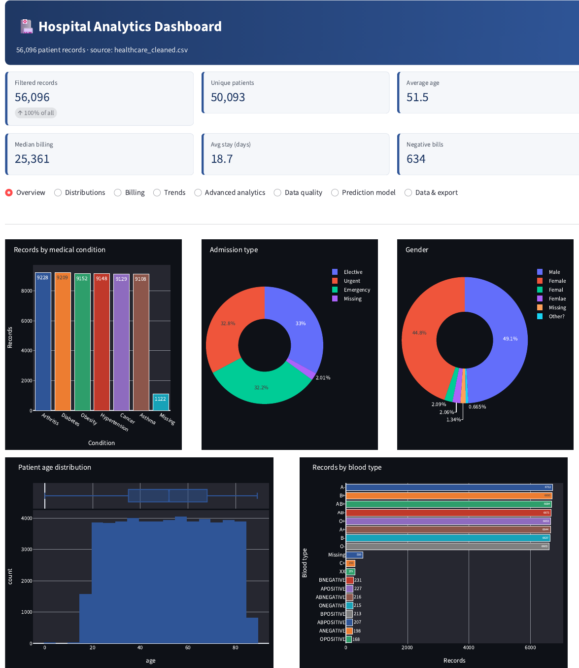
Overview section: banner, six KPI cards, records by condition, admission-type and gender donuts.
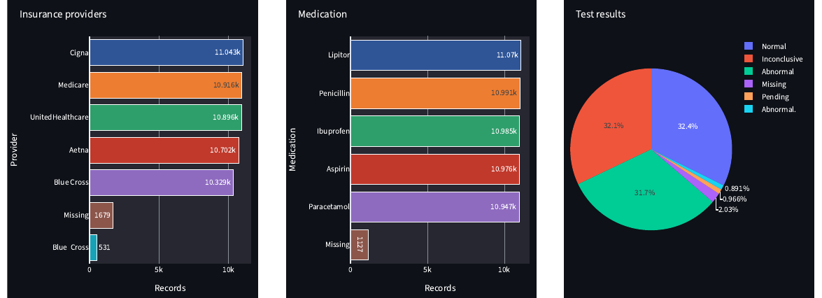
Overview (continued): insurance, medication and test-result charts.
2. Billing Analysis
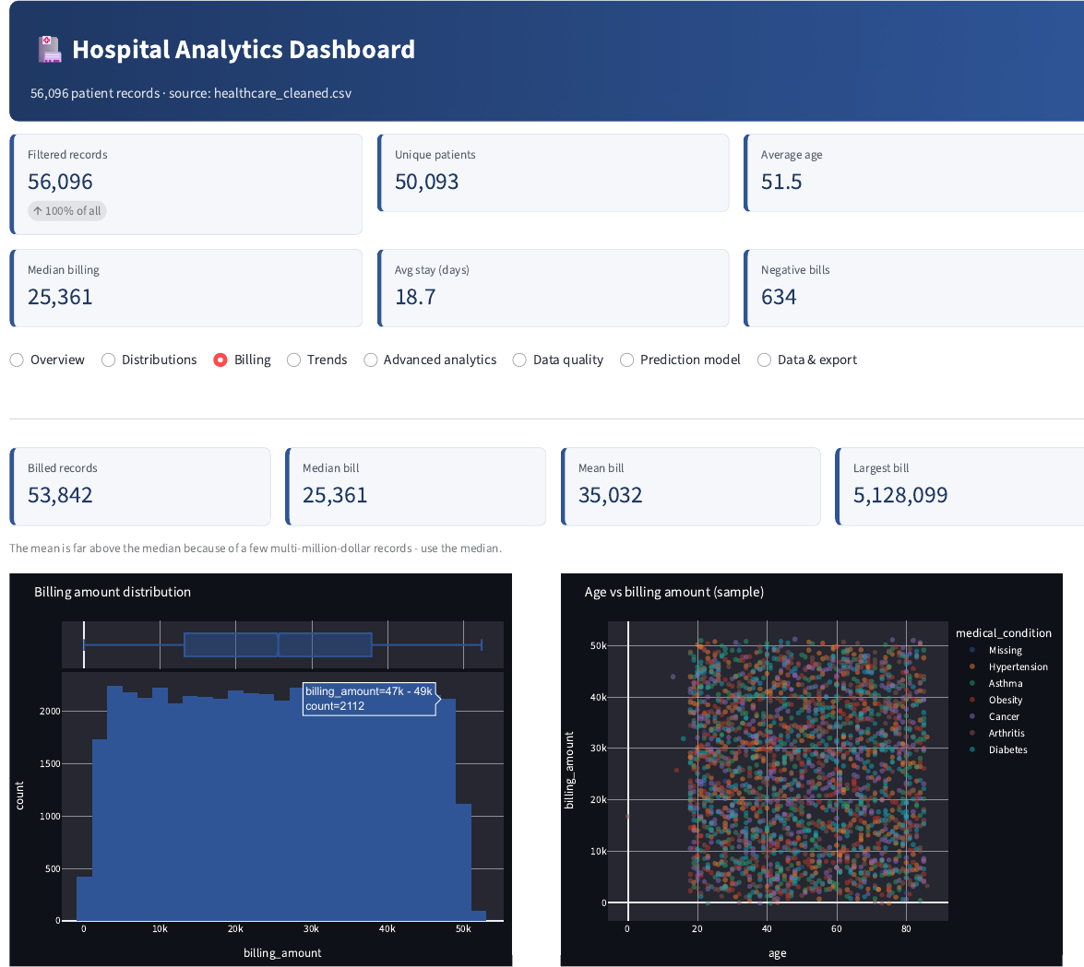
Billing section: billing histogram (outliers removed) and age-versus-billing scatter.
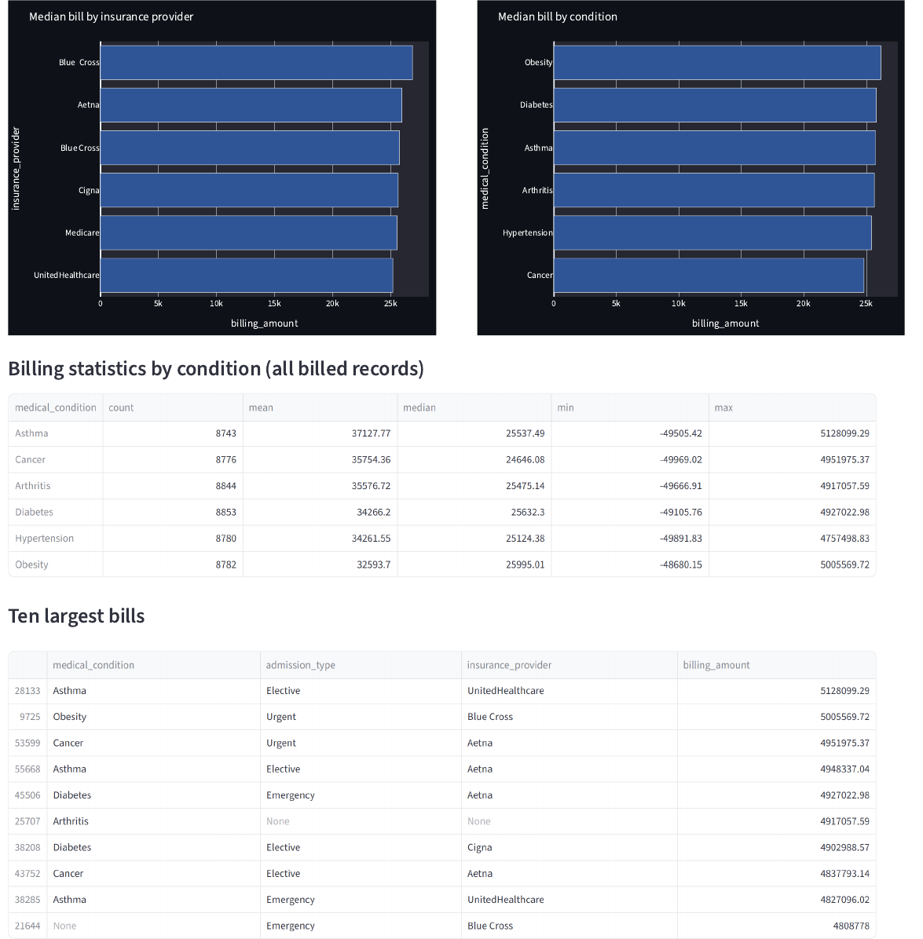
Billing (continued): median bill by insurance and condition, statistics table and ten largest bills.
3. Advanced Analytics
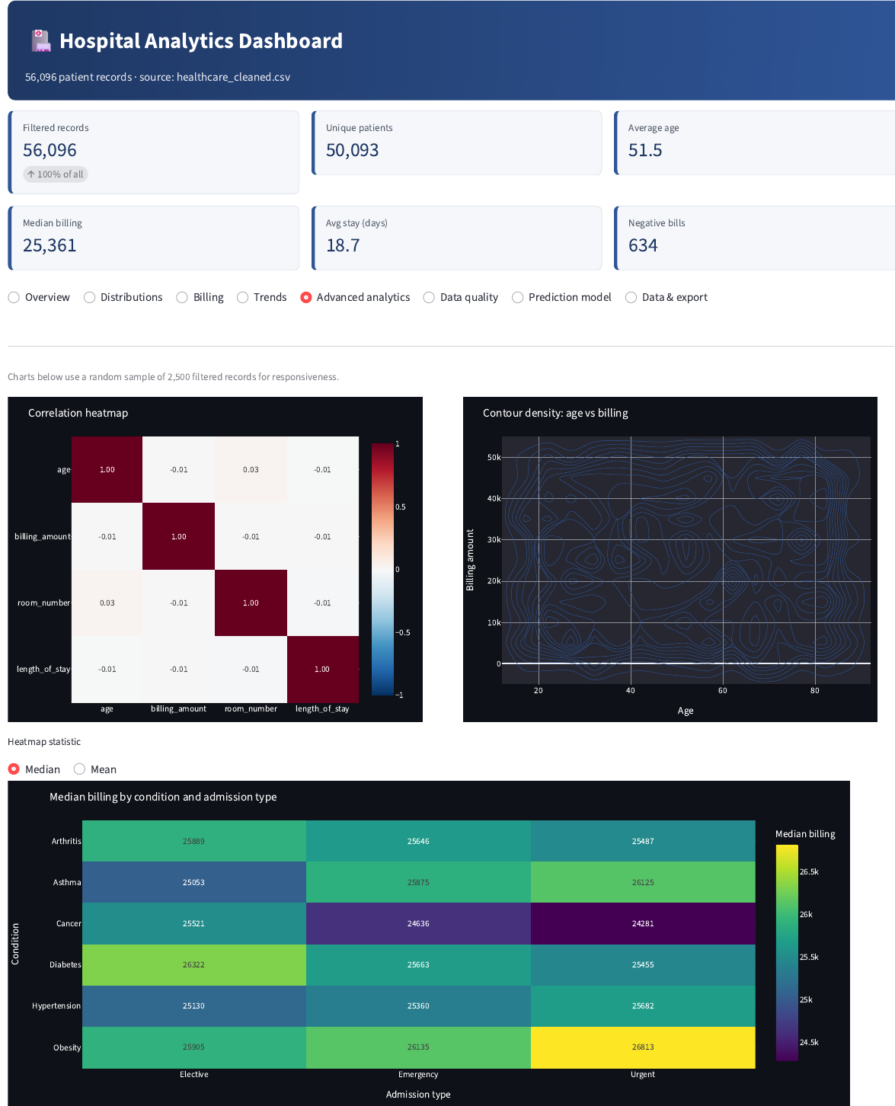
Correlation heatmap, age–billing contour and median-billing heatmap by condition and admission type.
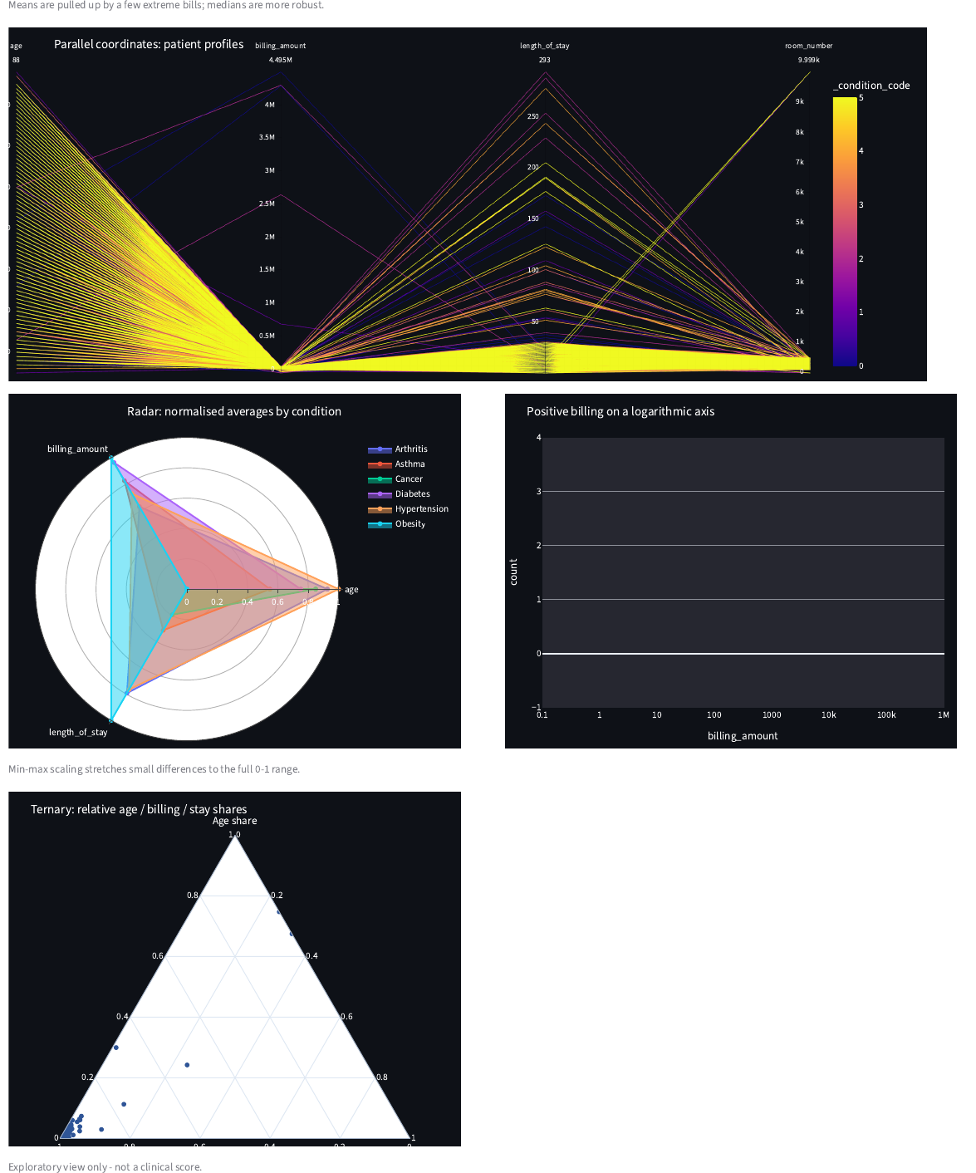
Parallel coordinates, radar chart, log-scale billing histogram and ternary plot.
4. Prediction Model
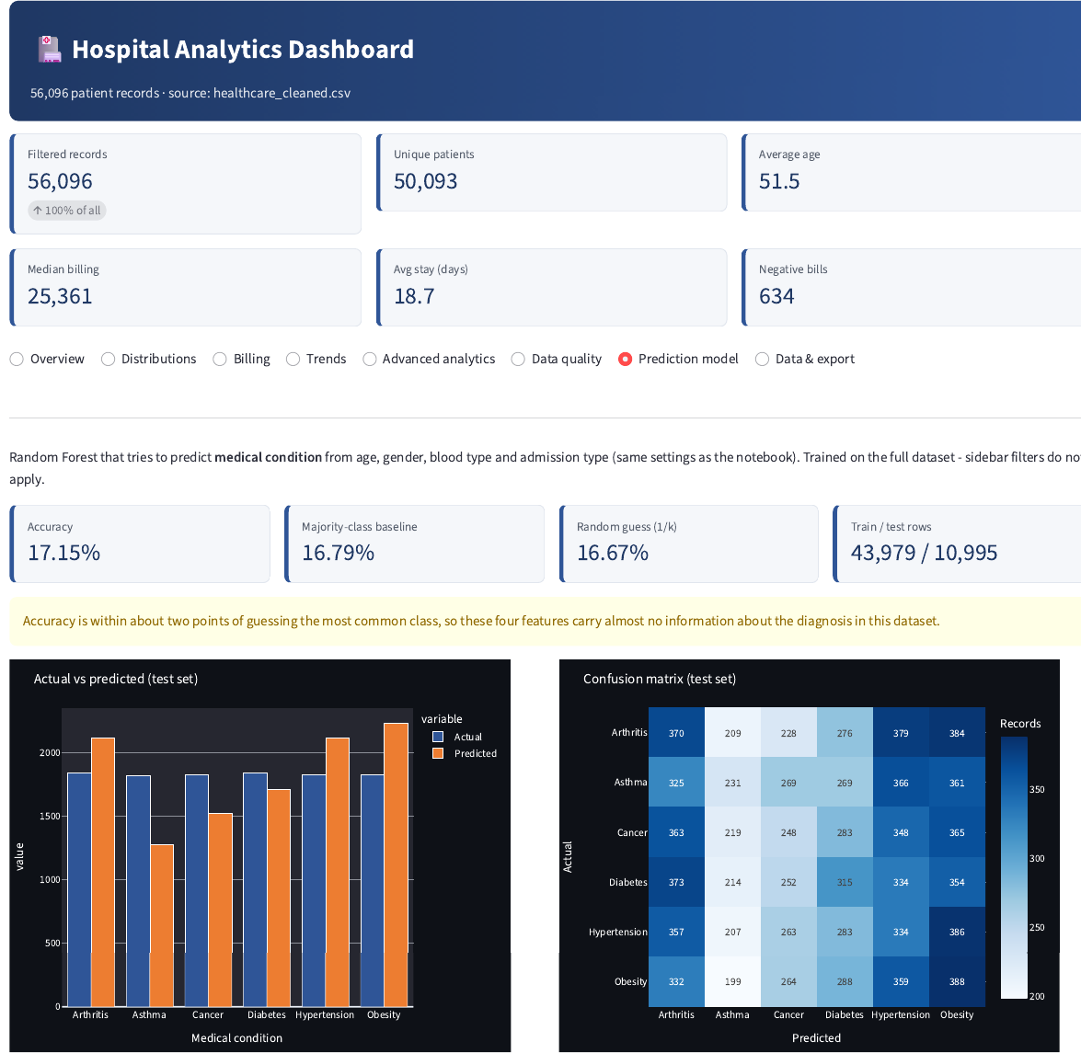
Accuracy 17.15% vs baseline 16.79% and random 16.67%, with warning, actual-vs-predicted chart and confusion matrix.
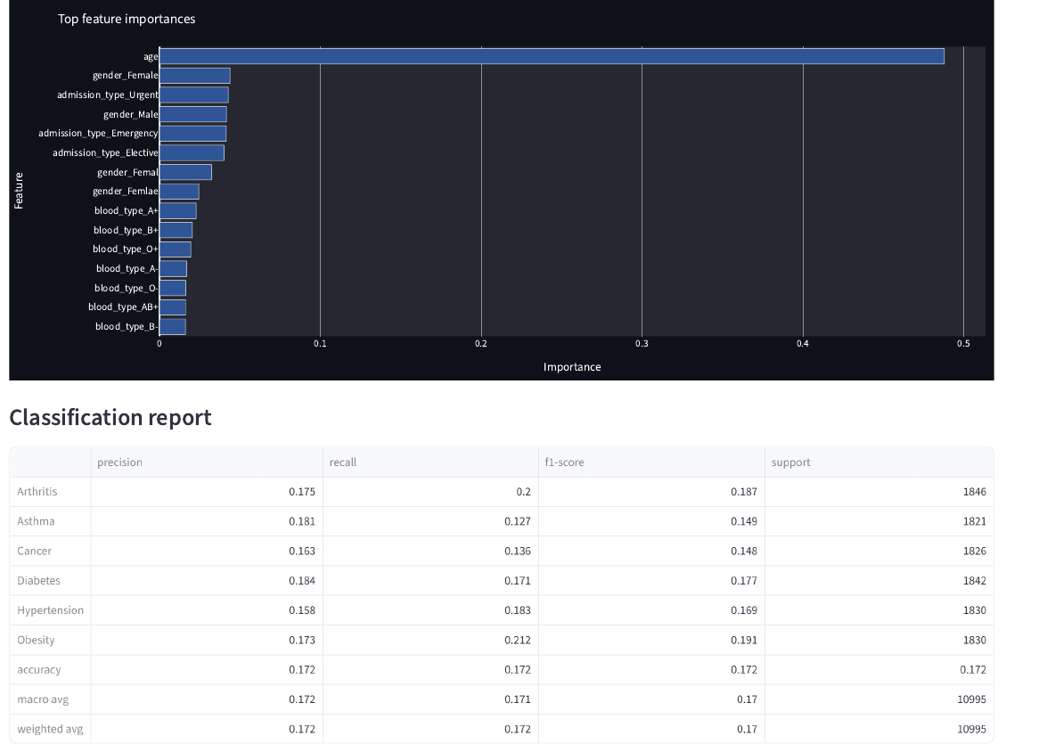
Feature importance and classification report (accuracy 0.172).
5. Data Cleaning and Missing Values
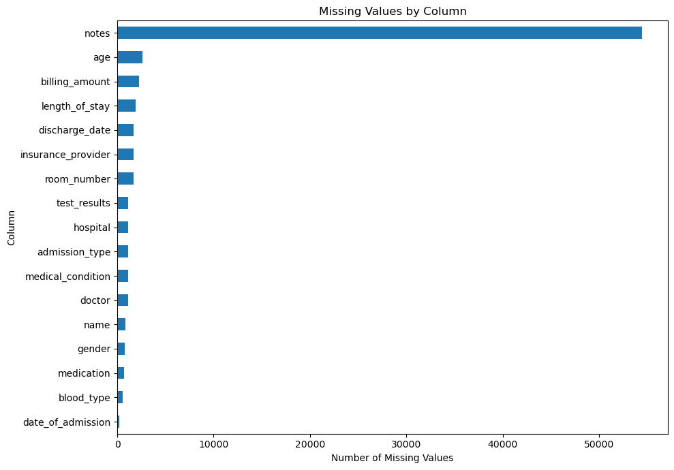
Missing values by column after cleaning.
6. Exploratory Charts (Notebook)
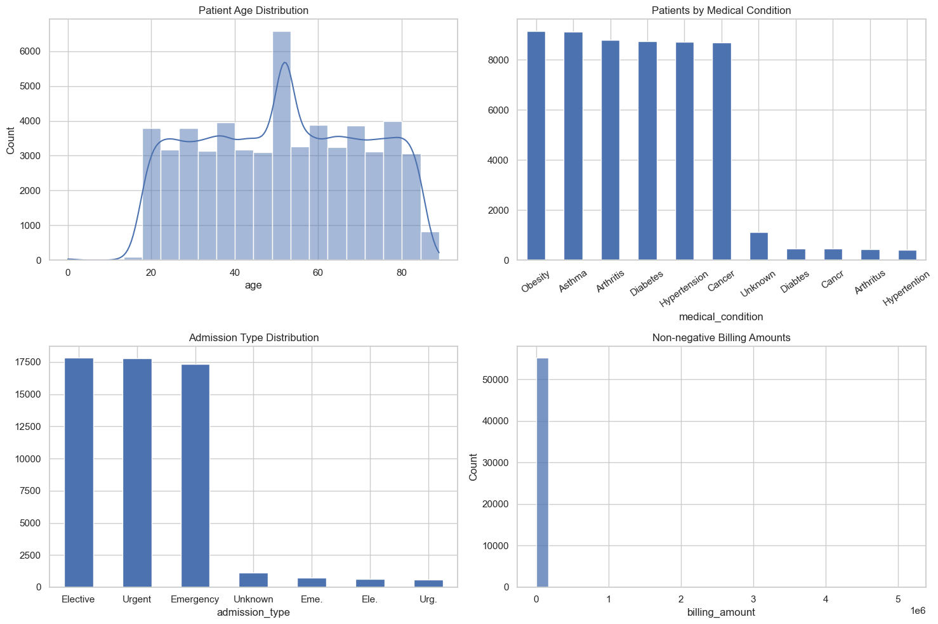
Four-panel overview of the analysis copy (age, condition, admission type, billing).
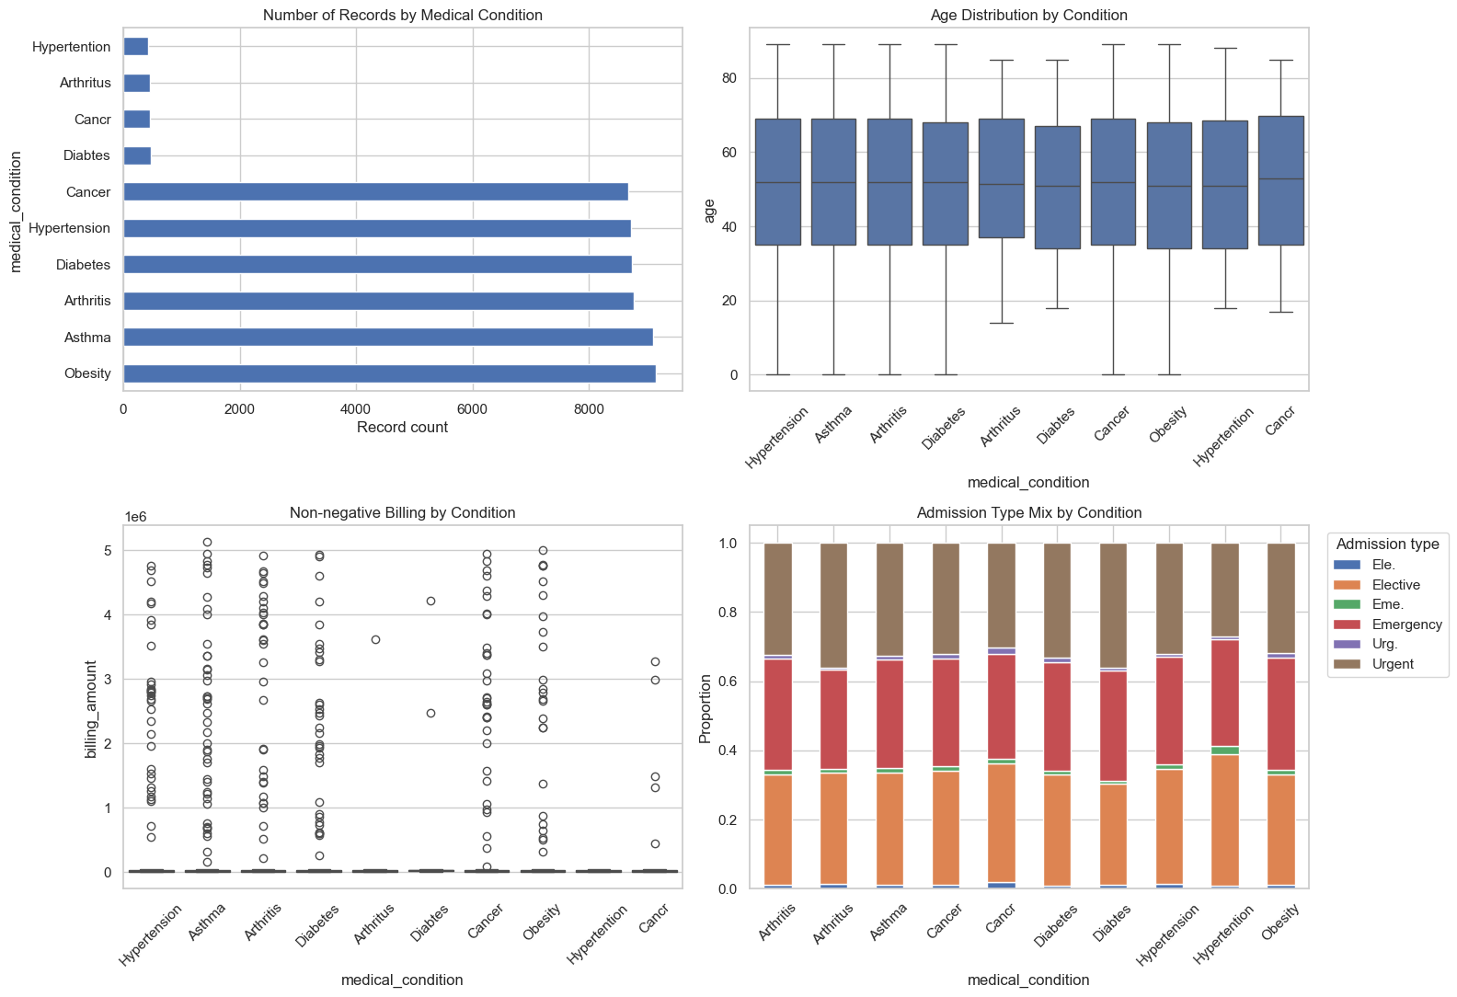
Records, age, billing and admission mix by medical condition.
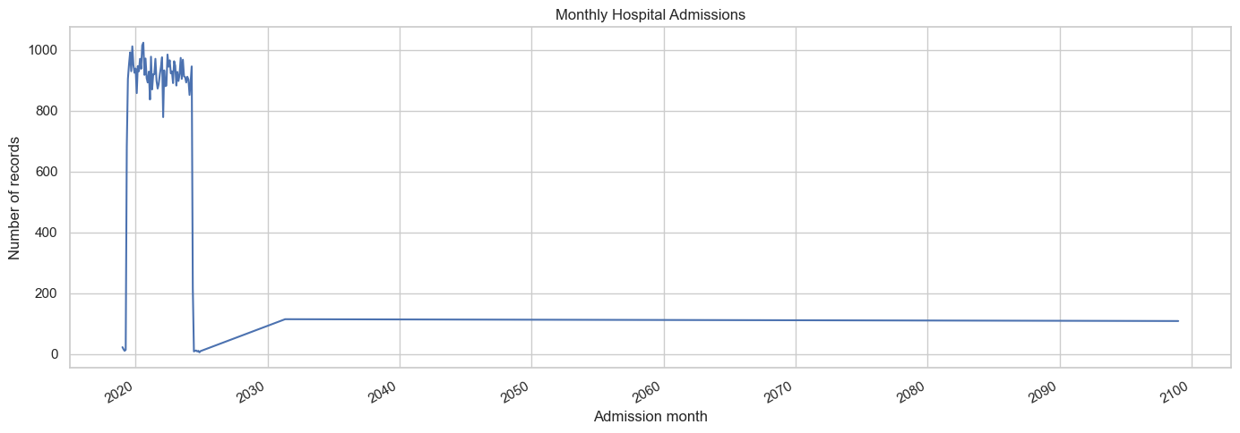
Monthly hospital admissions.
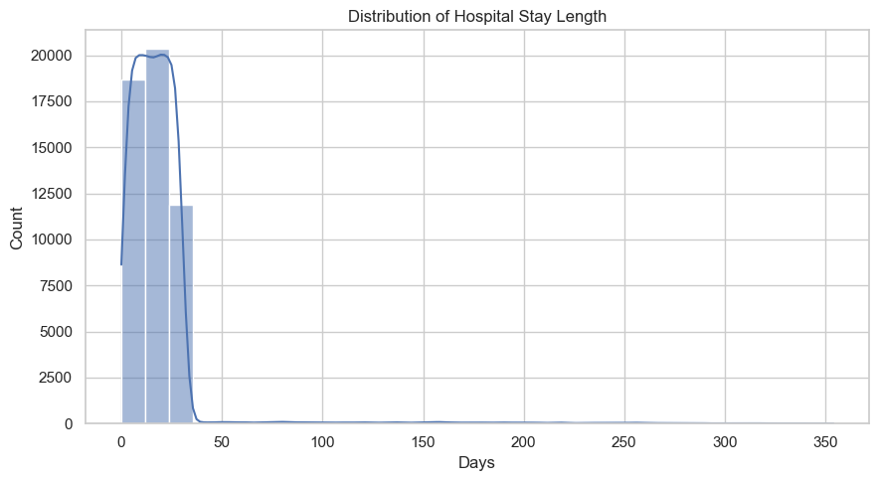
Distribution of hospital stay length.
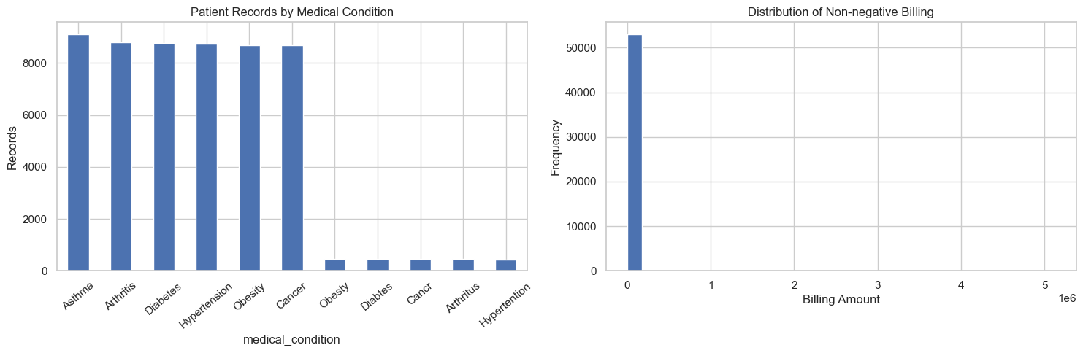
Condition counts and non-negative billing histogram.
7. Model Output (Notebook)
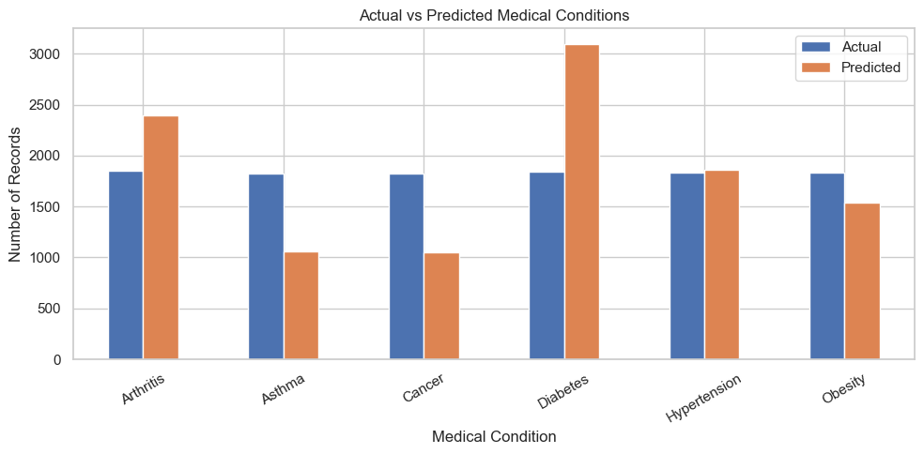
Actual versus predicted records per condition on the test set.
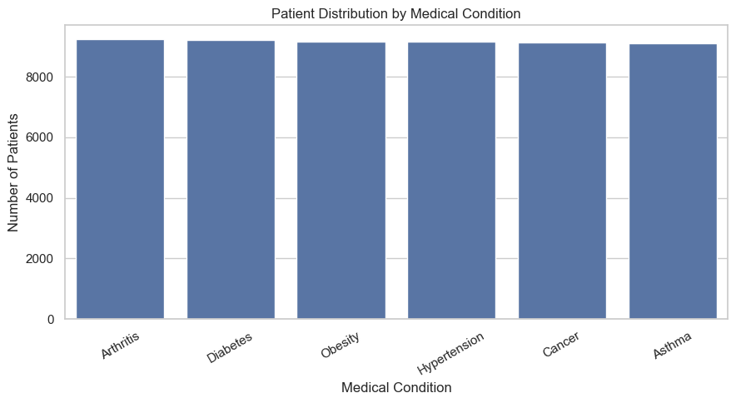
Patient distribution by medical condition after label standardisation.
8. Interactive Jupyter Dashboard
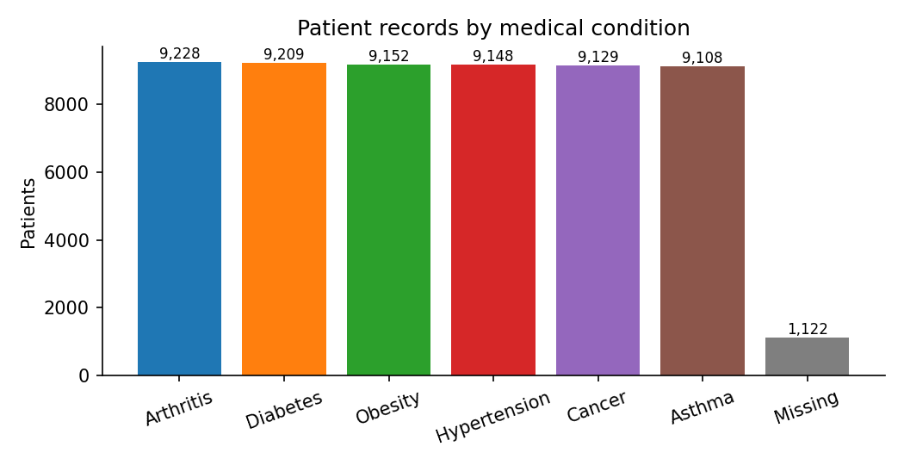
Patient records by medical condition.
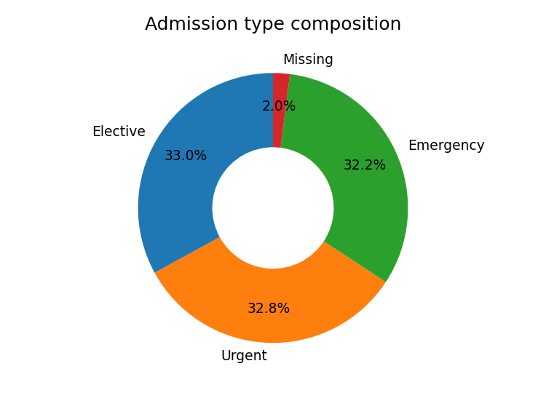
Admission type composition.
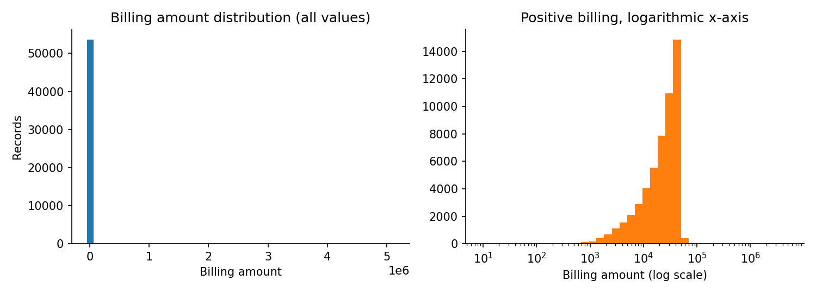
Billing distribution: linear and logarithmic axes.
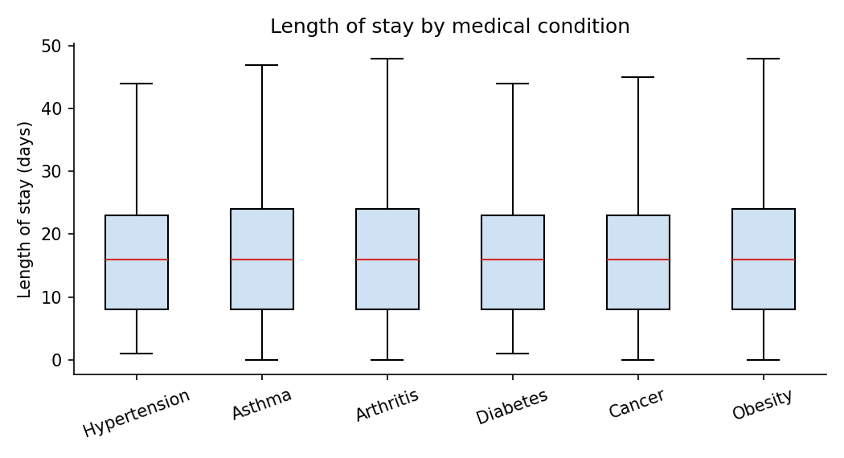
Length of stay by condition.
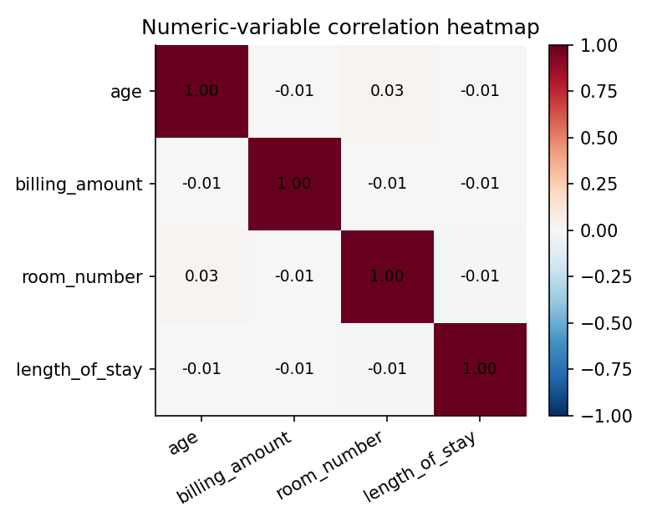
Correlation heatmap.
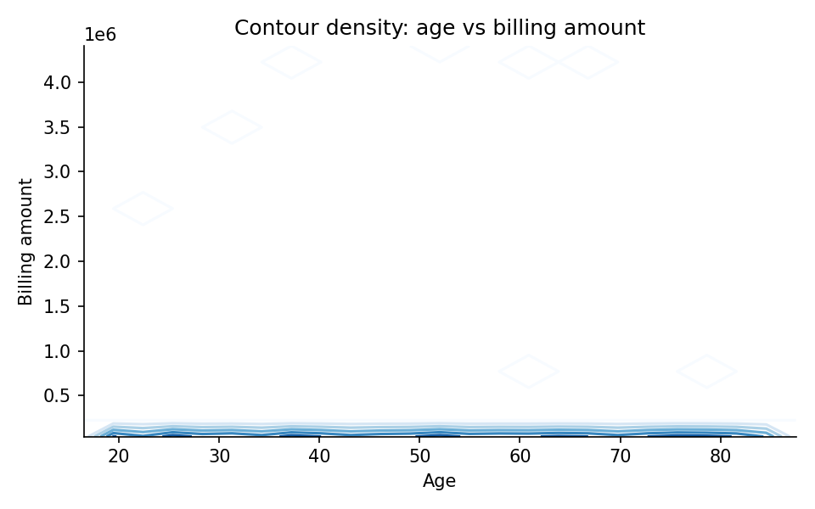
Contour density of age against billing.
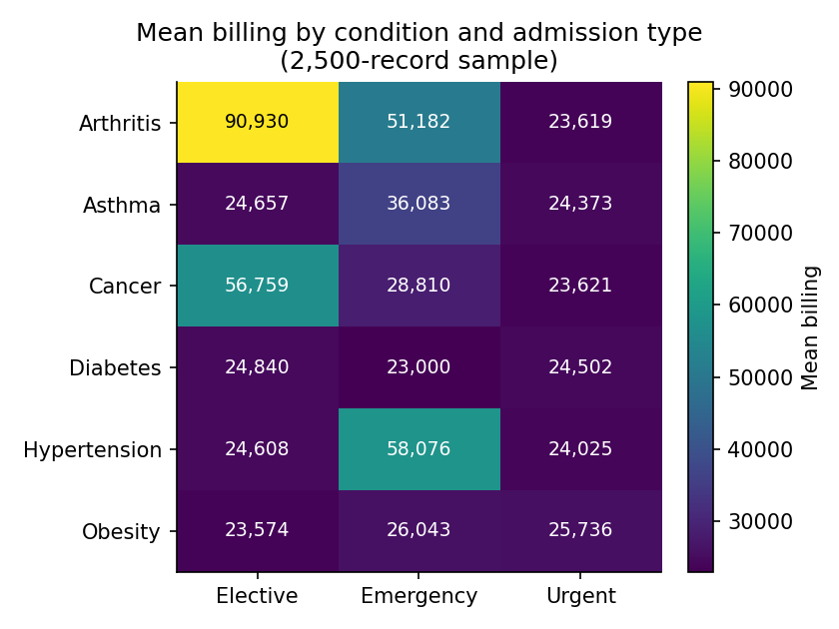
Mean billing by condition and admission type.
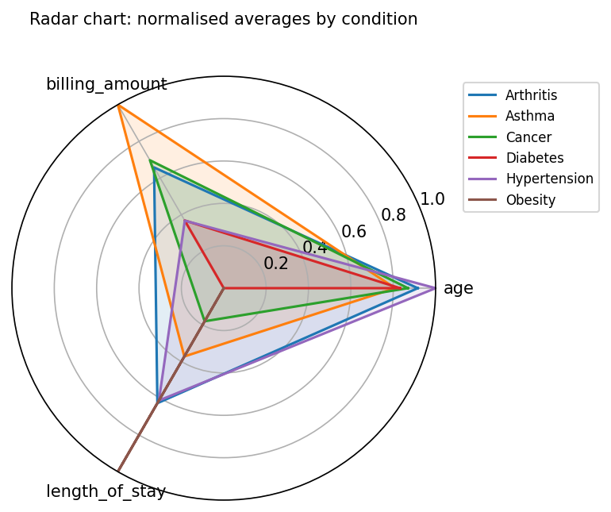
Radar chart of min–max-normalised averages.
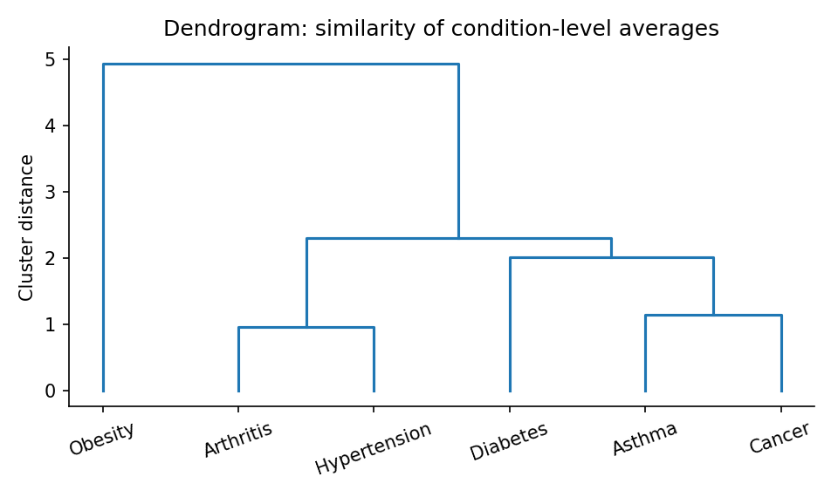
Dendrogram of the six conditions.
LIMITATIONS:
- Spelling and abbreviation variants (Diabtes, Cancr, Eme., Ele., Urg. – about 1,799 and 1,998 rows) survive in the saved CSV and are fixed later in the dashboard and model cells, not at source.
- Cleaning logic is duplicated across two overlapping notebook pipelines (In [4]–[6] and [7]–[10]); a single script would be easier to audit.
- Ambiguous dates: 2,072 stays have discharge before admission; day/month ambiguity is suspected but not confirmed.
- Future admission dates (around 2031 up to ~2099) are not validated; the Streamlit app excludes them from the trend but they remain in the data.
- 634 negative bills and 175 bills above one million are flagged but unexplained without a business rule.
- Median-filling age creates an artificial spike at 52 in the notebook analysis charts.
- The model reaches chance-level accuracy, uses a small forest (30 trees), and the notebook run still contained 50 duplicates.
- Near-uniform categories and zero correlations mean results do not describe real hospitals.
- There is no patient ID and names are not unique; names should be masked before sharing the app with real patient data.
CONCLUSIONS:
The project cleaned a 57,720-row messy hospital dataset into 56,096 analysis-ready records, documented every rule with before-and-after counts, and explored conditions, admissions, billing and stays. It delivers an end-to-end workflow: a Jupyter notebook for cleaning, EDA and modelling, and a Streamlit analyst dashboard with about 35 interactive charts. The main finding is that, in this dataset, patient attributes do not predict diagnosis (accuracy 16.6% against 16.7% by chance), and the near-balanced, uncorrelated data behaves like synthetic data. Results should therefore be treated as a demonstration of method, not as clinical or financial findings about real patients.

