Intra-Nasal Vaccines in Pets
Nasal route of vaccination is a relatively new method of immunization. Intra-nasal vaccines are given at the site of potential infection, they are considered more protective by some veterinarians. Studies have shown that intranasal vaccines act to protect your pet more quickly than the equivalent injectable vaccine does.
Intranasal vaccines result in higher nasal antibody levels, less shedding of organisms (meaning less chance of spreading the disease), and fewer symptoms, when challenged with the disease. Because no vaccine is 100% effective, a pet can still get sick, if exposed to a condition, even if they’ve been vaccinated. But pets who are vaccinated with intranasal vaccines have fewer signs of illness.
Nasal vaccination generates mucosal immunity as well as systemic immunity. The aim of mucosal immunization is the induction of local immunity at the port of pathogen entry. In particular, mucosal antibodies can readily neutralize invading viruses at the luminal site of the epithelial layer and prevent their entry into host cells. Such an immune exclusion effect is mainly mediated by secretory IgA (SIgA), which is effectively induced by mucosal but not parenteral immunization.
All the veterinarians are well aware of the deadly consequences of Canine Parvo Virus. Parvo in a new puppy is a dog owner’s worst nightmare. In a matter of days, a perfectly healthy puppy can go from playful and active state to fatally ill condition. Parvo in dogs is a preventable disease. However, all new puppy owners and breeders need to be aware of the risks of parvo, preventive measures and relevant therapies to cure the puppies from parvovirus. Breeds like German Shepherds, Rottweilers and Doberman Pinschers are at increased risk of contracting the parvovirus.
Puppies are born with antibodies from their vaccinated mothers. As these antibodies fade, they become susceptible. The stress of weaning and a secondary parasite or infection, along with parvo, can lead to a more severe case of parvo, which is why it is very important for the timely vaccination of the pet.
Indian Immunologicals Limited takes pride in its Nasal Vaccine: Megavac-P Nasal. Megavac -P Nasal is live attenuated vaccine against Canine Parvo Virus. Megavac-P Nasal can be administered in puppies of 4-6 weeks of age. The vaccine does not interfere with maternal immunity and therefore generates fast immune response leading to superior protection.
Megavac-P Nasal is a freeze dried vaccine with 0.5 ml sterile diluent. Post reconstitution, 0.5 ml of the vaccine is to be administered in either of the nostrils. This Intra-nasal vaccine is indeed a painless and safe vaccine that vouches for a better efficacy with ease of administration.
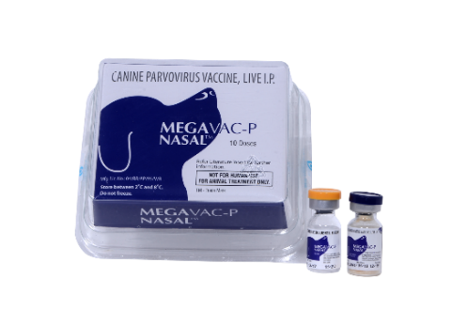

References:
- Petplan.com (2019), Right on the nose, Intra nasal vaccines in pets.
( https://www.gopetplan.com/blogpost/intranasal-vaccines-for-dogs-and-cats)
- Akc.org (2017), What every owner should know about Parvo in dogs. (https://www.akc.org/expert-advice/health/parvo-in-dogs/)
- Liu H, Patil HP, de Vries-Idema J, Wilschut J, Huckriede A (2013) Evaluation of Mucosal and Systemic Immune Responses Elicited by GPI-0100- Adjuvanted Influenza Vaccine Delivered by Different Immunization Strategies. PLoS ONE 8(7): e69649. https://doi.org/10.1371/journal.pone.0069649

Disclaimer: All information provided herein is for informational purpose only, not intended for trading advice and does not constitute recommendations or endorsements of any issuer, security or action. No reader should make any decision without conducting his own research and due diligence. Neither, Indian Immunologicals Limited / the author nor any of his associates is liable for any informational errors or for any actions taken in reliance on information contained therein. To the maximum extent permitted by law, Indian Immunologicals Limited / the author and his associates disclaim any and all liability in the event anything in this article proves to be inaccurate, incomplete or unreliable, or results in any kind of loss.

