TinyTax Developer Walkthrough
Confirmation Statements — Portal Walkthrough
This document covers the CS01 (Confirmation Statement) section of the TinyTax portal, for the engineering team. Produced by exploring the live production app directly against DROPLOGICX LTD (company no. 15152081), cross-referenced to UK-Tax-Filing-Platform-PRD.docx ("the PRD").
PRD CROSS-REFERENCE — Exploration conditions
DropLogicX's confirmation statement filing window for its current statement date (19/09/2027) does not open until that date, so the actual CS01 filing form itself was not reachable in this walkthrough — only the deadline-tracking list view was. As with the VAT document, this is a narrower walkthrough than the CT600/Accounts and SA100 documents for that reason: the module's filing window genuinely has not opened for the one real company available to explore against.

1. The Confirmation Statements list
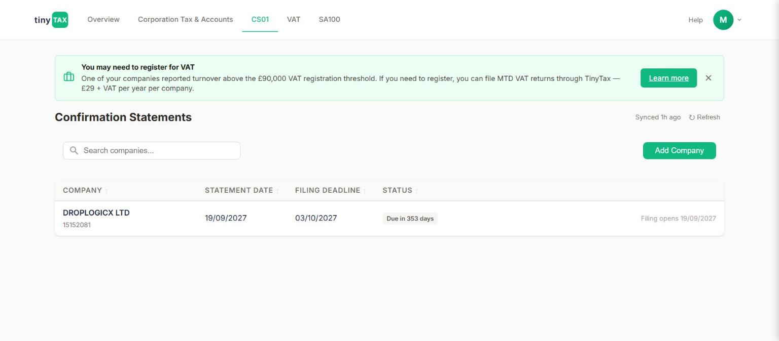
Confirmation Statements tab — one row per company, with statement date, filing deadline, and status.
Field | What it does / why it's asked
COMPANY | DROPLOGICX LTD, 15152081 — same company-row pattern as the CT600/Accounts and VAT tabs.
STATEMENT DATE | 19/09/2027 — the date the confirmation statement is made up to. This is distinct from the filing deadline next to it.
FILING DEADLINE | 03/10/2027 — 14 days after the statement date (standard Companies House confirmation-statement filing window).
STATUS | "Due in 353 days" at the time of this walkthrough, with a secondary note "Filing opens 19/09/2027" — i.e. the statement date and the date the filing window opens are the same date, and the actual filing/edit form isn't reachable before then.
Add Company | A button present on this tab (not on VAT's company list, which only lists existing companies) suggesting CS01 tracking can be set up for a company independently of whether it's already using the CT600/Accounts or VAT modules — worth confirming with the team whether this is company-level onboarding shared across modules or genuinely CS01-specific.
PRD CROSS-REFERENCE — Rule 3.6.3
The PRD requires a confirmation statement at least once every 12 months, for every company including dormant and non-trading ones — this is independent of whatever CT600/Dormant status a company has in the Corporation Tax & Accounts module (see the companion CT600/Accounts document, Section 2, where the Dormant company type's own HMRC-return guidance explicitly does not extend to this filing). Filing fee: £50 online (confirmed current rate from 1 February 2026), £110 by paper — not shown anywhere in this list view; worth confirming whether/where the fee is surfaced to the user before submission.
PRD CROSS-REFERENCE — Rule 3.6.3, continued
A confirmation statement confirms or updates: directors and secretary, PSCs (persons with significant control), registered office, registered email address, SIC code, statement of capital, and shareholder information. Directors and PSCs must also complete identity verification as part of the filing regime now in force. None of this content was reachable in this pass since the filing window is closed for DropLogicX — the fields above are documented from the PRD as what to expect/verify once a company's window is open.

2. What the filing form should contain — inferred from the PRD, not observed
Not directly observable in this walkthrough. Documented here as a checklist for whoever next explores this module once a company's filing window is open (either DropLogicX nearer 19/09/2027, or a disposable test company set up with an earlier statement date):
- Confirm or amend each of the six categories above (directors/secretary, PSCs, registered office, registered email, SIC code, statement of capital, shareholder info) — likely one review screen per category given the pattern of the CT600 wizard's multi-step structure.
- Director and PSC identity verification as part of the filing — a relatively new Companies House requirement; confirm how/whether TinyTax surfaces or defers to Companies House's own identity verification service for this step, since it may not be something the platform can complete entirely in-app.
- The £50 online filing fee — confirm how payment is collected (same payment method as the VAT module's £29+VAT/year pricing, or a separate one-off payment flow).
- Submission destination: Companies House only — unlike the CT600/Accounts module's two separate HMRC/Companies House submit buttons, a confirmation statement has a single filing destination, so this module should need only one submit action, not two.

3. Relationship to the other three modules
CS01 is the only one of the four filing types in this portal that applies to every company every year regardless of trading activity, Company Type, or VAT registration status — it is not gated by Dormant status (unlike the CT600's Dormant-specific guidance) and has no registration threshold (unlike VAT's £90,000 trigger). The PRD's own standing rule to re-verify rates before each new tax year (Section 3.9) applies most lightly to this module among the four, since the £50 fee and 12-month cycle are comparatively stable facts rather than annually-revised rates.

Appendix: What this document could and could not verify
Status | Detail
Verified directly in the live portal | List view layout (statement date, filing deadline, status, "Filing opens" note); Add Company action; the tab's position in the overall navigation.
Documented from the PRD, not yet observed in-app | The actual CS01 edit/review form; the six confirm-or-update categories; identity verification flow; £50 fee collection; single Companies House submission.
Recommended next step | Revisit this module nearer DropLogicX's 19 September 2027 window, or set up one disposable/sandbox test company with an earlier statement date specifically to walk the live filing form — the same approach recommended for the VAT module's nine-box return.

