TinyTax Developer Walkthrough
Corporation Tax & Accounts — Full Portal Walkthrough
This document explains the Corporation Tax & Accounts section of the TinyTax portal end to end, for the engineering team. It was written by exploring the live production app directly — navigating every screen, toggling every Company Type, expanding every collapsible section, and reading the rendered page content — rather than from a screen recording. Every field is explained, every CT600 box number is noted where the UI shows one, and every rule is cross-referenced to UK-Tax-Filing-Platform-PRD.docx ("the PRD").
PRD CROSS-REFERENCE — Exploration conditions
Explored against DROPLOGICX LTD (company no. 15152081), a real production company, using its existing draft for the year to 30 September 2026. All monetary figures shown in screenshots are dummy/placeholder test data entered for this walkthrough, not DropLogicX's real financial position. The walkthrough proceeds all the way to the final "Submit Corporation Tax to HMRC" / "Submit Accounts to Companies House" screen and stops there — neither button was ever clicked, and nothing was transmitted to HMRC or Companies House in the course of producing this document.

1. Entry point: the Corporation Tax & Accounts list
The module opens on a list with one row per accounting period for the company, not one row per company. DropLogicX has three periods: 30 Sep 2024 and 30 Sep 2025 (both already filed — green ticks under Accounts and CT600), and 30 Sep 2026 (an open draft).
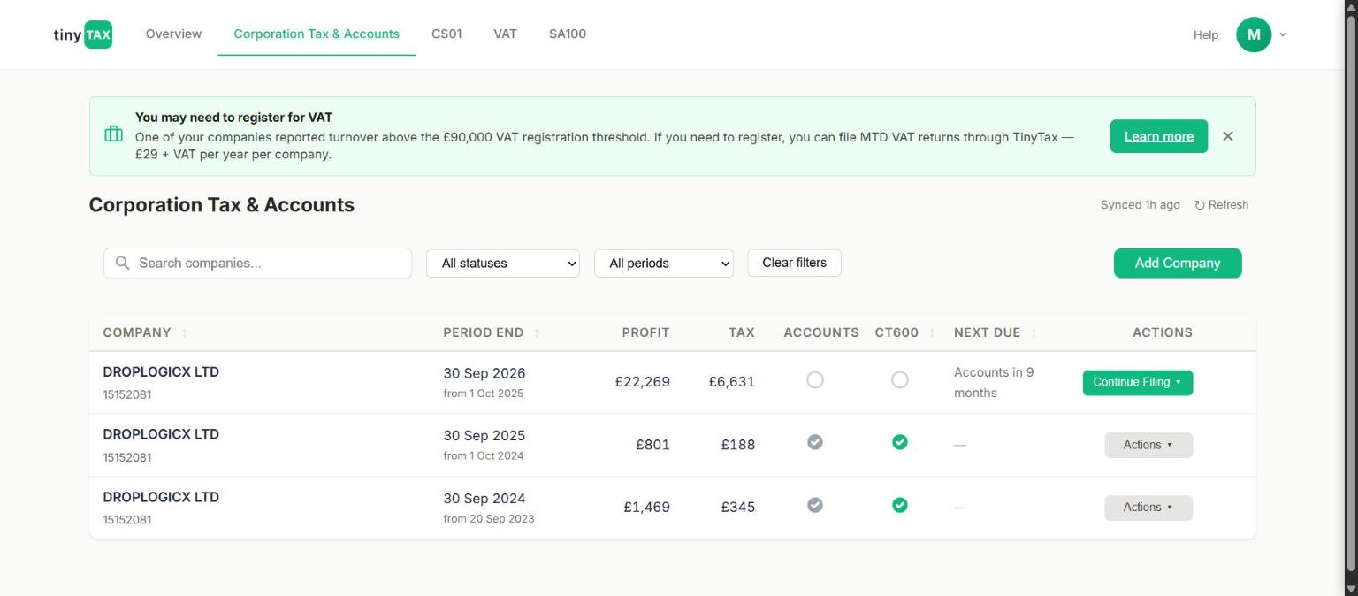
Corporation Tax & Accounts list. Each row is one accounting period, with independent Accounts/CT600 status and a Profit/Tax summary.
Field | What it does / why it's asked
Profit / Tax columns | Quick-glance summary pulled from the period's tax computation (e.g. £22,269 profit / £6,631 tax for the 2026 draft). Updates live as the draft is edited.
Accounts / CT600 status circles | Two independent indicators, because Companies House accounts and the HMRC CT600 are legally separate filings that happen to share one data-entry form here. A period can show one filed and the other not.
Next Due | Countdown to the next unmet deadline for that period (e.g. "Accounts in 9 months"). Blank once both are filed.
Continue Filing / Actions dropdown | For an open draft, expands to three filing-scope choices: "Corporation tax (CT600) and accounts" (both together, the normal path), "Corporation tax (CT600) only", and "Accounts only" — confirming the two filings can be worked and submitted independently even though the form is shared. The same menu also exposes two status-check links, "Has this CT600 been sent to HMRC?" and "Has HMRC asked for a CT600?", and a destructive "Delete Draft" action.
PRD CROSS-REFERENCE — Rule 3.1.6 / 3.1.8
The two status circles map directly to the PRD's point that a Company Tax Return is three things submitted together (CT600, iXBRL accounts, tax computations) but is tracked here as two user-facing filings (CT600 to HMRC, Accounts to Companies House) with two independent deadlines: 12 months after period end to file the CT600 (Rule 3.1.6), 9 months after period end for Companies House accounts (Rule 3.6.1). The "CT600 only" / "Accounts only" split in the dropdown is the product surfacing that independence directly.

2. Company Type — the field-set switch
Opening a draft lands on step 1, Enter Details, with a company summary card (name, number, registered address, directors, accounts & tax period) and a Confirm/Verify control pinned at the top of every step.
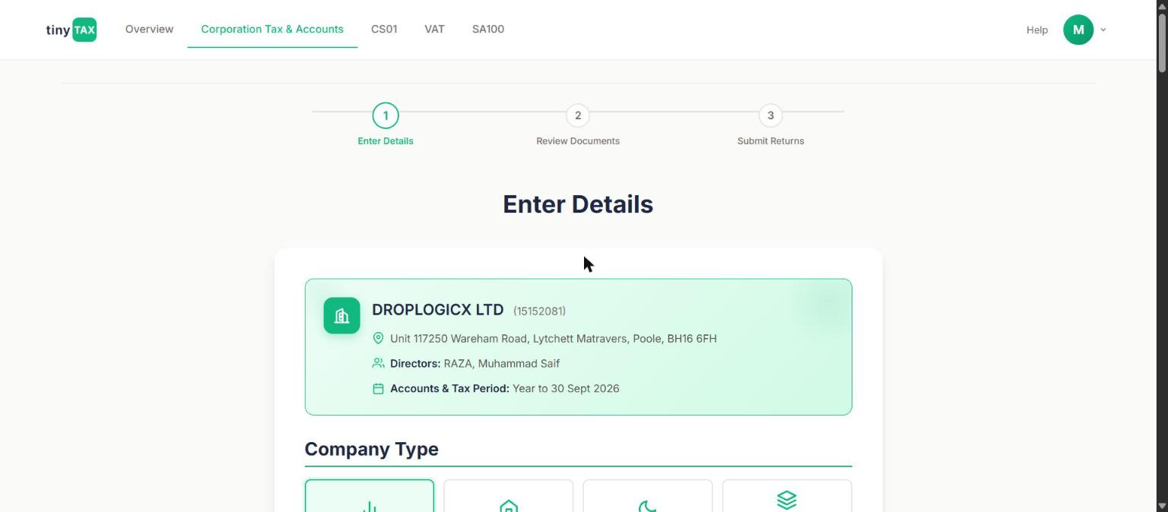
Enter Details — step 1 of 3. Company summary card pulled from Companies House data, with Confirm/Verify.
Company Type is the first and most consequential choice on the form: Trading, Property, Dormant, or Mixed Income (incl. holding & investment). It is a client-side form-branching switch, not a label — changing it adds or removes entire sections of the rest of the form. The table below is the field-set comparison across all four, captured by toggling the switch directly.
Field | What it does / why it's asked
Trading | Full Profit & Loss (Turnover, Interest income, Cost of raw materials, Staff costs, Depreciation, Other charges), full Balance Sheet, and the full Tax Computation block (Losses, Capital allowances, Balancing charges, Specialist adjustments). The default, and the type used for the worked screenshots in Sections 3–6 below.
Property | Same shape as Trading — P&L, Balance Sheet, and Tax Computation all shown — but oriented around rental/property income rather than trading income. The field set observed is structurally identical to Trading; the distinction is reporting classification (and, per Rule 3.4.8, a different future tax-rate track for the equivalent Income Tax side of property income, not something that applies to CT600 itself).
Dormant | Hides Profit & Loss entirely. Only the Balance Sheet is shown (still as a two-year comparison), plus a dedicated HMRC guidance block at Review & Submit — see Section 9. "Average # of Employees" also disappears from Accounts Information for this type.
Mixed Income (incl. holding & investment) | Shows an expanded P&L and Balance Sheet with additional line categories for mixed trading/investment income, for companies that don't fit cleanly as pure Trading or pure Property (e.g. a holding company with some rental and some investment income).
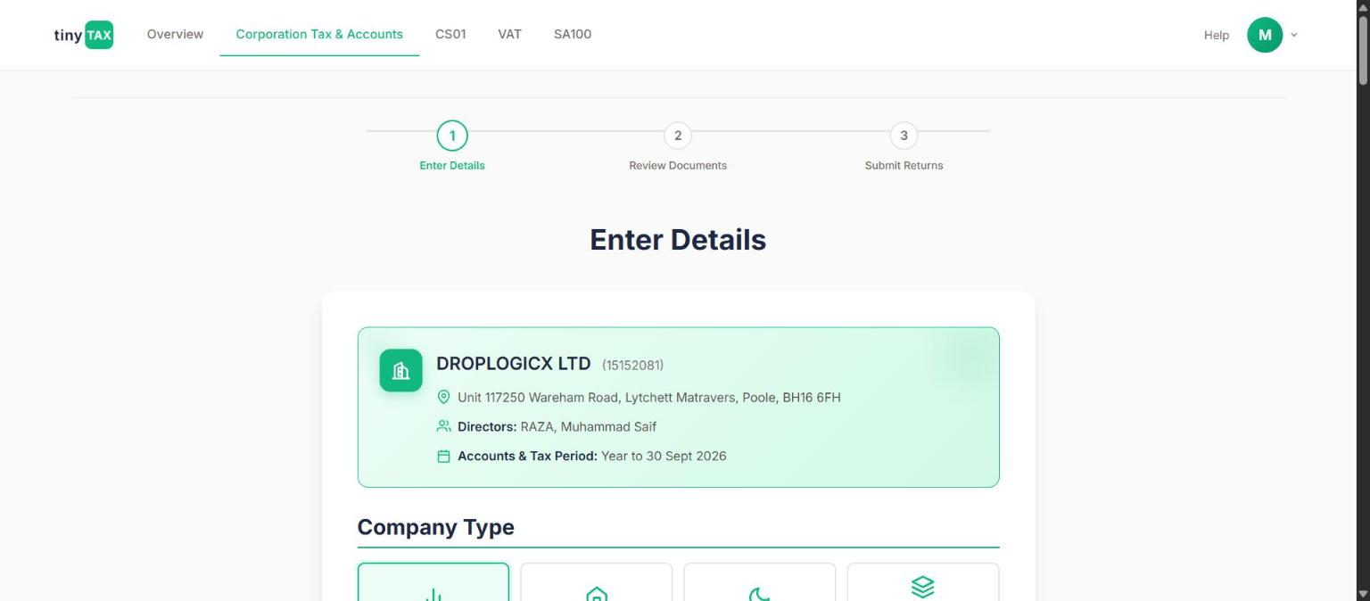
Company Type selector — four options, each changing the field set shown for the rest of the form.
⚠ FOR ENGINEERING — Dormant is a silent data-dropping gate
When Dormant is selected, the in-app copy warns that income/expense fields are hidden entirely for the rest of the form. A company with any income or expenses this period must not be filed as Dormant — those figures would be silently absent from the return rather than validated against it. This is a correctness-critical client-side gate worth a dedicated test: switching Company Type after entering P&L data should either carry a warning or clear the hidden data, not leave it in an inconsistent, invisible state.
PRD CROSS-REFERENCE — Section 3.9, open item VR-20
The PRD does not define "Dormant" as a numbered rule — it is a product concept layered on the accounts-format rules (3.1.8). Section 3.9's open item VR-20 explicitly flags as unresolved: "Exactly when a dormant company must still file a nil CT600, versus when it can be excused entirely." Treat the Dormant-specific copy and gating in this module (Section 9 below) as provisional product logic pending that sign-off, not as confirmed compliance copy.

3. Filings: CT600 toggle, accounts type, accounting period
Below Company Type sits the Filings block, present for all four company types:
Field | What it does / why it's asked
Corporation tax return (CT600) | Yes/No toggle, defaults to Yes. A user-facing choice of filing scope — it is not a determination of whether HMRC actually requires a return for the period; see the VR-20 cross-reference above.
Annual accounts | Yes/No toggle, independent of the CT600 toggle, for whether Companies House accounts are filed this period.
Type of accounts | Micro-entity (FRS 105) or Small company (FRS 102). Defaulted here to Micro-entity. Per Rule 3.1.8a this classification should come from an automatic 2-of-3 test (turnover ≤ £1,000,000; balance sheet total ≤ £500,000; ≤ 10 average employees for micro-entity; the wider £15,000,000 / £7,500,000 / 50-employee bands for small company) applied at company setup, not left as a free user choice. Worth confirming with the team whether this dropdown is a pre-computed default with an override, or an unchecked manual selection — the PRD is explicit that a non-accountant user should not be asked to self-select the framework.
Accounting Period | Shows the fixed period start date and a dropdown of period-end options, each annotated ("Next due", "Accounts filed"), plus a "Need to file for different dates?" link for edge cases — e.g. a first accounting period longer than 12 months, which Rule 3.1.5 says must be force-split into two separate CT600 filings rather than submitted as one.
PRD CROSS-REFERENCE — Rule 3.1.8a / 3.1.8b
3.1.8a: the 2-of-3 micro-entity test should drive the Type of accounts default automatically. 3.1.8b (forward-looking, confirmed date): from 1 April 2028, Companies House's ECCTA reforms require both micro-entity and small company accounts to include a full profit & loss account — the balance-sheet-only view this product currently shows for Dormant filings will not remain compliant indefinitely, and abridged accounts are being phased out across the board.

4. Profit & Loss (Trading / Property / Mixed Income types)
Shown as a two-year comparison (current period alongside the prior filed period). Box numbers are HMRC's own CT600/computation box numbers, shown inline in the UI next to the field label.
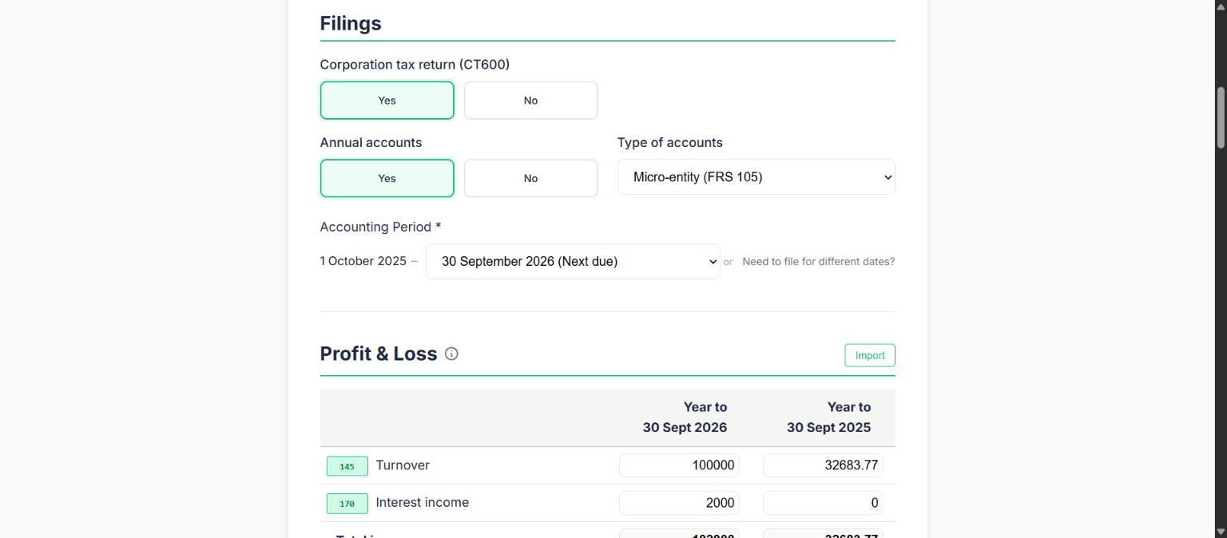
Profit & Loss — Turnover (box 145) and Interest income (box 170), two-year comparison.
Field | What it does / why it's asked
145 — Turnover | Trading income for the period. £100,000 (test data, 2026) vs £32,683.77 (2025 actual, filed).
170 — Interest income | Non-trading interest received (e.g. bank interest). £2,000 (test data) vs £0. Also appears again lower down under "Interest Income" in the Tax Computation block — see Section 6.
Cost of raw materials and consumables / Staff costs / Depreciation / Other charges | Standard P&L expense lines, each shown in brackets (accounting convention for a deduction) with a two-year comparison.
Total income / Total expenses / Profit before tax / Corporation tax / Profit for the year | Computed subtotals, not independently editable — they roll up from the lines above plus the tax computation result.
Import | A button present on both P&L and Balance Sheet sections (not exercised in this walkthrough) — worth confirming with the team what source formats it accepts, given Rule 3.3.3's digital-links principle for VAT; an equivalent "no manual re-typing of figures that already exist digitally" expectation is reasonable for accounts data too even though the PRD states that constraint specifically for VAT.

5. Balance Sheet
Shown for every company type, including Dormant (where it is the only financial section). Also a two-year comparison.
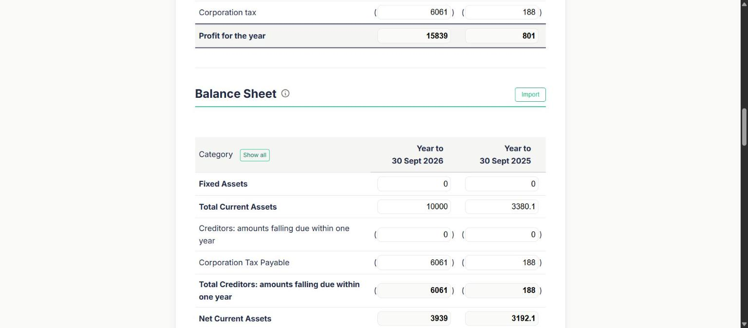
Balance Sheet section, following the Corporation tax row in the P&L.
Field | What it does / why it's asked
Fixed Assets / Total Current Assets | Non-current and current assets.
Creditors: amounts falling due within one year | Short-term liabilities, shown separately from Corporation Tax Payable below it.
Corporation Tax Payable | CT owed for the period — computed by the tax computation engine (box 440, see Section 6), not entered directly.
Net Current Assets / Total Assets Less Current Liabilities / Net Assets | Computed subtotals.
Creditors: amounts falling due after more than one year | Long-term liabilities.
Share Capital / Retained Earnings / Shareholders' Funds | Shareholders' Funds (Share Capital + Retained Earnings) must equal Net Assets exactly, or the accounts do not balance.
PRD CROSS-REFERENCE — Rule 3.0 / 3.0.4
Section 3.0 establishes the double-entry constraint the engineering team must enforce: Net Assets must equal Shareholders' Funds. Section 3.0.4 warns this is necessary but not sufficient — a balance sheet can balance arithmetically while still being substantively wrong (e.g. two figures transposed into the wrong boxes), so the balancing check alone is not full validation.

6. Tax Computation — Current Year (Trading / Property / Mixed Income)
A collapsible block with four sub-sections, each independently expandable ("Show"/"Hide"). All were expanded for this walkthrough.

6.1 Losses
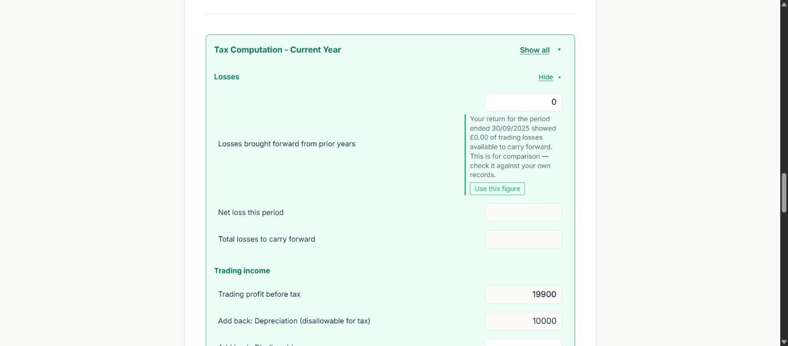
Losses sub-section, with the prior period's carried-forward figure offered for reuse.
Field | What it does / why it's asked
Losses brought forward from prior years | Pre-filled with a reference note: "Your return for the period ended 30/09/2025 showed £0.00 of trading losses available to carry forward. This is for comparison — check it against your own records," with a "Use this figure" button. A sensible UX pattern: it surfaces the platform's own prior-period data as a suggestion rather than silently auto-filling it, leaving the user able to override from their own records.
Net loss this period / Total losses to carry forward | Computed from the period's own trading result plus the brought-forward figure.
Trading income / Trading profit before tax / Add back: Depreciation / Add back: Disallowable expenses | The bridge from accounting profit to taxable trading income — depreciation and disallowable items (client entertainment, fines, etc.) are added back here per Rule 3.1.10.
PRD CROSS-REFERENCE — Rule 3.1.12
Trading losses: the PRD requires the user be offered a choice between carry-back (set against the prior 12 months' profit, immediate refund) and carry-forward (set against future total profits), not a silent default to either. The claim window is 2 years from the end of the loss-making period, overriding the general 4-year claims deadline. This "Losses brought forward" field is the carry-forward half of that mechanism; confirm with the team whether a carry-back election is offered elsewhere in the flow, since it was not visible in this walkthrough.
PRD CROSS-REFERENCE — Rule 3.1.10
Disallowable expenses added back here (depreciation always in full; client entertainment never deductible; fines and penalties never allowable; capital-transaction legal fees disallowable while routine trading legal fees remain allowable) are a core set, not exhaustive — the PRD lists further items (impairment of investments, non-trivial gifts, subscriptions to non-trade bodies) a full rules engine should eventually cover.

6.2 Capital allowances
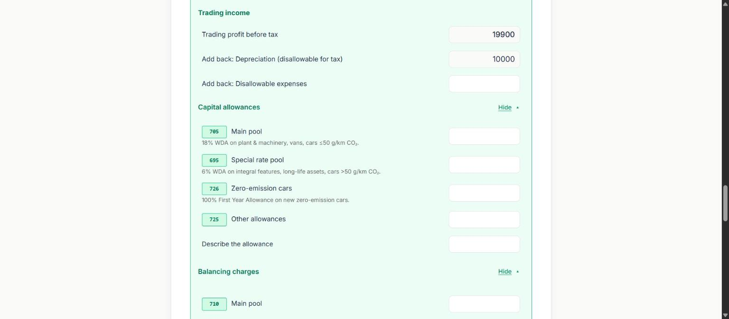
Capital allowances and Balancing charges, expanded. Box numbers 705/695/726/725 and 710/700/727/730.
Field | What it does / why it's asked
705 — Main pool | UI label: "18% WDA on plant & machinery, vans, cars ≤50 g/km CO₂."
695 — Special rate pool | "6% WDA on integral features, long-life assets, cars >50 g/km CO₂."
726 — Zero-emission cars | "100% First Year Allowance on new zero-emission cars."
725 — Other allowances | Free-text "Describe the allowance" field alongside the amount, for allowances that don't fit the three pools above.
710 / 700 / 727 / 730 — Balancing charges | Mirror set to the four allowance boxes above, for balancing charges (clawback) on disposal of assets from each pool.
⚠ FOR ENGINEERING — Main pool WDA is labelled 18%, PRD requires 14% for this accounting period
The UI's box 705 label reads "18% WDA". PRD Rule 3.1.9a states the main-pool WDA rate was cut to 14% for accounting periods beginning on or after 1 April 2026, with a hybrid blended rate for periods straddling that date — and DropLogicX's own 2026 draft period (1 October 2025 – 30 September 2026) straddles it. The 18% label matches the pre-Budget rate, not the rate the PRD says is current for this platform's launch window. This is worth a direct, explicit check with engineering/product: either (a) the displayed label is stale copy and the underlying calculation is already correct, or (b) the calculation itself is still using 18%, which would misstate Corporation Tax payable for any company with a main-pool balance in a period from 1 April 2026 onward. Flagging rather than fixing, since this document is a walkthrough, not a code change.
PRD CROSS-REFERENCE — Rule 3.1.9 / 3.1.9a / 3.1.9b
Zero-emission cars get 100% FYA (matches the 726 label). Special rate pool at 6% also matches the PRD. Separately, 3.1.9b: cars can never use AIA or full expensing regardless of how new or business-critical — they are always pooled by CO2 band (100% if zero-emission, 14% main pool if 1–50 g/km, 6% special rate if over 50 g/km). Confirm box 725/730 ("Other allowances", free-text) isn't being used as a workaround that lets a car purchase bypass this pooling logic.

6.3 Interest Income and Specialist adjustments
Field | What it does / why it's asked
170 — Interest income | Repeated here from the P&L (Section 4) as its own tax-computation line — interest is a non-trading item that needs its own box in the final CT600 even though it's entered once in the P&L.
Other adjustments | Free-text amount, "add if positive, deduct if negative" — a catch-all adjustment line.
326 — Associated companies | Count field. Required input, per Rule 3.1.4 below, for the marginal relief calculation to be correct.
640 — The company has written down or sold intangible assets | Flag/checkbox-style field for intangible asset disposals, a specialist area with its own tax treatment not otherwise covered in this form.
165 — Net trading profits | Computed rollup.
315 — Profits chargeable to corporation tax | The final taxable-profit figure the marginal relief formula is applied to.
PRD CROSS-REFERENCE — Rule 3.1.4
Box 326 (Associated companies) is exactly the required field Build Rule 3.1.4 calls for: the £50,000/£250,000 marginal relief thresholds are divided by (1 + number of associated companies), pro-rated for short accounting periods. The PRD flags that a passive holding company only holding shares in subsidiaries is excluded from this count by a legal test that isn't a simple ownership-percentage check — worth confirming whether box 326 carries any in-app guidance distinguishing that case, since getting it wrong changes the CT rate band available.

6.4 Profits chargeable and Corporation Tax Payable
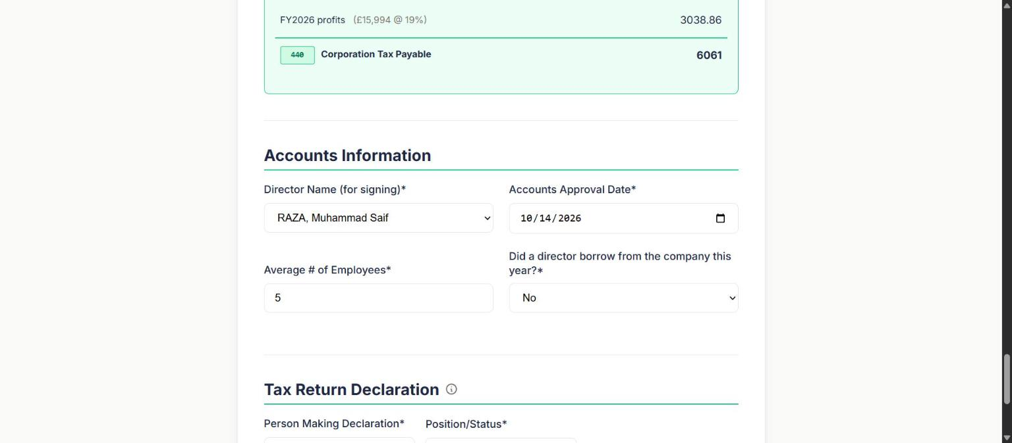
Tail of Tax Computation (FY2026 profits @ 19%, box 440 CT Payable) plus Accounts Information.
Field | What it does / why it's asked
FY2025 profits (£15,906 @ 19%) / FY2026 profits (£15,994 @ 19%) | The platform splits the accounting period's profit across UK financial years (each running 1 April–31 March) because Corporation Tax rates are set per financial year, not per company accounting period — a period that straddles 1 April must be apportioned and each slice taxed at its own FY's rate. Both slices shown here use 19%, the small profits rate (Rule 3.1.1, profits ≤ £50,000), consistent with this company's modest test-data profit.
440 — Corporation Tax Payable | £6,061 in this test draft — the final computed CT600 figure, feeding the Balance Sheet's "Corporation Tax Payable" line and the dashboard's Tax column.
PRD CROSS-REFERENCE — Rule 3.1.1 / 3.1.2 / 3.1.3
At this profit level (taxable profit well under £50,000) the small profits rate (19%) applies directly with no marginal relief tapering needed — marginal relief only engages between £50,001 and £250,000 (Rule 3.1.2), per the £100,000-profit worked example the PRD designates as a permanent regression test (Rule 3.1.3: £22,750 payable). Re-run this walkthrough with a profit figure in the £50,001–£250,000 band if a developer specifically needs to see the marginal relief UI/figures in action — not captured in this pass since the test data lands in the small profits band.

7. Accounts Information
Field | What it does / why it's asked
Director Name (for signing) | Dropdown of the company's registered directors, or "Other (enter manually)".
Accounts Approval Date | Board-approval date for the statutory accounts.
Average # of Employees | Only shown for Trading/Property/Mixed Income — absent for Dormant (Section 2 above). Feeds the micro-entity/small-company 2-of-3 test (Rule 3.1.8) as one of the three criteria.
Did a director borrow from the company this year? | Yes/No. A single company-level field that triggers a materially complex compliance area if Yes — see the flag below.
⚠ FOR ENGINEERING — A single Yes/No field cannot represent the director's-loan rules correctly
If this question were answered Yes, Rule 3.1.13/3.1.13a requires the loan amount AND the date each individual loan was made — s455 tax is charged per loan, at a rate fixed by that loan's own date (25% / 32.5% / 33.75% / 35.75%, banded from 6 April 1999 / 2016 / 2022 / 2026 respectively), not by the accounting period end. A close company can have multiple loans made in different bands, requiring multiple lines on the CT600A supplementary form (the PRD's own worked example: two £10,000 loans five days apart, taxed £3,375.00 and £3,575.00 — two lines, two rates). A single Yes/No toggle on this screen cannot capture that; confirm whether a dedicated loan sub-flow appears elsewhere when Yes is selected, since it wasn't reachable from this field in the walkthrough. Separately, Rule 3.1.13b warns never to describe an eventual s455 reclaim as immediately available on repayment — the reclaim is only due 9 months + 1 day after the end of the accounting period in which repayment happened, routinely 18–24 months after the actual repayment.

8. Tax Return Declaration
Field | What it does / why it's asked
Person Making Declaration | Defaults to the same director selected for Accounts Information signing.
Position/Status | Free-text role (e.g. "Director").
Save Progress / View Draft Submission | Save Progress is a manual checkpoint; the form also autosaves independently — a "Saved at [time]" confirmation appears at the bottom without an explicit save click whenever a field changes and loses focus.
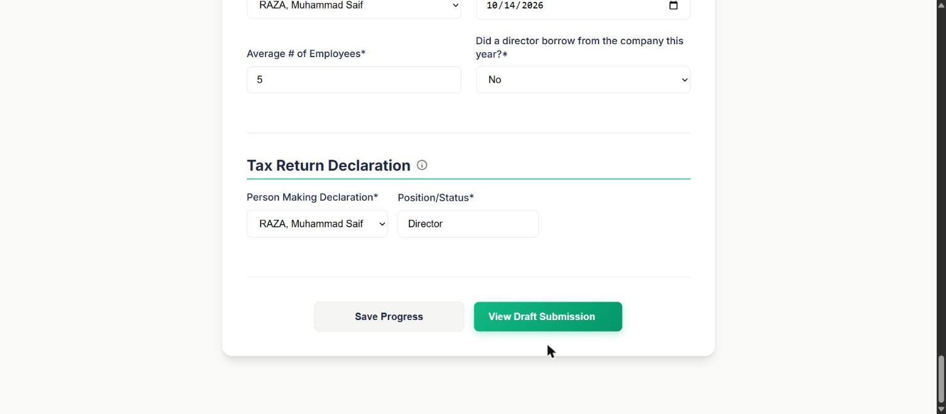
Bottom of step 1: Save Progress / View Draft Submission, with the autosave confirmation.

9. Review & Submit (step 2 → step 3)
"View Draft Submission" advances to Review & Submit, where the company summary card now also shows the resolved Company Type as a badge ("TRADING COMPANY" in this pass), and four documents are generated.
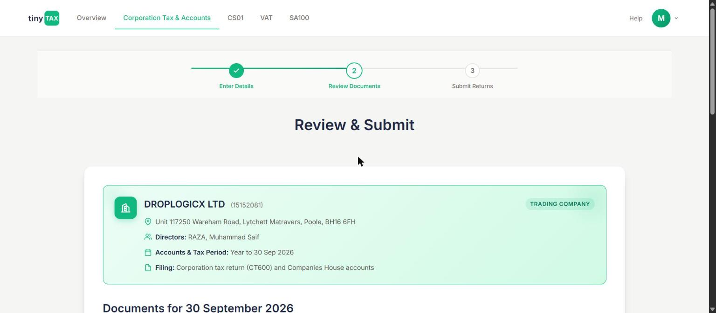
Review & Submit — step 2, with the Company Type badge and a "Generating your documents…" toast confirming async generation.
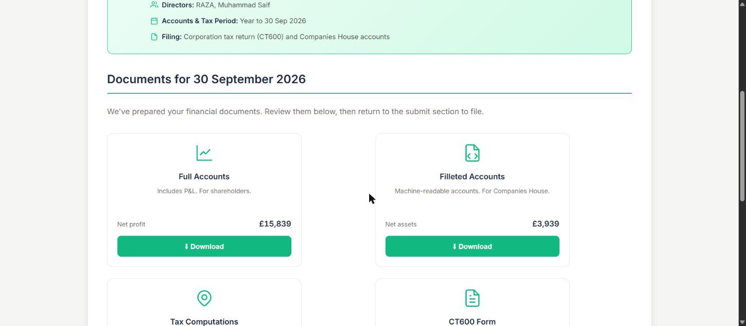
The four generated documents: Full Accounts, Filleted Accounts, Tax Computations, CT600 Form.
Field | What it does / why it's asked
Full Accounts | "Includes P&L. For shareholders." Shows Net profit (£15,839 in this test draft) as a quick-glance figure.
Filleted Accounts | "Machine-readable accounts. For Companies House." — the iXBRL-tagged submission output (Rule 3.6.5). Shows Net assets (£3,939).
Tax Computations | "Corporation tax calculations. For HMRC." Shows Tax payable (£6,061.00), matching box 440 from Section 6.4.
CT600 Form | "Traditional paper form layout. Your return is filed digitally." — the CT600 rendered in HMRC's familiar box-numbered layout for user review, even though the actual submission is electronic via Government Gateway.
All four cards show a brief "Generating…" state before the Download button activates, confirming document generation is an asynchronous job rather than synchronous with page load — relevant to how the frontend polls for completion.
PRD CROSS-REFERENCE — Rule 3.1.8 / 4.0
The four documents map directly onto the PRD's definition of a Company Tax Return as three things submitted together (CT600 form, iXBRL accounts, tax computations) plus a fourth, shareholder-facing Full Accounts that isn't itself submitted to HMRC. Separately, Section 4.0 of the PRD notes that CT600 (and legacy SA100) submissions run over HMRC's older XML/Government Gateway mechanism, not the modern REST/OAuth2 APIs used for VAT and MTD ITSA — a materially more involved integration than the VAT module covered in the companion VAT document.

10. Final step: submit — and where this walkthrough stops
Scrolling past the four document cards reaches the final section, "Final Step: Submit Your Filing," with an info panel on required credentials and two separate, independent submit buttons.
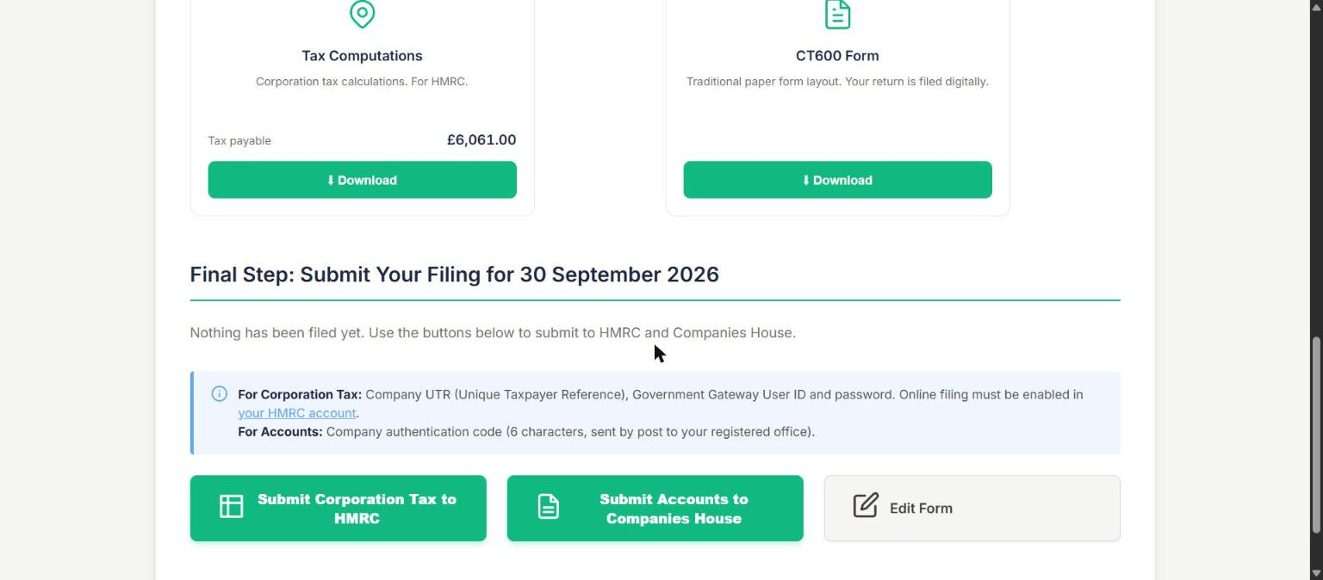
Final submit section: credential requirements, then two separate submit buttons (HMRC / Companies House) plus Edit Form.
Field | What it does / why it's asked
Credential info panel | "For Corporation Tax: Company UTR, Government Gateway User ID and password. Online filing must be enabled in your HMRC account. For Accounts: Company authentication code (6 characters, sent by post to your registered office)." Two completely different credential sets for the two destinations, consistent with them being separate government bodies with separate authentication mechanisms.
Submit Corporation Tax to HMRC / Submit Accounts to Companies House | Two independent submit actions, matching the independent CT600/Accounts toggles from Section 3 and the independent status circles from Section 1 — a user could in principle submit one without the other.
Edit Form | Returns to step 1 without submitting either filing.
Per the task's governing instruction, this walkthrough stops here. Neither "Submit Corporation Tax to HMRC" nor "Submit Accounts to Companies House" was clicked at any point in producing this document — nothing was transmitted to HMRC or Companies House for DropLogicX Ltd.

Appendix: Test data used in this walkthrough
Item | Value
Company | DROPLOGICX LTD, company number 15152081 (real production company; all figures below are dummy/placeholder test data entered for this walkthrough, not DropLogicX's real financial position)
Accounting period | 1 October 2025 – 30 September 2026
Company Type used for Sections 4–9 screenshots | Trading
Type of accounts | Micro-entity (FRS 105)
Turnover (145) / Interest income (170) | £100,000 / £2,000
Associated companies (326) | Not separately captured in this pass — confirm default/required state with the team
Average # of Employees | 5
Corporation Tax Payable (440) | £6,061.00
Director (signing / declaration) | RAZA, Muhammad Saif
Did a director borrow this year? | No

