TinyTax Developer Walkthrough
Self Assessment — Portal Walkthrough
This document covers the Self Assessment (SA100) section of the TinyTax portal, for the engineering team. Produced by exploring the live production app directly, cross-referenced to UK-Tax-Filing-Platform-PRD.docx ("the PRD").
⚠ FOR ENGINEERING — Internal tab name vs UI label — a naming inconsistency worth flagging
The dashboard's URL for this section is /dashboard/?tab=directors — the internal tab identifier is "directors", but the on-screen label and page title are both "SA100" / "Self Assessment". Harmless today, but worth renaming the internal identifier (or at least noting the mismatch in code comments) before it causes confusion for a future developer grepping the codebase for "SA100" and not finding this route.
PRD CROSS-REFERENCE — Exploration conditions
Explored against Muhammad Saif Raza, the sole director of DROPLOGICX LTD, using the portal's own 2025-26 return. To see the live tax calculation engine in action, a PAYE/dividend income row was entered with placeholder test figures (Pay £30,000, UK tax £4,000, Dividend £20,000) and the return was left on autosave ("Saved at 18:18"). The return was never submitted — "Submit to HMRC" was not clicked at any point, and nothing was transmitted to HMRC for this director in the course of producing this document. All monetary figures below are dummy/placeholder test data, not Mr Raza's real income.

1. Entry point: the Self Assessment list and per-person filings
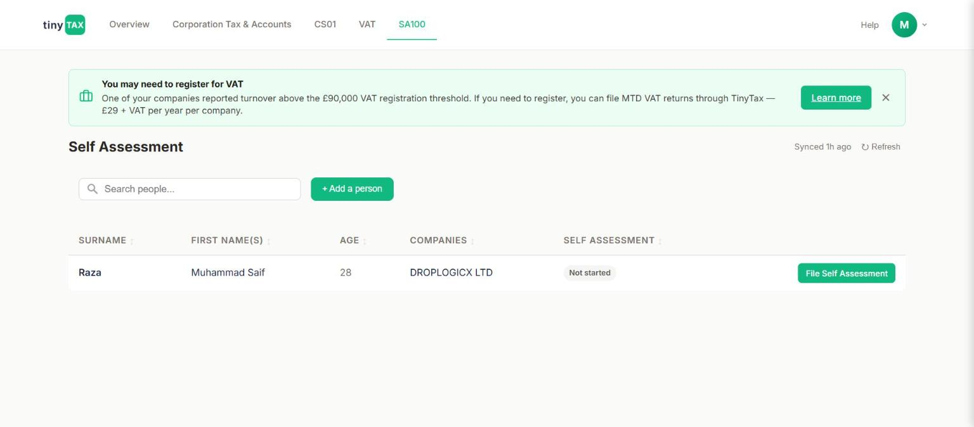
Self Assessment tab — one row per person (not per company), with age, associated companies, and filing status.
Field | What it does / why it's asked
SURNAME / FIRST NAME(S) / AGE | One row per individual, not per company — the PRD's SA100 module is personal, and a person can be linked to more than one company (shown in the COMPANIES column).
COMPANIES | Which of the user's companies this person is associated with — DROPLOGICX LTD here.
SELF ASSESSMENT status / File Self Assessment | "Not started" status with a direct action button into that person's filing list.
+ Add a person | Lets a new individual (e.g. a second director, or a shareholder who isn't a director) be added to the SA100 module independently of the company records driving the other three modules.
Clicking "File Self Assessment" opens a per-person filings list (not shown here as its own screenshot — see the empty-state note below), which for a person with no prior returns shows only a "Start 2025-26 return" action and the message "No Self Assessment returns yet."

2. The SA100 form — scope and structure
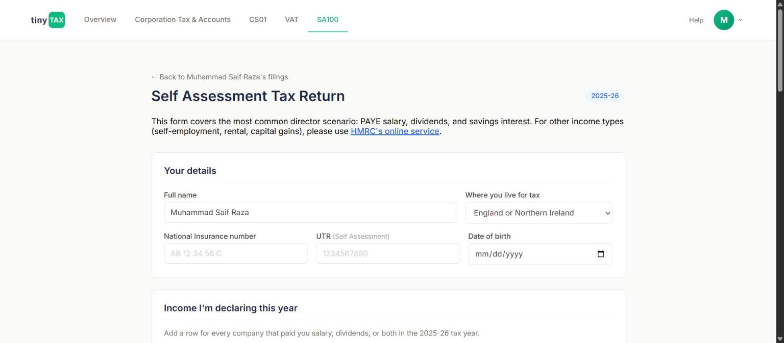
Self Assessment Tax Return (2025-26) — Your details and the start of Income I'm declaring this year.
An explicit scope statement sits directly under the page title: "This form covers the most common director scenario: PAYE salary, dividends, and savings interest. For other income types (self-employment, rental, capital gains), please use HMRC's online service." This is a deliberate, disclosed product boundary, not a gap discovered by exploring — worth keeping in mind when reading the rest of this document, since none of the self-employment/rental/capital-gains SA100 sections exist in this build at all.
Field | What it does / why it's asked
Full name / Where you live for tax | Where you live for tax is a dropdown: England or Northern Ireland / Scotland / Wales — this drives which Income Tax band rates apply, since Scotland in particular has its own distinct Income Tax bands not covered by the PRD's rate table (which is the England/NI/Wales table).
National Insurance number / UTR (Self Assessment) / Date of birth | Standard identity fields for the return; UTR is the Self Assessment Unique Taxpayer Reference, separate from the company's Corporation Tax UTR used in the CT600 module.
PRD CROSS-REFERENCE — Section 4.0 / Rule 3.4.1
Per the PRD's technical-fork note (Section 4.0), SA100 submission runs over the same older XML/Government Gateway mechanism as CT600, not the modern REST/OAuth2 APIs used for VAT and MTD ITSA — budget integration effort accordingly, and expect it to share more engineering overlap with the CT600 submission layer than with the VAT module. The England/NI/Wales Income Tax bands shown in PRD Rule 3.4.1 (Personal Allowance £12,570; Basic rate 20% to £50,270; Higher rate 40% to £125,140; Additional rate 45% above) are the ones this form's calculation should be using for the two "Where you live for tax" options that aren't Scotland — Scotland's own bands are not in the PRD excerpt reviewed for this document and should be checked separately if Scottish users are in scope.

3. Income I'm declaring this year
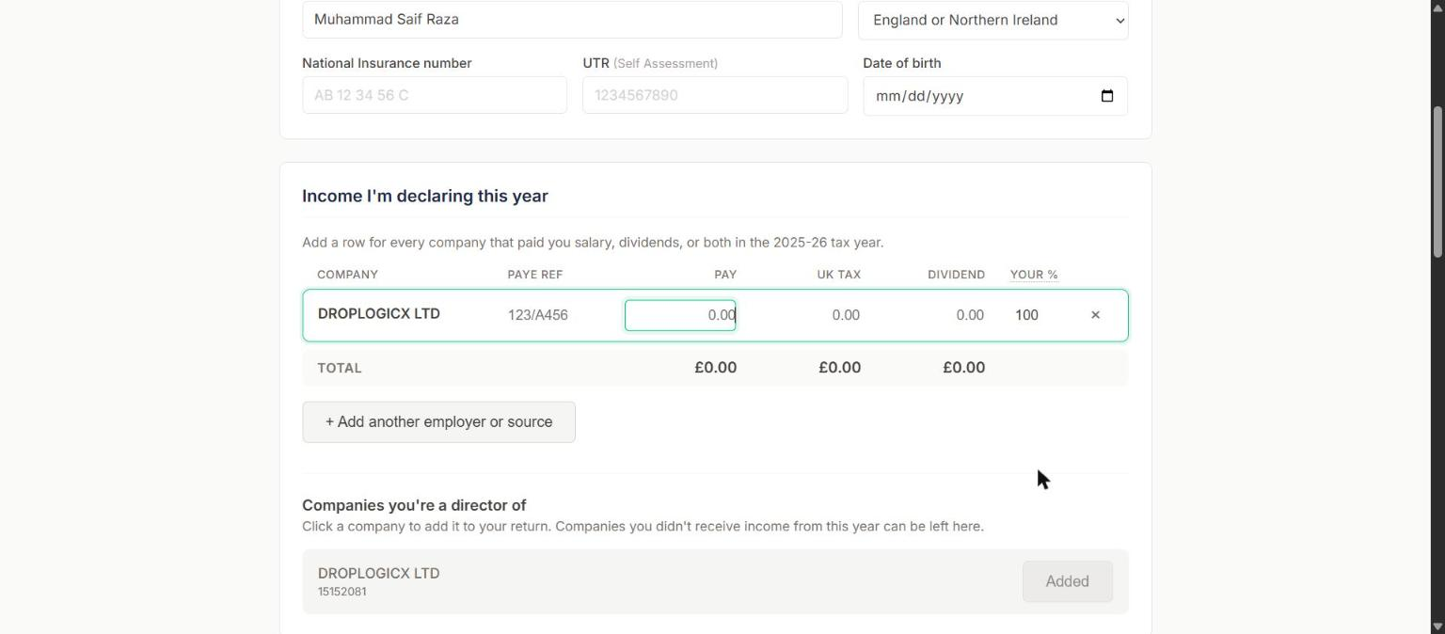
An income row added for DROPLOGICX LTD, with PAYE reference auto-filled and Pay/UK tax/Dividend/Your % editable.
Field | What it does / why it's asked
Companies you're a director of → + Add to return | Rather than a blank "add an employer" form, the company the person is already a director of (DROPLOGICX LTD, pulled from existing company records) is offered as a one-click add — another instance of the platform reusing data it already holds instead of asking the user to re-type it, in the same spirit as Rule 3.3.3's digital-links principle for VAT (stated there specifically for VAT, but a sensible pattern reused here for a different filing type).
PAYE REF | Auto-filled (123/A456 in this test data) once the company is added — presumably pulled from the company's own PAYE scheme reference rather than user-entered.
PAY / UK TAX / DIVIDEND | Three editable currency fields per company row: gross pay, tax already deducted via PAYE, and dividends received from that company.
YOUR % | Editable percentage, defaulting to 100 — relevant for a company with more than one shareholder-director, where dividend income must be apportioned by shareholding, not assumed to belong entirely to the person filing.
+ Add another employer or source | For income from a source other than one of the user's own companies (e.g. a separate employer).

4. Interest income and Tax adjustments
Field | What it does / why it's asked
Interest income — BANK OR BUILDING SOCIETY / GROSS INTEREST | A repeatable list, empty by default ("No bank accounts listed yet"), with "+ Add another account". Not populated in this walkthrough (left at £0.00) — the live tax calculation in Section 5 below therefore shows the Pay/Dividend path only, not the savings-interest path.
Tax adjustments — four checkboxes | "I'm repaying a student loan", "I made personal pension contributions", "My spouse transferred £1,260 of their Personal Allowance to me", "I made Gift Aid donations". Introduced with "Most owner-directors leave this section blank" — framing these as exceptions rather than the default path, consistent with the form's stated scope as a director-focused tool. None were ticked in this walkthrough.

5. Your tax calculation — live, and verified against the PRD's worked method
This section recalculates live as income fields are edited. With Pay £30,000 / UK tax £4,000 / Dividend £20,000 entered for DropLogicX and 100% attributed, the engine produced:
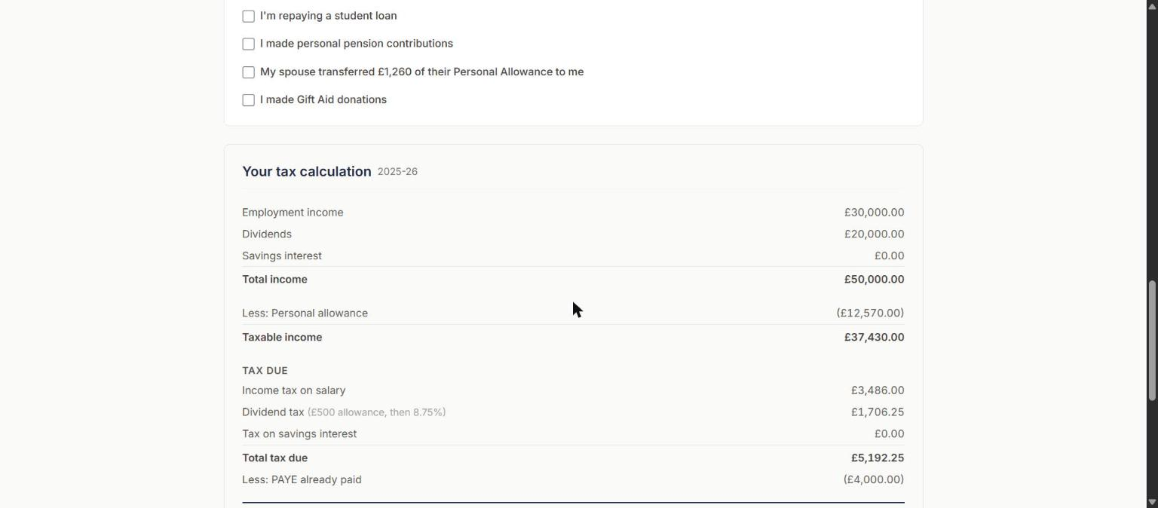
Live tax calculation: income, Personal Allowance, taxable income, and the tax-due breakdown by income type.
Field | What it does / why it's asked
Employment income / Dividends / Savings interest / Total income | £30,000 / £20,000 / £0.00 / £50,000.00 — a straight sum of the entered figures.
Less: Personal allowance / Taxable income | (£12,570.00) / £37,430.00 — the full Personal Allowance applied with no taper, correct per Rule 3.4.1 since total income (£50,000) is well under the £100,000 taper threshold.
Income tax on salary | £3,486.00 — this is 20% of (£37,430 taxable income − the dividend portion), i.e. salary is taxed first within the bands before dividends are stacked on top. £30,000 pay minus £12,570 PA leaves £17,430 of salary actually inside the taxable-income figure... see the ordering check below for how this reconciles with Rule 3.4.5a.
Dividend tax (£500 allowance, then 8.75%) | £1,706.25 — the UI states the rate used in its own label.
Total tax due / Less: PAYE already paid / Tax to pay | £5,192.25 / (£4,000.00) / £1,192.25, due 31 January 2027 — correctly dated as the Self Assessment balancing-payment deadline for the 2025-26 tax year (Rule 3.4.3).
PRD CROSS-REFERENCE — Rule 3.4.5a — ordering check against this live result
PRD Rule 3.4.5a requires dividends to be stacked as the top slice of income, above salary — fill the Personal Allowance and each band with salary first, then stack dividends into whatever band space remains, as a sequential fill rather than two independent calculations added together. Reconstructing this result against that method: salary £30,000 uses the full £12,570 Personal Allowance plus £17,430 of basic-rate band, leaving £20,270 of basic-rate band width (£37,700 total) for dividends. £20,000 of dividends entirely fits inside that remaining basic-rate space, so under Rule 3.4.5a: £500 at 0% (the dividend allowance) + £19,500 at the basic dividend rate. The live result's £1,706.25 figure equals £19,500 × 8.75% exactly, confirming the engine is applying the ordering rule correctly — salary absorbed first, dividends stacked on top into the remaining basic-rate space, dividend allowance correctly treated as a 0% band occupying space rather than a deduction (Rule 3.4.5b). This specific input (£30,000 salary / £20,000 dividend / 100%) is a usable regression-test input in its own right, alongside the PRD's own worked examples in Rule 3.4.5.
⚠ FOR ENGINEERING — 8.75% is correct for THIS tax year only — do not treat it as a stale rate
At first glance the UI's "8.75%" label might look like the pre-Budget dividend basic rate, since PRD Rule 3.4.5 states the 2026/27 basic dividend rate is 10.75% (increased from 8.75% at Autumn Budget 2025). But this form is explicitly filing the 2025-26 tax year (visible in the "2025-26" badge at the top of the form and in the "2025-26" label on the tax calculation), and the PRD states the new 10.75%/35.75%/39.35% dividend rates take effect "6 April 2026, already live" — i.e. from the START of the 2026/27 tax year, not before. For a 2025-26 return, 8.75% is the correct rate, and the live calculation above is consistent with the PRD. The thing to actually verify with the team: when this product begins accepting 2026-27 returns (filable from April 2027 onward), does the calculation engine switch to 10.75%/35.75%/39.35% for that tax year while keeping 8.75%/33.75%/39.35% available for any 2025-26 return still being completed late? The PRD's Section 3.9 standing rule ("re-run a verification pass on every numeric value... before each new UK tax year begins") applies directly here.

6. Declaration and submission
At the foot of the form: a statement that submitting constitutes a legal declaration that the information is correct and complete ("A false return can lead to prosecution"), a single checkbox declaration, and two buttons: Save Progress and Submit to HMRC.
Field | What it does / why it's asked
Declaration checkbox | "I declare that the information I have given on this tax return is correct and complete to the best of my knowledge and belief." No separate Position/Status field here (unlike the CT600's Tax Return Declaration) — presumably because an SA100 is inherently a personal declaration by the filer about themselves, with no equivalent "on behalf of a company, in what capacity" question needed.
Save Progress | Manual checkpoint; the form also autosaves — "Saved at 18:18" appeared after editing the income row, without an explicit save click, the same autosave pattern observed in the CT600/Accounts module.
Submit to HMRC | Per this task's governing instruction, never clicked. The return remains an unsubmitted draft for Muhammad Saif Raza.

Appendix: Test data used in this walkthrough
Item | Value
Person | Muhammad Saif Raza, director of DROPLOGICX LTD (15152081)
Tax year | 2025-26
Where you live for tax | England or Northern Ireland
Pay / UK tax deducted / Dividend / Your % | £30,000 / £4,000 / £20,000 / 100% (test data, not Mr Raza's real income)
Interest income | £0.00 (not populated in this pass)
Total income / Taxable income | £50,000.00 / £37,430.00
Total tax due / Tax to pay | £5,192.25 / £1,192.25, due 31 January 2027

