TinyTax Developer Walkthrough
VAT Returns — Portal Walkthrough
This document covers the VAT section of the TinyTax portal, for the engineering team. It was produced by exploring the live production app directly against DROPLOGICX LTD (company no. 15152081). Every field is explained and cross-referenced to UK-Tax-Filing-Platform-PRD.docx ("the PRD").
PRD CROSS-REFERENCE — Exploration conditions and a deliberate boundary
DropLogicX has no VRN (VAT registration number) registered in TinyTax — its VAT Returns row shows "No VRN added". The portal's own banner states DropLogicX's turnover crossed the £90,000 VAT registration threshold and prompts registration. No VRN, real or fabricated, was entered into this live production company's VAT settings while producing this document: that would create a false registration record against a real company. This document is therefore necessarily a walkthrough of the VAT module's entry point and its surrounding guidance, not of a populated nine-box return — the return-entry screens themselves were not reachable without adding a VRN first. This is a narrower document than the CT600/Accounts and SA100 walkthroughs for that reason, not because the module is simpler.

1. Entry point: the VAT Returns list
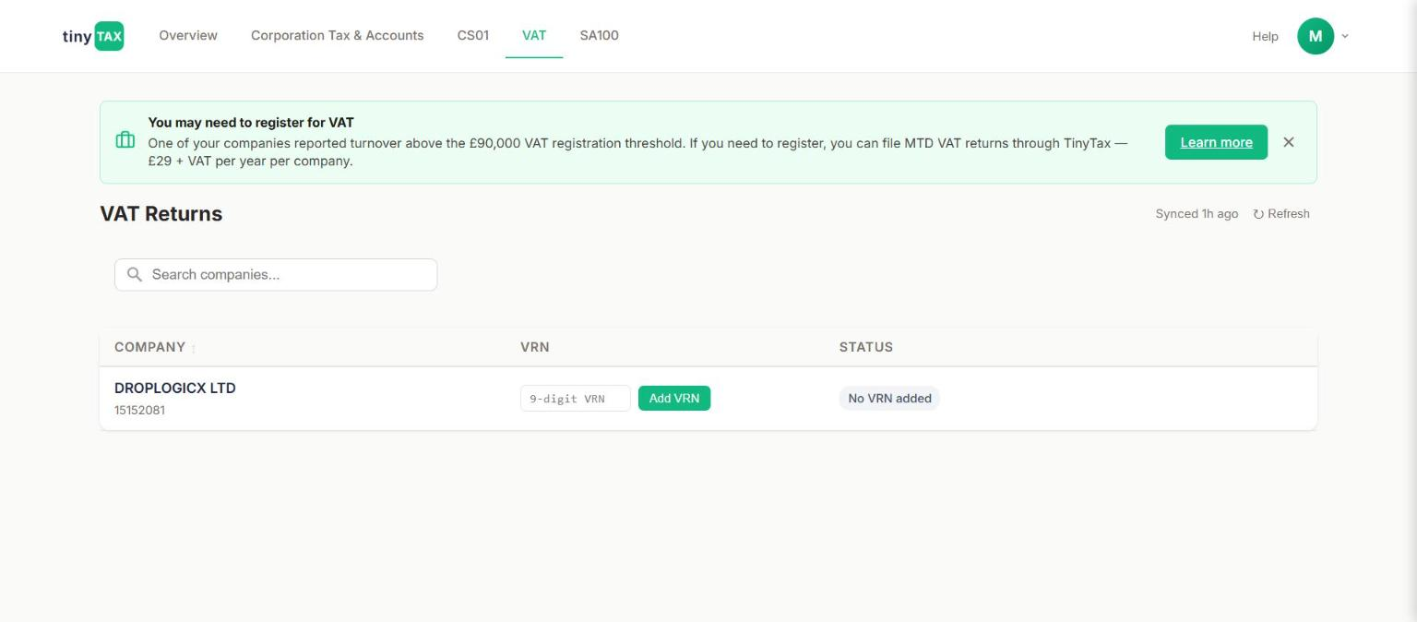
VAT Returns tab — the registration-threshold banner, and the per-company VRN entry row.
Field | What it does / why it's asked
"You may need to register for VAT" banner | Persistent, dismissible (×) banner shown across every tab once a company's turnover crosses the threshold, not just on the VAT tab — it was visible in every screenshot captured for this document and the CT600/Accounts document alike, confirming it's a global notice driven by company-level data, not a VAT-page-local one. Copy: "One of your companies reported turnover above the £90,000 VAT registration threshold. If you need to register, you can file MTD VAT returns through TinyTax — £29 + VAT per year per company," with a "Learn more" link.
COMPANY / VRN / STATUS table | One row per company. DropLogicX shows VRN column as an inline 9-digit input plus an "Add VRN" button, and STATUS as "No VRN added".
9-digit VRN input | Placeholder text reads "9-digit VRN", confirming the expected format (a UK VAT number is 9 digits, sometimes shown with a GB prefix and spaces in HMRC's own formatting — worth confirming with the team whether the stored/submitted format strips or requires that prefix).
PRD CROSS-REFERENCE — Rule 3.3.2
The £90,000 figure in the banner is the current registration threshold per the PRD (a rolling 12-month taxable-turnover test, or an expectation of exceeding it in the next 30 days alone — not a simple "turnover this tax year" check). The PRD's Build Rule 3.3.2 is explicit that this check needs continuous rolling-window tracking plus a forward-looking 30-day test, both able to trigger the prompt independently. Worth confirming with the team whether the banner's underlying logic actually implements the rolling-window test, or is presently a simpler annual-turnover comparison — the banner text alone doesn't reveal which, and getting this wrong either nags a company that doesn't yet need to register or, worse, fails to prompt one that does.
PRD CROSS-REFERENCE — Rule 3.3.2, deregistration
The PRD also defines a separate, lower deregistration threshold of £88,000 (expected taxable turnover), which a company can use to voluntarily deregister once crossed. No deregistration UI was visible on this page for a company with no VRN registered — by definition not reachable until a VRN exists — so this should be checked separately once a test company with an active VAT registration is available to explore.

2. What happens after "Add VRN" — inferred from the PRD, not observed
Adding a VRN was not exercised in this walkthrough (see the exploration-conditions note above). Based on the PRD, the following is what the subsequent screens should contain, and is offered as a guide for what to verify once a disposable/test company with its own VRN is available to explore safely:
Field | What it does / why it's asked
The nine-box return | Boxes 1–5 are VAT amounts to the penny; boxes 6–9 are net values to the whole pound. Box 3 = Box 1 + Box 2. Box 5 = the absolute (unsigned) difference between Box 3 and Box 4. Boxes 8–9 are informational subsets of boxes 6–7 respectively (goods only, not services, moved to/from Northern Ireland and the EU) and must never be added on top of 6/7 — they're already included within them.
Zero-rated vs exempt supplies | Must be modelled as genuinely distinct in the data layer: zero-rated supplies are taxable supplies at 0% and do appear in Box 6; exempt supplies fall outside VAT entirely and are excluded from the box 6/7 figures altogether. Conflating the two produces an incorrect return.
Digital links / no manual re-typing | Per Rule 3.3.3, the platform must never present a plain text box for a user to re-type a VAT total read off a spreadsheet — once a figure exists digitally anywhere in the user's records, it must reach the VAT return via file import, API connection, or a formula-linked cell, never a keystroke. Manual entry is only legitimate for a transaction that has never existed digitally anywhere before. This should be checked directly against whatever input mechanism the actual return-entry screen uses once reachable.
Flat Rate Scheme | A structurally different calculation (gross VAT-inclusive turnover × a sector rate, generally no input VAT reclaim) rather than a toggle on the standard output-minus-input formula. Includes the "limited cost business" override (16.5% flat rate, catching most pure-service businesses like consultants/IT contractors) which must be re-checked every period, not fixed at signup. Whether this module is in scope for the MVP, and whether this "Add VRN" flow leads anywhere to a scheme choice, should be confirmed with product — the PRD explicitly recommends standard accounting first and Flat Rate as a phase 2 addition if only one is built initially.
PRD CROSS-REFERENCE — Build Rule 3.3.6a / open item VR-27
Boxes 6–9 must be whole-pound integers per HMRC's own MTD VAT API schema — that part is a confirmed hard constraint. The rounding DIRECTION for those boxes (nearest, up, or down) is explicitly flagged in the PRD's own Section 3.9 open-items register as unconfirmed from any published HMRC source; the PRD's reference engine defaults to round-half-up as a documented assumption, not a confirmed rule. This is worth checking directly in whatever VAT calculation code exists, since it's called out by name as needing professional sign-off before going live (VR-27).

3. Filing periods, deadlines, and the architecture this module is built on
Not directly observable from the explored screens (no active VAT registration to show deadlines against), but documented here from the PRD since it governs how this module should behave once a company is registered:
- Standard VAT period: quarterly.
- Deadline for both filing and payment: 1 calendar month and 7 days after the end of the VAT period — payment must have cleared into HMRC's account by that date, not merely been initiated.
- A nil return or a repayment return follows exactly the same deadline as a return with tax to pay — the obligation doesn't relax because nothing is owed.
PRD CROSS-REFERENCE — Section 4.0 — the technical fork
VAT (MTD) runs on HMRC's modern REST API with OAuth2 authentication, a properly documented OpenAPI specification, and a sandbox test environment — the PRD calls this "the easier, faster integration" compared to CT600/SA100's older XML/Government Gateway mechanism (see the companion CT600/Accounts document, Section 9). This is useful context for sequencing: a working VAT submission integration is a meaningfully smaller lift than the CT600/SA100 equivalent, and the £29+VAT/year/company pricing shown in the registration banner suggests VAT filing is positioned as a lightweight add-on product, consistent with that lower integration cost.

Appendix: What this document could and could not verify
Status | Detail
Verified directly in the live portal | Registration-threshold banner text and trigger; VRN entry row and input format (9-digit); the VAT tab's position in the overall navigation alongside Corporation Tax & Accounts, CS01, and SA100.
Documented from the PRD, not yet observed in-app | The nine-box return screen itself; zero-rated/exempt handling; digital-links enforcement; Flat Rate Scheme; rounding behaviour on boxes 6–9; deregistration flow.
Recommended next step | Set up one disposable/sandbox test company (not DropLogicX, and not any other real production company) with a test VRN, to walk the actual nine-box return entry and submission screens the same way this document walks the CT600/Accounts and SA100 modules.

