DCIT 204/308 JOINT DSA SEMESTER PROJECT
Graph Representation and Disjoint Set Module
Ghana Smart Service Operations Optimizer — University of Ghana Campus Cleaning Context
This section documents the graph and disjoint-set contribution for a campus cleaning service optimizer. The graph models University of Ghana, Legon campus locations as vertices and directly usable campus connections as weighted undirected edges.

1. Scope and role
The module represents 55 University of Ghana campus locations and 111 direct connections. It provides adjacency-list and adjacency-matrix representations and supports BFS, DFS, Dijkstra, Prim and Kruskal. A custom Disjoint Set (Union-Find) implementation provides makeSet, find, union by rank and path compression, and is used by Kruskal.

2. Dataset provenance and realism
The selected facilities and relative network topology were checked against University of Ghana campus materials and a University of Ghana RSGIS Lab campus map. The map shows named roads including J.B. Danquah Avenue, Ebenezer Laing Road, J.K.M. Hodasi Road, Volta Road, Botanical Gardens Road and W.E.B. Dubois Road, together with academic buildings, halls, sports facilities, the hospital, police station and fire service.
The public sources do not publish a surveyed distance for every selected connection. Consequently, the distance values in the dataset are explicitly constructed/estimated walking-route distances for algorithmic experimentation. They are not presented as official surveyed UG measurements. Travel time is estimated using 75 metres/minute, and roadConditionWeight is a project modelling factor.
Map-relative X/Y coordinates are included for graph visualisation. They are not GPS coordinates and are not used as the primary shortest-path weight.

3. Dataset summary
Item | Value | Meaning | Primary use
Locations | 55 | Vertices in the campus graph | Graph construction
Edges | 111 | Direct campus connections | Traversal and MST
Primary weight | distance_m | Estimated walking distance in metres | Dijkstra/Prim/Kruskal
Travel time | travelTime_min | Approximate walking time | Operational analysis
Condition factor | roadConditionWeight | Project route-condition factor | Optional composite cost

4. Graph representation
The graph is undirected because the model assumes that a selected campus connection can normally be traversed in either direction by a cleaning team. The adjacency list stores only existing connections, requiring O(V+E) space. The adjacency matrix stores a V×V table, requiring O(V²) space and providing direct edge lookup.
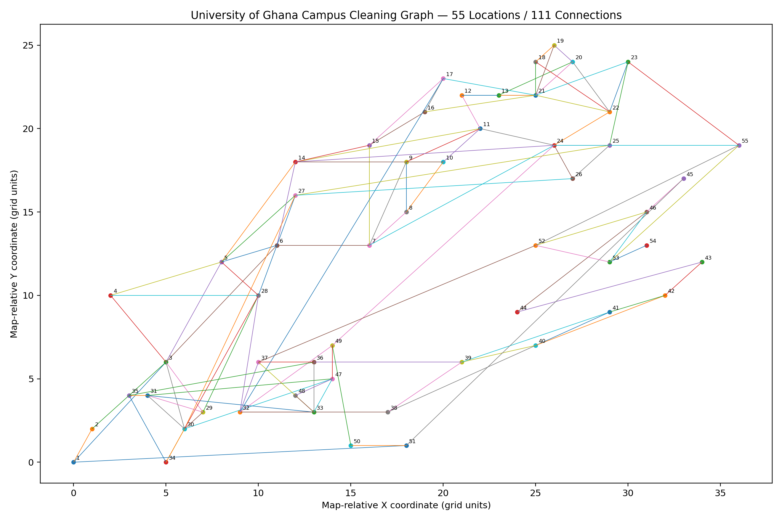
Figure 1. Map-informed graph topology. Node labels correspond to locationId values in locations.csv.

5. Algorithms implemented
Algorithm | Campus interpretation | Complexity
BFS | Reachability/traversal from a cleaning dispatch point | O(V+E) using the adjacency list
DFS | Deep traversal and connectivity exploration | O(V+E) using the adjacency list
Dijkstra | Shortest-distance route between two campus locations | O((V+E) log V) with the custom binary min-heap implementation
Kruskal | Minimum spanning network using sorted edges | O(E log E) dominated by edge sorting
Prim | Alternative minimum spanning network | O((V+E) log V) with the custom binary min-heap
Disjoint Set | Maintains connected components during Kruskal | Near-constant amortized cost per operation with path compression + union by rank

6. Disjoint Set / Union-Find
Each location initially forms its own component. union(a,b) combines two components. find(x) returns the representative of x's component. Path compression shortens paths during find, while union by rank keeps the component trees shallow. In Kruskal, an edge is accepted only when its endpoints belong to different components; otherwise it would create a cycle.

7. Team-specific results generated from the dataset
A BFS from the Main University Gate reaches all 55 locations. A Dijkstra run from the Main University Gate to the Department of Computer Science gives a shortest distance of 1,180 m in this constructed network, with the path: Main Gate → JQB → Bookshop → Physics → Computer Science.
Kruskal produces 54 selected edges and a minimum spanning-tree total of 12,540 m. Prim also produces 54 selected edges and the same total of 12,540 m. Equal totals provide a useful cross-check of the MST implementations on this dataset.
These results are algorithmic results for the constructed dataset; they are not claims about official measured walking routes.

8. Correctness and edge-case evidence
- BFS: every reachable vertex is eventually discovered because each removed vertex causes all of its unvisited neighbours to be enqueued.
- Dijkstra: when a vertex is removed from the minimum-distance heap, its current distance is the smallest unsettled distance; with non-negative edge weights, later paths cannot improve it.
- Kruskal: an edge joining two different components can be added without forming a cycle. Repeatedly selecting the lightest such edge yields a minimum spanning tree.
- Disjoint Set: find returns a component representative; union changes the representative structure only when the two roots differ. Path compression preserves component membership while reducing future find cost.

9. Testing evidence
The included GraphModuleTest checks BFS and DFS reachability, Dijkstra reachability/path reconstruction, Kruskal and Prim spanning-tree completeness and equal MST cost, Disjoint Set operations, component sizes, and invalid-input handling. The test run completed successfully during development.
The overall project still needs the other team members' tests to reach the brief's minimum of 40 tests across all modules.

10. Trace tables
Full CSV traces are included in the traces/ directory. The important files are bfs_trace_main_gate.csv, dfs_trace_main_gate.csv, dijkstra_trace_main_gate_to_cs.csv, dijkstra_distance_table.csv, kruskal_union_find_trace.csv and disjoint_set_trace.csv.
Step | Edge | From | To | Weight | Decision
1 | E30 | 12 | 13 | 120 m | ACCEPT
2 | E42 | 18 | 19 | 140 m | ACCEPT
3 | E45 | 19 | 20 | 140 m | ACCEPT
4 | E2 | 1 | 2 | 150 m | ACCEPT
5 | E11 | 5 | 6 | 150 m | ACCEPT
6 | E43 | 18 | 21 | 150 m | ACCEPT
7 | E27 | 11 | 12 | 160 m | ACCEPT
8 | E47 | 20 | 21 | 160 m | REJECT - same component (cycle)
9 | E105 | 47 | 48 | 160 m | ACCEPT
10 | E14 | 5 | 28 | 180 m | ACCEPT
11 | E17 | 7 | 8 | 180 m | ACCEPT
12 | E21 | 8 | 9 | 180 m | ACCEPT

11. Performance experiment
The included PerformanceRunner.java generates connected test graphs with 50, 100, 200 and 500 vertices, runs BFS, DFS, Dijkstra, Kruskal and Prim three times per size, and writes average nanosecond timings to performance/graph_runtime.csv.
For the final report, the team must run this on the same designated machine used for the other experiments and state the machine specification. Do not copy the development environment's timing values into the final report without rerunning the experiment.

12. Files supplied
- data/locations.csv — 55 campus locations with map-relative coordinates
- data/roads.csv — 111 connections with distance, travel time and condition factor
- src/GraphModule.java — graph, adjacency list/matrix, BFS, DFS, Dijkstra, Prim, Kruskal, custom heap and Disjoint Set
- src/GraphModuleTest.java — tests for the module
- src/PerformanceRunner.java — performance experiment runner
- traces/ — team-specific traversal, shortest-path and Union-Find/Kruskal traces
- figures/campus_graph.png — graph visualisation
- data/README_dataset.md and SOURCES.md — provenance and usage notes

13. References
- University of Ghana. Welcome to UG Legon Campus.
- University of Ghana. 2026 Matriculation Ceremonies document — campus description.
- University of Ghana RSGIS Lab. University of Ghana Campus Map.
- Radio Univers 105.7 FM. Finding your way around the streets of Legon.
- Cartogiraffe. Dr. J.B. Danquah Avenue, Accra map and nearby-location information.

