Abstract—The objective of this paper is to empirically compare the predictive power of the linear regression model on house price prediction. A sample of 21613 houses in Kings County, USA sold between May 2014 and May 2015 is selected from the Kaggle website. More than 15 factors including house size, house age, house type, number of bedrooms, number of bathrooms, number of garages and geographical location are considered. Important factors are chosen using random forest algorithm. Empirical results support the potential of linear regression on house price prediction, although previous studies have commented on its black box nature and achieved conclusions.
House Sales in King County, USA
EDA & Modelling (November 2018)
Saurabh, Department of Computer Science Engineering, The NorthCap University, Gurugram-122001, India

Index Terms—Linear Regression, Random Forest, House Price

Introduction
An accurate prediction on the house price is important to prospective homeowners, developers, investors, appraisers, tax assessors and other real estate market participants, such as, mortgage lenders and insurers [1]. Traditional house price prediction is based on cost and sale price comparison lacking of an accepted standard and a certification process. Therefore, the availability of a house price prediction model helps fill up an important information gap and improve the efficiency of the real estate market [2].
Over the last two decades there has been a proliferation of empirical studies analyzing residential property values. Each succeeding research has generally improved the predictive power of the models by emphasizing attributes of property value such as housing site, housing quality, geographical location and the environment. More recent studies have focused on location externalities, transaction costs and factors affecting the future expected cost in homeownership (Norman, 1982).
In US, most people know the benefit of owning a house, because buying a house is considered the most utilized and profitable investment. US has high ratio of people owning their houses with over 64% of its citizens living in their own houses. As house market in US is thriving, house price becomes a crucial factor for house seekers.
The regression models have been commonly used to estimate house prices and property values. Most of the models include housing attributes such as location, neighborhood, and house size. This paper uses the regression method to empirically determine the house prices in Kings County, USA. Secondary data from 21613 houses in Kings County is used in a for the house price prediction.

Data Exploration and Manipulation
Exploration of data was done by the virtue of dimensions, structure, types of variables along with the overall summary. Two columns including date and id were of least importance, so they were dropped. A new attribute for the housing dataset, ‘Age’ was computed which shows the difference between ‘Selling year’ and ‘Built year’. If a house was renovated, ‘Built year’ was replaced by ‘Renovated year’.

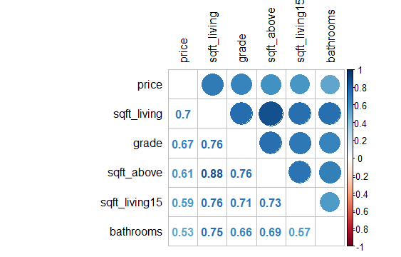
Fig. 1. The figure shows the variables having maximum positive correlation (r >0.5). It also becomes clear the multicollinearity is an issue.

Data Visualization and Analysis
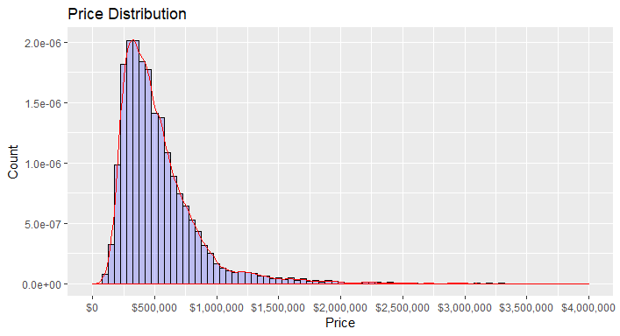 Fig. 2. This distribution shows that the sale prices are right skewed. This was expected as few people can afford very expensive houses.
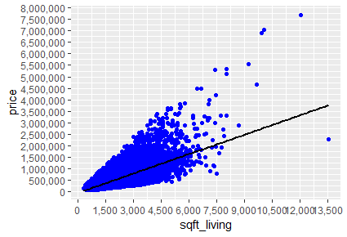
Fig. 3. The figure shows the numeric variable with the second highest correlation with sales price is the above sqft living area. This supports the fact that big houses are generally more expensive.

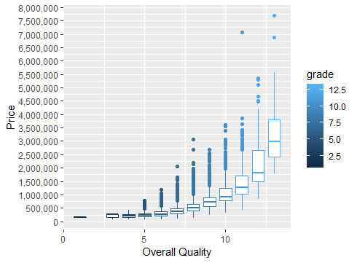
Fig. 4. The figure shows that the overall quality has a strong positive correlation with sales price among the numeric variables (0.67). It rates the overall material and finish of the house.

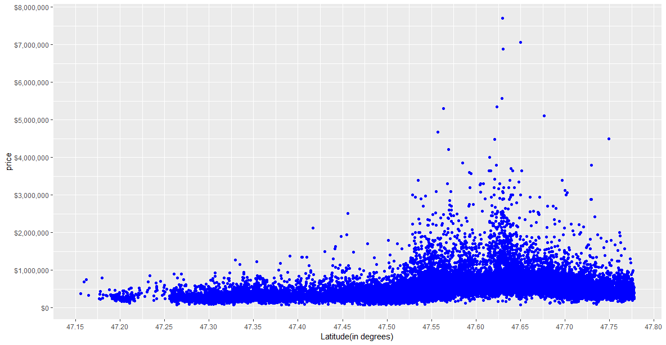

Fig. 5. The above scatterplot shows the distribution of sales price according to the geographic location. We can see a spike between the latitude values 47.60 and 47.65 indicating high price of property in the region.

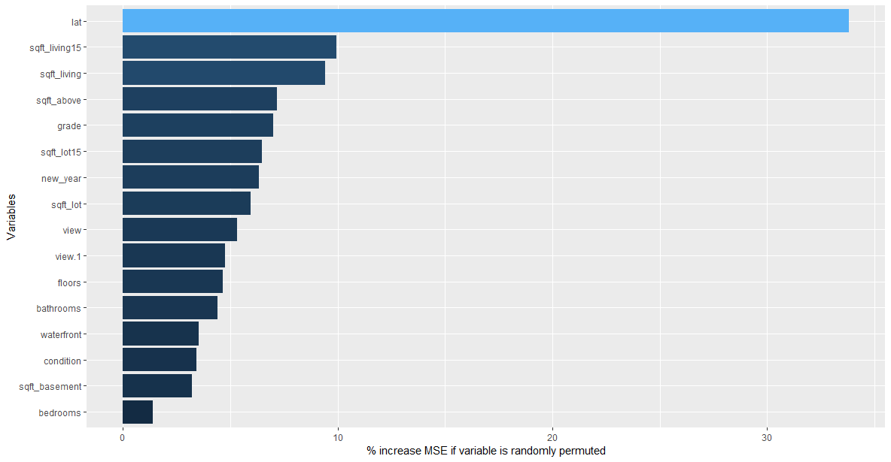
Fig. 6. The figure gives an overview of the most important variables including the categorical variables before moving on to visualization. As we only want to get an indication of the variable importance, we used a Random Forest model with only 100 trees. And does not take very long as only a small number of trees can be specified.

LINEAR REGRESSION MODEL
The simple linear regression model is, a model with a single regressor x that has a relationship with a response y that is a straight line. This simple linear regression model is

where the intercept β₀ and the slope β₁ are unknown constants and ε is a random error component. The errors are assumed to have mean zero and unknown variance σ². Additionally, we usually assume that the errors arc uncorrelated. This means that the value of one error does not depend on the value of any other error.
It is convenient to view the regressor x as controlled by the data analyst and measured with negligible error, while the response y is a random variable. That is, there is a probability distribution for y at each possible value for x. The mean of this distribution is

and the variance is

Thus, the mean of y is a linear function of x although the variance of y does not depend on the value of x. Furthermore, because the errors are uncorrelated, the responses are also uncorrelated. The parameters and β₁ are usually called regression coefficients. These coefficients have a simple and often useful interpretation. The slope β₁ is the change in the mean of the distribution of y produced by a unit change in x. If the range of data on x includes x = 0, then the intercept β₀ is the mean of the distribution of the response y when x = 0. If the range of x does not include zero, then β₀ has no practical interpretation.

CONCLUSION
This paper empirically checks the predictive power of the linear regression model on house price prediction. Linear regression models are tested for their predictive power using 21613 houses information in Kings County, USA. The results from linear regression models support the previous findings. The R² of linear price models is 68%. The linear price models show poorer results on out-of-sample forecast, especially when comparing with the advanced algorithms like neural network models [4]. Therefore, a linear model might not be the best model to use to predict prices as it does not take into account the interaction between variables. A better way to predict house prices would be use neural networks or time series models.
References
- Frew, James, and G. Jud. "Estimating the value of apartment buildings." Journal of Real Estate Research 25.1 (2003): 77-86
- Calhoun, Charles A. "Property valuation models and house price indexes for the provinces of Thailand: 1992-2000." Housing Finance International 17.3 (2003): 31-41.
- Introduction to Linear Regression Analysis, Douglas C. Montgomery, Elizabeth A. Peck, G. Geoffrey Vining
- Limsombunchai, Visit. "House price prediction: hedonic price model vs. artificial neural network." New Zealand Agricultural and Resource Economics Society Conference. 2004.

 

