AI Market Research Assistant (Config-Driven Multi-Agent System)
A full-stack, config-driven AI agent pipeline that gathers market details dynamically, evaluates drafts using a multi-agent critique layout, and compiles structured C-suite intelligence reports.
---

📖 Project Overview
The **AI Market Research Assistant** is designed to generate premium, comprehensive C-suite business reports from a single business idea and target location. It achieves this by coordinating specialized agents in a cost-optimized, sequential pipeline. By using **Light models** (fast, low-cost) for initial research phases and **Heavy models** (high-reasoning) for synthesis and auditing, the system optimizes token consumption while preserving analytical quality.
---

⚡ Key Features
* **Multi-Provider LLM Router**: Powered by `litellm` to support Ollama, OpenAI, DeepSeek, Gemini, Qwen, and OpenAI-compatible endpoints natively.
* **Cost-Optimized Task Routing**: routes Research, Competitor, Pricing, and Trend tasks to a "Light Model" and routes Coordinator, Writer, and Fact Checker tasks to a "Heavy Model".
* **Dynamic UI Model Switching**: Allows users to select providers and models for light/heavy tasks and input API keys directly in the UI.
* **Premium Multi-Theme Support**: Features three custom-designed, high-contrast themes: Dark, Light, and Solarized.
* **Non-Blocking Observability System**: Writes date-segregated session logs in Indian Standard Time (IST) using background threadpools to ensure the server event loop remains unblocked.
* **Zero-Leakage Key Masking**: Recursively scrubs credentials, API keys, and passwords from all files written to disk.
* **Real-time Terminal Logs Stream**: HTTP polling console showing pipeline steps as they execute.
* **C-Suite Report Dashboard**: Clean tabbed panels for Executive Summary, Market Overview, SWOT Analysis, Critique Log, and Raw JSON data.
---

📂 File Layout Structure
```
Multi-Agent Research System/
├── project_documentation.md # Consolidated project overview, setup & running guide
├── config/
│ └── config.yaml # Base truth configuration (R2 / R3)
├── backend/
│ ├── config.json # Runtime UI configuration overrides (R2)
│ ├── main.py # FastAPI monolith backend (R1 / R2 / R5)
│ ├── agent_orchestrator.py # Multi-agent logic using LiteLLM (R3 / R4 / R6)
│ ├── search_tool.py # DuckDuckGo search utility wrapper
│ ├── observability.py # Non-blocking thread log engine (IST/masking)
│ ├── test_orchestrator.py # Offline/online pipeline test script
│ └── test_live_apis.py # HTTP E2E backend integration test script
├── frontend/ # Next.js App Router (R7)
│ ├── package.json
│ ├── app/
│ │ ├── layout.js # HTML metadata & styles import
│ │ ├── page.js # Main client view with LocalStorage configuration
│ │ └── globals.css # Color tokens, multi-theme styles, log panels
└── logs/ # Top-level root logs directory
└── reports/ # Generated task reports directory
└── [task_id]/
├── meta.json # Task metadata & models utilized
├── progress.json # Logs console list (polling updates)
└── report.json # C-suite structured report data
```
---

🏗️ Architecture & Sequential Routing
The system runs as a FastAPI monolith backend coupled with a Next.js App Router frontend:
```mermaid
graph TD
A[Request Target: Business Idea + Location] --> B[Coordinator Agent - Heavy Model]
B --> C[Parallel Web Search Fetches]
C --> D[General Research Agent - Light Model]
C --> E[Competitor Landscape Agent - Light Model]
C --> F[Pricing & Monetization Agent - Light Model]
C --> G[Industry Trends Agent - Light Model]
D --> H[Writer Agent - Heavy Model]
E --> H
F --> H
G --> H
H --> I[Fact Checker Agent - Heavy Model]
I --> J[Polished Report JSON Output]
```
1. **Coordinator Agent (Heavy model)**: Receives inputs, plans the workflow steps, and initiates the research threads.
2. **Specialized Light Agents (Light model)**: Conduct fast parallel research for General Market Overview, Competitor Analysis, Pricing, and Trends. Default local model is `ollama/llama3.1:8b`.
3. **Writer Agent (Heavy model)**: Synthesizes individual drafts into an integrated business intelligence draft.
4. **Fact Checker Agent (Heavy model)**: Auditor that refines the text, critiques SWOT gaps, and formats JSON outputs to align with the database validation schema.
---

🛠️ REST API Specs
Exposed on port `8000`:
* **`GET /settings` & `GET /api/settings`**: Returns currently resolved configuration mapping (masked API keys, active light & heavy provider and model names).
* **`POST /settings` & `POST /api/settings`**: Saves dynamic overrides (API key, light/heavy provider, model) to `backend/config.json`.
* **`GET /api/runs`**: Scans the `reports/` folder, reads tasks metadata, and returns a sorted history of runs.
* **`POST /research` & `POST /api/research`**: Generates a unique task UUID, creates directory metadata, launches the multi-agent LiteLLM research pipeline in a background thread, and immediately returns the `task_id` (queued).
* **`GET /api/runs/{task_id}/progress`**: Exposes progress steps and stage logs (polled by the Next.js logs terminal).
* **`GET /api/runs/{task_id}/report`**: Returns the finalized structured C-suite JSON report once completed.
---

🚀 Setup & Installation

Prerequisites
* **macOS** or compatible Unix/Linux shell.
* **Python 3.10+** (tested on 3.11).
* **Node.js 18+** with `npm` package manager.

1. Set Up Backend API
Create a Python virtual environment and install dependencies:
```bash

Navigate to the workspace root
cd "/Users/apple/Desktop/Multi-Agent Research System"

Initialize virtual env
python3 -m venv backend/.venv
source backend/.venv/bin/activate

Upgrade pip and install dependencies
pip install --upgrade pip
pip install fastapi uvicorn litellm PyYAML duckduckgo-search pydantic python-dotenv
```

2. Set Up Frontend Dev Server
Navigate to the frontend folder and install node modules:
```bash
cd frontend
npm install
npm install lucide-react
```
---

⚙️ Running Locally
To launch the application locally, you must run both the backend server and frontend server simultaneously:

Step A: Launch Backend API
Ensure your Python virtual environment is activated, then run:
```bash

From workspace root
backend/.venv/bin/uvicorn backend.main:app --host 0.0.0.0 --port 8000
```
* API Server runs on: `http://localhost:8000`
* Interactive Swagger Docs: `http://localhost:8000/docs`

Step B: Launch Next.js Dev Server
```bash

Navigate to frontend folder
cd frontend
npm run dev
```
* Next.js server runs on: `http://localhost:3000`
---

💡 Usage & User Journey (Step-by-Step)

1. Initial Dashboard
When you launch the application, you'll be greeted by the central dashboard, which tracks total orchestrations, active agents, finished reports, and lists your past runs.
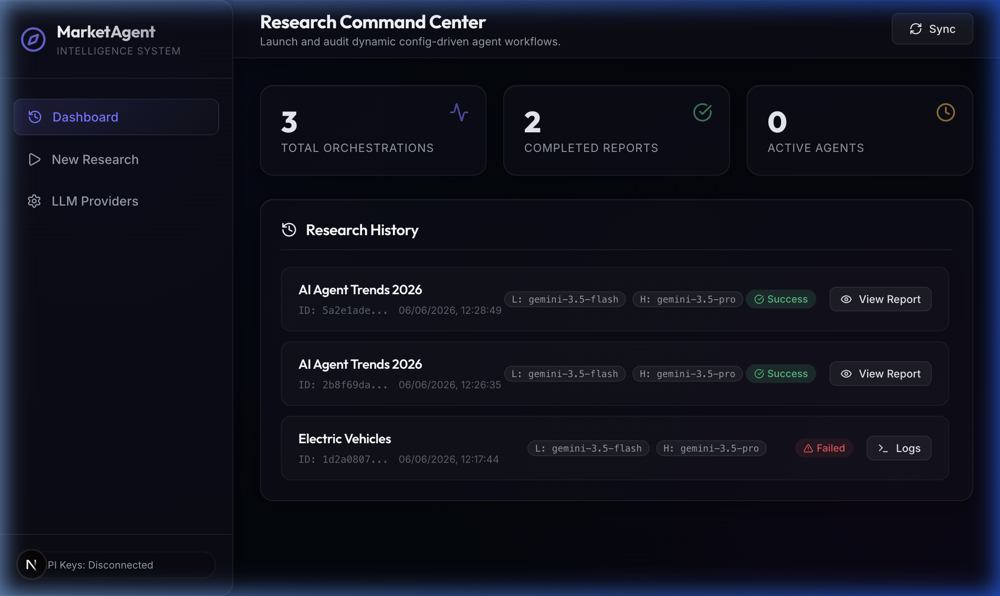

2. Configuring LLM Providers
Navigate to the **LLM Providers** tab to dynamically assign models for both Light and Heavy agent tasks.
- **Ollama**: Select Ollama and specify `llama3.1:8b`. No API key is required.
- **Cloud Providers**: Select OpenAI, Gemini, DeepSeek, or Qwen and paste your API key. Keys are saved securely to your browser's **LocalStorage** (zero-backend-cost architecture).
- **Mocking**: Type **`MOCK_KEY`** in the key field to perform dry runs offline without utilizing API tokens.
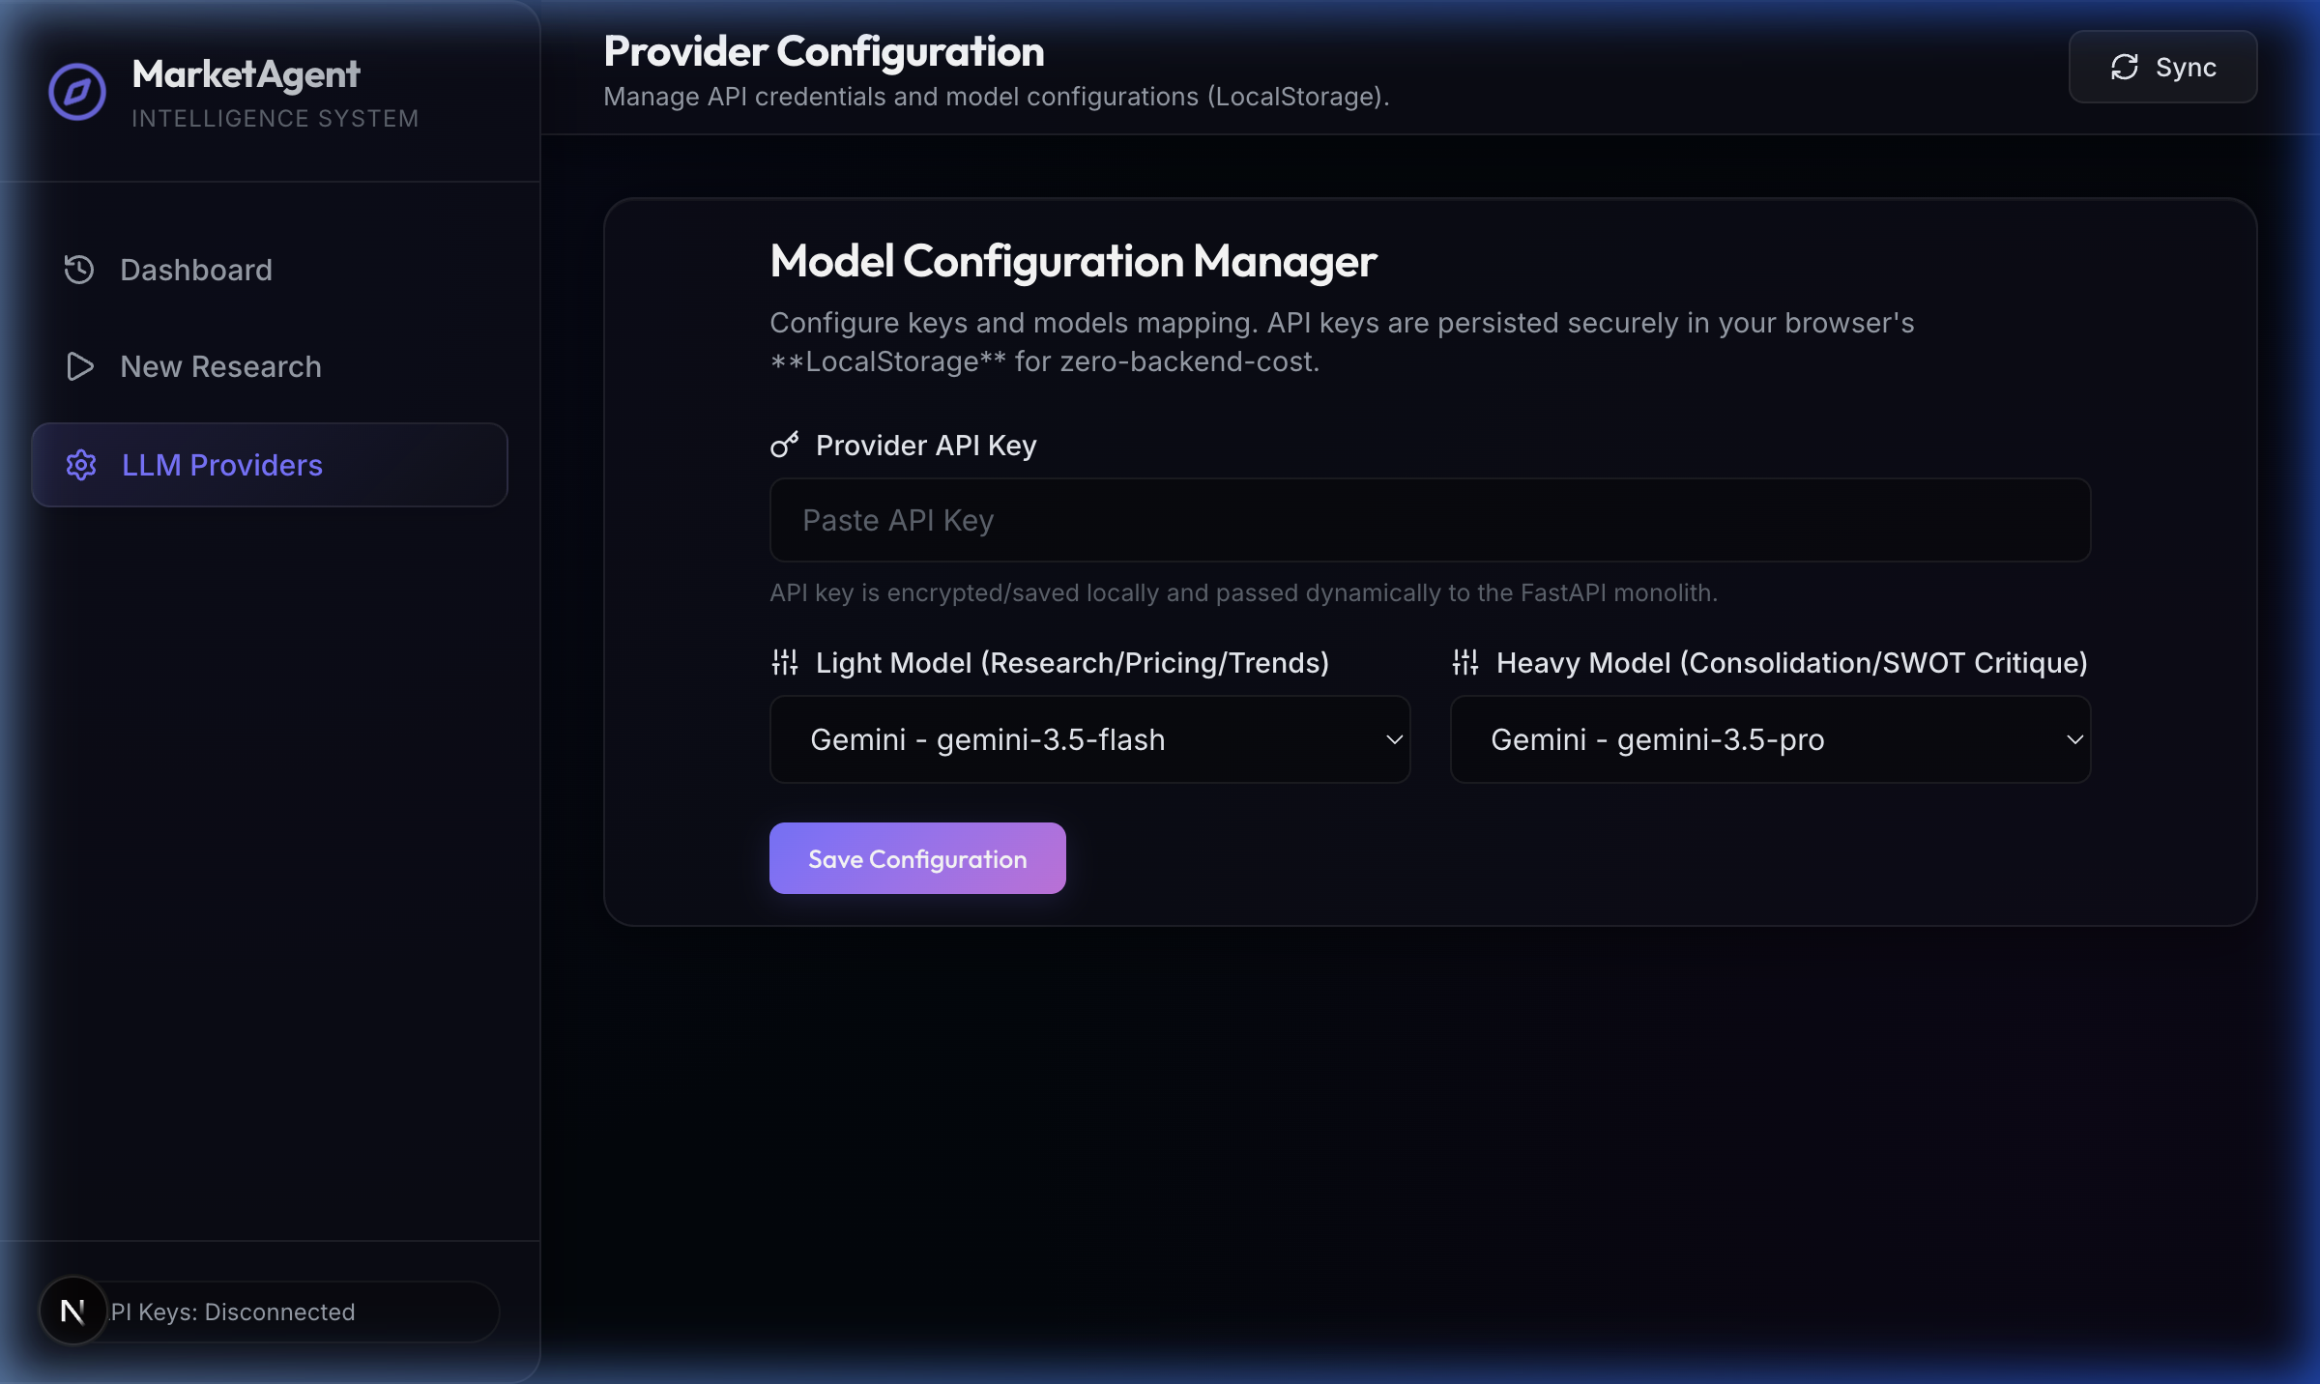

3. Launching a Research Task
Navigate to **New Research**. Enter your target **Business Idea / Concept** (e.g. `Specialty Coffee Shop`) and the **Target Location / Area** (e.g. `Brooklyn, NY`), then click Launch.
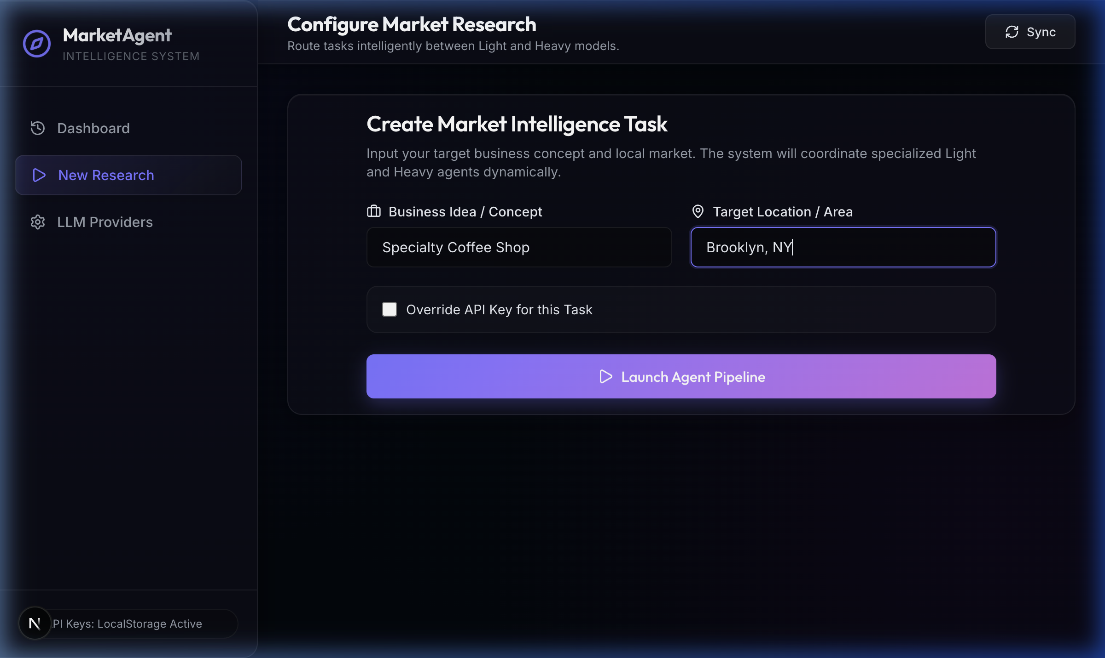

4. Tracking Pipeline Progress
The system displays a real-time progress stepper (Queued ➔ Researching ➔ Critique ➔ Refining ➔ Polishing) alongside a live terminal console streaming HTTP polling events from the FastAPI backend.
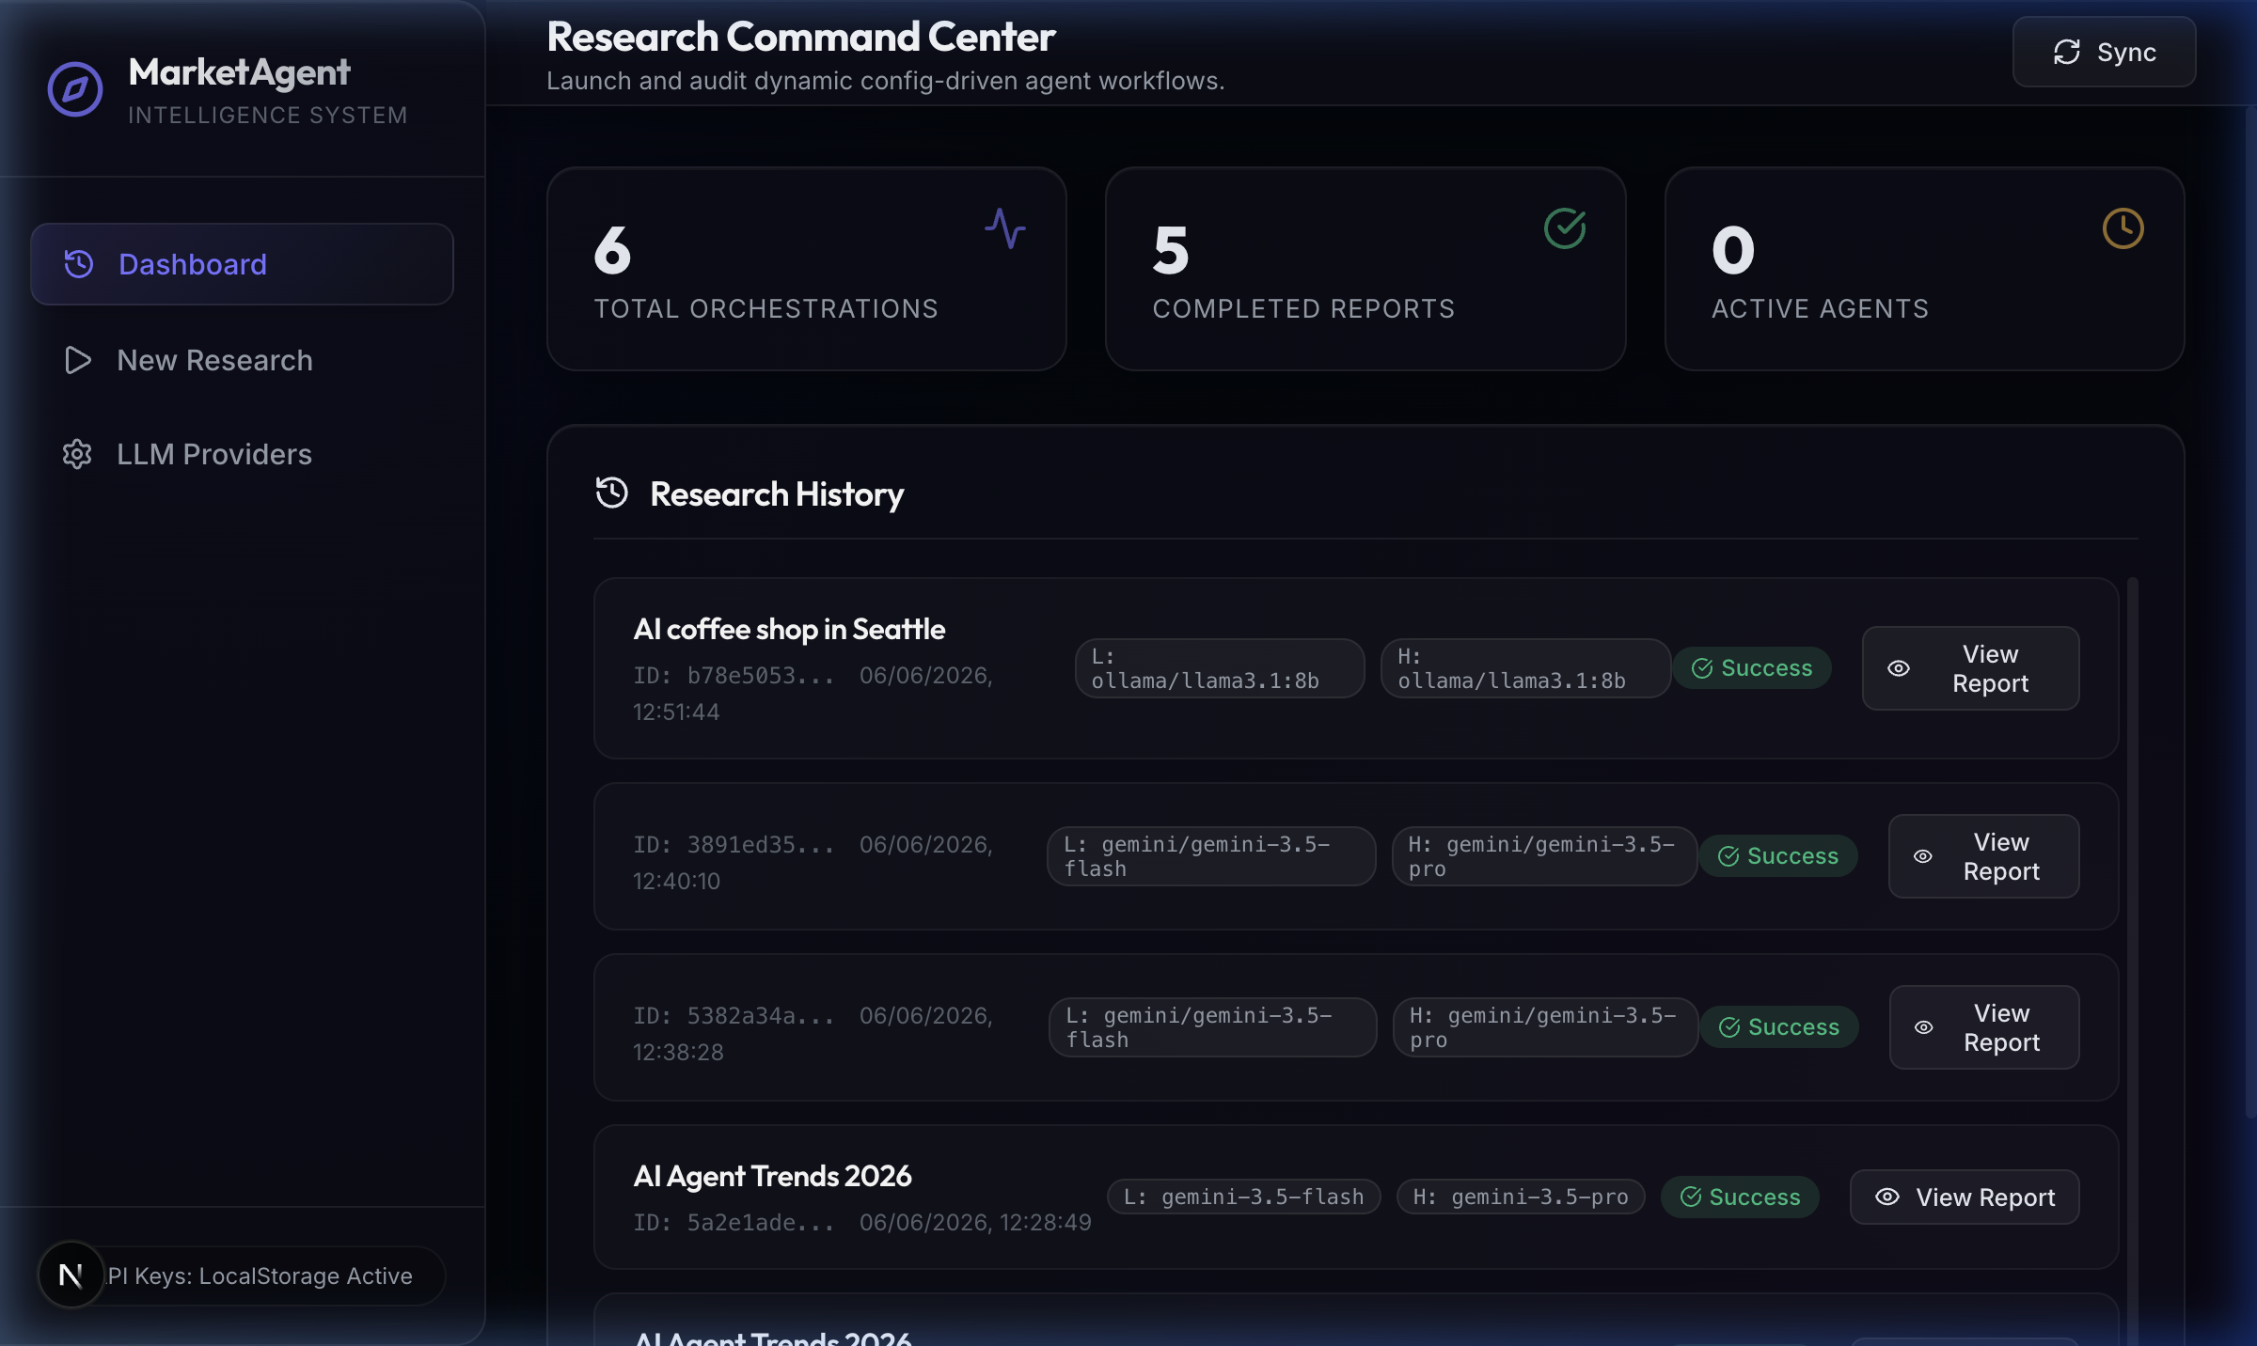

5. Reviewing the Final Report
Once the Fact Checker agent finishes, the fully compiled C-suite report is rendered with tabbed navigation.

SWOT Analysis
A detailed matrix highlighting Strengths, Weaknesses, Opportunities, and Threats based on the multi-agent synthesis.
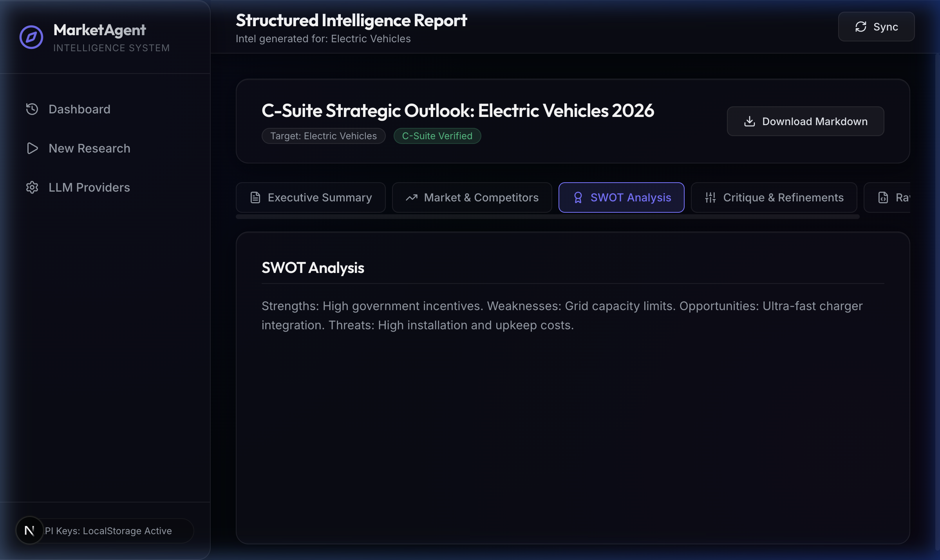

Critique & Refinement Logs
The Heavy model systematically audits the initial drafts provided by the Light models. Here you can track all the logical gaps identified and how they were subsequently refined.
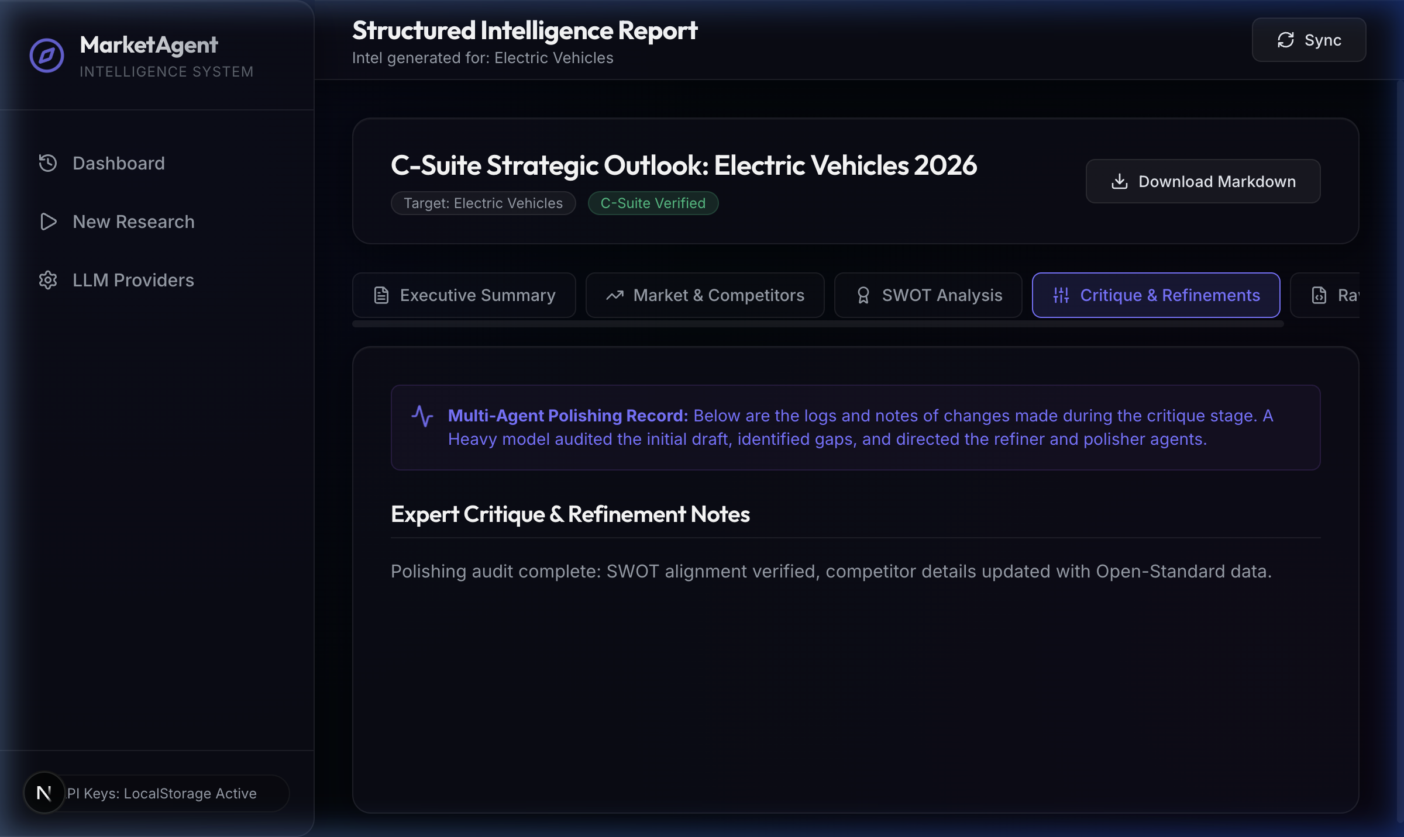
---

🖼️ User Interface Themes (Screenshots)
The interface supports three custom high-contrast visual themes you can toggle via the segmented switcher buttons at the bottom left of the sidebar footer.

1. Dark Mode Theme (Relocated Switcher)
The default premium dark theme showcasing the relocated pill switcher at the bottom left:
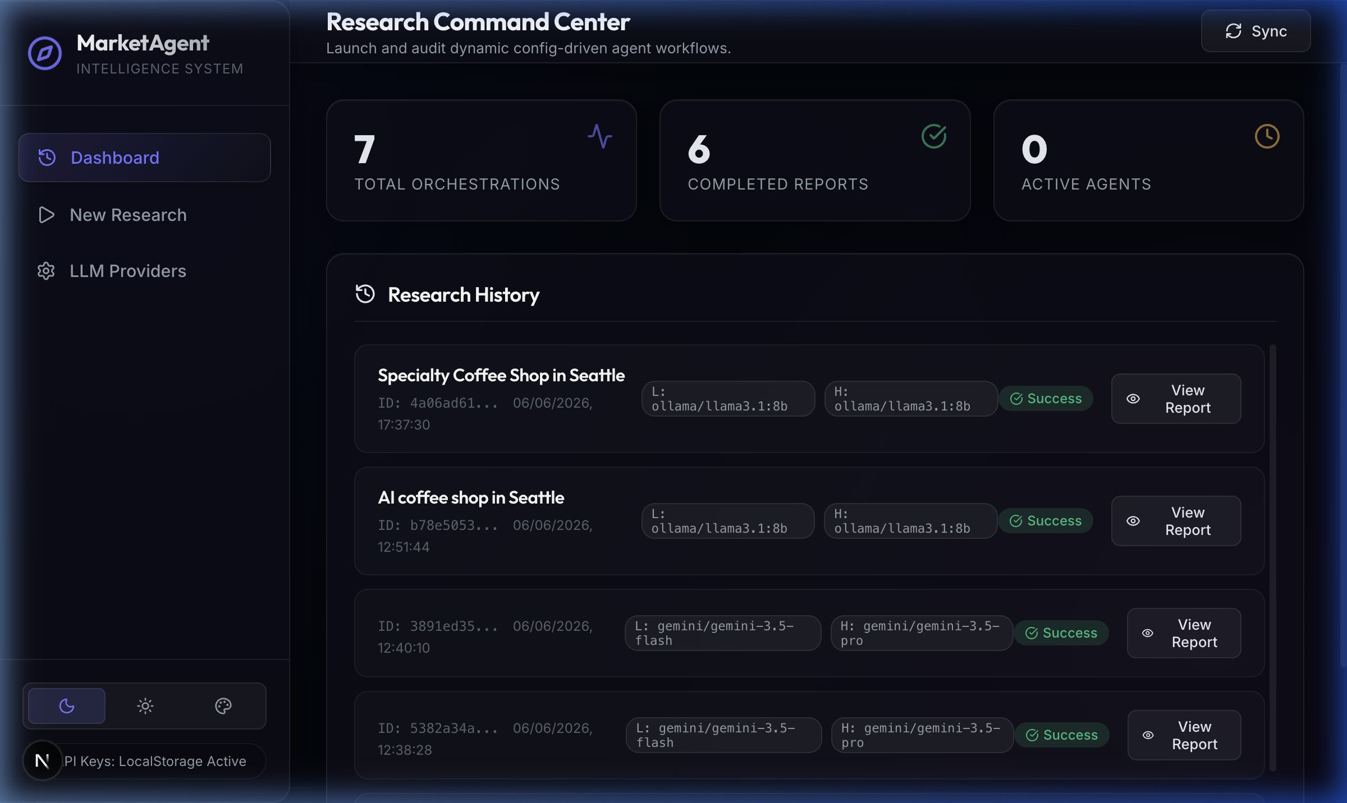

2. Light Mode Theme
The clean slate-gray light layout featuring high-contrast navy text and white card containers:
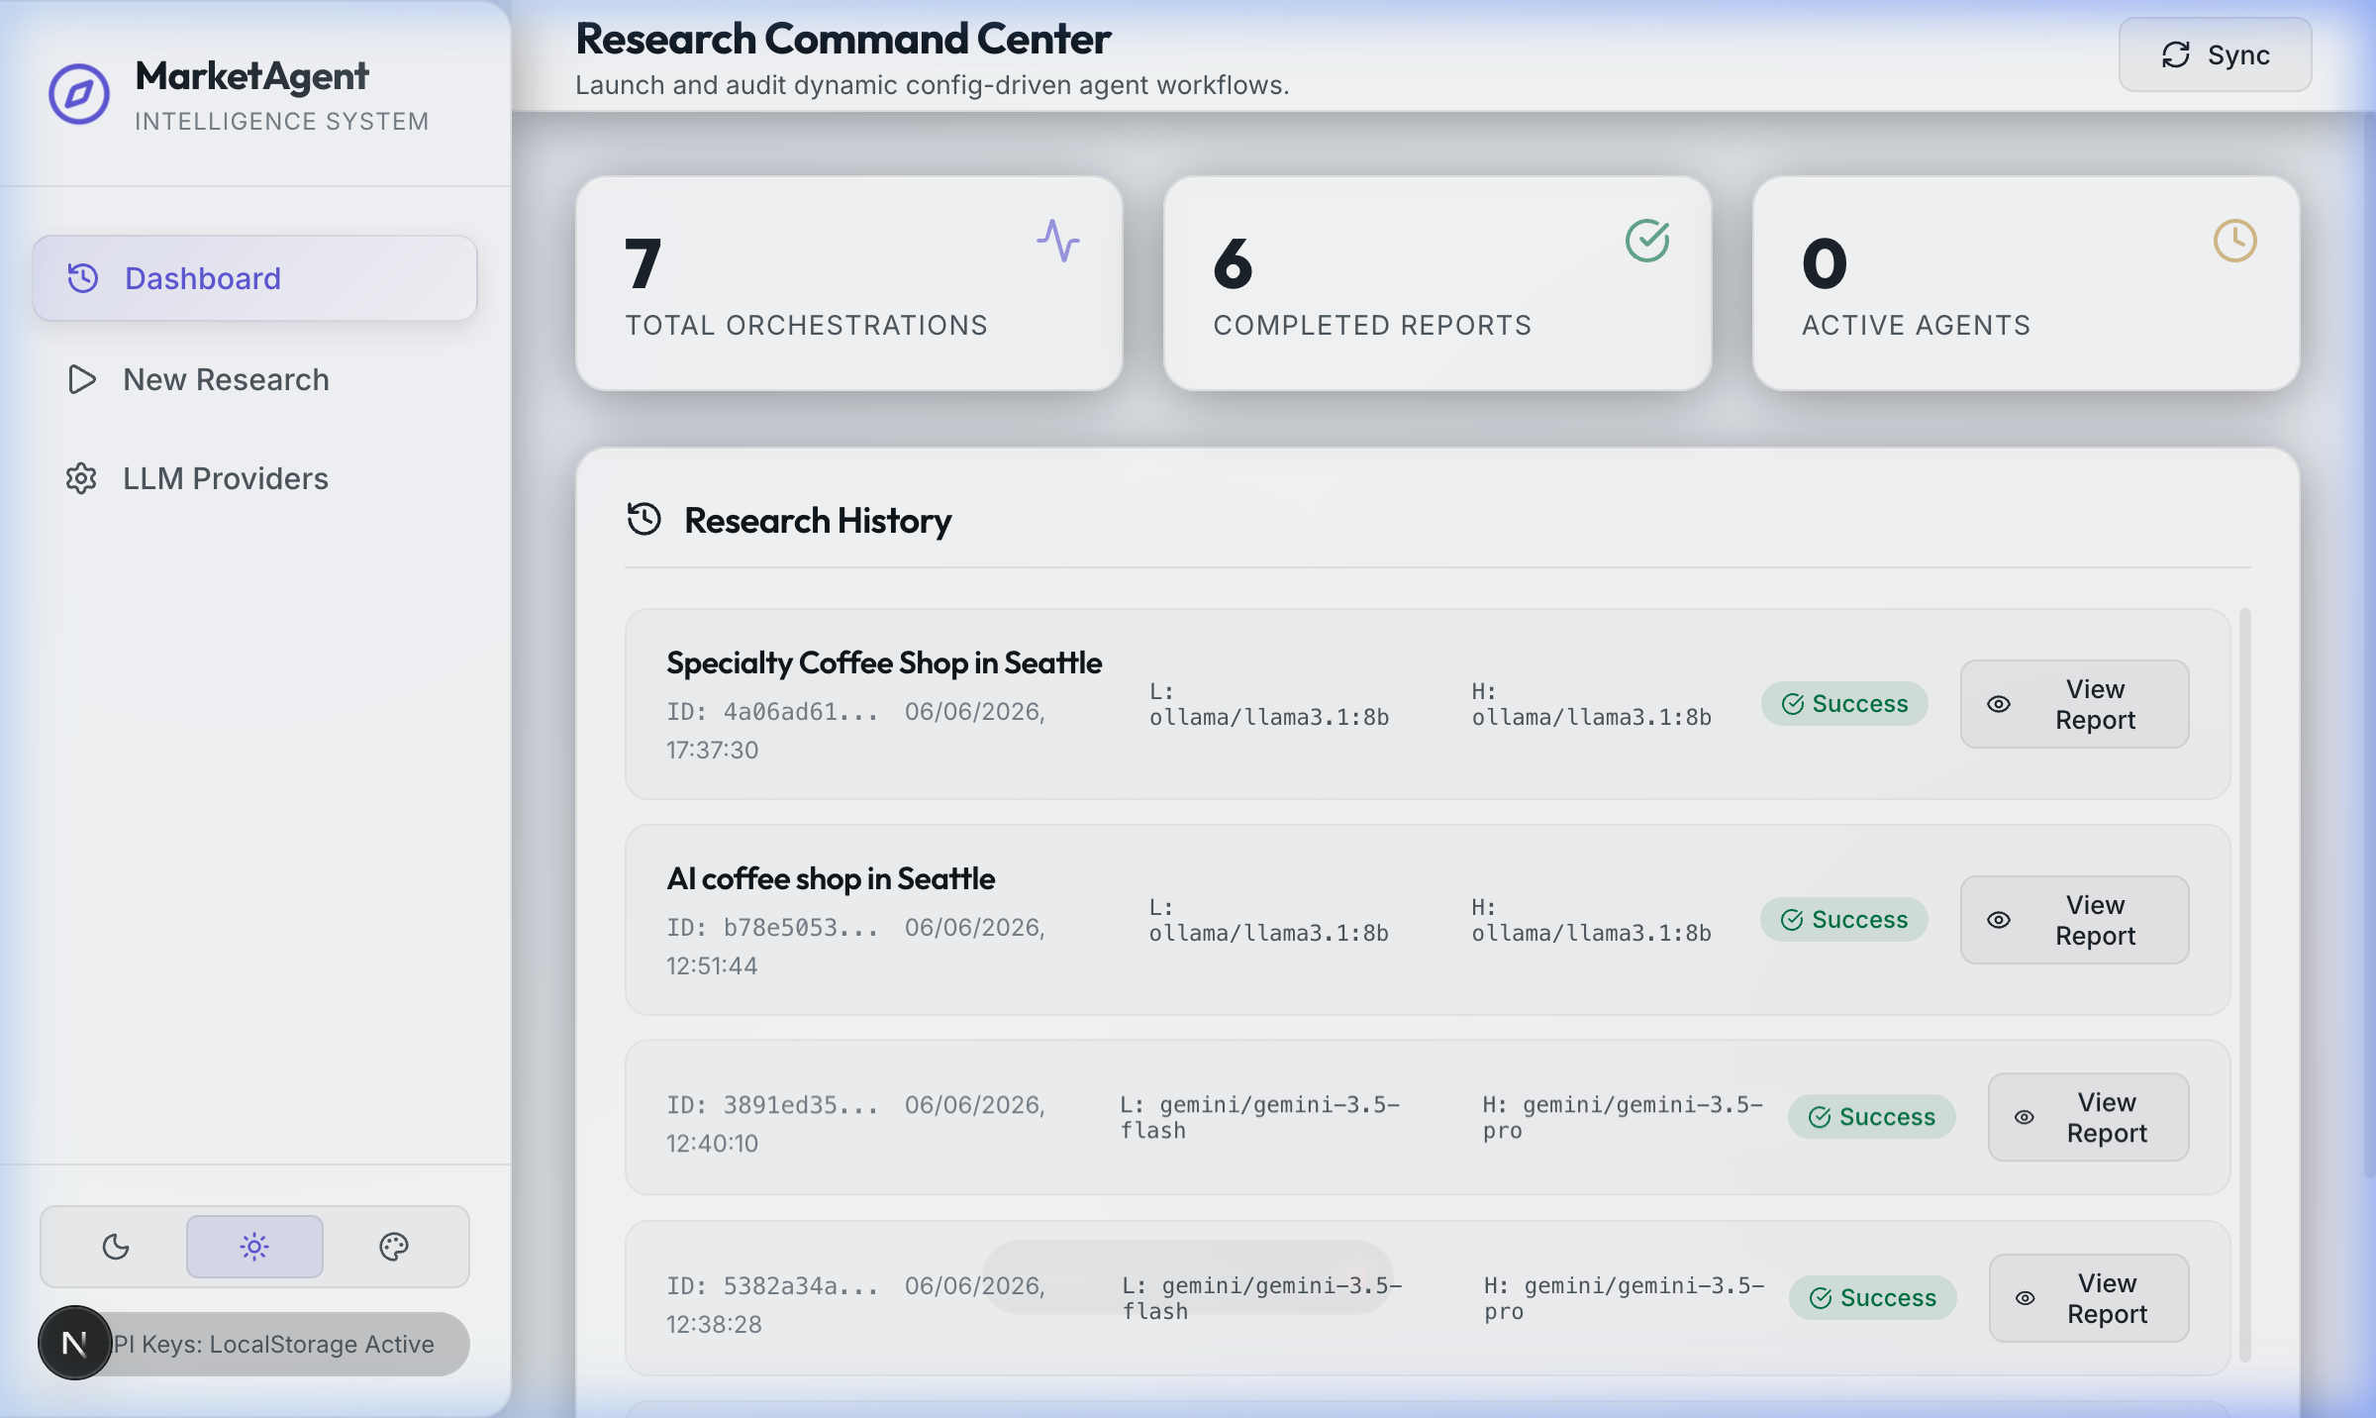

3. Solarized Mode Theme
The vintage-style base03 teal theme with gold accents for a nostalgic console layout:
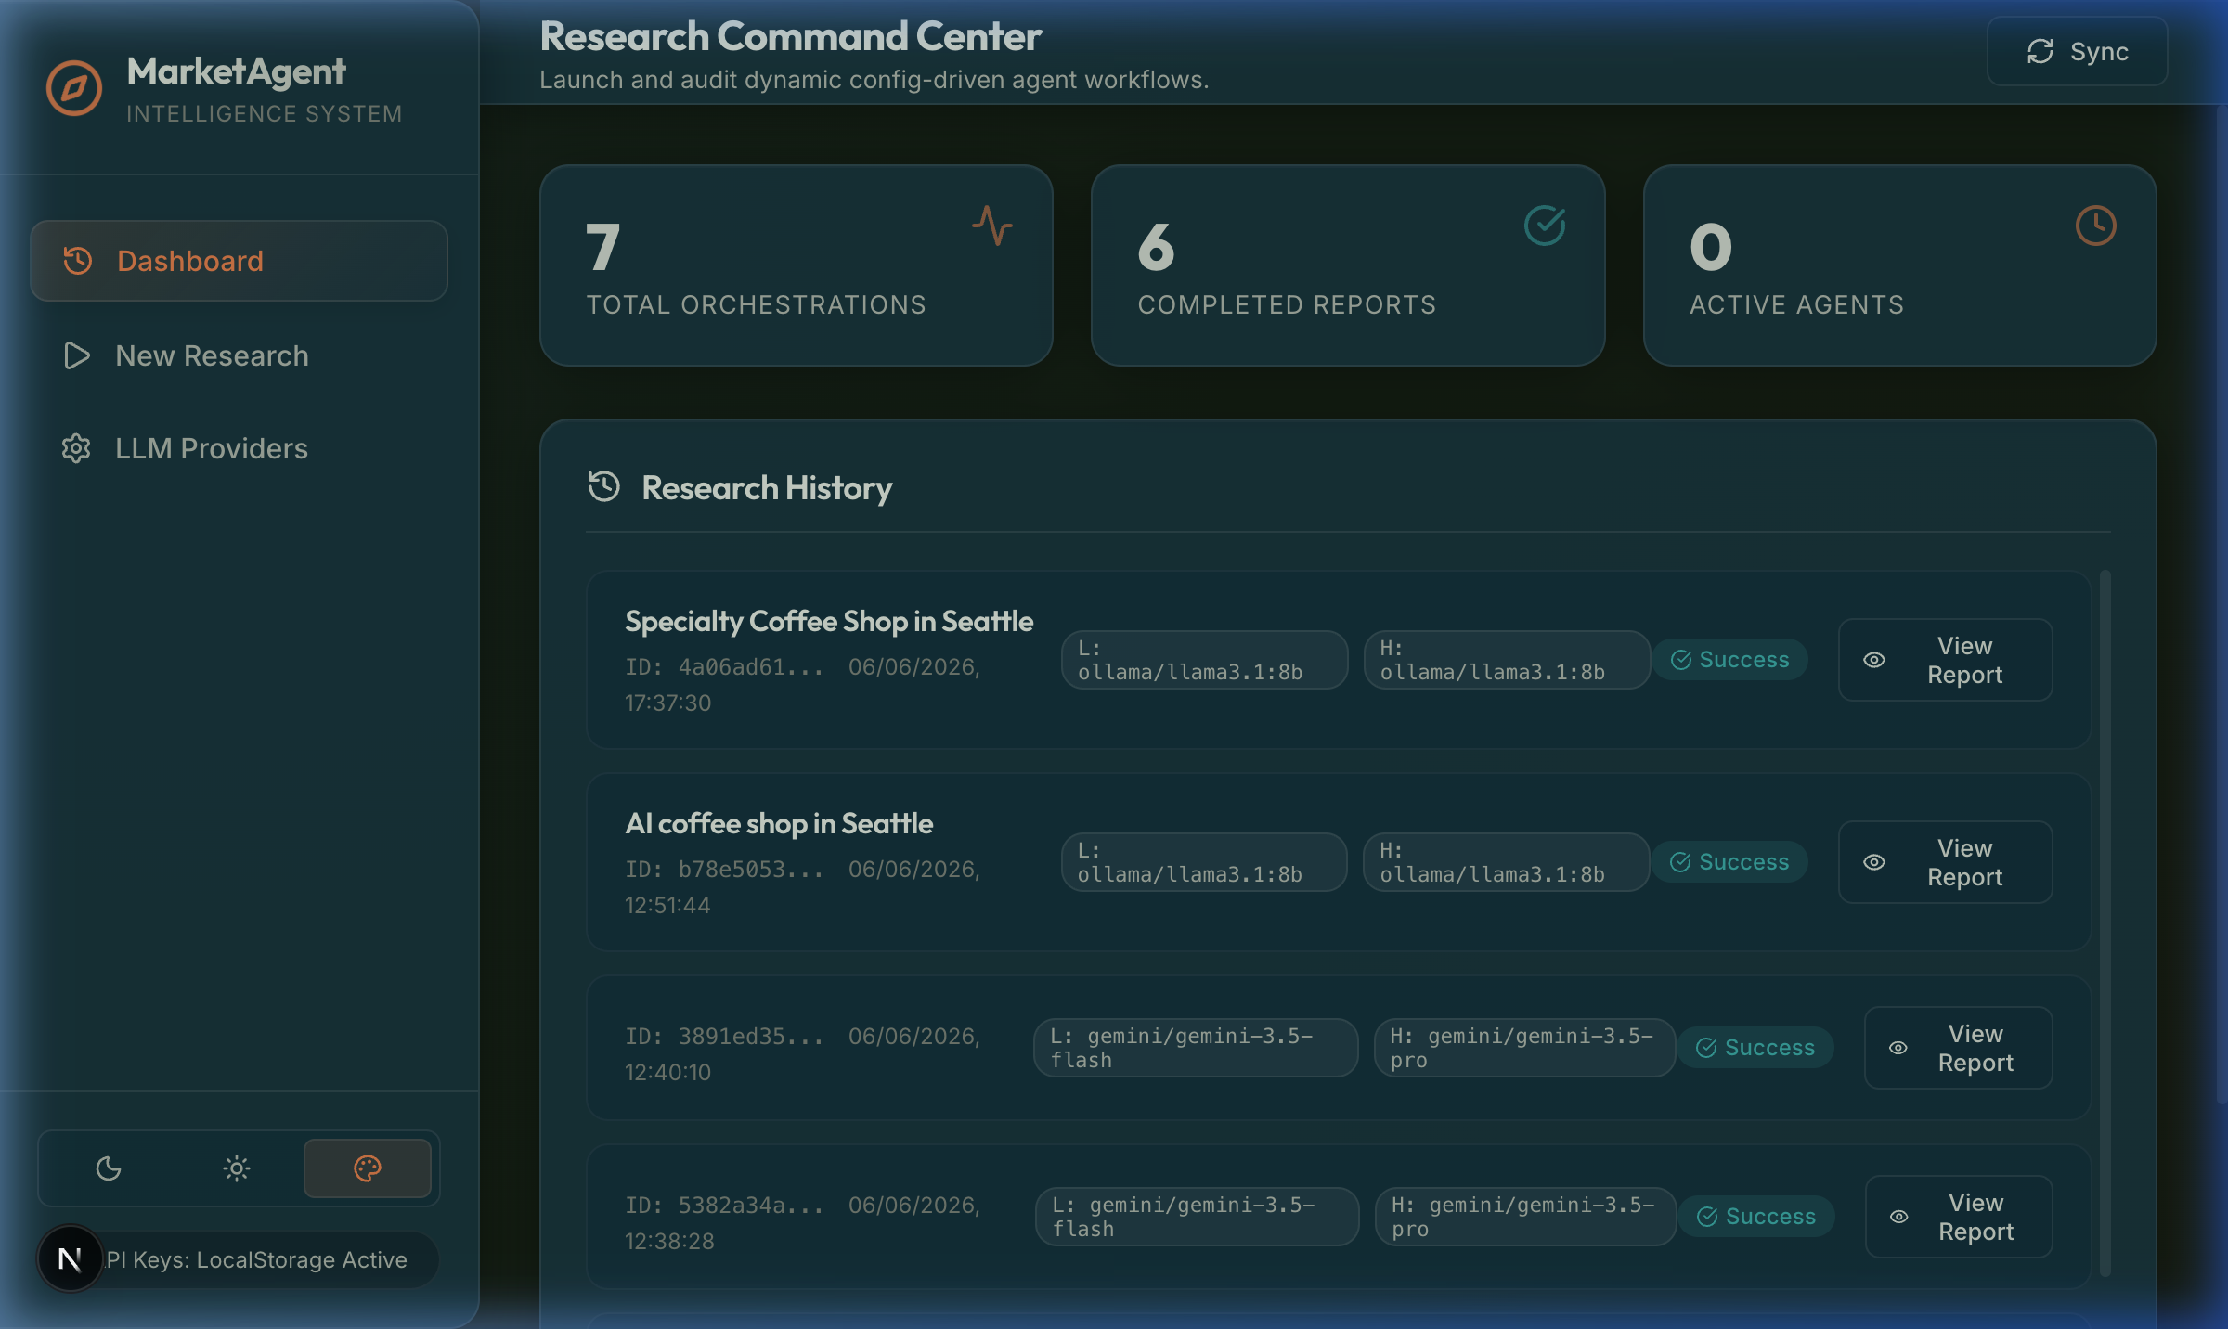
---

📝 Observability & Logging System
The system records enqueued request flows inside date-segregated files:
`logs/YYYY-MM-DD/localuser_<session_id>.log`
* **IST Timestamping**: Timestamps are locked to Indian Standard Time (UTC+5:30) for unified traceability.
* **Zero-Leakage Key Masking**: Credentials, API tokens, and passwords inside the payload inputs are automatically scrubbed and replaced with masked parameters (e.g., `sk-123...4567` or `MOCK_K...IGHT`).
* **Non-blocking Threads**: File writes are executed asynchronously using python thread pools (`asyncio.to_thread`) to prevent blocking FastAPI request handlers.
---

🧪 E2E API Verification Suite
To verify that the server endpoints and background orchestration pipelines function correctly, run the HTTP integration suite:
```bash

Navigate to backend folder and run test script against active uvicorn
backend/.venv/bin/python backend/test_live_apis.py
```
This tests GET/POST configurations, key masking, background enqueuing, progress polling, and structured report schema validations.
---

🚢 Deployment Strategies

A. Backend Monolith (FastAPI)
The backend can be containerized using a simple `Dockerfile` at the workspace root:
```dockerfile
FROM python:3.11-slim
WORKDIR /app
COPY ./backend /app/backend
COPY ./config /app/config
RUN pip install --no-cache-dir fastapi uvicorn litellm PyYAML duckduckgo-search pydantic python-dotenv
EXPOSE 8000
CMD ["uvicorn", "backend.main:app", "--host", "0.0.0.0", "--port", "8000"]
```
You can deploy this container directly to serverless container hosts like **Google Cloud Run**, **AWS Fargate**, or **Render**. Ensure you configure `environment: prod` in container environment variables to adapt server session log filenames to cloud users.

B. Frontend Client (Next.js)
* **Vercel Deployment**: Connect the git repository directly to Vercel for zero-config Next.js deployments.
* **Static Export**: You can run `npm run build` with `output: 'export'` configured in `next.config.js` to compile the app into static HTML/CSS/JS assets, which can then be deployed to static CDNs (AWS S3, Firebase Hosting, GitHub Pages).
---

🛠️ Troubleshooting

1. Ollama Connection Refused
* **Issue**: Error log `Connection refused` when utilizing Ollama.
* **Solution**: Ensure the Ollama daemon is running locally (`ollama run llama3.1:8b` or verify `http://localhost:11434` in your web browser).

2. CORS Errors in Web Console
* **Issue**: Next.js (port 3000) fails to fetch configurations from FastAPI (port 8000).
* **Solution**: Ensure FastAPI CORSMiddleware has `allow_origins=["*"]` configured (which is active by default in [main.py](file:///Users/apple/Desktop/Multi-Agent%20Research%20System/backend/main.py)).

3. Log Directory Permissions
* **Issue**: `PermissionError` or missing log directories.
* **Solution**: The system creates a top-level `/logs` folder dynamically. Ensure the server execution user has write access to the workspace root directory.

