CURRENT_TABLE

CurrentTable

Usage: [%CURRENT_TABLE%]
Description: Returns a string representing the current table accessed by a prior call to [%TABLE_LIST%] - See: ZeraSystems.CodeNanite.ListOfTables
Assuming you create a node with the label - [%TABLE_LIST%].cs as shown below:
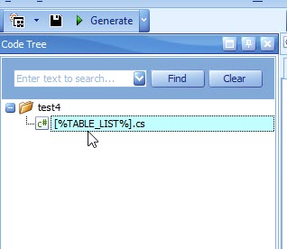
And then add the [%CURRENT_TABLE%] code nanite as the code:
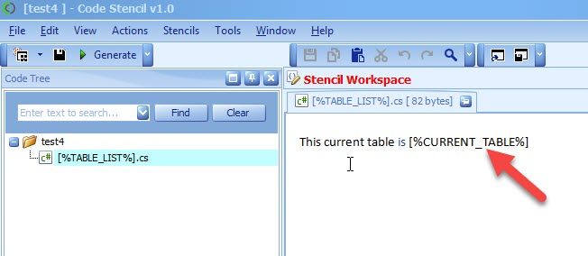
When the code is generated, each file will output the name of the table currently being processed.
