HORIZ_COLUMNS

ExpandColumnsHorizontally

Usage: [%HORIZ_COLUMNS%]
Description: Generates the list of columns in a table as a comma separated string horizontally.
The ability of this Code Nanite to produce results is dependent on this other nanite - [%TABLE_LIST%] ( See: ZeraSystems.CodeNanite.ListOfTables).

Assuming you create a node with the label - [%TABLE_LIST%].cs as shown below:
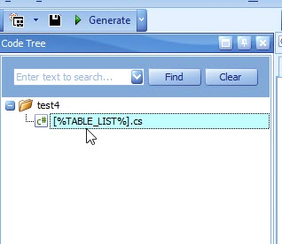

And then add the [%HORIZ_COLUMNS%] Code Nanite in the code editor:

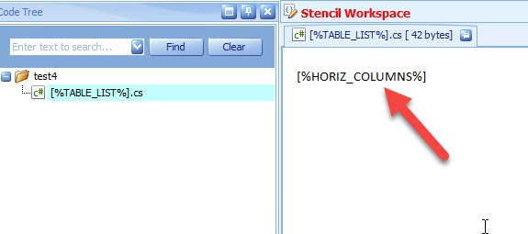
When the code is generated, each file will output the columns in the table currently being processed, separated by commas.

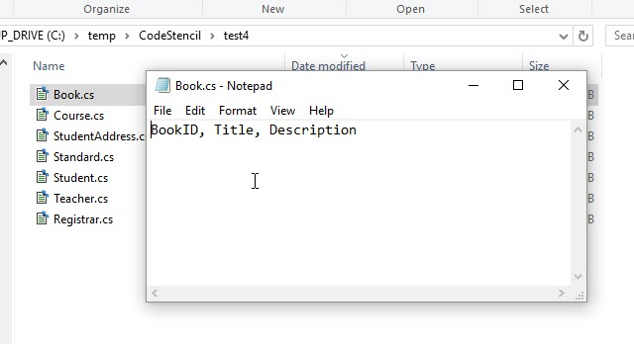
Just like it is listed under the Global Schema:

