Installation Instructions for SAS AMO Demo Spreadsheets

Below are installation instructions for the SAS AMO Demo Spreadsheets presented by Scott Bass at the 2013Q1 SNUG meeting.

- Login to the SAS Management Console as an administrator user. You need the rights to be able to import a SAS package file to create the stored processes used by the Excel workbooks.
- Decide which user you’ll run the AMO demos with, for example sasdemo, or your own userid.
- Navigate to the “My Folder” for the selected user. For example, on my system:
SAS Folders à User Folders à sbass à My Folder
- I recommend creating a sub-folder for these stored processes, for example “SNUG”.
- Import the attached SAS Package File (SPK) into that folder, i.e.
SAS Folders à User Folders à sbass à My Folder à SNUG.
- Verify the import by logging into the SAS Management Console with your demo user account.
- You should see something like:

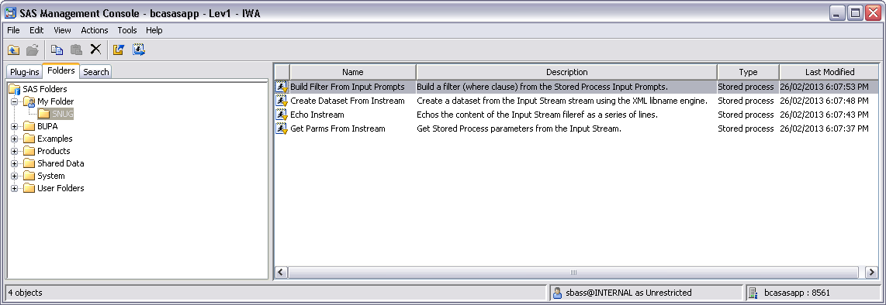

- If for some reason you can’t get the access rights to create these stored processes following the above instructions, you can “manually” create the stored processes via Enterprise Guide. I’ve included screenshots for the stored process properties and included code within each Excel workbook. See the Screenshots and Code tabs.
- More than likely, those Excel workbooks containing stored processes will not work “out of the box”. My conjecture (this is just a guess) is that SAS AMO stores the stored process metadata ID as the “link” to the stored process, rather than the SAS Folder path. But, even if it used the folder path as the link, unless your userid is sbass ;-), we’ve still “pulled the rug out” from under the stored process links.
The workaround is very simple: just create a new worksheet, click “Reports”, and drop the appropriate stored process onto the new worksheet. Using the old worksheet as a guide, set the properties (eg. the SAS theme) as desired. Then, you can delete the old worksheet pointing to the old stored process.
Alternatively, just make a copy of each workbook, keeping the old one as a guide, and making the changes to the new one in place, by deleting the old content and dropping in the new, identical content.
- For workbooks containing VBA code:
Alt-F11 brings up the Visual Basic editor, and Alt-F8 brings up the macro window, from which you can run the VBA macro(s).
- If you’re creating a workbook from scratch that will contain VBA code:
Make sure you create a reference to the SAS AMO plugin (Alt-F11, Tools à References à (find your version of the SAS AMO plugin and tick the checkbox).
Click Insert à Module to insert a new Module. The name doesn’t really matter; I’ve left mine the default name of Module1.
You can use View à Object Browser (F2) to see all the objects available to your VBA project, including the SAS AMO objects. However, MUCH better documentation is available in the AMO help. From the SAS AMO tab in the Excel workbook: SAS Tab à Help icon à Help for the SAS Add-in for Microsoft Office, navigate to “Automating the SAS Add-in with Visual Basic Code” near the bottom.

I’m happy to help or answer any questions. However I prefer such questions go to my personal rather than work account, since these questions aren’t strictly work related. Feel free to email me on sas_l_739@yahoo.com.au if you have any questions or issues setting up these demo AMO workbooks.

Scott Bass

