**TASK1 PART E**

**READINGS:**

1. For sequence:

P1: ECG->ECHO->TM

P6: ECG->ECHO

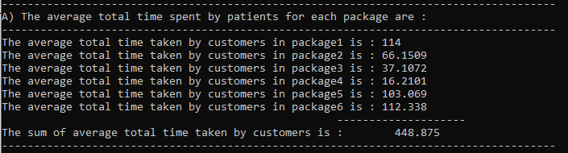

1. For sequence:

P1: ECG->TM->ECHO

P6: ECG->ECHO

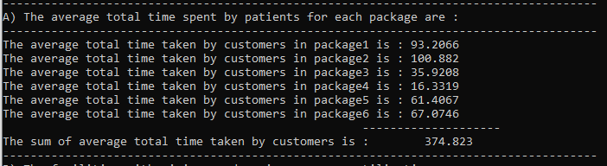

1. For sequence:

P1: ECHO->ECG->TM

P6: ECG->ECHO

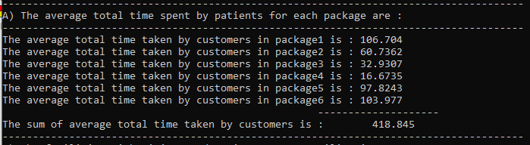

1. For sequence:

P1: ECHO->TM->ECG

P6: ECG->ECHO

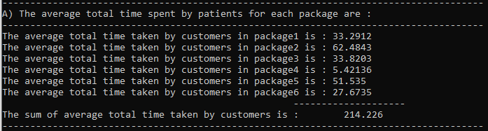

1. For sequence:

P1: TM->ECHO->ECG

P6: ECG->ECHO

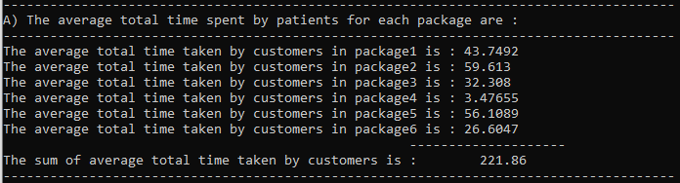

1. For sequence:

P1: TM->ECG->ECHO

P6: ECG->ECHO

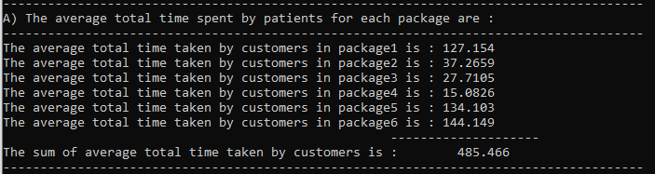

1. For sequence: (The original sequence)

P1: ECG->ECHO->TM

P6: ECHO->ECG

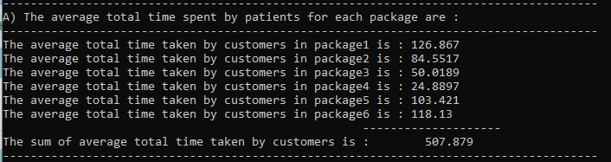

1. For sequence:

P1: ECG->TM->ECHO

P6: ECHO->ECG

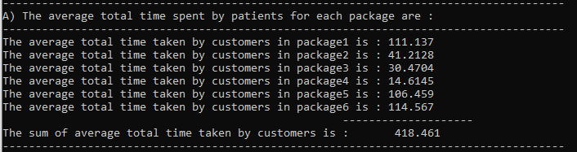

1. For sequence: (use this)

P1: ECHO->ECG->TM

P6: ECHO->ECG

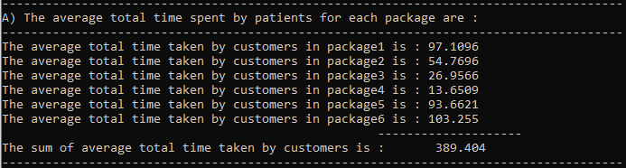

1. For sequence:

P1: ECHO->TM->ECG

P6: ECHO->ECG

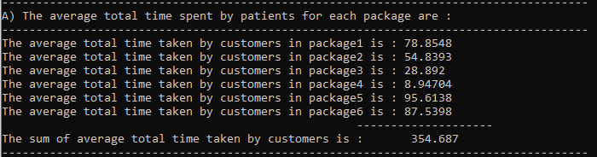

1. For sequence:

P1: TM->ECHO->ECG

P6: ECHO->ECG

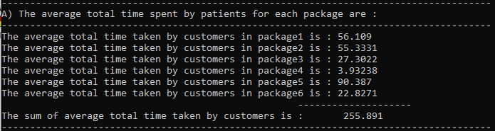

1. For sequence:

P1: TM->ECG->ECHO

P6: ECHO->ECG

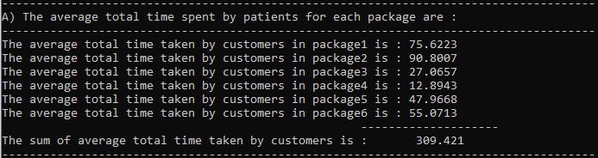

**FINDINGS:**

By observing the above readings of all the 12 sequences possible the findings which I got are listed below.

* The original sequence was: Sequence number 7 in which the average total time for each package was quite high.
* But if we consider the other sequences say: Sequence 4,5 and 11 then it can be observed that the average total time for each package is drastically reduced for these sequences and it is in range of 200.0-300.0.

**CONCLUSION:**

With the above findings the final conclusion for the question:

“Can we improve the average total time spent by all patients by changing the sequence of tests in the packages? “

The average total time spent by all patients can surely be improved by changing the sequence of tests in the packages. In this case I ran the simulation for 3 days with below values of lambda,

60 30 50 40 55

50 40 60 30 55

55 60 50 40 30

And it was observed that the below sequences are giving a much better average total time spent by all patients:

* Sequence 11: P1: - TM->ECHO->ECG, P6: - ECHO->ECG
* Sequence 4: P1: - ECHO->TM->ECG, P6: - ECG->ECHO
* Sequence 5: P1: - TM->ECHO->ECG, P6: - ECG->ECHO

**TASK2 PART A**

For normal queue:

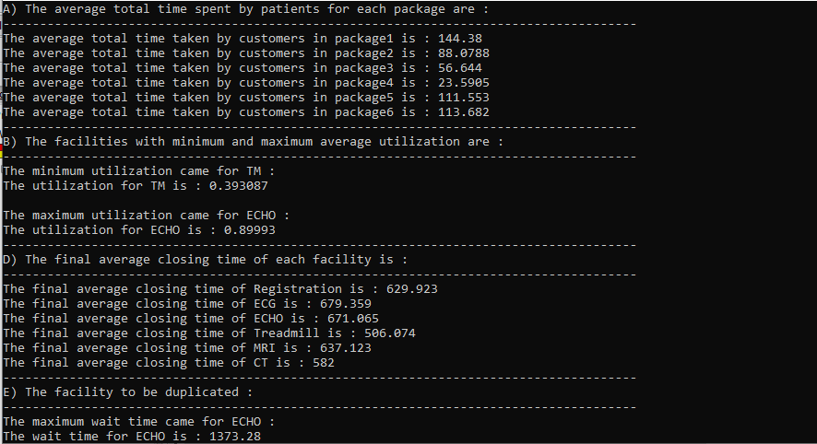

For priority queue:

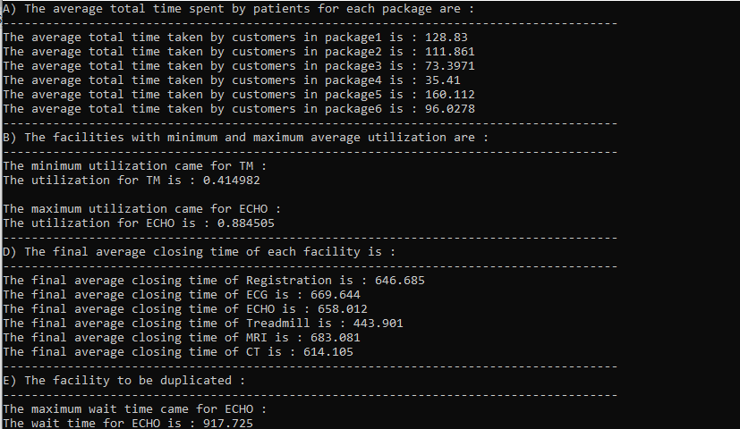

The priority queue is maintained to prioritize the patients who have package 1 and package 6 for facilities.

**CONCLUSION:**

* As seen from above results the average total time for patients with package 1 and package 6 has decreased if they are prioritized. Therefore this kind of implementation will favor the patients with package 1 and package 6.

**TASK2 PART B**

Dynamic sequence selection as per wait time:

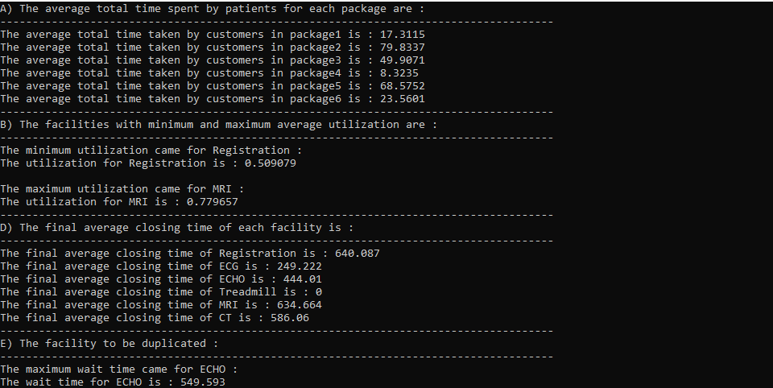

**CONCLUSION:**

* This is the most enhanced version of simulation in which 2 crucial things are kept in mind

1. The patients with package 1 and package 6 are prioritized as they have spent some extra bucks.
2. The facility to which patients with package 1 and 6 should be sent is decided dynamically with the help of current wait time of each facility. Example if patient belongs to package 1 he/she has 3 choices of facilities namely ECG ,ECHO ,Treadmill .Now the facility to which patient is to be sent is decided by measuring current wait time of each facility lets say currently wait time of ECG is the least so patient is sent to ECG. Now after the patient is done with ECG he/she has again 2 choices namely ECHO ,Treadmill therefore again the current wait time for each is calculated and the patient is sent to the facility which has least wait time.

* By doing this kind of modeling we can observe that the simulation is producing the results in which average total time of patients is most optimal.