**HTML**

**HTML** stands for **Hyper Text Markup Language**

##### ****What is hypertext?****

In simple words, you can say hypertext is a text which contains a link to another text.

* **What is a markup language?**

A markup language is a computer language that consists of easily readable keywords, names, or tags that contribute to the overall formatting of a page’s appearance.

**Sytnax**

**<html>**

**<head>**

**<title>First</title>**

**</head>**

**<body>**

**<H1>This Heading</h1>**

**</body>**

**</html>**

* **DOCTYPE! HTML:** This is the declaration of the document type.
* **HTML:** This is known as the HTML root element. It contains a head & body tag.
* **head:** It contains meta-information about the document. It includes various tags like title, link, script. Etc
* **title:** The title tag is used to display the title on the browsers tab
* **Body:** the body content is what displays on the front end of the browser

##### ****What are Tags in Html?****

HTML tags are simply keywords that specify how web browser formats and displays content on the screen

#### ****Types of Tags in Html****

There are three types of tags in Html

1. paired tags
2. unpaired tags
3. self-closing tags.

##### ****Paired Tags****

Paired tags in Html are those tags that have both opening tags and closing tags.

<h1>This is heading </h1>

##### ****Unpaired Tags****

Unpaired tags in Html are those tags that have only an opening tag and do not have a closing tag.

<br>

<hr>

##### ****Self-Closing Tags****

Self-closing tags in Html are those tags that do not require closing tags

<img src=”url.png” alt=”this is an image”/>

* **Here you can see src, alt, and inside the opening tag they are known as attributes**

**Basic HTML Tags**

* <h1>This is heading 1</h1>
* <p>This is a paragraph.</p>
* <a href="https://www.url.com">This is a link</a>
* <img src="iamge.jpg" alt="image.com" width="104" height="142">
* <u> underlined</u>
* <strike>strikethrough</strike>
* <sup>superscript</sup>
* <sub>subscript</sub>

HTML Element

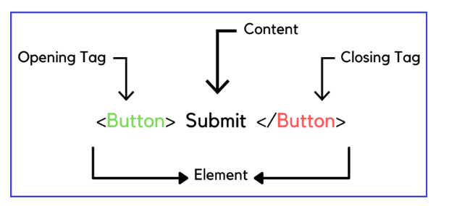

HTML Attribute

* HTML attributes provide additional information about HTML elements.
* Attributes are always written in name-value pairs inside the opening tag of an element
* There are two ways to specify the URL in the src attribute:

1. **Absolute URL** - Links to an external image that is hosted on another website
2. **Relative URL** - Links to an image that is hosted within the website.

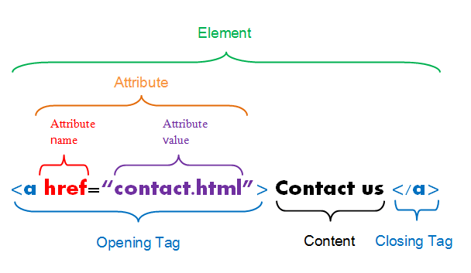

Example:

1. <a href="https://www.url.com">Visit W3Schools</a>
2. <img src="img_girl.jpg">
3. <img src="img_girl.jpg" alt="Girl with a jacket">

HTML Style

<tagname style="property:value;">

Table

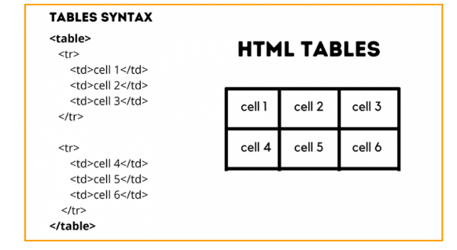

Example:

<!DOCTYPE html>

<html>

<body>

<h2>A basic HTML table</h2>

<table border="1">

<tr>

<th>Name</th>

<th>Age</th>

<th>Country</th>

</tr>

<tr>

<td>Jon</td>

<td>28</td>

<td>Russia</td>

</tr>

<tr>

<td> Ray</td>

<td>33</td>

<td>Australia</td>

</tr>

</table>

</body>

</html>

**Style table border**

<!DOCTYPE html>

<html>

<head>

<style>

table, th, td {

border: 2px solid slateblue;

background-color:aliceblue;

border-collapse:collapse;

}

</style>

</head>

<body>

<table style="width:100%">

<tr>

<th>Sr No</th>

<th>Name</th>

<th>Age</th>

<th>Result</th>

</tr>

<tr>

<td>1</td>

<td>John Einstein</td>

<td>14</td>

<td>Pass</td>

</tr>

<tr>

<td>2</td>

<td>Grace Olive</td>

<td>15</td>

<td>Pass</td>

</tr>

</table>

</body>

</html>

**\*\*\*Colspan\*\*\***

<!DOCTYPE html>

<html>

<head>

  <title>colspan</title>

<style>

table, th, td {

  border: 1px solid black;

  border-collapse: collapse;

  background-color:lightblue;

  padding:5px;

}

</style>

</head>

<body>

<br>

<table style="width:100%">

  <tr>

    <th COLSPAN="2">Full Name</th>

    <th>Age</th>

  </tr>

  <tr>

    <td >Jack</td>

    <td>Efron</td>

    <td>33</td>

  </tr>

  <tr>

    <td>Alex</td>

    <td>Roberts</td>

    <td>23</td>

  </tr>

</table>

</body>

</html>

**Rowspan**

<!DOCTYPE html>

<html>

<head>

<style>

table, th, td {

  border: 1px solid black;

  border-collapse: collapse;

}

</style>

</head>

<body>

<caption>Rowspan attribute</caption>

<table style="width:100%">

  <tr>

    <th>Name</th>

    <td>Obama</td>

  </tr>

  <tr>

    <th rowspan="2">Phone</th>

    <td>9588676676</td>

  </tr>

  <tr>

    <td>97445655466</td>

  </tr>

</table>

</body>

</html>

HTML zebra stripes

<!DOCTYPE html>

<html>

<head>

<style>

table {

  border-collapse: collapse;

  width: 100%;

}

th, td {

  padding: 8px;

}

tr:nth-child(even) {

  background-color: #D6EEEE;

}

</style>

</head>

<body>

<h2>Zebra Striped Table</h2>

<table>

  <tr>

  <th>First Name</th>

  <th>Last Name</th>

  <th>Points</th>

  </tr>

  <tr>

  <td>pradeep</td>

  <td>guess</td>

  <td>100</td>

  </tr>

  <tr>

  <td>losss</td>

  <td>Griffin</td>

  <td>$150</td>

  </tr>

  <tr>

  <td>Joe</td>

  <td>Swanson</td>

  <td>$300</td>

  </tr>

  <tr>

  <td>Cleveland</td>

  <td>Brown</td>

  <td>$250</td>

  </tr>

</table>

</body>

</html>

HTML offers web authors three ways for specifying lists of information. All lists must contain one or more list elements. Lists may contain −

* **<ul>** − An unordered list. This will list items using plain bullets.
* **<ol>** − An ordered list. This will use different schemes of numbers to list your items.
* **<dl>** − A definition list. This arranges your items in the same way as they are arranged in a dictionary.

In Unordered list There are four types of list bullets:

1. **Disc**
2. **Circle**
3. **Square**
4. **None**

<!DOCTYPE html>

<html lang="en">

<head>

    <meta charset="UTF-8">

    <meta http-equiv="X-UA-Compatible" content="IE=edge">

    <meta name="viewport" content="width=device-width, initial-scale=1.0">

    <title>list</title>

</head>

<body>

    <ul type="circle">

        <h4>Fruits</h4>

        <li>Mango</li>

        <li>Orange</li>

        <li>Watermelon</li>

      </ul>

      <ol>

        <h4>Vegetables</h4>

        <li>Brinjal</li>

        <li>Spinach</li>

        <li>Potato</li>

      </ol>

</body>

</html>

**Syntax by css**

<ul style="list-style-type:disc;">

<ul style="list-style-type:square;">

<ul style="list-style-type:none;">

**Syntax for OL**

<ol type = "1"> - Default-Case Numerals.

<ol type = "I"> - Upper-Case Numerals.

<ol type = "i"> - Lower-Case Numerals.

<ol type = "A"> - Upper-Case Letters.

<ol type = "a"> - Lower-Case Letters.

**DL list**

<!DOCTYPE html>

<html>

   <head>

      <title>HTML Definition List</title>

   </head>

   <body>

    <!--

<dl> − Defines the start of the list

<dt> − A term

<dd> − Term definition

</dl> − Defines the end of the list

     -->

      <dl>

         <dt><b>HTML</b></dt>

         <dd>This stands for Hyper Text Markup Language</dd>

         <dt><b>HTTP</b></dt>

         <dd>This stands for Hyper Text Transfer Protocol</dd>

      </dl>

   </body>

</html>

**Task**

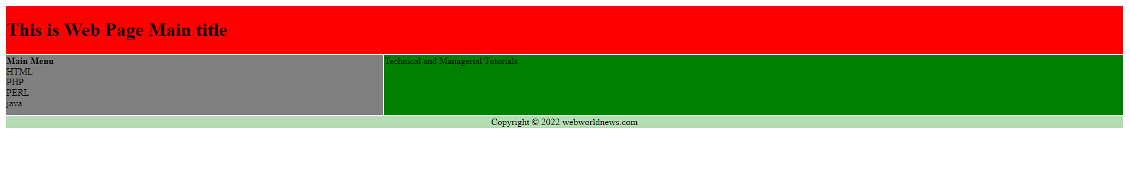

<!DOCTYPE html>

<html>

   <head>

      <title>HTML Layout using Tables</title>

   </head>

   <body>

      <table width = "100%" border = "0">

         <tr>

            <td colspan = "2" bgcolor = "red">

               <h1>This is Web Page Main title</h1>

            </td>

         </tr>

         <tr valign = "top">

            <td bgcolor = "grey" width = "50" height="100">

               <b>Main Menu</b><br >

               HTML<br >

               PHP<br >

               PERL <br>

               java<br>

            </td>

            <td bgcolor = "green" width = "100" >

               Technical and Managerial Tutorials

            </td>

         </tr>

         <tr>

            <td colspan = "2" bgcolor = "#b5dcb3">

               <center>

                  Copyright © 2022 webworldnews.com

               </center>

            </td>

         </tr>

      </table>

   </body>

</html>

**ID & Classes**

* Ids are unique so we can’t apply the same id to different elements as we did in classes
* we can style only one element at a time. It is very important to note that Html documents can’t have two elements with the same ids.
* Classes can applied to multiple elements
* Id’s can be apply for single element
* <!DOCTYPE html>
* <html lang="en">
* <head>
* <meta charset="UTF-8">
* <meta http-equiv="X-UA-Compatible" content="IE=edge">
* <meta name="viewport" content="width=device-width, initial-scale=1.0">
* <title>Document</title>
* </head>
* <body>
* <div class="card" id="card1">
* <h2>CARD1</h2>
* <p>This is CARD 1</p>
* </div>
* <div class="card" id="card2">
* <h2>CARD2</h2>
* <p>This is CARD 2</p>
* </div>
* <div class="card" id="card3">
* <h2>CARD3</h2>
* <p>This is CARD 3</p>
* </div>
* </body>
* </html>

##### ****Block-Level Elements in HTML****

Block elements are elements that begin on a new line. A block element takes up the entire width available for that content. Block-level elements also have a top and bottom margin around the element.

##### ****Inline Elements in HTML****

Elements that do not start on a new line are referred to as inline elements. It does not begin on a new line and occupies only the necessary width, i.e., the space defined by the tags defining the HTML element,

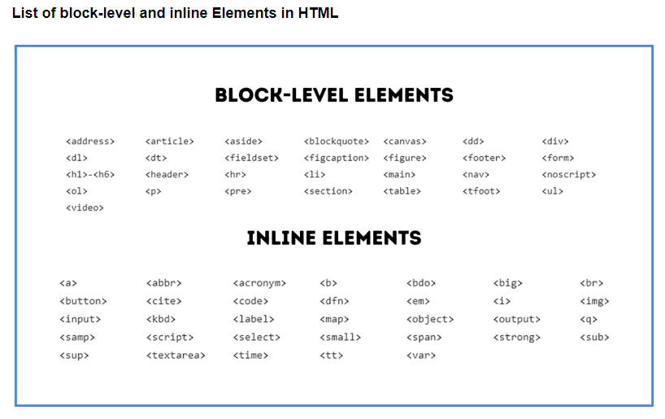

**Form**

HTML forms are used to collect user input. A form will collect input from site visitors and send it to a back-end application, then it will perform the necessary processing on the passed data

<!DOCTYPE html>

<html>

<body>

<h2>HTML Forms</h2>

<form >

  <label for="fname">First name:</label><br>

  <input type="text" id="fname" name="fname" ><br>

  <label for="lname">Last name:</label><br>

  <input type="text" id="lname" name="lname"><br><br>

  <input type="submit" value="Submit">

</form>

</body>

</html>

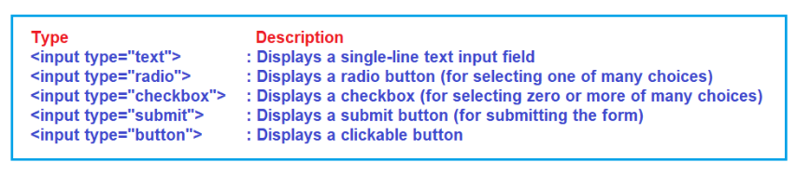

<!DOCTYPE html>

<html lang="en">

<head>

<title>form</title>

</head>

<body>

<form>

    <fieldset>

    <legend>Personal Details</legend>

<p>

        <label>

        Salutation

        <br />

        <select name="salutation">

            <option>--None--</option>

            <option>Mr.</option>

            <option>Ms.</option>

            <option>Mrs.</option>

            <option>Dr.</option>

            <option>Prof.</option>

        </select>

        </label>

    </p>

<p>

        <label>First name: <input name="firstName" /></label>

    </p>

<p>

        <label>Last name: <input name="lastName" /></label>

    </p>

<p>

        Gender :

        <label><input type="radio" name="gender" value="male" /> Male</label>

        <label><input type="radio" name="gender" value="female" /> Female</label>

    </p>

<p>

        <label>Email:<input type="email" name="email" /></label>

    </p>

<p>

        <label>Date of Birth:<input type="date" name="birthDate"></label>

    </p>

<p>

        <label>

        Address :

        <br />

        <textarea name="address" cols="30" rows="3"></textarea>

        </label>

    </p>

<p>

        <button type="submit">Submit</button>

    </p>

    </fieldset>

</form>

</body>

</html>