Digital Clock
  - By Animesh Bodhak
This project is a digital clock that is based purely on synchronous logic circuitry. A top-level view of the design is as follows:
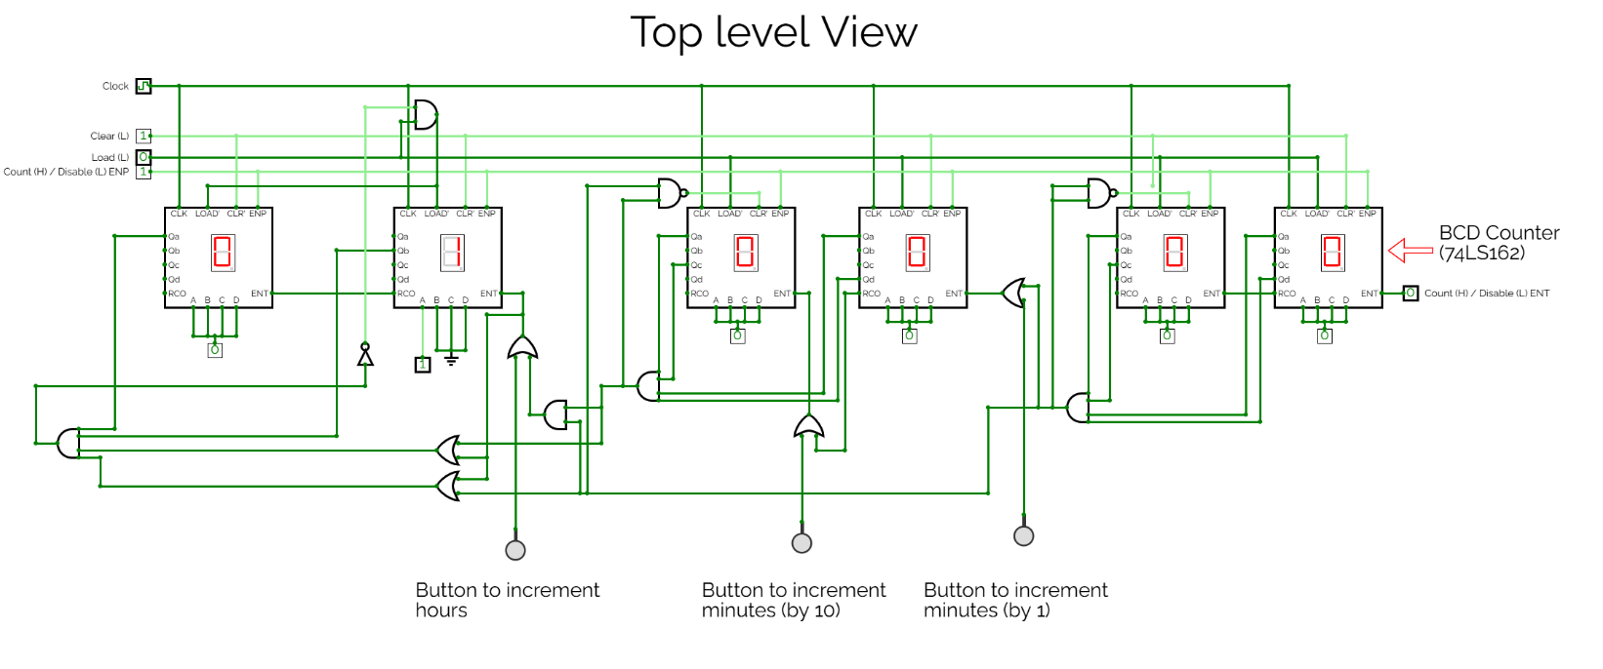
Figure 1: Top-level view of circuit from Simulation (on CircuitVerse)

Links
The following are useful links regarding this project:
- GitHub Repository Link: https://github.com/codevortex/Digital-Clock
- CircuitVerse Simulation Link: https://circuitverse.org/users/434705/projects/digital-clock-using-ti-chips-simulation
- YouTube Demo + Explanation Video: https://www.youtube.com/watch?v=8hRFmEG6mPo

Clock Generation
First and foremost, the clock is generated using a Duty Cycle Square Wave Oscillator circuit (provided by Scott Wang):
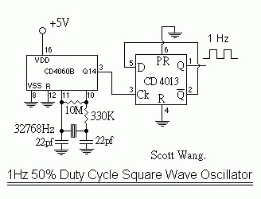
Figure 2: 1Hz Duty Cycle Square Wave Oscillator Circuit by Scott Wang
This circuit uses a 32.768kHz crystal in combination with two 22pf Capacitors, one 10M Ω Resistor, and one 330K Ω resistor to generate a 32.768kHz pulse. This pulse is first brought down to 2Hz by the CD 4060B 14-stage through hole binary counter. The CD 4013B CMOS Dual D-Type Flip-Flop further decreases the frequency to 1Hz.

$\overline{\text{ENP}}$, $\overline{\text{ENT}}$, $\overline{\text{Clear}}$, $\overline{\text{Load}}$ Inputs
The 1Hz clock generated by the aforementioned crystal circuitry is fed to six 74LS162 BCD Counter ICs. A high level at the $\overline{\text{ENP}}$, $\overline{\text{ENT}}$, $\overline{\text{Clear}}$, and $\overline{\text{Load}}$ inputs for the chip allows the BCD counter to increment on the next clock pulse (positive rising edge). When the counter resets from 9 to 0, a pulse is sent through the RCO output. This pulse can be used to increment the next BCD counter.
Because the $\overline{\text{ENP}}$ input is used for carry look-ahead circuitry (which is not needed for the digital clock), it is set to a constant high level.
The $\overline{\text{ENT}}$ input is used to increment the BCD counter. By making the $\overline{\text{ENT}}$ input a high or low level, the timing of increment is controlled. For example, to increment the units digit of hours, the $\overline{\text{ENT}}$ input is high only when the seconds is 59 (i.e., 1010 = 5, 1001 = 9). Buttons are used in conjunction with the OR gate to allow for a manual increment in the BCD counter.
A low-level at the $\overline{\text{Clear}}$ input causes the BCD counter to clear on the next clock pulse irrespective of the $\overline{\text{ENP}}$ or ENT inputs. To make this clear function synchronous throughout the digital clock, the $\overline{\text{Clear}}$ input is connected to each BCD counter. The $\overline{\text{Clear}}$ input is also used to reset the BCD counter to 0 after it passes 5 (in minutes and hours).
A low-level at the $\overline{\text{Load}}$ sets the clock to 01:00:00 on the next clock pulse regardless of $\overline{\text{ENP}}$ or $\overline{\text{ENT}}$ inputs. $\overline{\text{Load}}$ is also used to reset the hour(s) BCD chip from 12 to 01.

Physical Board
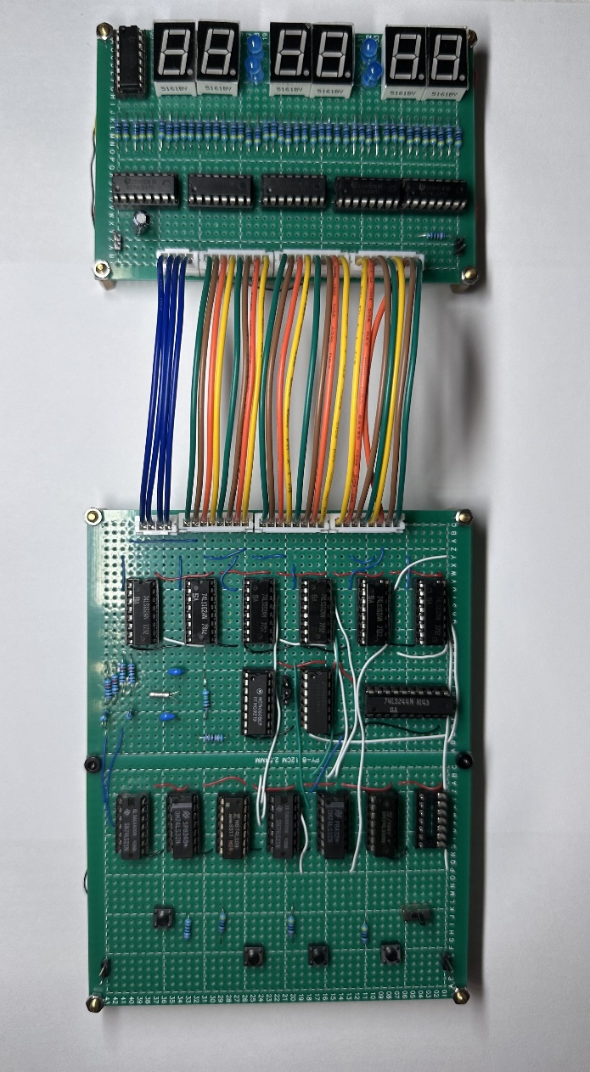
The board is subdivided into two portions: A display portion (top) and a logic portion (bottom). The logic portion contains both the digital logic to drive the synchronous BCD counters as well as a clock portion to generate a 1Hz clock (see clock generation section above).
The display portion (top) uses six 7-segment LEDs (common anode) to show the time in HH: MM: SS. Six 74LS47 BCD to 7-Segment Decoder/Driver ICs are used to drive these LEDs. Because the 74LS47 IC is an open collector, 470 Ω resistors are used to protect the decoder IC.
The logic portion implements the logic circuitry seen in the simulation using the 74LS00 Quad 2-Input NAND, 74LS08 Quad 2-Input AND, 74LS21 Dual 4-Input AND, and 74LS32 Quad 2-Input OR Gates. The left-most button is used to reset the clock to 01:00:00 via $\overline{\text{Load}}$. The 3 middle buttons are used to increment the hours, 10s digit of minutes, and units digit of minutes (from left to right). A pause switch (bottom right) pauses the clock via $\overline{\text{ENT}}$.
The clock generation portion (middle) uses the aforementioned clock circuitry (by Scott Wang) to generate a 1Hz clock. The CD4013 CMOS IC, however, cannot drive the six 74LS162 BCD Decade Counters. A buffer is thus used via the 74LS244 Octal Buffers and Line Drivers w/ 3-state outputs IC (bottom right of middle board).
Figure 3: Layout of Digital Clock Board

