|  |  |  |
| --- | --- | --- |
| **-**  **LAB101 Assignment** | **Type:** | **Short Assignment** |
| **Code:** | **C.S.P0037** |
| **LOC:** | **36** |
| **Slot(s):** | **1** |

**Title**

Identify Square Numbers.

**Background**

N/A

**Program Specifications**

Implement a program to prompt users to input a positive natural number.

Check if the inputted number is a square number.

***Function details:***

1. Function 1: Display a screen to ask users to input a positive natural number.

* Users run the application, the program display a screen prompting users to input a positive natural number.
* Users input the number, perform Function 2.

1. Function 2: Check if the inputted number is square number.

* If the inputted number is a square number, return its square root of 2.
* If the inputted number is not a square number, return -1.
* Perform Function 3.

1. Function 3: Output result to the screen.

After performing the Function 3, the program asks users to input any key to repeat the Function 1.

***Expectation of User interface:***

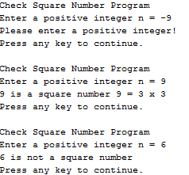

**Guidelines**

**Definition**:

A square number or perfect square is an integer that is the square of an integer; in other words, it is the square (power of 2) of some integer with itself.

* Example: 4, 9, 1.000.000 are square numbers, because:

4 = 2²

9 = 3²

1.000.000 = 1.000²

**Hint**:

Use the function “**double sqrt (double x)**” in the “math.h” library for the square root of 2 of a number.

*\* Students should use the provided dump_line() function to clear the buffer after invoking the scanf() function (call: dump_line(stdin))*.